class Person {

constructor (public Name : string, public Age: number) {}

}

var list = new Array<Person>();

list.push(new Person("Baby", 1));

list.push(new Person("Toddler", 2));

list.push(new Person("Teen", 14));

list.push(new Person("Adult", 25));

var oldest_person = list.reduce( (a, b) => a.Age > b.Age ? a : b );

alert(oldest_person.Name);

var Person = /** @class */ (function () {

function Person(Name, Age) {

this.Name = Name;

this.Age = Age;

}

return Person;

}());

var list = new Array();

list.push(new Person("Baby", 1));

list.push(new Person("Toddler", 2));

list.push(new Person("Teen", 14));

list.push(new Person("Adult", 25));

var oldest_person = list.reduce(function (a, b) { return a.Age > b.Age ? a : b; });

alert(oldest_person.Name);

var myArray = ["a",1,"a","2","1"];

var unique = myArray.filter((v, i, a)=>a.indexOf(v) === i) ;

// unique is ["a",1,"2","1"];

**Use object { } to prevent duplicates**

function uniqueArray1( ar ) {

var j = {};

ar.forEach( function(v) {

j[v+ '::' + typeof v] = v;

});

return Object.keys(j).map(function(v){

return j[v];

});

}

And I wondered which one is faster. I've made [sample Google Sheet](https://docs.google.com/spreadsheets/d/1-Vr4dD0GE0dv1PN9Ng6SyNwn8A407L1zw9uE1cBMwjQ/edit#gid=0) to test functions. Note: ECMA 6 is not avaliable in Google Sheets, so I can't test it.

Here's the result of tests: [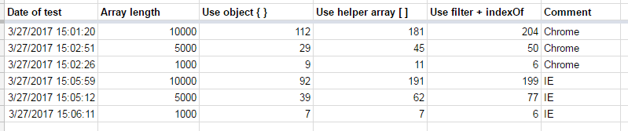](https://i.stack.imgur.com/eCBVm.png)