SAINT ANN PARISH
REQUEST FOR PROPOSALS
Lawn Care & Grounds Maintenance Services
2027 Grounds Maintenance Procurement Package

Issue date | October 2026
Initial service term | March 1, 2027 – February 29, 2028
Optional renewals | Two one-year extensions, by mutual agreement
Proposal due | ____________________________
Mandatory site walk | ____________________________

Service locations: Saint Ann campus, Saint Ann Cemetery, and Sacred Heart Cemetery
Prepared as an editable procurement package. Final quantities are to be verified during the mandatory site walk.

Purpose and procurement objective
Saint Ann Parish is soliciting proposals from qualified lawn care and grounds-maintenance contractors to provide reliable, safe, respectful, and appearance-focused service across the Saint Ann campus in Phoenixville Borough and two parish cemeteries. The objective is to establish a single accountable service standard while allowing bidders to price each location separately and in combination.
Every firm receives the same questions, so answers can be compared side by side. Please answer each question directly and attach documents where requested. Please submission your submission by October 23rd, by the close of business day (5:00 PM).
Important distinction: parcel acreage is not mowing acreage.
Public property records are useful for understanding the scale of the cemetery properties, but roads, buildings, trees, hardscape, grave markers, planting beds and other features reduce the actual turf area. The acreage figures below are procurement planning values, not survey quantities. Every bidder must inspect, measure and certify its own service quantities before submitting a price.

Properties and Planning Quantities
The source document identifies approximately six campus buildings, a playground, dispersed lawn strips and a larger grass field, plus all grass areas at Saint Ann Cemetery and Sacred Heart Cemetery. The campus description includes Holy Family School at 3rd and Buttonwood, grass along 3rd Street/Jones Street and the playground curb, lawn around the church and parish office, the main grass field, Saint Joseph House at 4th and Main, and Saint Ann Chapel.
Location | Address | Public-record scale | RFP planning assumption
Saint Ann campus | 500–604 S. Main St / 221 3rd Ave area, Phoenixville | Known indexed parcels include Holy Family School at 221 3rd Ave (0.64 ac) and 502 Main St (0.30 ac); submitted aerial shows additional parish parcels. | Planning turf estimate: ~0.8–1.2 ac, dispersed; bidder to measure all strips, field and building perimeter lawn.
Saint Ann Cemetery | 378–300 W. Pothouse Rd (tax-record parcel commonly indexed as 305 W. Pothouse Rd) | 20.00 ac parcel; APN 27-050-0040.000E. | Planning mowable range: ~17–19 ac. High trimming burden around markers/monuments; bidder to verify.
Sacred Heart Cemetery | 1261 Fillmore St, Phoenixville | 3.30 ac parcel; APN 15-040-0510.000E. | Planning mowable range: ~2.7–3.1 ac. Bidder to verify turf, drives, tree areas and marker density.
Property-record basis: public-record aggregators drawing from Chester County tax/public-record data report 20.00 acres for 305 W. Pothouse Road, 3.30 acres for 1261 Fillmore Street, 0.64 acre for 221 3rd Avenue, and 0.30 acre for 502 Main Street. These values should be confirmed against Chester County ChescoViews/tax parcel records during procurement.

Site Maps
The following aerials were supplied with Saint Ann’s lawn-care request and are included as orientation exhibits. Boundaries shown are approximate and do not replace the mandatory field walk.
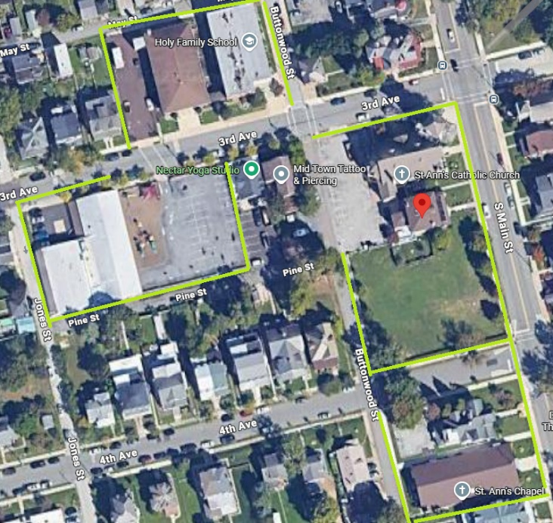
Exhibit A – Saint Ann campus: dispersed lawn strips, grass field and chapel area.
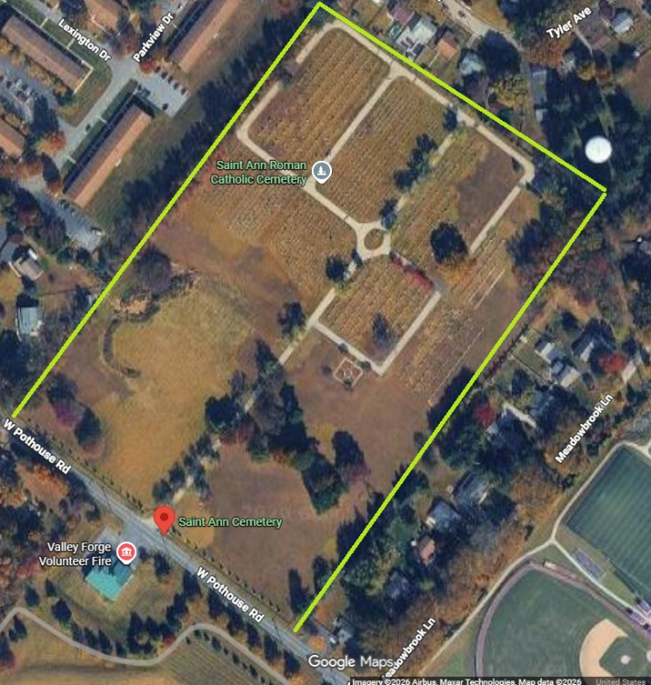
Exhibit B – Saint Ann Cemetery: all maintained grass areas within the cemetery service area.
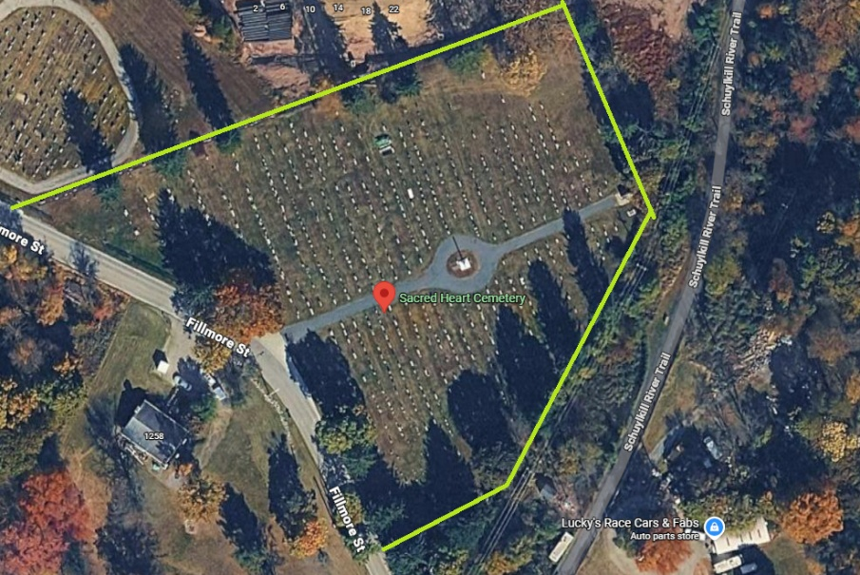
Exhibit C – Sacred Heart Cemetery: all maintained grass areas within the cemetery service area.

Contract Structure
Initial term: March 1, 2027 through February 29, 2028, with two optional one-year extensions by mutual written agreement.
The Parish may award all locations to one contractor or reject any or all proposals when in the Parish’s interest.
Pricing shall include all labor, supervision, transportation, fuel, routine equipment, hand tools and ordinary consumables necessary to perform the base scope.
The Parish reserves the right to add or remove minor service areas by written change order using the bidder’s stated unit rates.
No subcontractor may be used without prior disclosure and written approval. The prime contractor remains fully responsible for quality, safety, insurance and schedule.
The contractor is financially responsible for damage caused by its personnel or equipment and shall notify the Parish immediately of any incident. Clear acknowledgement of such is required.

Base Scope of Services

Mowing and turf appearance
Mow all designated turf areas on a regular growth-based schedule, normally weekly during peak spring and fall growth and adjusted during summer heat/drought.
Target mowing height: generally 3.0–3.5 inches for established cool-season turf unless the Parish directs otherwise. Never scalp turf or remove more than approximately one-third of the leaf blade in a single mowing.
Change mowing patterns where practical to reduce compaction, rutting and directional wear.
Do not mow saturated soil when equipment would rut, tear or compact the turf. Reschedule promptly after conditions permit.
Maintain sharp blades and equipment in safe operating condition. Torn or shredded turf resulting from dull blades is unacceptable and the responsibility to be reseeded by the contractor.
Mulch/recycle clippings when conditions permit. Remove windrows, clumps or excess clippings that create an unsightly appearance or smother turf.

Trimming, edging and cleanup
String-trim around buildings, signs, trees, poles, fences, curbs, headstones, monuments, markers and other obstacles each service cycle as needed to create a uniform appearance.
Edge sidewalks, curbs and defined landscape-bed edges on a schedule sufficient to maintain crisp boundaries; at minimum every second mowing during active growth unless conditions warrant more frequent service.
Before mowing, pick up litter, branches and other debris that could become projectiles or be shredded by equipment. All movable signs are to be moved out of mowing path and returned to proper location.
After service, blow/sweep clippings and debris from sidewalks, steps, parking areas, roadways, curbs, entrances, playground hardscape, headstones and monuments. The contractor may use dumpsters as needed.
The contractor shall not discharge grass, stones or debris toward pedestrians, vehicles, windows, or buildings.

Campus Specific Service Requirements
Service all turf shown during the site walk, including grass around Holy Family School, along 3rd Street/Jones Street and the playground curb, around the church/parish office, the main grass field, Saint Joseph House, Saint Ann Chapel, and other Parish-designated campus lawn areas.
Schedule mowing to avoid student arrival, dismissal, recess, and outdoor school activities. Equipment shall not operate in an occupied playground area.
Before-school CARES begins at 7:00 AM
Recommended student arrival: 7:50–8:00 AM
The school day begins: 8:10 AM
Dismissal: 3:00 PM
Coordinate around Masses, funerals, weddings, parish events and building operations. The Parish may identify blackout windows for individual days. These are the scheduled Mass times:
Monday - Thursday: 7:30 AM
Friday - Saturday: 8:30 AM
Thursday Evening: 7:30 PM
Saturday Evening: 4:30 PM - CHAPEL
Sunday: 7:00 AM - CHURCH
Sunday: 8:00 AM Confessions - CHURCH
Sunday: 9:30 AM Misa - CHURCH
Sunday: 9:30 AM Mass- CHAPEL
Sunday: 4:00 PM Mass- CHURCH
Protect vehicles, windows, HVAC equipment, fencing, play equipment, signs, curbs, and building finishes from thrown debris and trimmer damage.
Maintain pedestrian routes and entrances free from clippings and trip hazards immediately after each visit.

Cemetery-specific service requirements
The contractor must always respect all grieving people in the cemetery. Simply answer their question and refer them to our head of cemetery operations. Please agree and comply with simple request, if less than 10 minutes of effort related to equipment on hand. Obviously, seeding and refilling of graves are outside of the RPF and contract remit.
Work shall pause or relocate when a funeral, interment, graveside service or family gathering is taking place nearby. Parish will work with foreman to ensure communication paths.
Maintain all designated turf areas at both cemeteries, including grass between grave rows, along drives, around monuments, around entrances and fence lines, and in other areas identified during the site walk.
No mower deck, wheel, trimmer head or other equipment may strike headstones, flat markers, monuments, benches, fences or memorial plantings. String line shall be used carefully adjacent to stonework; metal blades are not permitted near monuments unless specifically approved.
Grass clippings shall not remain on headstones, monuments, markers, roads, walkways or memorial decorations after service.
Holiday and grave decorations are to be handled only according to Parish direction. The contractor shall not independently remove memorial items unless specifically authorized.

Leaf and seasonal cleanup
Perform spring cleanup before the first regular mowing cycle: collect winter debris, branches and accumulated leaves from maintained turf and edges.
Perform fall leaf removal sufficient to prevent heavy leaf matting on turf, roads, sidewalks and around grave markers. At least two major fall cleanups shall be included in the base proposal unless the bidder clearly states an alternate schedule.
Remove normal small storm debris encountered during routine service. Major limb/tree debris outside normal service shall be handled only after authorization at quoted unit rates.

Optional turf and landscape services
The following items shall be priced separately so Saint Ann can select services based on condition and budget. No chemical application is authorized unless specifically included in the final contract or approved in writing.
Soil testing and written turf fertility recommendations.
Fertilization program based on soil/turf needs rather than a fixed calendar alone.
Pre-emergent and post-emergent weed control; spot treatment preferred where practical.
Grub/insect or disease treatment when monitoring indicates need.
Core aeration and overseeding of selected campus or cemetery turf.
Bare-area repair using seed, topsoil and/or sod.
Landscape-bed weeding, edging and mulch installation.
Shrub pruning and ornamental maintenance.
Tree pruning/removal by separately qualified personnel.
Irrigation inspection/repair if an irrigation system exists in any serviced area.
Pennsylvania pesticide requirement
Any contractor applying pesticides/herbicides to property of another must comply with Pennsylvania Department of Agriculture licensing requirements. School and playground property can trigger additional applicator and notification requirements. The selected contractor must provide current business/applicator credentials, product labels/SDS, application records and all required notices before treatment.

Recommended service calendar
Period | Expected service pattern
March | Spring cleanup; first mowing only if growth warrants; edge/bed cleanup.
April–June | Flower beds are to be weeded, cleaned, and mulched. Normally weekly mowing/trimming; higher growth may require schedule adjustment. Ensure grass is mowed week before Memorial Day. Ensure veterans flags remain in tack for Memorial Day.
July–August | Normally 7–14 day growth based interval depending on heat/drought; do not mow dormant turf unnecessarily. Clear debris as needed. Ensure grass is mowed week before July 4th.
September–October | Normally weekly as growth resumes; begin leaf management. Ensure grass is mowed week before Labor Day. Final cuts as needed.
November–December | Major leaf cleanup; winter-ready site cleanup.
January–February | No routine mowing; authorized storm debris or special work only.
The Parish prefers a performance-based schedule: turf should remain within the specified height/appearance standard rather than being cut on an inflexible date when growth conditions do not warrant mowing.

Quality standards and service-level expectations
Standard | Required result
Turf height | Generally 3.0–3.5 in.; adjust for drought/conditions with Parish approval.
Appearance | Uniform cut; no scalping, skips, windrows, excessive tire tracks or clumping.
Trimming | Uniform height around obstacles; no bark, fence, siding or monument damage.
Hardscape cleanup | Completed before crew leaves site every visit.
Missed service | Notify Parish same day; weather-delayed service normally recovered within 48 hours after conditions allow.
Damage reporting | Immediate verbal/email notice, followed by written incident record and repair plan.
Routine issue reporting | Report sinkholes, sunken grave areas, fallen limbs, irrigation leaks, vandalism, unsafe conditions or other observations.
Documentation | Electronic service log identifying date, crew, location, services performed and exceptions.

Special-event and cemetery coordination
Contractor shall designate one dispatcher/supervisor who can adjust crews for funerals, school events and Parish needs.
Upon reasonable notice, the Parish may request additional services which a cemetery turf and access areas are presentation ready before a funeral or major observance.
Contractor shall not block cemetery roadways, church entrances, school fire lanes or emergency access with vehicles or trailers.
Fueling, blade changes and major maintenance shall be performed away from visitors and sensitive areas when practical.

Staffing, equipment and safety
Provide trained, uniformed or readily identifiable crews supervised by an experienced foreperson.
Use commercial-grade equipment suited to each location. The contractor shall identify mower widths and equipment proposed for narrow cemetery rows and campus strips.
Maintain backup equipment sufficient to prevent recurring missed service from mechanical failure.
Follow OSHA requirements and manufacturer safety procedures. Operators shall use appropriate PPE and maintain guards/shields.
Keep keys and running equipment under operator control; do not leave equipment accessible to students or the public.
Use traffic cones or other controls when loading/unloading near streets or when work affects pedestrian/vehicle movement.

Environmental and turf-health practices
Follow integrated pest management principles where practical: monitor, identify and treat only when necessary.
Prevent fertilizer, pesticide and grass-clipping discharge into storm drains, roadways and drainage channels.
Use soil testing before lime or major fertility corrections when practical.
Adjust mowing height upward during summer stress where needed to protect cool-season turf.
Report recurring drainage, compaction, bare-soil or disease problems rather than masking them with repeated chemical treatment.

Insurance, licensing and contractual requirements
Requirement | Minimum / documentation
Commercial General Liability | Commercial General Liability Insurance – Vendor shall maintain Commercial General  Liability insurance covering bodily injury and property damage on an “occurrence” form in an  amount not less than $1,000,000 Each Occurrence / $2,000,000 General Aggregate /  $1,000,000 Products/Completed Operations Aggregate.
Commercial Auto | Automobile Liability Insurance 2 – Vendor shall maintain Automobile Liability insurance for all  owned, hired, and non-owned vehicles in an amount not less than $5,000,000 each accident.
Workers’ Compensation | Workers’ Compensation and Employers’ Liability Insurance 11 – Vendor shall maintain  Workers’ Compensation insurance with statutory limits and Employers’ Liability insurance in an  amount not less than $1,000,000 Each Accident / $1,000,000 Each Employee / $1,000,000  Policy Limit.
Umbrella / Excess | $1,000,000 minimum recommended
Pesticide business/applicator license | Required when chemical applications are included; provide current Pennsylvania credentials
Additional insured | Saint Ann Parish and other entities designated by Parish/Archdiocese, where required by contract
Subcontractors | Same coverage and compliance standards; certificates required before work
Final insurance language and limits should be reviewed by the Parish/Archdiocese insurance representative before award.

Proposal Response Requirements
Completed Contractor Questionnaire and Bid Form included with this RFP.
Company profile, ownership, years in business and primary contact information.
Description of commercial/institutional and cemetery grounds-maintenance experience.
Proposed staffing and equipment deployment for Saint Ann locations.
Service schedule and approach to weather delays, peak growth and special events.
Three references for comparable work; at least one cemetery and one school/church/institutional reference are preferred.
Current certificates of insurance and applicable licenses, including pesticide credentials if chemical services are proposed.
Pricing for all locations for stated work in RFP
Pricing for optional services using the RFP price schedule.
List of exceptions, exclusions, assumptions and subcontractors.
Sample service report or quality-control checklist from a comparable property, with confidential information redacted.

How to respond
- Return the completed questionnaire, pricing sheet (Section I) and Certificates of Insurance to: Jeffrey Fisher Director of Operations, Operations@chruchofSaintAnn.org.

Certification
I certify that the answers above are true and complete. I understand that false or incomplete answers may disqualify my firm.
Name: ______________________ Title: ______________________
Signature: ______________________ Date: ______________

