SAINT ANN PARISH
REQUEST FOR PROPOSALS
Snow Removal Services
2026/2027 Snow and Ice Removal Procurement Package
Issue date | October 2026
Initial service term | November 1, 2026 – October 31, 2027
Optional renewals | Two one-year extensions, by mutual agreement
Proposal due | ____________________________
Mandatory site walk | ____________________________
Service locations: Saint Ann campus, Saint Ann Cemetery, and Sacred Heart Cemetery
Prepared as an editable procurement package. Final quantities are to be verified during the mandatory site walk.

Purpose and procurement objective

Instructions for responding firms
Saint Ann's Parish is soliciting proposals from qualified snow and ice management contractors for the coming winter season and beyond.
Every firm receives the same questions, so answers can be compared side by side. Please answer each question directly and attach documents where requested. Please submission your submission by October 23rd by 5:00 PM.

Properties and Planning Quantities

Property overview
- Main campus (Phoenixville Borough): 4 blocks along S Main St, Buttonwood St, 3rd Ave and 4th Ave. It includes Saint Ann Church (3rd Ave and Main St), the parish office and rectory (502 S Main St), Saint Ann Chapel (604 Main St) and Holy Family School (221 3rd Ave). There are 6 buildings in total.
- Main campus quantities: about 3,100 linear feet of sidewalk, about 57,000 sq ft of paved lots and drives.
- Two cemeteries: Saint Ann Cemetery on W Pothouse Rd (300–378 block; listed at 305 W Pothouse Rd), and Sacred Heart Cemetery at 1261 Fillmore St.
- Standard for the main campus: all walks, entrances, steps, ramps and lots cleared and treated so people can walk into and out of every building safely. This must be done before each Mass, before the school day, and before funerals and events.
- Standard for the cemeteries: all interior roadways cleared within 36 hours after a storm ends.
- Borough ordinance: public sidewalks must be cleared within 24 hours of snowfall ending.
A marked site map and a pre-bid walk-through of all three sites are available on request. The quantities in this questionnaire are estimates, and each firm should verify them at the walkthrough themselves or with Director of Operations of Saint Ann’s.

Site inventory and estimated quantities
The main campus has about 3,100 linear feet of sidewalk and about 57,000 sq ft (1.3 acres) of paved lots and drives. It also has a green area of about 40,000 sq ft used for parking. These figures were measured from the parish's marked site map at roughly 1.3 ft per map pixel and are accurate to about ±20%.
Area | Location | Sidewalk (linear ft) | Lots and drives (sq ft) | Other items
1. Holy Family School block | North side of 3rd Ave, from May St to Buttonwood St | ~700 (3rd Ave ~260, Buttonwood ~195, May St ~250) | ~10,000 (lot and drive on the west side of the school) | School entrances, student drop-off
2. Block west of Buttonwood | 3rd Ave from Jones St toward Buttonwood; Pine St | ~515 (3rd Ave ~330, Jones St ~185) | ~25,000 (lot between 3rd Ave and Pine St) | Building entrances
3. Church block | 3rd Ave to 4th Ave, Buttonwood St to S Main St | ~1,275 (3rd Ave ~240, S Main ~395, 4th Ave ~235, Buttonwood ~405) | ~16,000 (lot and curved drive west of the church) | 3 walkways from S Main St to church and office entrances, ~150 ft total
4. Chapel block | South of 4th Ave, Buttonwood St to S Main St | ~595 (4th Ave ~230, S Main ~180, Buttonwood ~185) | ~6,000 lot, plus a drive of ~165 ft | 2 walkways from S Main St to chapel entrances, ~90 ft total
Main campus total |  | ~3,100 area | ~57,000 paved area
Saint Ann Cemetery | W Pothouse Rd (listed at 305; parcels 300–378) | none | Interior roadways, length to be measured | About 3,500 recorded graves; roads only, 36-hour standard
Sacred Heart Cemetery | 1261 Fillmore St | none | Interior roadways, length to be measured | Adjoins Holy Trinity and Sts. Peter & Paul cemeteries; roads only, 36-hour standard

  - Graphic of Main Campus
The following aerials were supplied with Saint Ann’s lawn-care request and are included as orientation exhibits. Boundaries shown are approximate and do not replace the mandatory field walk.
Areas in red indicate where snow will need to be removed. Lots are indicated by boxes. Long walkway between 602 and 604 main street is along walkway enclosing the Saint Joseph house.
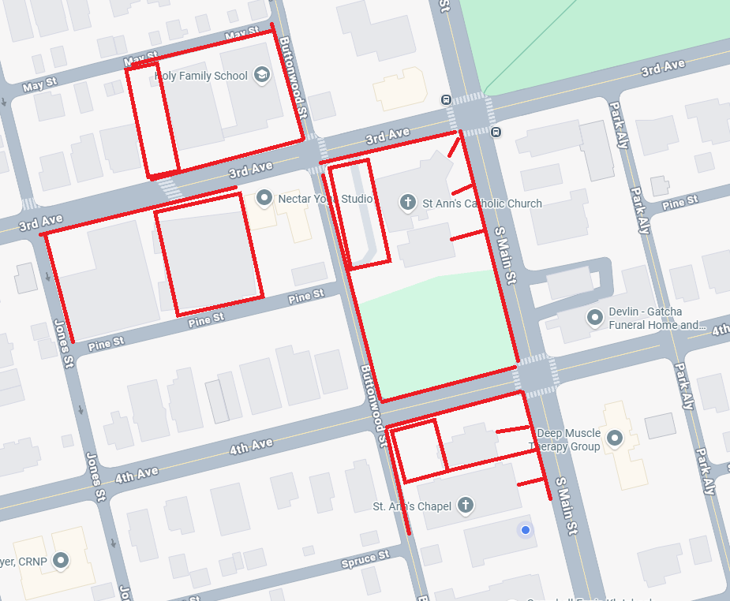
Exhibit A – Saint Ann campus: red areas show areas to be cared.
Saint Ann Cemetery
378-300 W Pothouse Rd, Phoenixville, PA 19460
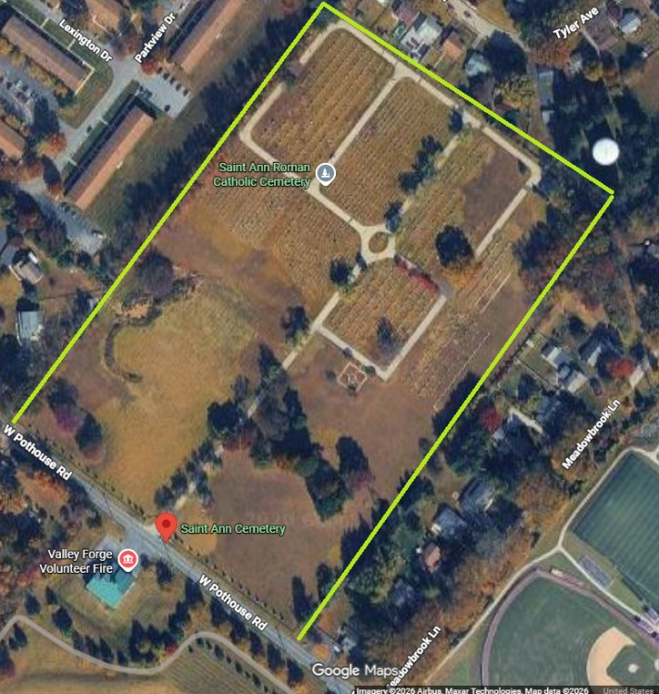

Sacred Heart Cemetery
1261 Fillmore St, Phoenixville, PA 19460
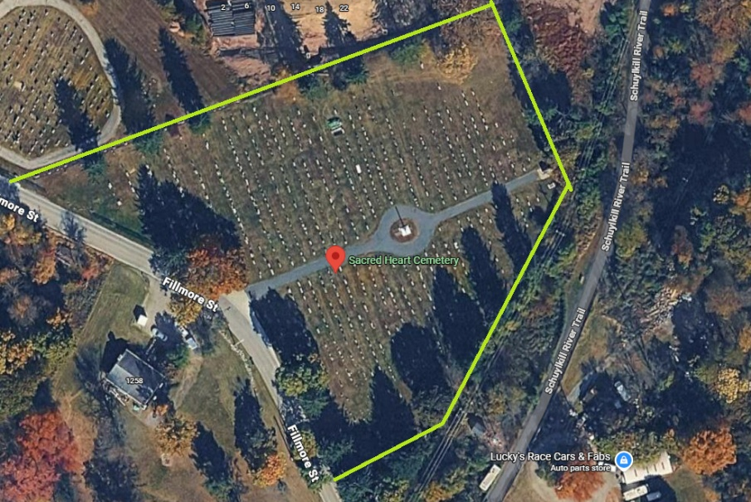

Contract Structure
- Initial term: November 1, 2026 through October 31, 2027, with two optional one-year extensions by mutual written agreement.
- The Parish may award all locations to one contractor or reject any or all proposals when in the Parish’s interest.
- Pricing shall include all labor, supervision, transportation, fuel, routine equipment, hand tools and ordinary consumables necessary to perform the base scope.
- The Parish reserves the right to add or remove minor service areas by written change order using the bidder’s stated unit rates.
- No subcontractor may be used without prior disclosure and written approval. The prime contractor remains fully responsible for quality, safety, insurance and schedule.
- The contractor is financially responsible for damage caused by its personnel or equipment and shall notify the Parish immediately of any incident. Clear acknowledgement of such is required.

Scope of service by area
Please confirm what is included for each area and note anything you would exclude or price separately.
Parking lots
- Vendor will plow and treat (salt or chemical) all drive lanes and every parking space, including handicap spaces and access aisles.
- All walkways, entrance ways, road walkways, and sidewalks will be cleared. Road walkways are area from the road to the sidewalk in concrete or asphalt.
- Excessive snow will be piled in designated areas.
- The Vendor will keep snow piles off drains, fire lanes, handicap spaces and sight lines at exits.
- Vendor will clear and salt the lots again after cars leave (post-Mass, school day, or post-event cleanup).
Playground used for parking
- The playground is also used for picking up and dropping off of children.
- Vendor will ensure snow is not pushed from the playground towards Main Street. The wall cannot sustain the pushing of snow, weight, and ice and melt.
- Will you stake or mark play equipment, curbs and edges before the season?
Sidewalks
- How will you clear the long stretches of sidewalk: by hand, with walk-behind blowers, or with sidewalk machines? How long will a full pass take?
- Can you guarantee public sidewalks are cleared within the Borough's 24-hour requirement after snowfall ends?
- What clear width will you maintain on walks (Borough minimum is 30 inches outside the business district, 48 inches inside it)?
- Will you clear curb cuts, crosswalks and bus stops adjacent to the property?
Buildings (6 buildings)
- Are all building entrances, steps, stoops, ramps, handrails and emergency exits included for all 6 buildings?
- Will you clear paths to fire hydrants, dumpsters and gas meters?
- Will you shovel or blow snow off ADA ramps (Church Hall lower entrance) before plowing starts?
Cemeteries (Saint Ann Cemetery, W Pothouse Rd; Sacred Heart Cemetery, 1261 Fillmore St)
- Can you guarantee all interior roadways at both cemeteries are cleared within 36 hours after a storm ends? Exception, when a scheduled funeral, this will need to be accelerated to have clear path 1 hour prior to funeral. Also, path of direct roadway so grave can be dug out as well, day before a funeral. This will take communication path between Parish, funeral director, Troxel and Contractor to manage.
- Will you clear entrance gates and turnaround areas? Snow is to be piled so it does not cover graves or monuments and placed in designated areas.

Company information
Please supply the following information with your bid.
- Legal business name, any DBAs, and entity type (LLC, corporation, etc.).
- Owner(s) and officers: full names and titles.
- Business address and the address of the yard or shop that would serve Saint Ann's.
- Primary contact for this account: name, cell phone, email.
- Year founded, and number of years providing commercial snow removal.
- Provide your PA Department of State entity number.
- PA Home Improvement Contractor registration number (if applicable) and its expiration date.
- Has the company been sold, merged or changed ownership in the last 3 years, or is a change pending?
- Are you a member of the Snow & Ice Management Association (SIMA), or do you hold any snow-related certifications (e.g., ASCA, SIMA CSP)?
- How many commercial snow accounts do you service this season? How many are churches, schools or other institutional sites?
- Provide 3 references for current, comparable accounts (ideally churches, schools, or multi-building campuses): contact name, phone, property address, and years served.
- Do you currently serve any other Archdiocese of Philadelphia parishes or schools?

Insurance, licensing and contractual requirements
Requirement | Minimum / documentation
Commercial General Liability | Commercial General Liability Insurance – Vendor shall maintain Commercial General  Liability insurance covering bodily injury and property damage on an “occurrence” form in an  amount not less than $1,000,000 Each Occurrence / $2,000,000 General Aggregate /  $1,000,000 Products/Completed Operations Aggregate.
Commercial Auto | Automobile Liability Insurance 2 – Vendor shall maintain Automobile Liability insurance for all  owned, hired, and non-owned vehicles in an amount not less than $5,000,000 each accident.
Workers’ Compensation | Workers’ Compensation and Employers’ Liability Insurance 11 – Vendor shall maintain  Workers’ Compensation insurance with statutory limits and Employers’ Liability insurance in an  amount not less than $1,000,000 Each Accident / $1,000,000 Each Employee / $1,000,000  Policy Limit.
Umbrella / Excess | $1,000,000 minimum recommended
Pesticide business/applicator license | Required when chemical applications are included; provide current Pennsylvania credentials
Additional insured | Saint Ann Parish and other entities designated by Parish/Archdiocese, where required by contract
Subcontractors | Same coverage and compliance standards; certificates required before work
Final insurance language and limits should be reviewed by the Parish/Archdiocese insurance representative before award.

Capacity, equipment and staffing
- List the equipment you would assign to this site: plow trucks, skid steers or loaders, salt spreaders, sidewalk machines (UTVs, walk-behind blowers), and liquid brine sprayers.
- Is the equipment owned or leased? What backup is available if a truck breaks down mid-storm?
- How many crew members would be assigned to this site per storm per storm size? How many for walks versus lots?
- Will the same crew and site supervisor service the property all season?
- How many total accounts is that crew responsible for during a storm? What is the route order, and where would Saint Ann's fall on it? It is imperative that Saint Ann’s get priority for weekend Masses and School weekdays.
- How much salt and ice melt do you stockpile before the season? What is your plan during a regional salt shortage?
- What training do operators and shovelers receive (safety, equipment, slip-and-fall prevention)?

Response times and scheduling
- At 1 inch of snow or 2 hours of snowing, clearing or salting will need to be started on walkways. We can negotiate both depending on storm and weather patterns. However, Parish life needs to continue.
- Can you guarantee lots, walks and entrances are clear and salted at least 1 hour before every scheduled Mass? Current schedule:
  - Monday - Thursday 7:30 AM (Church)
  - Friday and Saturday 8:30 AM (Church)
  - Saturday Vigil 4:30 PM (Chapel)
  - Sunday 7:00 AM and 9:30 AM (Church) and
  - Sunday 9:30 AM (Chapel)
  - Holy Days 8:00 AM and 6:30 PM (Chapel)
- Funerals and events are sometimes scheduled on short notice. How much notice do you need to add an extra visit?
- How do you decide when to salt for ice or freezing rain with no snow accumulation?
- What is your guaranteed response time after a call from the parish?
- If you cannot meet a guaranteed time, what is the remedy (credit, reduced charge, etc.)?
- Do you track forecasts with a meteorologist or weather service?
- Can you have Holy Family School's walks, entrances and drop-off area clear before students arrive on school days by 7:00AM?
- How will you sequence the work: main campus first, then both cemeteries within 36 hours, without pulling crews off the campus?
- After a large storm (12 inches or more), how long will it take to fully clear the church and chapel areas, the whole of the main campus, and the cemeteries? Please break down accordingly.

Ice management and property protection
- Do you pre-treat lots and walkways with brine or salt before a storm? Is pre-treatment included or billed separately?
- What de-icing products will you use on asphalt, on concrete walks and steps, and near building entrances?
- How do you avoid damaging concrete, brick, stone steps and landscaping with salt?
- Do you monitor and treat refreeze (melt-off from piles and roofs) in the days after a storm? Is that included?
- Do you supply and refill ice-melt buckets at building entrances for parish staff?
- Before the season, will you walk the site with the parish and mark curbs, islands, drains, lighting and playground equipment?
- Who pays to repair damage your crew causes to pavement, curbs, lawns, fences, walls, or equipment? How and when is damage reported?
- How do you repair lawn and turf damage in the spring?

Communication and documentation
- Who is the parish's 24/7 contact during a storm? Give the name and cell phone number.
- How will you notify the parish when crews arrive and finish (text, app, email)?
- Do you keep a time-stamped service log for every visit (arrival and departure time, work done, materials applied, photos)?
- Will you give the parish copies of those logs, and keep them for at least 3 years? Logs are critical if a slip-and-fall claim is filed.
- Do you provide certified weather or storm reports to support your invoices?
- How do you handle complaints or missed areas during a storm?
- Will you attend a pre-season meeting and a post-season review with parish staff?

Pricing sheet
Please price both options, so the parish can compare. Include all labor, equipment, materials and fuel surcharges.
Option 1: Fixed seasonal contract
Item | Price ($)
Season total (all events, no overages)
Season dates covered (start and end)
Payment schedule (e.g., monthly installments)
Snowfall cap (if any) and price above the cap
Option 2: Per-event pricing
Item | Price ($)
Plowing, all lots and playground lot, 1–3 inches
Plowing, 3–6 inches
Plowing, 6–12 inches
Plowing, each additional 6 inches over 12
Sidewalks and all 6 building entrances, per clearing
Salting lots and playground lot, per application
Salting sidewalks and entrances, per application
Pre-treatment (brine), per application
Refreeze or ice-only visit
Snow hauling or relocation, per hour or per load
Hourly rate by equipment type (truck, loader, skid steer, shoveler)
Option 3: Cemetery roadways
Item | Price ($)
Saint Ann Cemetery roadways, per plowing
Sacred Heart Cemetery roadways, per plowing
Both cemeteries, seasonal price
Short-notice clearing for a burial (route to grave and mourner path)
Roadway lengths your price is based on (linear ft)
State whether the cemeteries are included in the Option 1 seasonal total or priced only here.
Other pricing questions
- Are there any fees not listed above?
- Do you offer a nonprofit or church discount?
- Do you require a deposit or a minimum number of events?
- How is billing documented (per visit, with service logs attached)?
- Will you hold these prices for a multi-year contract? For how many seasons?
- What are the cancellation terms for either party?
How to respond
- Return the completed questionnaire, pricing sheet (Section I) and Certificates of Insurance to: Jeffrey Fisher Director of Operations, Operations@chruchofSaintAnn.org.

Certification
I certify that the answers above are true and complete. I understand that false or incomplete answers may disqualify my firm.
Name: ______________________ Title: ______________________
Signature: ______________________ Date: ______________

