Responding to a Critique: Can the Method Be “Tuned” to Hide Vaccine Harm?
In my previous article (https://x.com/compose/articles/edit/2070554948492750848) I presented a simulation study demonstrating the modified SCCS had reasonable power for detecting a 50% increased risk of SIDS immediately after vaccination provided age bins were specified to adjust for age bias, and the results were robust across reasonable choices of age bins (the method was biased and invalid if age bins, or much-too-wide age bins were used).
After these simulations were posted, Jikkyleaks published an article arguing that the modified SCCS can be manipulated by adding more and more age bins to make a genuine vaccine effect disappear, repeating his baseless allegations that the method had been designed to “hide vaccine injury.”
(https://x.com/Jikkyleaks/status/2071169422002184206)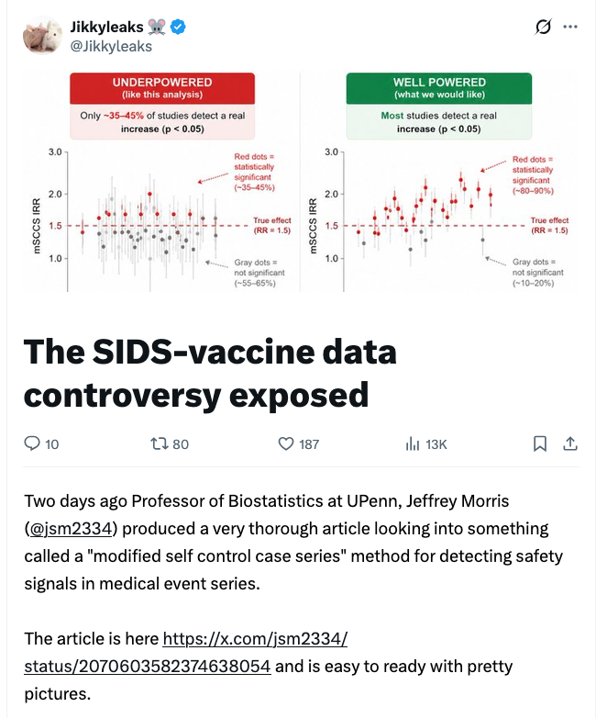
Much of his post consists of speculative accusations to which I will not dignify a reply, but the actual substantive part of his argument is built on simulation settings he ran, and I did go back and critically evaluate that, and found it rests on two statistical errors that, once corrected, reverse its conclusion.
His analysis did two things:
- He replaced the background SIDS age curve with a smoother version (shown below). This changes nothing of consequence in the results, but kudos to him for taking more time than I did in finding a nice, smooth, plausible age distribution for baseline SIDS risk.
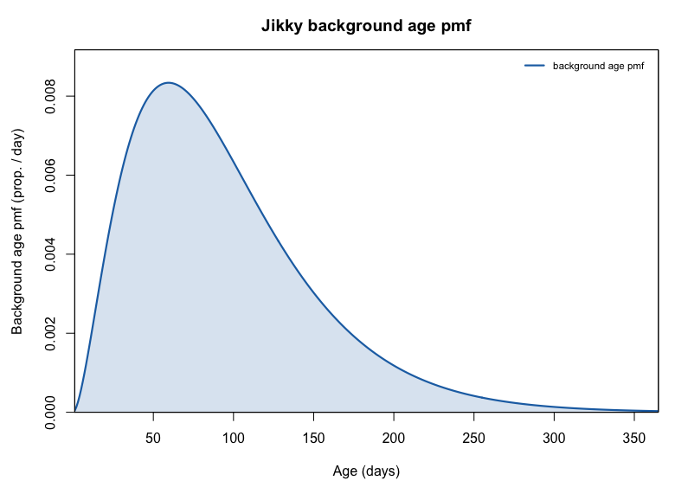
Jikky’s smooth background SIDS age distribution.
- He ran his own simulations and showed that statistical power falls as the number of age bins increases, which he presented as evidence that the method can be tuned to suppress a vaccine signal.
The smoother background is nice. The problem is the inference he tries to draw from the second point, which overlooks two basic requirements of a valid statistical test, and when these are corrected his results disappear.
Error 1: Power without calibration
Jikkyleaks ranks the bin choices by statistical power alone, praises the “monthly” bins because they “detect the signal 100% of the time” and likens the finer specifications (fortnightly, weekly, and the “Morris” bins) to attempts “by people at vested-interest universities” to make a real vaccine effect vanish.
But power is meaningless on its own. A test’s power can only be interpreted once you know it is calibrated -- that it has the correct Type I error (false-positive) rate. A test with 100% power may simply be a test that always declares harm, including when there is none.
He reported neither the Type I error rate nor the coverage of the 95% confidence interval. I added both, by running his exact settings under the null (IRR = 1.0, no vaccine effect) and computing CI coverage. This is the complete, honest version of the table he should have presented:
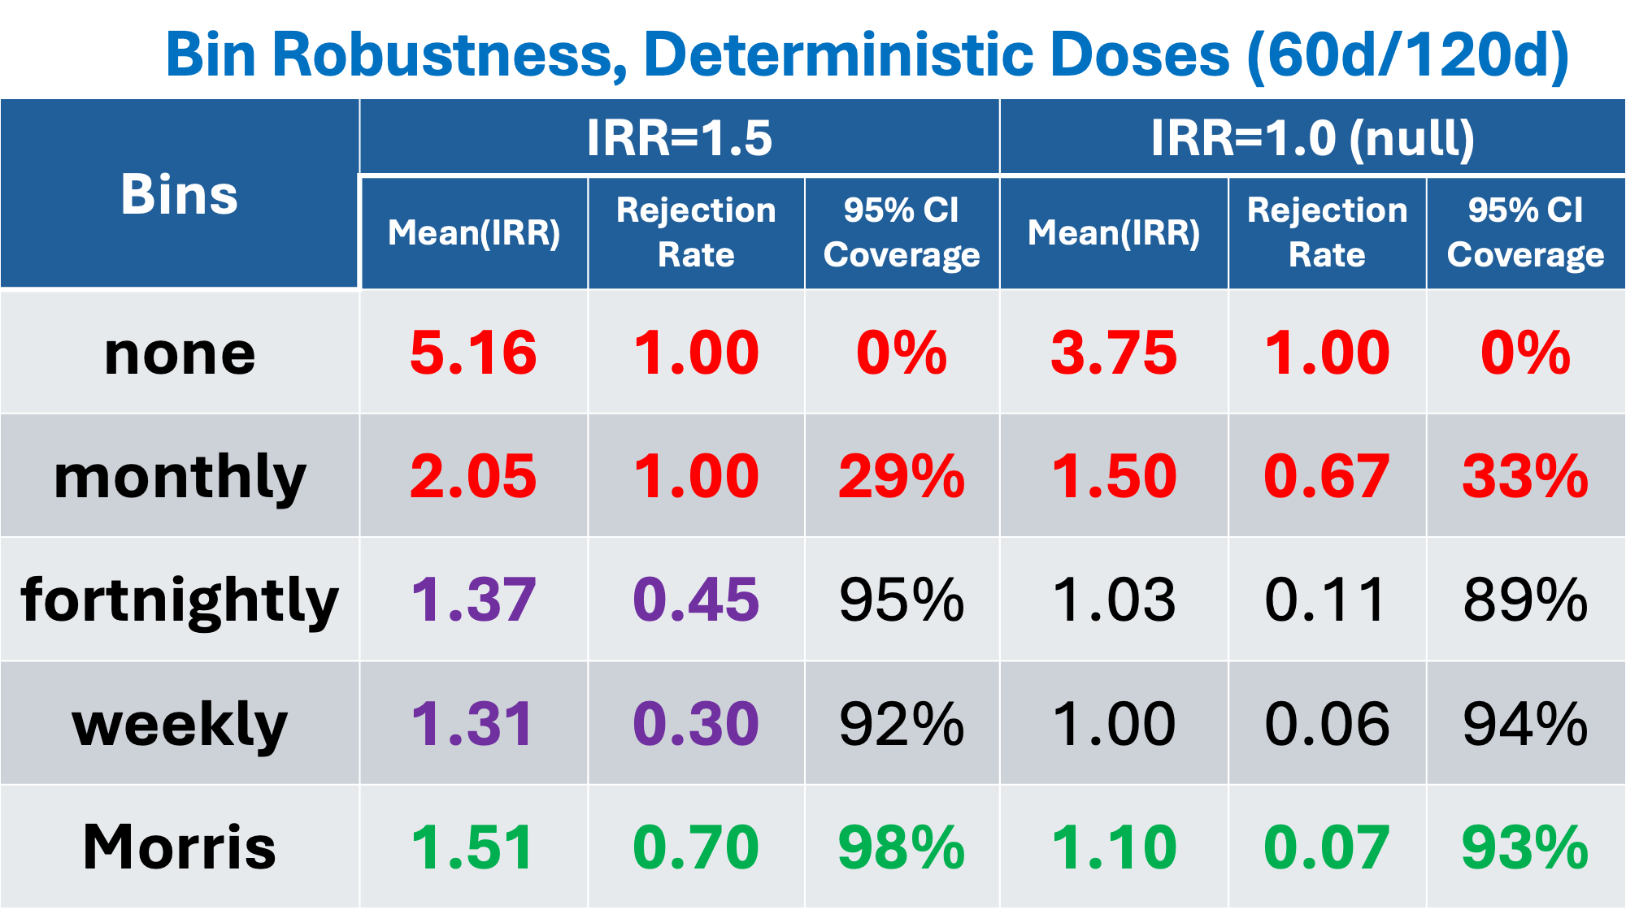
Operating characteristics under Jikky’s deterministic dosing, adding the null (Type I error) and 95% CI coverage he omitted.
Reading his own settings against these two columns:
- “none” (no age bins): a false-positive rate of 100% and 0% coverage. Under the null, with no vaccine effect at all, it declares harm every time, and the mean estimated IRR is 3.75. This is the no-age-adjustment catastrophe documented earlier in this article.
- “monthly”: a false-positive rate of 67% and 33% coverage under the null. A method that concludes harm two-thirds of the time when there is none is not “powerful”—it is broken and invalid. Jikkyleaks ignores this fact in praising this choice of having “100% power.”
- The “Morris” bins have the best operating characteristics of any specification tried: 70% power, a 7% false-positive rate, and 93–98% coverage—near-nominal on both, and near-unbiased (mean IRR 1.51 against a true 1.5).
- The fortnightly and weekly bins do have lower power (45% and 30%), but they are well calibrated (false-positive 11% and 6%, coverage 89–95%). The lost power, as we will see, is directly caused by his unrealistic and pathological choice of dosing schedule.
In short, the two specifications he endorses for “high power” achieve it only through gross bias and broken calibration, while the specification named after me is the best-behaved of the lot.
Error 2: An unrealistic, deterministic dosing schedule
The second error is more subtle and critically important for this discussion. In his simulation, every infant receives dose 1 at exactly day 60 & dose 2 at exactly day 120, with no variation whatsoever.
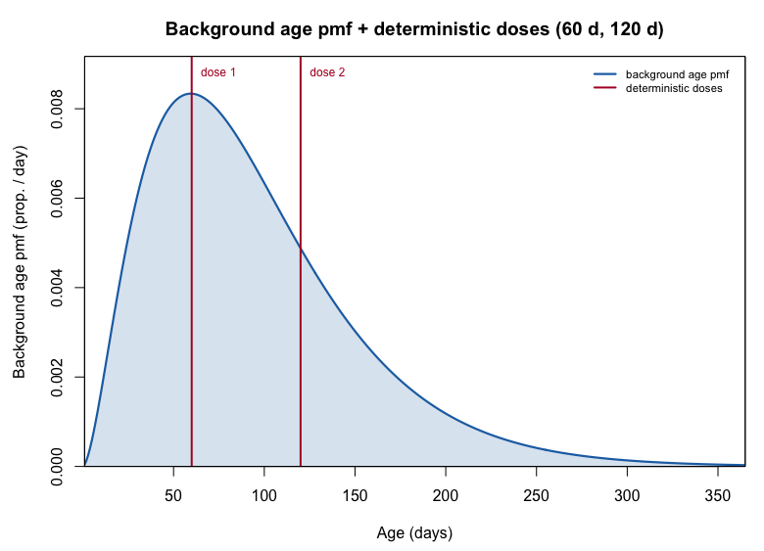
Jikky’s fixed dose ages (60 and 120 days) shown over the background SIDS age curve.
With deterministic dosing, age and time-since-dose become the same variable: the age effect and the vaccine effect are perfectly confounded in the narrow windows around days 60–62 and 120–122. That collinearity, not the number of bins, is what destabilizes the estimates and drains power when bins are added. The fine bins only appear to “lose power” because the design has eliminated the very information the method needs to separate age from exposure.
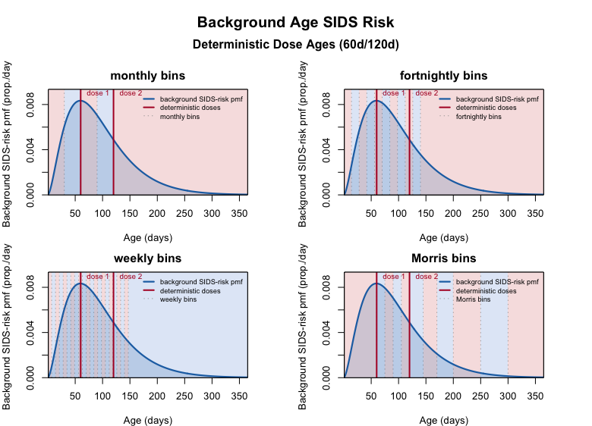
The four bin sets over the background curve with the fixed dose ages. Where bin boundaries fall near the dose ages, the age term and the vaccine term compete to explain the same days.

I pointed this out to him at least six times this week, yet he would never acknowledge the point.

https://x.com/jsm2334/status/2069863290914639982?s=20
https://x.com/jsm2334/status/2070464101847855310?s=20

https://x.com/jsm2334/status/2070447100836426152?s=20

https://x.com/jsm2334/status/2070177541046817082?s=20

https://x.com/jsm2334/status/2069542569613152469?s=20

In spite of the fact that the simulation R code I shared with him, and which he used in to run the simulation presented in his attempted rebuttal, contained realistic stochastic dose times derived from public UK data, he chose not to use them, but instead used these deterministic dose times instead – with every single child getting dose 1 precisely on day 60 & dose 2 precisely on day 120.
In my initial response to his post, I asked him why he did this, reminding him that I explained this choice would conflate age and dose and not allow the modified SCCS with age bins to successfully deconvolve the age and dose effects, leading to instability and poor performance.
https://x.com/jsm2334/status/2071210933049815425?s=20
His response was that his simulation was simply intended to show that even in the “cleanest data scenarios” that “my method” (a.k.a. the modified SCCS) was “deliberately intended to be able to be manipulated.” (He then tried to abruptly change the subject and for some reason insisted I send him full patient-level data from millions of pediatric medical records in PEDSnet – data to which I do not even have access and could obviously not send to him – but I’ll ignore this absurd demand and focus on the substantive argument).
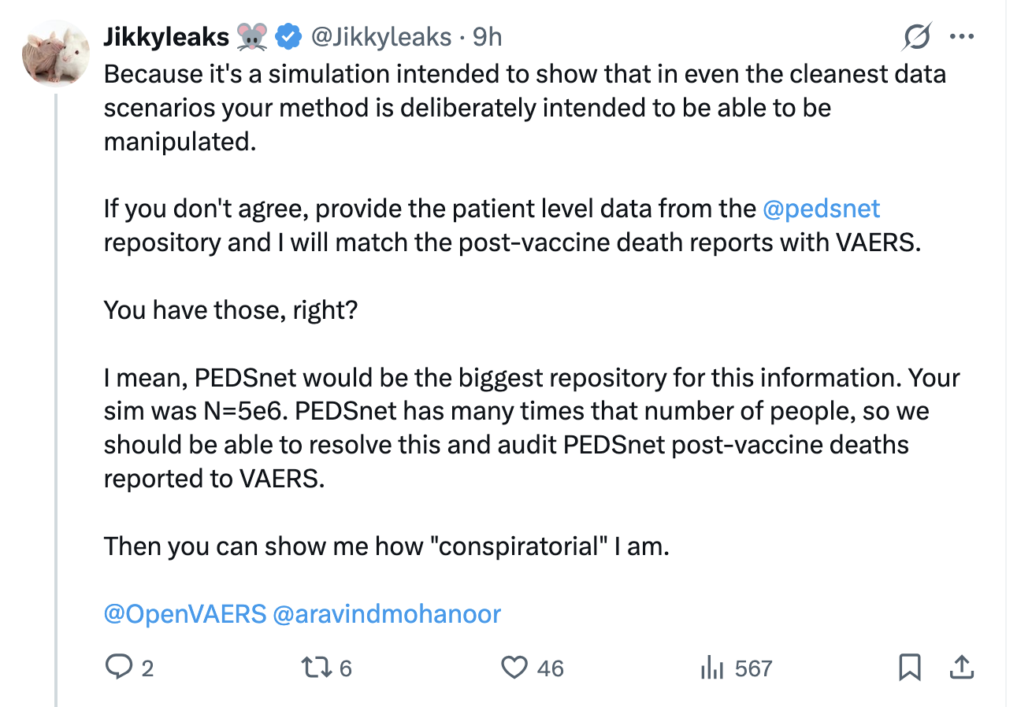https://x.com/Jikkyleaks/status/2071213077630951729?s=20

He ignored my explanation that his choice of deterministic dose schedules was far from “the cleanest” and in fact, was the most pathological choice he could make.
So, next, I simply reran his simulation code using the stochastic UK dose schedule in place of his deterministic 60d/120d schedule to see if this had an impact on his simulations, as I suggested they would.
Rerun with realistic (stochastic) dose timing
I repeated his exact simulation with realistic dose timing: dose 1 drawn from the publicly available UK vaccination-age distribution, and dose 2 placed roughly 60 days later with realistic variability. (His simulation used two doses, so I matched that here; my original used all three.) As before, I added a null run for Type I error and computed CI coverage, as is necessary for any honest investigation of the properties of a statistical method.
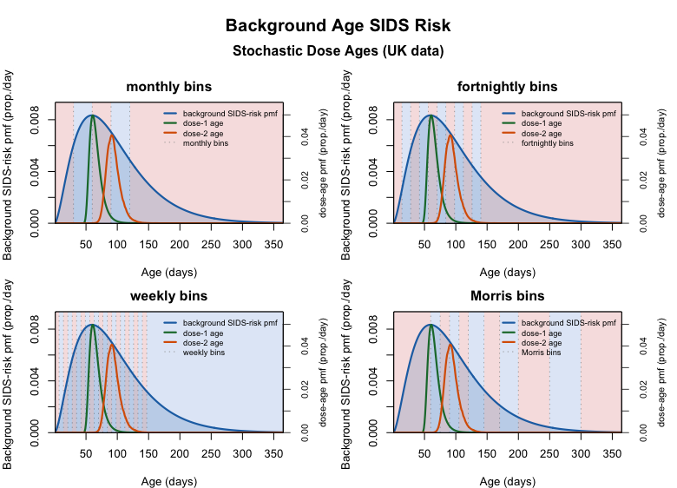
Background SIDS age curve with the UK dose-1 and dose-2 age distributions and the four bin sets.
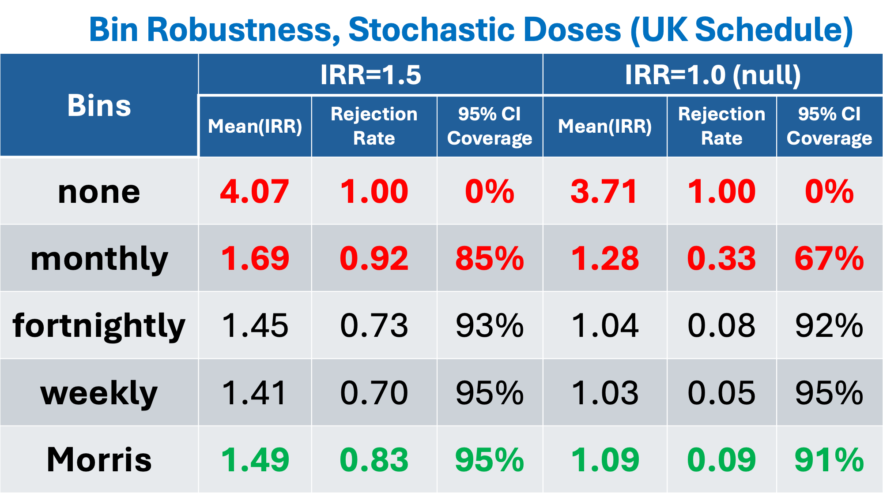
Operating characteristics under realistic UK dose timing, with Type I error and 95% CI coverage.
Once dose timing is allowed to vary, the “failure” upon which he built his case disappears:
- Fortnightly and weekly bins recover to 73% and 70% power, with near-nominal Type I error (8% and 5%) and coverage (92–95%), nothing like the poor performance he reported under fixed dosing.
- The Morris bins are again the best: 83% power, near-unbiased (mean IRR 1.49), 9% Type I error, and 91–95% coverage.
- The coarse specifications remain broken: “none” still declares harm 100% of the time under the null with 0% coverage, and “monthly” 33% of the time with 67% coverage.
With realistic dosing, the modified SCCS cleanly deconvolves age bias from vaccine effect, retaining good power across every reasonable bin choice while preserving Type I error and coverage.
This is exactly the conclusion of my original simulation: the method is robust across reasonable choices of age bins.
It is clear that the decreasing power with increasing bin size upon which he built his entire response article was caused by his pathological choice of deterministic dose schedules (just as I repeatedly warned him it would).
In spite of what he tried to say in his post, increasing the number of bins was not a “manipulation” capable of “hiding vaccine harm”, and the modified SCCS performed well, and certainly was not “deliberately intended to be able to be manipulated.”
The only manipulation was in Jikky’s simulation, omitting type 1 error and choosing a deterministic dose schedule that destabilized the method he is trying to claim is invalid.
Interpretation of Results: Is Jikkyleaks’ Claim True?
- The result is the opposite of Jikkyleaks’s thesis. The modified SCCS does not hide harm. Under realistic conditions it detects a true 50% increase in post-vaccination SIDS risk with good power across reasonable age bin choices and stays calibrated.
- In the simulations, the only way to break the method was to make the bins far too wide -- and that failure is conservative. It manufactures harm where there is none (inflated IRRs, 100% false positives); it does not erase harm that is real.
- The simulation did not support Jikkyleak’s claim that the modified SCCS can be readily manipulated to hide vaccine harms, and certainly not that it was designed such that it was “deliberately intended to be manipulated.”
- The only way he got the method to have greatly reduced power to detect harm was to make a pathological choice of an unrealistic deterministic dosing schedule in which each child got the dose on the exact same day of age, which as I explained to him many times conflates age and dose to make the method unable to separate them out.
Comments about Statistical Power
- On the study not reaching 90%: power is governed by the sample size, which in this case is number of SIDS cases, and this sample size is not large enough to reach it for an effect size of IRR=1.50. That is basic statistics, not a scandal.
- The same simulation code I developed is a useful tool for researchers to use to design a study, to determine how large a study must be to reach any target power, as well as to investigate performance for various assumed age distributions of background SIDS risk, and to investigate robustness of the design to various choices of age bins for each.
- His article pointed out the low power noted in the Kuhnert paper – but note that was in a very small study with only 300 SIDS cases, and only looking at a 4th dose that not all children received. Of course, power is low in that setting, but that again is not anything wrong with the method, but a simple function of the sample size too low to detect an effect that small.
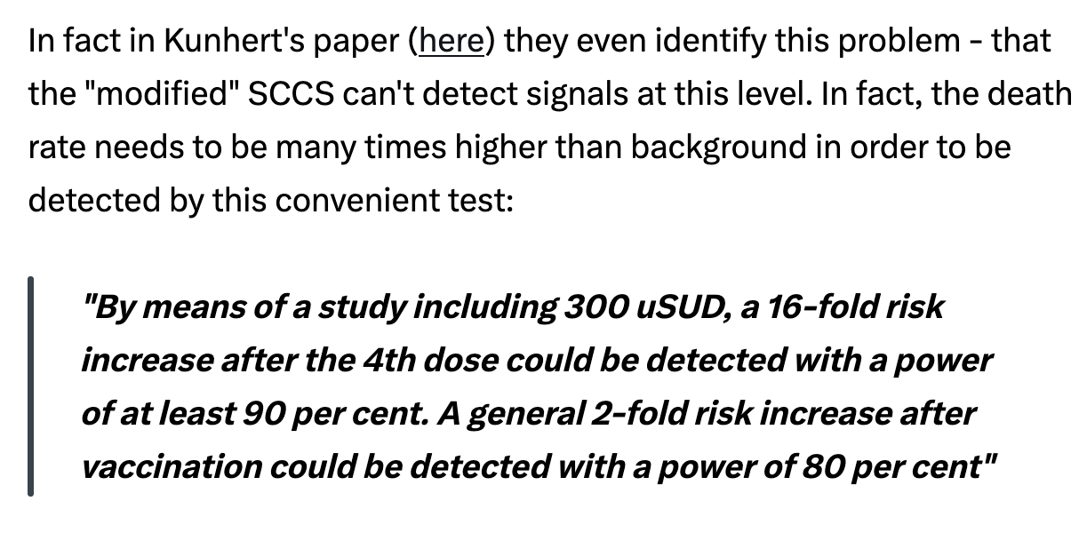
- As seen in these simulations, for a realistic study on a population of 5 million infants with 1/5000 SIDS rate, the modified SCCS has plenty of power (65-85%) for detecting a 50% increased risk, and the method is robust across any reasonable choice of age bins.
Importance of the Choice of Age Bins
The one true point in his post is that while it is absolutely necessary to adjust for age bias in a modified SCCS in this setting, it is critical to choose the age bins carefully, as I emphasized in my original article and reemphasize here. This is a normal modeling question, and not some scandalous characteristic of some method designed to be abused as his conspiratorial mind immediately thinks. He could have simply said “choice of age bins is important, and must be carefully considered, justified and sensitivity assessed” and saved himself a long ranting post, and I’d have agreed with him and we could have had a nice substantive discussion on how to choose these bins and assess sensitivity to them.
Here are key factors to keep in mind when selecting age bins for a modified SCCS.
- Not too broad. Wide bins leave residual age confounding that contaminates the vaccine effect, so care must be taken to not make them too broad.
- Not unnecessarily narrow. Extra bins spend degrees of freedom which does reduce power to some degree; make the bins only as fine as needed to capture the age trend.
- No need for equal spacing. Bins should be narrow where baseline risk changes rapidly and wider where it is flat, precisely what the Morris bins do, and there is no reason to make them equal in width.
- Report sensitivity transparently. Sensitivity to bin choice should always be reported, but these simulations show robustness across reasonable choices, so there is no evidence in these simulations – either Jikkyleaks or mine – that the method can be easily tuned to conceal a real effect.
Conclusion
The modified SCCS does what it was designed to do. When age is modeled with reasonable bins, it is well calibrated and powered to detect a genuine post-vaccination increase in SIDS risk, and it is robust across sensible choices of age bins. The only apparent ways to make it fail are to ignore age entirely or to use bins far too wide… and even then it fails conservatively, inventing harm where there is none rather than hiding harm that is real.
Jikkyleaks’s central claim -- that the modified SCCS was built so that it could be manipulated to conceal vaccine injury -- is supported neither by his simulation nor by mine. The only manipulation on display was in his own analysis: reporting power while omitting Type I error, and choosing a deterministic dosing schedule guaranteed to confound age with exposure. Remove those two artifacts and his argument collapses. The modified SCCS remains a sound and transparent tool for asking whether SIDS risk rises immediately after vaccination, and looking at results across six studies in five countries, all with reasonable choices of age bins, the evidence suggests, “no.”
Simulation R Scripts to Reproduce Results
The R scripts used to perform all the simulations in this and in the previous article, and to generate figures are all provided in the following github repository:
https://github.com/Jeffrey-S-Morris/SIDS-SCCS-Simulation

