A script

**Choose Output Inline**

Our project is about the Hodgkin Huxley model. The goal is to simulate the action potential of a neuron using the model. We have written a description of the model and placed all related code in this live script.

(Skip the description of the model)

We have used two sets of parameters, one obtained from this tutorial website (point at the link), and one from the original paper of the HH model. We will use the latter set.

We will first simulate the action potential when we stimulate the neuron by injecting some current for 5 ms. Just adjust the current that you want to simulate and wait for the program to run. (Set I_i to 3.68 and run).

As you can see, this is the injected current, and the result is this action potential spike. There is the depolarization spike, and then the hyperpolarization period that follows. The shape is accurately simulated.

Besides the action potential, we can also see the activations of the three different gating subunits, and also the potassium and sodium current during the action potential.

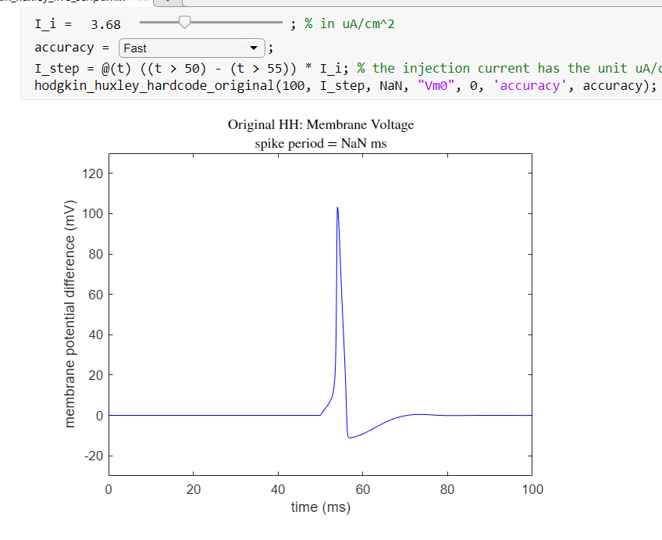

depolarization

hyperpolarization

Then, we can try injecting a constant amount of current. (First inject 2.69, keep tf at 200) If we inject too small of a current, there will only be one action potential. (Then inject 7.69 or something) If we inject a great current, however, we will start to see a train of action potential spikes. (Inject 8.69 and 9.69) As we increase the current injected, the frequency of these spikes will also increase.

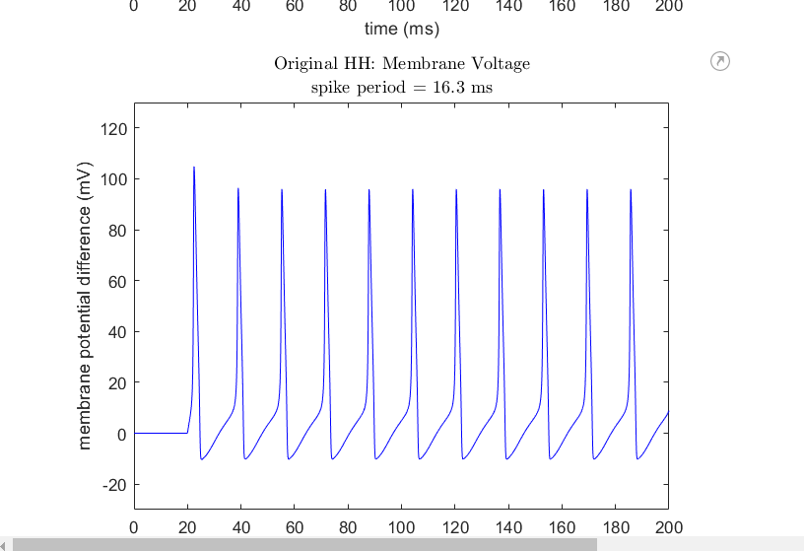

To understand the relationship between the injected current and the frequency of these spikes, we can run this program to help us draw a plot.

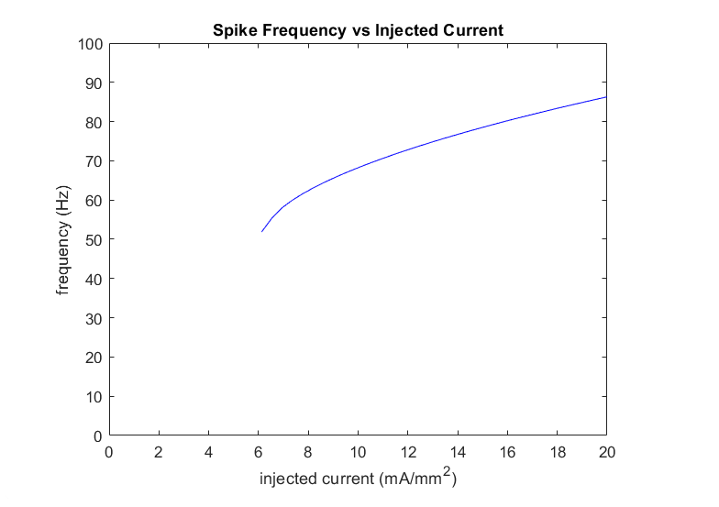

We see that the frequency increases with the injected current.

Lastly, if we inject a ramped current, we can observe the relative refractory period of the neuron. A larger current will be able to generate another action potential while the neuron is still recovering from an action potential.

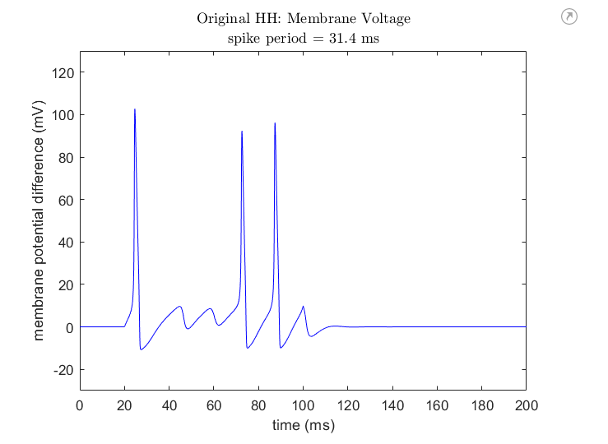

Scientists usually measure the conductance of potassium and sodium ion of a neuron by clamping the voltage of the neuron, and observing the current of the individual ions. Here, we have set up a model for doing exactly this. If we apply a -10V voltage step for 100 ms (see the voltage graph), then the current flow will be like this.

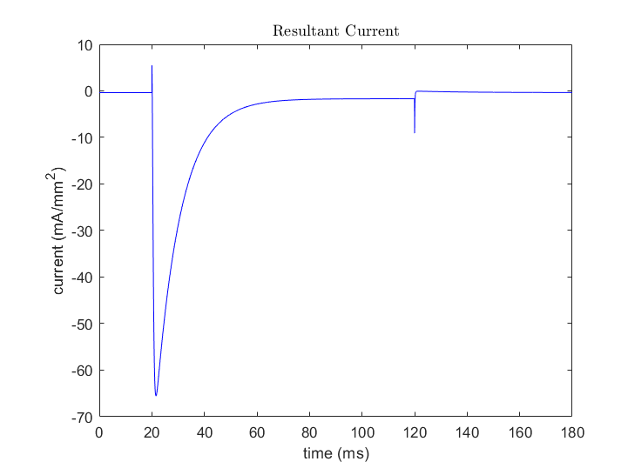

As a further investigation into action potentials, we have tried simulating cardiac action potentials too. We used the Luo-Rudy model. However, the simulation is slightly buggy. This is what we got.

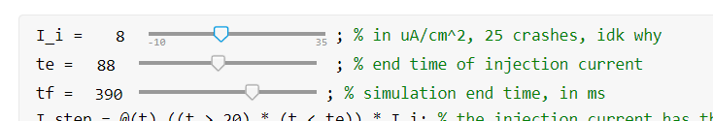

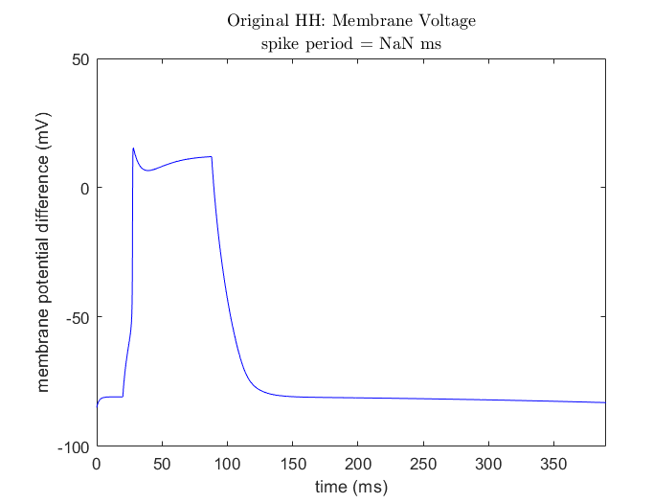

The characteristic plateau of the action potential can be seen. However, certain features are missing, perhaps because there are still bugs in the program.

This concludes our project.