**链路聚合实验**

**实验4-1 链路聚合实验**

**学习目标**

* 掌握链路聚合原理
* 掌握链路聚合配置

**链路聚合技术分析**

* 随着网络规模不断扩大，用户对骨干链路的带宽和可靠性提出了越来越高的要求。在传统技术中，常用更换高速率的接口板或更换支持高速率接口板的设备的方式来增加带宽，但这种方案需要付出高额的费用，而且不够灵活。
* 采用链路聚合技术可以在不进行硬件升级的条件下，通过将多个物理接口捆绑为一个逻辑接口，来达到增加链路带宽的目的。在实现增大带宽目的的同时，链路聚合采用备份链路的机制，可以有效的提高设备之间链路的可靠性。
* CISCO 链路聚合模式匹配图
* 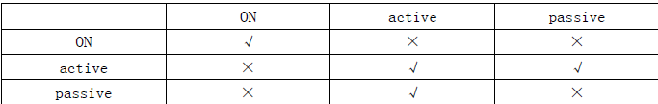
* 本项目中汇聚交换机SW1和SW2之间需要进行链路聚合提高带宽及提升链路可靠性。

**拓扑图**

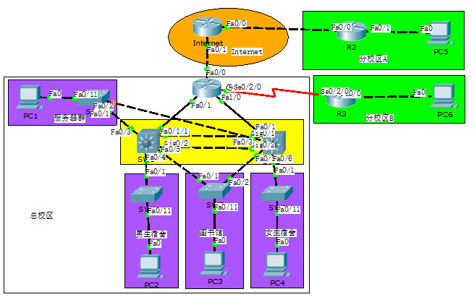

图1拓扑

**操作步骤**

1. **创建链路聚合端口**

1、将《网络项目拓扑搭建实验》中保存的拓扑打开:拓扑中SW1和SW2之间各有两个端口互联，可将G0/1和G0/2加入同一链路聚合组中。

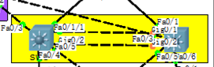

2、在SW1上创建port-channel：

|  |
| --- |
| *SW1>enable*  *SW1#conf*  *Configuring from terminal, memory, or network [terminal]?*  *Enter configuration commands, one per line. End with CNTL/Z.*  *SW1(config)#interface port-channel 12* |

3、在SW2上创建port-channel：

|  |
| --- |
| *SW2>enable*  *SW2#conf*  *Configuring from terminal, memory, or network [terminal]?*  *Enter configuration commands, one per line. End with CNTL/Z.*  *SW2(config)#interface port-channel 12* |

1. **物理接口关联port-channel**
2. 将SW1的G0/1和G0/2加入port-channel12中，参考命令如下：

|  |
| --- |
| *SW1(config-if)#int g0/1*  *SW1(config-if)#channel-group 12 mode active*  *SW1(config-if)#int g0/2*  *SW1(config-if)#channel-group 12 mode active* |

1. 查看SW1上etherchannel状态：

|  |
| --- |
| *SW1#show int etherchannel*  *GigabitEthernet0/1:*  *Port state = 1*  *Channel group = 12 Mode = Active Gcchange = -*  *Port-channel = Po12 GC = - Pseudo port-channel = Po12*  *Port index = 0 Load = 0x00 Protocol = LACP*  *Flags: S - Device is sending Slow LACPDUs F - Device is sending fast LACPDUs*  *A - Device is in active mode. P - Device is in passive mode.*  *Local information:*  *LACP port Admin Oper Port Port*  *Port Flags State Priority Key Key Number State*  *Fa0/1 SA down 32768 0x0 0x0 0x25*  *Age of the port in the current state: 13244d:10h:55m:54s*  *GigabitEthernet0/2:*  *Port state = 1*  *Channel group = 12 Mode = Active Gcchange = -*  *Port-channel = Po12 GC = - Pseudo port-channel = Po12*  *Port index = 0 Load = 0x00 Protocol = LACP*  *Flags: S - Device is sending Slow LACPDUs F - Device is sending fast LACPDUs*  *A - Device is in active mode. P - Device is in passive mode.*  *Local information:*  *LACP port Admin Oper Port Port*  *Port Flags State Priority Key Key Number State*  *Fa0/2 SA down 32768 0x0 0x0 0x26*  *Age of the port in the current state: 13244d:10h:55m:54s*  *----*  *Port-channel12:Port-channel12 (Primary aggregator)*  *Age of the Port-channel = 00d:00h:00m:48s*  *Logical slot/port = 2/12 Number of ports = 0*  *HotStandBy port = null*  *Port state =*  *Protocol = 1*  *Port Security = Disabled* |

1. 将SW2的G0/1和G0/2加入port-channel12中，参考命令如下：

|  |
| --- |
| *SW2(config-if)#int g0/1*  *SW2(config-if)#channel-group 12 mode active*  *SW2(config-if)#int g0/2*  *SW2(config-if)#channel-group 12 mode active* |

1. 查看SW2上etherchannel状态：

|  |
| --- |
| *SW2#show interfaces etherchannel*  *GigabitEthernet0/1:*  *Port state = 1*  *Channel group = 12 Mode = Active Gcchange = -*  *Port-channel = Po12 GC = - Pseudo port-channel = Po12*  *Port index = 0 Load = 0x00 Protocol = LACP*  *Flags: S - Device is sending Slow LACPDUs F - Device is sending fast LACPDUs*  *A - Device is in active mode. P - Device is in passive mode.*  *Local information:*  *LACP port Admin Oper Port Port*  *Port Flags State Priority Key Key Number State*  *Fa0/1 SA down 32768 0x0 0x0 0x25*  *Partner's information:*  *LACP port Admin Oper Port Port*  *Port Flags Priority Dev ID Age key Key Number State*  *Fa0/1 SA 32768 0003.E436.CA98 0x0 0x0 0x25*  *Age of the port in the current state: 00d:00h:00m:08s*  *GigabitEthernet0/2:*  *Port state = 1*  *Channel group = 12 Mode = Active Gcchange = -*  *Port-channel = Po12 GC = - Pseudo port-channel = Po12*  *Port index = 0 Load = 0x00 Protocol = LACP*  *Flags: S - Device is sending Slow LACPDUs F - Device is sending fast LACPDUs*  *A - Device is in active mode. P - Device is in passive mode.*  *Local information:*  *LACP port Admin Oper Port Port*  *Port Flags State Priority Key Key Number State*  *Fa0/2 SA down 32768 0x0 0x0 0x26*  *Partner's information:*  *LACP port Admin Oper Port Port*  *Port Flags Priority Dev ID Age key Key Number State*  *Fa0/2 SA 32768 0003.E436.CA98 0x0 0x0 0x26*  *Age of the port in the current state: 00d:00h:00m:08s*  *----*  *Port-channel12:Port-channel12 (Primary aggregator)*  *Age of the Port-channel = 00d:00h:13m:37s*  *Logical slot/port = 2/12 Number of ports = 2*  *HotStandBy port = null*  *Port state =*  *Protocol = 1*  *Port Security = Disabled*  *Ports in the Port-channel:*  *Index Load Port EC state No of bits*  *------+------+------+------------------+-----------*  *0 00 Gig0/1 Active 0*  *0 00 Gig0/2 Active 0*  *Time since last port bundled: 00d:00h:00m:08s Gig0/2* |

1. **保存配置**
2. 全网设备保存配置，防止掉电配置丢失。

参考配置：

*R1#wr //各设备特权模式下保存配置*

*Building configuration...*

*[OK]*

1. 查看全网设备配置保存是否成功，防止掉电配置丢失。

参考配置：

*R1#show startup-config //特权模式下查看保存的配置*

1. 保存拓扑。

单击“保存”，保存拓扑信息。

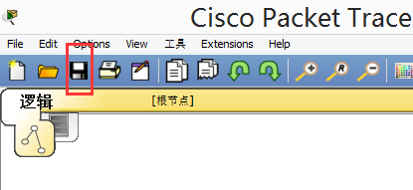

1. 以学号+名字+日期命名拓扑并保存，用U盘带走文件。

