sJeffrey Benjamin Brown
2016 June 15

The Reflective Set of Labeled Tuples:
A simple, expressivity-maximal generalization of the graph

Computer scientists spend a lot of time finding ways to represent problems using a simple, small vocabulary called Data Structures. These include:

- Arrays, also known as tables or grids.
- Tuples, meaning pairs (“2-tuples”), triples (“3-tuples”), quadruples, etc.
- Sets, also known as collections.
- Lists, which are like sets, but with their elements ordered first to last.
- Maps, also known as dictionaries.
- Graphs, also known as networks.

This paper introduces another one, only slightly more complex than a graph. It is the Reflective Set of Labeled Tuples, or RSLT. It is unique in that it can express anything, in a uniform, uncomplicated way.
Graphs, which are just collections of things connected in pairs, have proven extremely useful as general-purpose data structures. A single graph can represent multiple kinds of things and multiple kinds of relationships. Facebook represents its users (and other things) in a graph. Google represents websites (and other things) in a graph.

Graphs are not as user friendly as they could be. Whereas nodes in a graph can only be connected in pairs, a relationship in a RSLT can have any number of members. Whereas the edges in a graph cannot be connected to other edges, the members of a relationship in a RSLT can themselves be relationships.

Natural languages like English or Spanish can express anything, too. The RSLT relies on natural language. In principle, as will be shown, natural language is all a user needs to know in order to enter data into a RSLT.

Unlike ordinary text, the RSLT is quickly traversable, like a tree, along every connection a user could possibly want. And it is queriable in the infinitely flexible way of a graph.

A graph can express anything, too! This paper shows how. Some facts, a graph expresses very naturally. More complicated kinds can be expressed as well, by using a different idiom for translating between real-world data and graph data. This paper will motivate, develop, and refine that idiom. It will then show how the interface can be separated from the implementation, so that a user need not know what a graph is at all. The remaining interface is the RSLT..

Table of Contents
Graphs 3
Undirected graphs 3
Directed graphs 4
Expressing more with a graph 4
The arity of a relationship 4
How to express relationships of any arity in a graph: The relationship-as-labeled-node idiom 5
Higher-order relationships 5
Template redundancy: A drawback 6
Abstracting the common template away: The relationship-as-unlabeled-node idiom 6
The Reflective Set of Labeled Tuples, or RSLT 7
The definition 7
For a user, it’s even easier! Separating interface from implementation. 8
From natural language to RSLT: A short trip 8
An invitation to coders 9
Extensions 10
Types 10
Subgraph Reflection: Directions, Stars and Branches 10
Directions 10
Stars 11
Branches 11
Subexpression Reflection 12
Algebra on Relationships 13
External, spacetime-optimized data structures can be hooked in the RSLT interface without sacrificing its optimizations 13
Example: Hooking a table into a RSLT 14
Appendix 14
Defining the RSLT in four lines of Haskell 14
Demonstration: Building expressions in a RSLT from the bottom up 15
The RSLT is equivalent to the reflective triplestore 18
Unifying Words and Phrases 18
Unifying Words and Templates 18
How the RSLT gets its name 19

Graphs
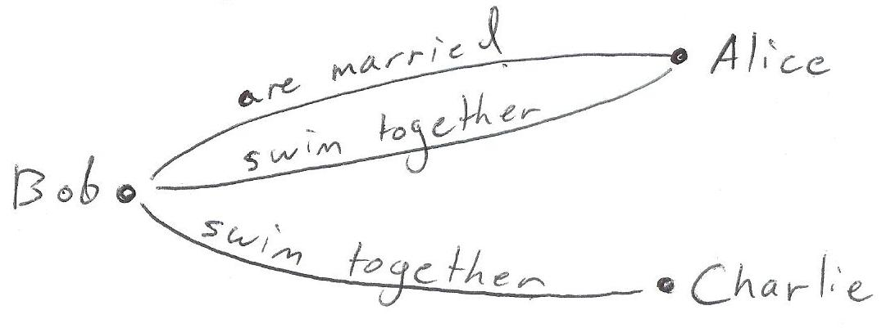
Figure 1: An undirected graph

Undirected graphs
Undirected graphs are commonly drawn as a set of dots with lines between them. The dots are called nodes, and (for historical reasons) the lines are called edges.

When computer scientists use graphs, they attach information called "node labels" and "edge labels". Figure 1 is an example. The node labels in Figure 1 are peoples' names, and the two edge labels are “are married” and "swim together".

Graphs can also be described symbolically, without using pictures. Data Set 1 describes the same undirected graph as Figure 1, without using a picture. Computers represent graphs symbolically.

Data Set 1
- nodes: Alice, Bob, Charlie
- edges:
  - are married: (Alice, Bob)
  - swim together: (Alice, Bob), (Bob, Charlie)

Notice that multiple edges can connect the same two nodes in a graph: Alice and Bob are married and swim together.
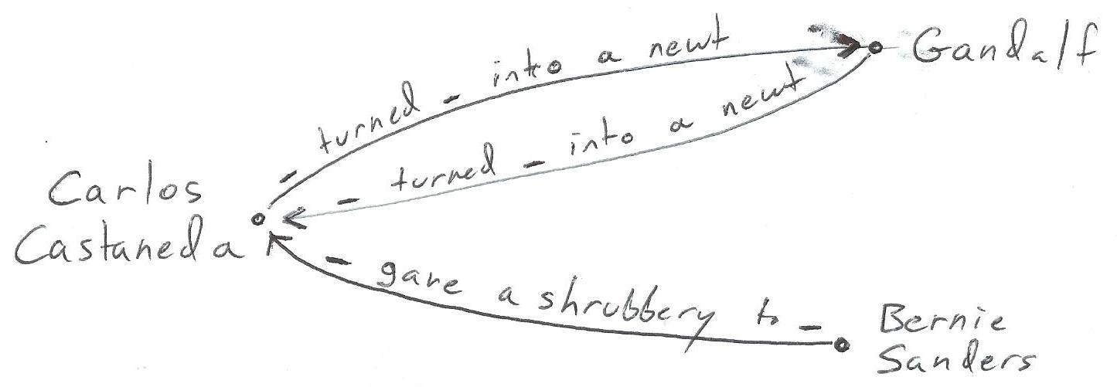
Figure 2: A directed graph

Directed graphs
Marriage and swimming together are both "undirected" or "symmetric" relationships. If you're married to someone, they are married to you. "Directed" relationships are not like that. If I disrupt your television, you might not disrupt mine. If I am colder than you, you are certainly not colder than me.

Directed graphs are like undirected ones, except the edges have arrowheads to indicate their direction. In text, they look the same, but their interpretation changes: now the order of the two nodes in an edge matters.

Figure 2 is a directed graph. The nodes are labeled with the names of sorcerers., and the two edge labels are “_ turned _ into a newt” and “_ gave a shrubbery to _”. Those "_" symbols are pronounced "blank". Each blank serves as a stand-in for a relationship member – that is, for one of the nodes the edge connects. By itself, an edge label provides only the “template” for a relationship: "_ turned _ into a newt" does not indicate who did that to who.
The nodes that bound an edge allow us to fill in the blanks in the edge’s label. For example, the top edge, which points (smudgily) from Carlos Castaneda to Gandalf, indicates that Carlos turned Gandalf into a newt. The one just below it indicates that Gandalf returned the favor to Carlos.

Directed relationships are hard to represent with an undirected graph. Undirected relationships, by contrast, are easy to represent in a directed graph: just use an arrow and ignore its direction. When data scientists talk about graphs, they generally mean directed graphs. This paper adheres to that convention.

Expressing more with a graph

The arity of a relationship
All the relationships we have seen so far are "binary" ones: they have exactly two members. Other kinds of relationships are possible. For instance, "_ said _ to _" relates three things; it is "ternary".

“Arity” is the word for the number of members in a relationship. Binary relationships have (or are) arity 2; ternary ones have arity 3. Any positive arity is possible; we could think of a 5-member relationship if we wanted to.

Arity 1 or "unary" relationships are also valid. Some important unary relationships include "maybe _", "not _", "for every _" and "there exists _".

How to express relationships of any arity in a graph:
The relationship-as-labeled-node idiom
Suppose we had to store this data in a graph:

Data Set 3
Bill studied history.
Ted did dance the air guitar for profit.

The first statement is a binary “_ studied _” relationship. The second is a an arity-4 "_ did _ the _ for _" relationship.

A graph only has nodes and edges, and edges only connect pairs of nodes. How, then, can we represent a relationship with four members?

We have to change how we read the graph.

In the relationship-as-labeled-node idiom (see Figure 3), there are two kinds of nodes: “word nodes” (ovals) and “relationship nodes” (boxes).

The word nodes include the relationship members: Bill, history, Ted, dance, air guitar, and profit. Notice that while word nodes usually represent single words, they can represent multi-word phrases like "air guitar" too. (The appendix titled “Unifying Words and Phrases” describes an implementation that recognizes the composition relationship between words and phrases.)
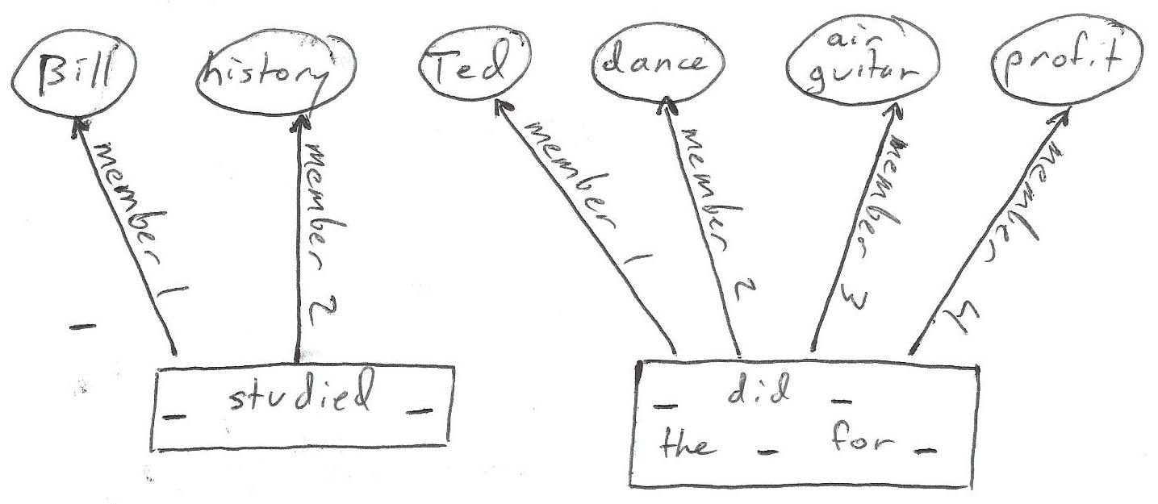
Figure 3: Relationships as labeled nodes.

Each relationship in Data Set 3 is represented, not by a single edge, but instead by a relationship node and the edges emitted from it. The label on a relationship node indicates the template for the relationship: either "_ likes _" or "_ did _ the _ for _". An arity-k relationship node emits k edges: an edge labeled member i connects it to the relationship’s ith member.

Higher-order relationships
The relationships we have seen so far are all “first-order”; in none of them is one relationship a member of another. But consider Statement 4:

Statement 4
Intel needs silicon because Intel makes computer chips.

Statement 4 consists of a "_ because _" relationship connecting a "_ needs _" to a "_ makes _" relationship. Its members are both first-order relationships, so it is a second-order relationship. It can be usefully thought of as comprising two “levels”, with the because relationship at the top level and the other two at the next. Every lower-level relationship is a member of a higher-level one.
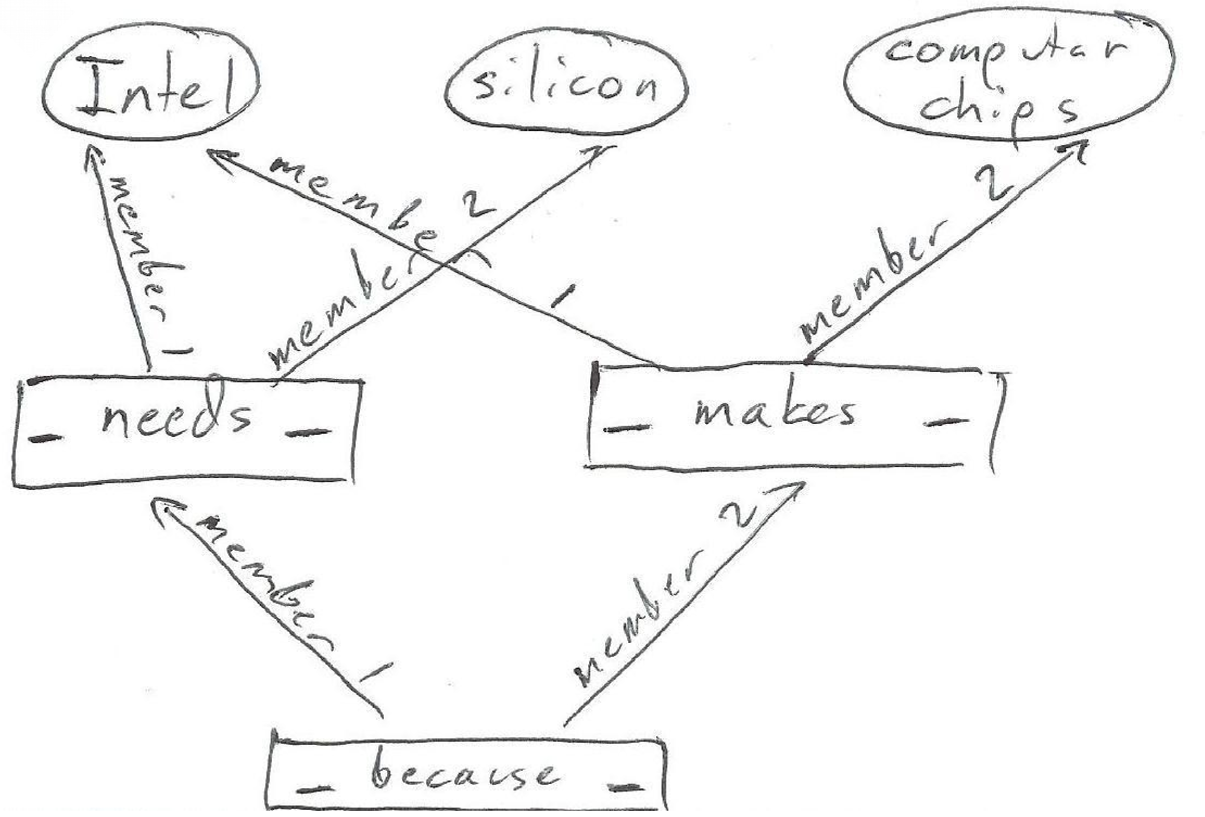
Figure 4: A higher-order relationship
Intuitively, the order of a relationship is the number of levels in it. Formally, an order-n relationship is one in which its members all have order n-1 or less and at least one of them has exactly order n-1.


Can we represent higher-order relationships? With the relationship-as-labeled-node idiom, yes, we can. Figure 4 encodes Statement 4 as a graph.

Template redundancy: A drawback
Consider the following pair of binary relationships:

Data Set 5
Donald has ten dollars.
Donald has a boat.
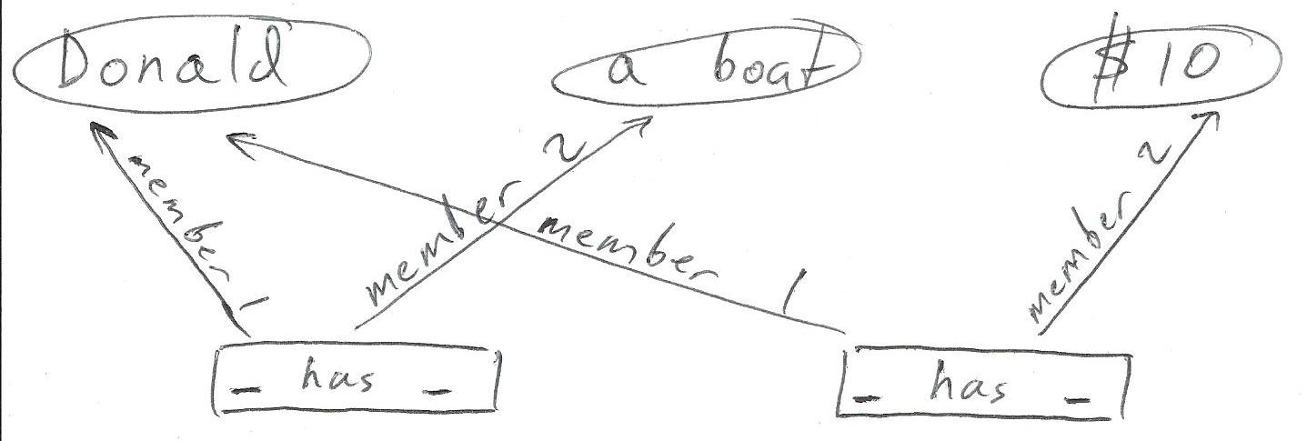
Figure 5: If relationship nodes are labeled with relationship templates like “_ has _”, then the templates are duplicated.
Figure 5 uses the relationship-as-labeled-node idiom to represent Data Set 5 with a graph. Notice that the two relationship nodes in Figure 5 carry redundant information: we have written the relationship template "_ has _" on both of them. Among data scientists, this is a red flag. To modify the template, you would have to modify every instance of it. To attach data to the template, you would have to attach that data to every instance. To verify that two relationships use the same template, you would have to compare them as strings. Redundant data wastes space and time.

Abstracting the common template away:
The relationship-as-unlabeled-node idiom
A slight modification, the relationship-as-unlabeled-node idiom, solves the template redundancy problem. In this new idiom, a relationship node contains no information at all! It is meaningful only because of the edges it emits.

In addition to the k edges that go to its k members, a relationship node emits one more edge, labeled template, toward a new kind of node, the “template node”. A template node’s label provides the template for a relationship: "_ likes _", "_ said _ to _", etc.

Figure 5.1 encodes the information in Data Set 5 using the relationship-as-unlabeled-node idiom. Rather than duplicating the label, each relationship node emits an edge to a single common relationship template node. This way, someone can efficiently modify the template, or attach data to it – a disambiguation, a warning, the date of creation, the author's name, etc.

The Reflective Set of Labeled Tuples, or RSLT
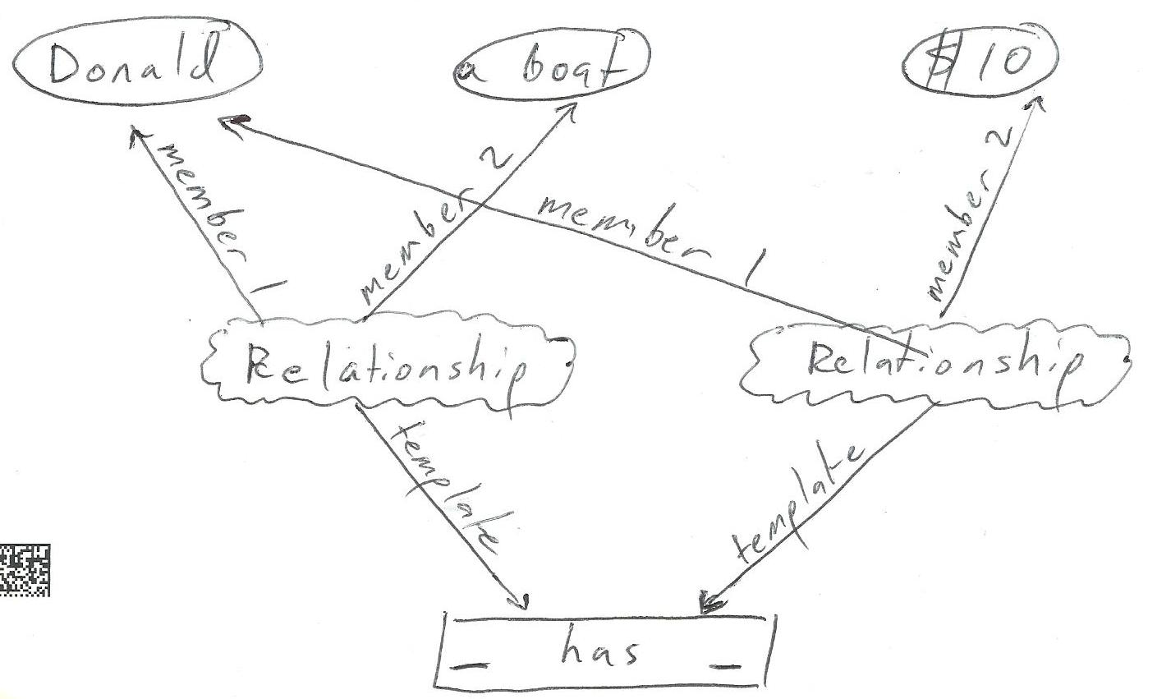
Figure 5.1: Relationship as unlabeled node

The definition
We’ve already got it! The relationship-as-unlabeled-node idiom implements, using a graph, the RSLT interface. The RSLT graph contains Word nodes, Template nodes and Relationship nodes.

The labels on Word and Template nodes contain text; Words look like “Alice” or “batmobile” and Templates look like “_ has _” or “_ uses _ to mean _”. Word and Template nodes can be understood completely without referring to the rest of the graph.

Relationships, by contrast, are encoded using both nodes and edges. An arity-k relationship is encoded using a Relationship node (with no attached data) and k+1 edges emitted from it. An edge to the Template carries the label template, and an edge to the i-th member carries the label member i.

Members of a Relationship can be Words or other Relationships. They can even be Templates – useful, among other reasons, because it allows one to attach information such as algebraic rules (“_ resembles _” is reflexive, “_ supports _” is transitive, etc.)

For a user, it’s even easier!
Separating interface from implementation.
The Words, Templates and Relationships in the RSLT can be implemented using the nodes and edges in a graph. A RSLT user, however, does not need to know about the graph.

It is only in this sense in which the RSLT is a new data structure. In principle, a RSLT offers nothing a graph does not offer, because a RSLT is a graph. Yet to a user who only deals with the interface, it is a generalization of the graph. The nodes in a graph can only be connected in pairs, but a relationship in a RSLT can have any number of members. The edges in a graph cannot be connected to other edges, but the members of a relationship in a RSLT can themselves be relationships.

From natural language to RSLT: A short trip
All that is required to input a natural language sentence into a RSLT is to make explicit how it divides as a sentence tree into nested relationships. Consider Data Set 7:

Data Set 7
Mildred Funnyweather has stable angina.
Mildred Funnyweather is a person.
Stable angina is a coronary artery disease.
Every person with coronary artery disease needs monitoring.

An English speaker somehow, in their head, parses Data Set 7 as Data Set 7.1.

Data Set 7.1
(Mildred Funnyweather) has (stable angina).
(Mildred Funnyweather) is a (person).
(Stable angina) is a (coronary artery disease).
(Every ((person) with (coronary artery disease))) needs (monitoring).

They might not be thinking about parentheses, but still a human listener knows where the parentheses belong! They know, for instance, that the fourth statement is not about every person, just every person with coronary artery disease.

Feeding nested parentheticals into a RSLT is straightforward and automable. (See the appendix titled “Building expressions from the bottom up”.)

Heavily nested parentheticals can be hard to read. “Nested # notation” is an alternative, equivalent text-based representation with a much lower punctuation burden:

Data Set 7.2
Mildred Funnyweather #has stable angina.
Mildred Funnyweather #(is a) person.
Stable angina #(is a) coronary artery disease.
##Every person #with coronary artery disease ###needs monitoring.

The # symbol adjacent to an expression indicates that the expression is (one of the labels in) a Template. Every other expression is a Relationship member. The varying number of # marks is used to indicate the precedence of Relationships.

In the last sentence, “##Every person #with coronary artery disease ###needs monitoring,” a computer can see (without understanding English) that the top relationship is needs, because needs carries the most # marks. So something needs something. What is needed? The right-hand member of the needs relationship is the single Word monitoring. What is doing the needing? The left-hand member of the needs relationship is “##Every person #with coronary artery disease.” Again, without knowing English, the computer can see that every is the top relationship in that expression, because it carries the most # marks. Thus continues the parse, from the top to the bottom of the expression, entirely automatically.

Nested # notation expresses higher-arity Relationships equally well. It is a convenience for human operators; for purposes of inputting data into a RSLT, nested parentheticals and nested # notation are equivalent.

An invitation to coders
The RSLT as described so far, I have implemented, in Haskell, using the Functional Graph Library. It is open-sourced on Github.

I need your help! Most of the rest of the ideas in this paper have not been implemented thoroughly. What follows is part report, part challenge.

Extensions

Types
Types makes languages safer. One “types” a relationship by declaring the kinds of things that can be assigned to its blanks.

Untyped, a Template such as "_ is a _" can be misused. A user could, for instance, encode the statement "Georgia is a pink", when pink is not the kind of word that makes sense in the second position of an #(is a) relationship. Typing would let you prevent such misuse, by specifying that the first Member should be a noun and the second a category.
The next section describes how to represent Branches. Once we can do that, typing is as easy as assigning a Branch to every blank in a Template. The ith member of a Relationship can be assigned a type by drawing an edge labeled type of member i from the Relationship node to a Branch node.

Subgraph Reflection: Directions, Stars and Branches
Branches are collections of stars. Stars are defined using directions.

Directions
Some relationships, like "x equals y", "x is like y", or "x contradicts y" are undirected, symmetric. They treat x and y the same. A symmetric relationship can be reversed without changing its meaning.

Other relationships are directed or asymmetric. Examples include "x needs y", "x clarifies y", or "x is an instance of y". For each, you could usefully declare one member position Up and the other member position Down.

Once you can give a name like Up to a direction, you can start at a node and say, “show me (this node and) all the nodes that are Up from here”. To do that is to request a star.

Stars
A Star in a RSLT consists of some central expression and all the expressions related to it in a particular way.

Figure A depicts the graph “What Needs What”. Every edge from X to Y in Figure A indicates that X needs Y. A thick blue line is drawn around the star of things that need air. The robot and the Barbie doll, since they do not need air, are not part of the star.

Further examples of star queries include "every town with a power plant,” “everything Harriet Tubman said about cooperation,” or "every rejection letter that demonstrates kindness".
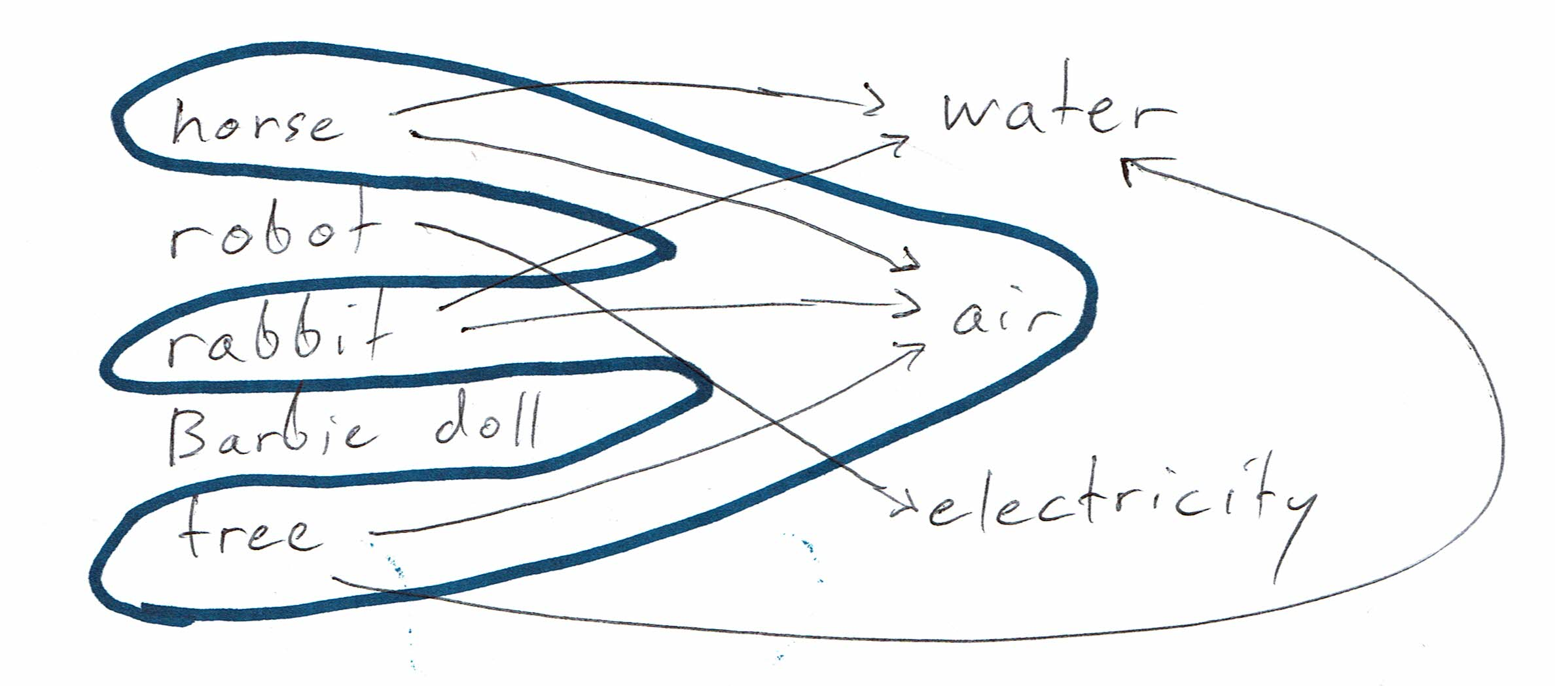
Figure A: What needs what

Branches
A branch in a graph is everything descended from a central node in a certain way, the simplest way being along a single Direction. The central node is called the “root” of the branch.
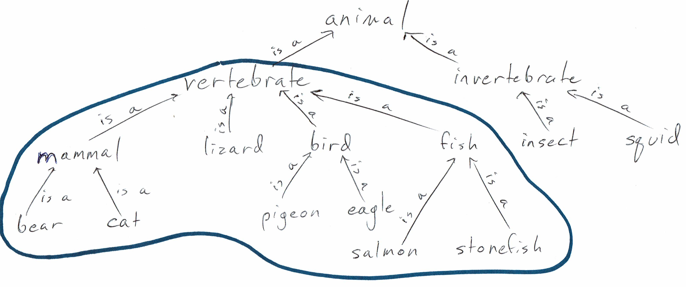
Figure B: The vertebrates are a branch of the animals
Figure B provides an example: The vertebrates are a branch of the animals. Mammals are vertebrates, so they are in the vertebrates branch. Bears are mammals, so they are in the vertebrates branch, despite not being directly connected to vertebrates.

A branch can be thought of as a set of successive generations of stars. To draw the vertebrate branch of animal, for example, you would start by drawing a star around vertebrate. That first star reaches mammal, lizard, bird and fish. (It does not reach animal, because the edge from vertebrate to animal points in the other direction.) Next you might draw the star around mammal, which would reach bear and cat. Etc.

Branches allow queries like these:

"everybody descended from Shakespeare"
"Kate the vice-president of engineering, and everybody reporting to Kate, and everybody reporting to someone who reports to Kate …"
"everybody I danced with today, and everybody they (the first generation of leaves) danced with today, and everybody they (the second generation of leaves) danced with today, ..."

A general Branch could use any collection of Directions, in any order – for instance, "show me everybody with a prior conviction for methamphetamine production who spoke to somebody who bought ephidrine in Orlando last year.”

The branch could be another type of RSLT node. A representation that included some control on the number of generations explored could represent stars as a special case, in which the number of generations is one.

Subexpression Reflection
There is a kind of statement that the RSLT as so far defined still cannot encode. Statement 8 presents an example – in ordinary English, in the nested parentheticals idiom, and in the nested # notation idiom:

Statement 8
As ordinary English: The volcano will fume until a cat stretches its legs.
As nested parentheticals: ((The volcano) will (fume)) until ((a cat) stretches (its legs)).
As nested # notation: The volcano ##will fume ####until a cat ##stretches its legs.

The word its in Statement 8 refers to the subexpression a cat. The pronoun it is meaningful to a human reader, but a computer would not know what it referred to. it cannot equivalently be replaced by another instance of a cat, because in that case they might refer to different cats. (It is hard to imagine how a cat would stretch another’s legs, given their lack of thumbs, but the computer doesn’t know that.)

The RSLT, in order to represent such statements, needs another kind of expression, which we will call the Subexpression Reference. In the graph implementation of a RSLT, a Subexpression Reference is a fourth kind of node. An edge labeled SubexRefRefs, points from the Subexpression Reference toward the subexpression it references. Another edge, labeled SubexRefClarifies, points toward the superexpression it clarifies. The Subexpression Reference node itself provides instructions for how to traverse from the top of the superexpression to the relevant subexpression.

To finish the example of Statement 8, the Subexpression Reference at its would emit an edge toward the expression a cat and another toward Statement 8. The Subexpression Reference node would indicate that the subexpression can be found by taking a right at until and then a left at stretches.

Algebra on Relationships
Some relationships adhere to certain transformation rules. “_ supports _” is a “transitive” relationship: If a supports b and b supports c, then a supports c. “_ resembles _” is a “reflexive” relationship: If a resembles b, then b resembles a.

Modeling transformation rules makes automatic reasoning possible. Prolog is an elegant example.

A RSLT could represent transformation rules as another kind of node in the graph. I hardly know where to begin doing that but it would be aweosme.

External, spacetime-optimized data structures can be hooked in the RSLT interface without sacrificing its optimizations
The RSLT has some good space properties, because it eliminates the need for redundant data. It has some good speed properties, for the same reasons trees and graphs do. What it is optimized for, however, is expressivity.

There are other data structures optimized for a particular kind of problem, which can outperform the RSLT on a speed or space basis. Using a RSLT does not mean sacrificing those optimizations!

Example: Hooking a table into a RSLT
A table (“array”) is a very space-efficient data structure. Imagine a table that reports how many kites were produced by which country in which year. It describes ten countries and ten years, so there are 100 numbers in the table. As an array, those 100 numbers are stored in sequence, packed as tightly as possible, with no other information between them.

If they were to be stored in the RSLT, each number would be a Member of an expression of this form:

Form A: "[country] produced [number] kites in [year]."
That would use more space.

However, the table can be "hooked" into the RSLT "interface" without changing how the table is stored. Doing so lets you query the data as if you had encoded 100 facts of Form A in the normal RSLT manner.

Such a hook must provide the following information: "The external data set at [address] encodes, for some years and some countries, how many kites were produced. The countries it covers are these ... The years it covers are these ... If someone asks about one of the available country-year pairs, here is how to find the corresponding number of kites."

Appendix

Defining the RSLT in four lines of Haskell
The RSLT graph types, as so far described, can be defined as follows:
import Data.Graph.Inductive
type RSLT = Gr Expression RSLTEdge
data Expression = Word String | Relationship | Template [String]
data RSLTEdge = UsesTemplate | UsesMember Int

The first line imports the Functional Graph Library. The second defines a RSLT as a graph in which the nodes are Expressions and the edges are RSLTEdges. The defines an Expression as either a Word (in which case it contains one string), a Relationship (in which case it contains no information), or a Template (in which case it contains a list of the strings that go between the blanks – for instance, the Template “_ gave _ to _” would contain the strings gave and to). The last line says that a RSLTEdge comes in two varieties: UsesTemplate (which contains no additional information) and UsesMember (which includes an integer indicating which position the member occupies.)
Note, however, that these type declarations do not encode all the information about what a RSLT can be. They omit the rules about the number and kind of edges that a Relationship must emit.

Demonstration: Building RSLT expressions from the bottom up
In principle, all that is needed to enter Data Set 7 is to type the four sentences in Data Sets 7.1 or 7.2. That top-down approach would be faster. The existing interface for entering data is slower to use, because it requires building each subexpression before creating a superexpression that uses them.

Because it is awkward and temporary, the purpose of this section is not to explain the existing interface. I just want to demonstrate that the data can be represented.

You can find the following code online, and with a Haskell interpreter like GHCI, run it yourself.

First, let's create an empty RSLT named "g":

> let g = empty :: RSLT

Next, let's insert into g the five Templates we will need:

> g <- pure $ foldl (flip insTplt) g
["every _"
,"_ is a _"
, "_ has _"
,"_ with _"
, "_ needs _"]

Now let's look at g:

> view g $ nodes g
(0,"#every _")
(1,"_ #(is a) _")
(2,"_ #has _")
(3,"_ #with _")
(4,"_ #needs _")

Each expression appears alongside its address. For instance, the unary "every _" Template resides at address 0, and the binary "_ needs _" Template is at address 4.

Next, lets put our first order expressions into the RSLT: the Words "person", "Mildred Funnyweather ", "stable angina", "coronary artery disease", and "monitoring". (With respect to English, three of those are mult-word phrases, but with respect to the RSLT they are all single Words.)

> g <- pure $ foldl (flip insStr) g
["person", "Mildred", "stable angina"
, "coronary artery disease", "monitoring"]

The new Words are inserted after the Templates:

> view g $ nodes g
(0,"#every _")
(1,"_ #(is a) _")
(2,"_ #has _")
(3,"_ #with _")
(4,"_ #needs _")
(5,"person")
(6,"Mildred")
(7,"stable angina")
(8,"coronary artery disease")
(9,"monitoring")

Now that we have both Templates and Words, we can start adding Relationships. First let's encode that Mildred is a person and stable angina is a coronary artery disease:

> g <- pure $ fromRight $ insRel 1 [6,5] g
-- creates node 10, "Mildred is a person"
> g <- pure $ fromRight $ insRel 1 [7,8] g
-- creates node 11, "stable angina is a coronary artery disease"

The first of those two commands says "insert into g a Relationship that uses the Template at address 1 ("_ is a _"), where the Members are the expressions at address 6 ("Mildred") and 5 ("person"). The second command is similar.

Rather than showing all of g, let's just look at the Relationships in it:

> view g $ nodes $ labfilter isRel g
(10,"Mildred ##(is a) person")
(11,"stable angina ##(is a) coronary artery disease")

Expressions 10 and 11 are the two new Relationships. In both of them, the ## symbol identifies the Relationship label "is a", on either side of which appear the two Members.

Last, let us encode the idea that every person with coronary artery disease needs monitoring:

> g <- pure $ fromRight $ insRel 3 [5,8] g
-- creates node 12: "person with coronary artery disease"
> g <- pure $ fromRight $ insRel 0 [12] g
-- creates node 13: "every person with coronary artery disease"
> g <- pure $ fromRight $ insRel 4 [13,9] g
-- creates node 14: "every person with coronary artery disease needs monitoring"

Here is the final RSLT:

> view g $ nodes g
(0,"#every _")
(1,"_ #(is a) _")
(2,"_ #has _")
(3,"_ #with _")
(4,"_ #needs _")
(5,"person")
(6,"Mildred")
(7,"stable angina")
(8,"coronary artery disease")
(9,"monitoring")
(10,"Mildred ##(is a) person")
(11,"stable angina ##(is a) coronary artery disease")
(12,"person ##with coronary artery disease")
(13,"####every person ##with coronary artery disease")
(14,"####every person ##with coronary artery disease ########needs monitoring")

Recall that the number of # symbols on a Relationship label indicates the order of that Relationship. Thus in expression 14, ##with binds first, then ####every, and last ########needs. I chose to make the number of # symbols start at 2 and increase exponentially (2, 4, 8, ...) so that visually parsing them would be easy: You can see which label has more # symbols without explicitly counting them.

Unifying Words and Phrases
Rather than representing a multi-word phrase like “Father’s Day” as a single word, it would be more natural to model the inclusion relationship between words and phrases that use the Words. Words in a phrase would be connected by the ternary “[word] precedes [word] in [phrase]” relationship. For display purposes, everything but the first two members would be suppressed, including the # marks.

“[word] precedes [word] in [phrase]” is associative in its first two members. For instance, the phrase “mother in law” could equally well be constructed by appending in to mother and then appending law, or by appending law to in and then appending that to mother.

Unifying Words and Templates
As currently specified, a Template contains a list of strings to present as labels between the blanks. For instance, in “_ gave _ to _”, the first visible label is gave and the second is to.

It would be better if those labels were themselves arbitrary RSLT expressions. The result would be a Template node which , like a Relationship node, carries no information in itself, instead relying entirely on its edges for meaning.

The RSLT is equivalent to the reflective triplestore
Any n-ary relationship can be represented as a tree of binary relationships. “_ did _ to _”, for instance, could be represented as “_ did (_ to _)”. The minimal RSLT is therefore equivalent to a reflective triplestore.

However, existing triplestore libraries are flat – a triple’s members can be strings, or numbers, etc., but they cannot themselves be other triples. To my astonishment, I have found no existing implementation, nor even mention, of reflection in a triplestore.

How the RSLT gets its name
A k-tuple is an ordered set of k things. For instance, (cat, mouse) is a 2-tuple. A labeled k-tuple is just a tuple with a label. (“_ glares at _”, (cat, mouse)) is a labeled 2-tuple, encoding the idea that the cat glares at the mouse.

The Relationships in a RSLT can be thought of as labeled tuples: the members form a tuple, and the Template provides a label. Since most of the nodes in a RSLT graph are Relationships, it seems fair to call the RSLT a set of labeled tuples.

(At this point we have seen three different senses of the word “label”. A node label attaches information to a node, an edge label attaches information to an edge, and a Template serves as the label for a Relationship. That potential confusion is why the term Template seemed better than Label.)

For a computer program, “reflection” is the capacity to view or modify itself. For a data structure, “reflection” is the capacity to refer to itself. Since one Relationship in a RSLT can be a member of another, the RSLT is reflexive.

Special thanks to Elliot Cameron, who helped me figure these things out.
I’ve been pronouncing it "RISS-ult", like “whistled”.
https://developers.facebook.com/docs/graph-api
https://www.google.com/intl/en_us/insidesearch/features/search/knowledge.html
including the ability to explicitly parse a sentence tree – admittedly, an infrequently needed skill among most speakers, but they already do it implicitly! Automatic parsers can, in principle, alleviate some of the burden.
See Neo4j for a beautiful example of a language for asking questions about graphs.
The word arity comes from the ar in the words binary, ternary, etc.
Parsed flat, that is. One could also reasonably parse them nested, as in for instance “Bill did (spin the chair) for profit.”
If you are wondering why someone would attach data to a relationship template, read on!
More precisely, the label on a relationship node indicates nothing but the fact that it is a relationship node, as opposed to a word or template node.
Specifically, if n is the number of relationships using the template, then whereas changes take O(n) operations to attach data using the relationship-as-labeled-node idiom, they take only O(1) using the relationship-as-unlabeled-node idiom.
Rather than as a graph, the RSLT could be implemented using triplestores, as described in one of the appendices.
For example, in the Template “_ does _ to _”, one label is does and the other is to.
For example, “Che ###used markers #and paper ##from China ###to write #about China” uses the ternary “_ used _ to _” relationship template.
https://www.haskell.org/
https://hackage.haskell.org/package/fgl-5.5.2.3/docs/Data-Graph-Inductive-Graph.html
https://github.com/JeffreyBenjaminBrown/digraphs-with-text
You could just as well call them True and False, or Zero and Pineapple.
This constitutes an exception to the usual rule that edges point exclusively from superexpressions to subexpressions.
https://github.com/JeffreyBenjaminBrown/digraphs-with-text/blob/master/introduction/demo.hs
There are four labels in a ternary relationship, because a label could lie before the first blank, or after the last. In “_ gave _ to _” only the second and third are visible; the first and fourth are the empty string.
“Minimal” meaning with Words, Templates and Relationships, but no Directions, Stars, Branches, or SubexRefs.
This is particularly true given that Words could be implemented as arity-0 Relationships. (Thanks to Devon Stewart for that observation.) Reflective Set of Labels and Labeled Tuples would be more accurate, but that name sounds complicated, and might impede adoption.

