Game Design Document

Fill up the following document

1. Write the title of your project.

Zombie Invasion

1. What is the goal of the game?

Kill the human

1. Write a brief story of your game.

There were 3 friends. One day one of the friends wanted to kill them beacause the other two friends became very popular in the country.

Then the 3rd friend took his car and rammed over them while they were crossing the road.a few days later both of the friends became zombies and they went to kill the 3rd friend. When they came to the front of his house, they saw plants gruading his house so they had to escape the plants and kill the human before they become into ghosts.

1. Which are the playing characters of this game?

* Playing characters are the ones who respond to the user based on the input from the user.

|  |  |  |
| --- | --- | --- |
| Number | Character Name | What can this character do? |
| 1 | Zombie1 | Move, use power ups |
| 2 | Zombie2 | Move, use power ups |
| 3 |  |  |
| 4 |  |  |
| 5 |  |  |
| 6 |  |  |
| 7 |  |  |
| 8 |  |  |

1. Which are the Non-Playing Characters of this game?

* Non-Playing characters are the ones that don't have an action or behavior when the user interacts with the game.

|  |  |  |
| --- | --- | --- |
| Number | Character Name | What can this character do? |
| 1 | repeater | Shoot projectiles |
| 2 | iceBergLettuce | Shoot projectiles |
| 3 | speedController | Change the speed of the zombie |
| 4 | powerFruit | Increases score and speed |
| 5 | man | Just stand |
| 6 |  |  |
| 7 |  |  |
| 8 |  |  |

Draw your imagination of this game. What does this game look like?

* Draw the game either on your computer or on paper.
* Add images of the game scenes to show each of the playing and non-playing characters at least once.

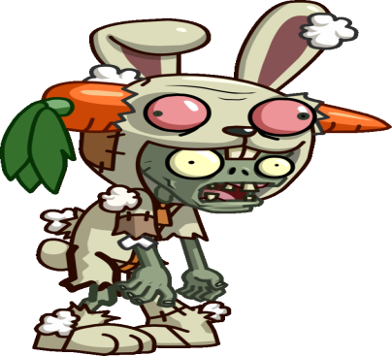

How do you plan to make your game engaging?

After crosssing the plants there will be a maze and after that a parcir course. After completeing that we can find the man and kill him

CONTROLS OF THE KILLERS

Up arrow for moving up

Down arrow for moving down

Left arrow for moving left

Right arrow for moving right