上机实验4

对象传递与静态成员

程序代码：

#include "iostream.h"

#include <string.h>

using namespace std;

class TStudent

{

private:

char m_Name[6];

static float m_ClassMoney;

public:

void InitStudent(char *);

void ExpendMoney(float);

static void ShowMoney();

};

float TStudent::m_ClassMoney=1000;

void TStudent::InitStudent(char name[])

{

strcpy(m_Name,name);

}

void TStudent::ExpendMoney(float money)

{

m_ClassMoney-=money;

cout<<m_Name<<"花费班费"<<m_ClassMoney<<endl;

}

void TStudent::ShowMoney()

{

cout<<"班费还剩余"<< m_ClassMoney<<endl;

}

void main()

{

TStudent stu[3];

stu[0].InitStudent("A");

stu[1].InitStudent("B");

stu[2].InitStudent("C");

stu[0].ExpendMoney(50);

TStudent::ShowMoney();

stu[1].ExpendMoney(98.5);

TStudent::ShowMoney();

stu[2].ExpendMoney(500.53);

TStudent::ShowMoney();

}

运行结果：

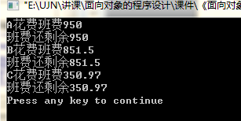

实验心得：

静态成员用static关键字