U.S. Grocery Price Inflation Analysis
2020–2025 | Google Data Analytics Capstone Case Study

Executive summary
This case study examines changes in U.S. grocery prices using the Consumer Price Index for All Urban Consumers (CPI-U), Food at Home. Based on annual averages calculated from the project workbook, the index rose approximately 25.19% from 2020 to 2025. The largest year-over-year increase in annual averages occurred in 2022 (11.42%). Inflation subsequently slowed, but the overall price index remained elevated.
The October 2025 observation is unavailable; the 2025 average uses the other 11 months. Results describe national index changes, not the exact grocery spending of an individual household.

Phase 1: Ask — Define the business problem
Objective: identify U.S. grocery price trends, determine the year with the largest increase, and explain the difference between inflation rates and price levels.
- How much did grocery prices change relative to 2020?
- Which year experienced the highest annual inflation?
- How did annual inflation evolve through 2025?
- What practical insights can households and businesses draw from these trends?

Phase 2: Prepare — Collect and understand data
Source: U.S. Bureau of Labor Statistics (BLS), CPI-U, Food at Home, U.S. city average; series ID CUUR0000SAF11. The project dataset contains monthly observations for January 2020–December 2025 in two fields: Date and Food_CPI.
Source landing page: https://www.bls.gov/cpi/data.htm. The CPI tracks price changes for a representative basket, rather than the actual purchases of a particular household.

Phase 3: Process — Clean and prepare
- Reviewed the monthly dates and CPI values and organized the data in Excel.
- Identified the unavailable October 2025 observation and left it blank rather than imputing a value.
- Maintained three worksheets: Project Overview, Food CPI Raw Data, and Annual CPI Summary.
- Calculated each annual average using Excel AVERAGE across the relevant monthly rows. Excel excludes the blank October 2025 cell.
- Formatted index levels as numbers and inflation rates as percentages; checked formulas and chart references.
Example formula: =AVERAGE('Food CPI Raw Data'!B2:B13) for the 2020 annual average.

Phase 4: Analyze — Measure inflation
Cumulative change is calculated as (current-year annual average / 2020 annual average) − 1. Annual inflation is calculated as (current-year annual average / prior-year annual average) − 1.
Year | Annual average CPI | Change from 2020 | Annual inflation
2020 | 250.23 | 0.00% | —
2021 | 258.89 | 3.46% | 3.46%
2022 | 288.45 | 15.27% | 11.42%
2023 | 302.93 | 21.06% | 5.02%
2024 | 306.54 | 22.50% | 1.19%
2025 | 313.27 | 25.19% | 2.20%
2022 recorded the highest year-over-year rise in annual average CPI (11.42%). Inflation then slowed to 5.02% in 2023 and 1.19% in 2024, before reaching 2.20% in 2025. The cumulative index change was 25.19% by 2025. Slower inflation means a slower rate of price increase, not necessarily falling prices.

Phase 5: Share — Communicate findings
Figure 1. Cumulative grocery price inflation relative to the 2020 annual average.
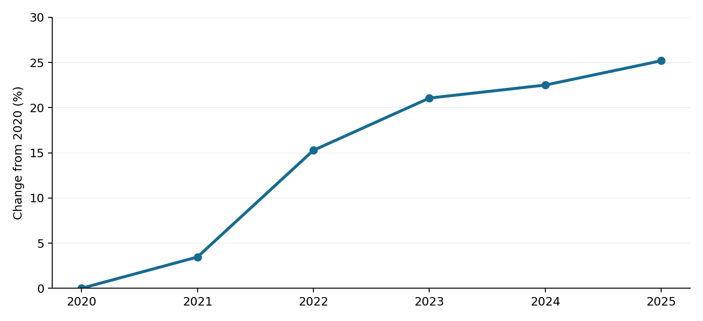
Figure 2. Year-over-year changes in annual average Food at Home CPI.
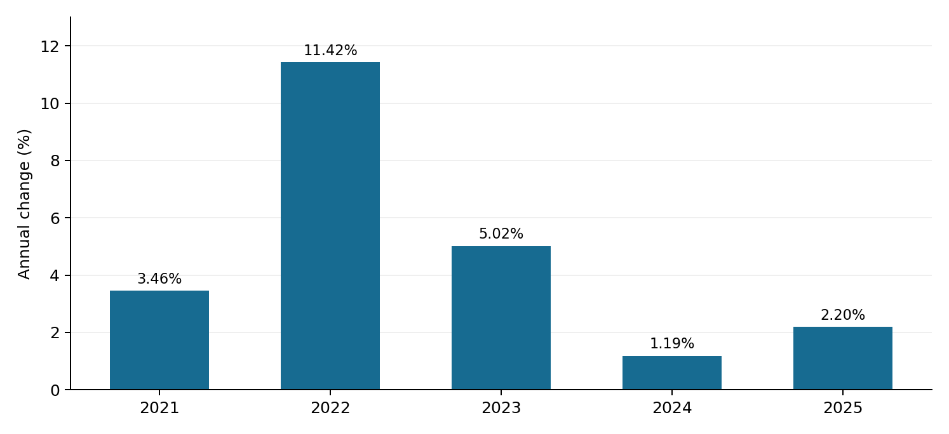
Together, the charts show a sharp acceleration in 2022 followed by slower annual increases, while the overall price index remains above its 2020 level.

Phase 6: Act — Conclusions and recommendations
- Monitor trends: Use annual CPI trends alongside recent monthly releases to understand longer-term price movements.
- Review budgets: Households can revisit grocery budgets as cumulative price changes affect purchasing power.
- Inform business decisions: Retailers can use national CPI as context, while also consulting local prices, supplier costs, and customer demand.
- Extend the analysis: Compare categories such as eggs, dairy, meat, and produce; add regional comparisons and wage-growth context.

Limitations and reproducibility
October 2025 is missing from the source dataset, so its annual average is based on 11 observations rather than 12. This reduces comparability with full-year averages. CPI reflects a representative national basket, not every household’s experience. Figures here were recalculated from the uploaded Excel workbook; a separate line-by-line comparison of every monthly observation against a current BLS download has not been completed.
Method and data: Microsoft Excel; BLS CPI-U Food at Home (CUUR0000SAF11). Workbook: Grocery_Inflation_Capstone_2020_2025.xlsx.
Key takeaway: grocery price inflation slowed after its 2022 peak, but the cumulative price level remained substantially higher than in 2020.

