Node JS is a JS runtime built on V8 engine. It is actually a C++ program (or Node.exe) so we can run it outside browser

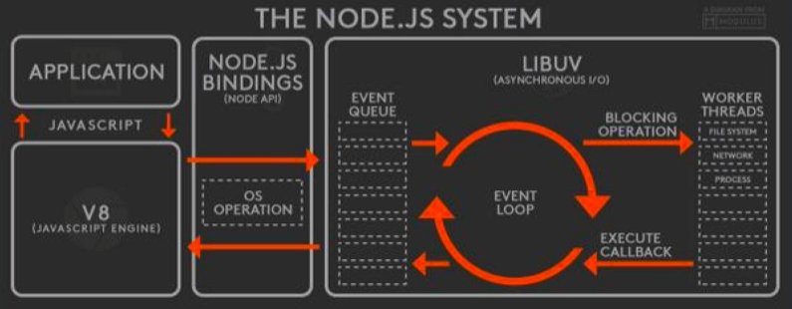

Node has object called Global (Instead of Window object in browser)

Normally used for server side as it got non-blocking execution of the code.

