## 1.

Which dance style is depicted below?

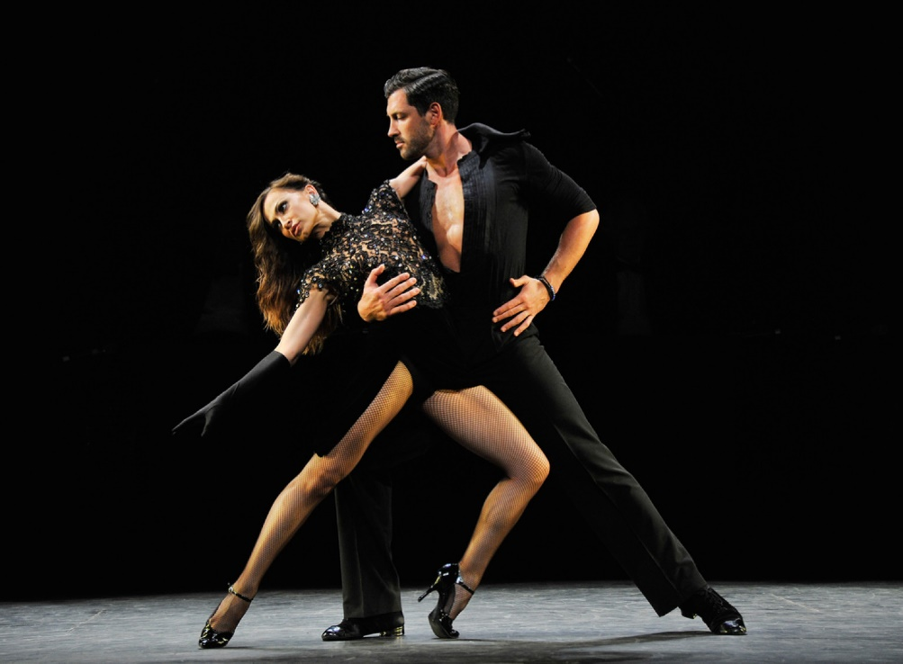

1. Jive
2. English Waltz
3. Tango
4. Quickstep

## 2.

Who has(/have) won the show

* Meryl Davis
* Zendaya
* Rumer Willis
* Sadie Roberston

## 3.

Who is this (former) pro



Mark Ballas

## 4.

Which Olympic athlete was the last one to win the Mirror Ball Trophy before Laurie Hernandez.

Meryl Davis

## 5.

Which dance style(s) has(/have) never been danced officially

* Hip hop
* Line dance
* Jitterbug
* Mambo
* Tap dance

## 6.

Who is this (former) pro



1. Sharna Burgess
2. Karina Smirnoff
3. Cheryl Burke
4. Jenna Johnson

## 7.

Who has gotten the most perfect scores in a season?

Bindi Irwin

## 8.

Which of these stars was(/were) the first elimination of their season?

* Kim Kardashian
* David Hasselhoff
* Rick Perry
* Doug Flutie

Questions:

Color scheme

String naming

For this project, I decided to create a quiz about Dancing with the Stars.  
The quiz poses questions about former participants and professional dancers.

Grading logic

+1 point for a correct multiple choice answer

+1 point for a correct open question answer

+1 point for each correct check question answer

-1 point for each wrong check question answer

I have two specific points I would to have feedback on:

For my strings I chose names like “question_1” and “answer_1_a”. Is this good practice or would a reference to the actual questions and answers be better, like “question_dance_style” and “answer_jive”?