程式碼請參閱:

https://github.com/JeffreyLinWeiYou/EE5324701_HW1

圖一:

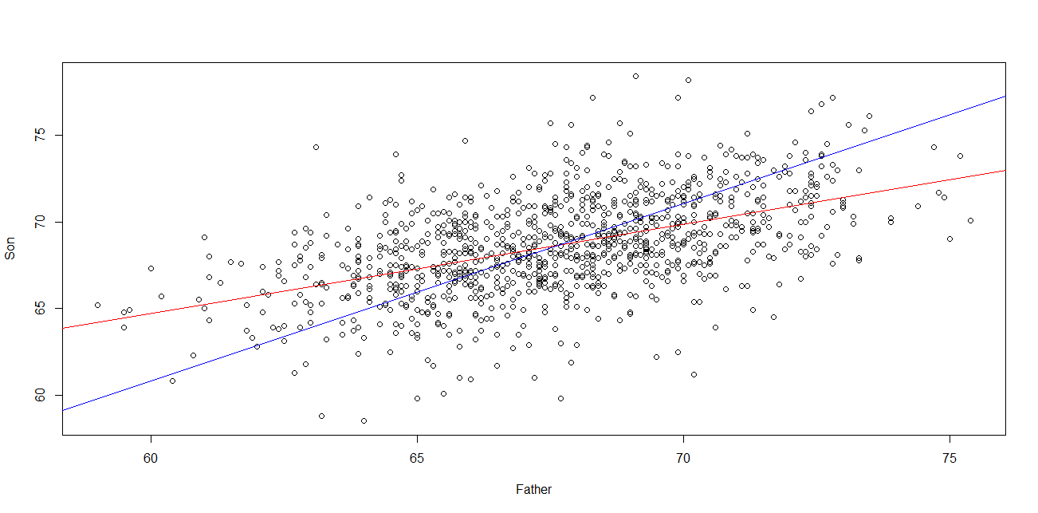

5.(a)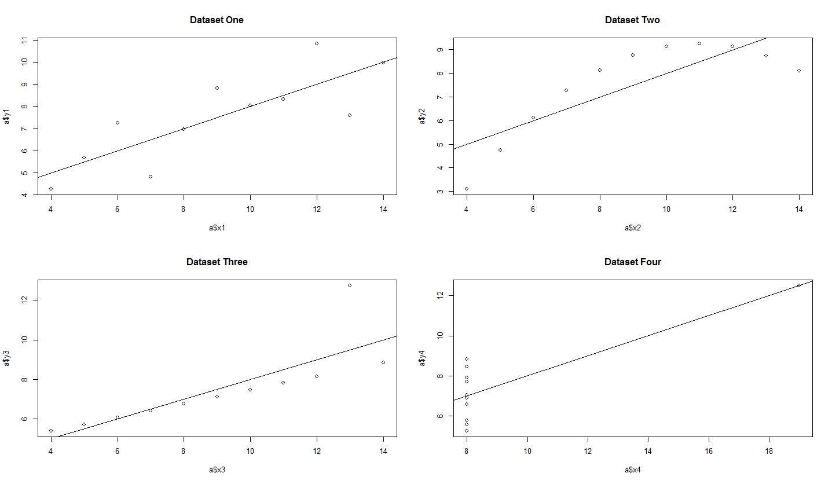

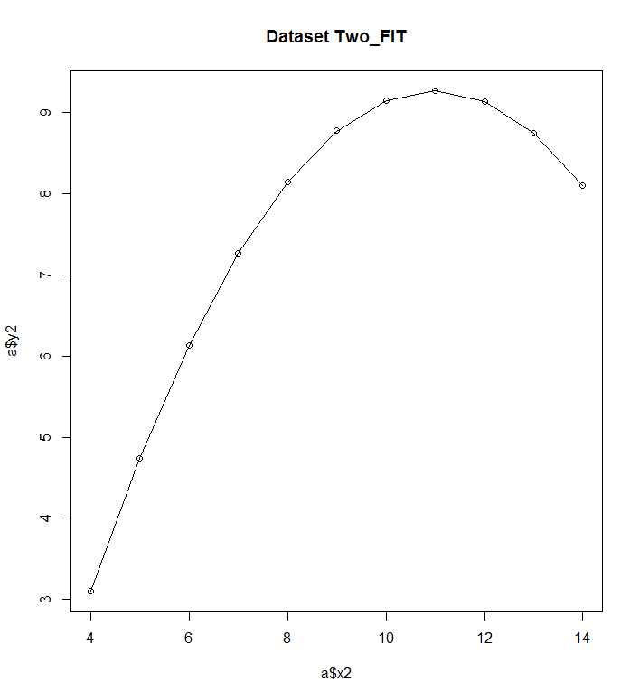

value:10 in Dataset 1 = 8.001

value:10 in Dataset 2 = 8.000909

value:10 in Dataset 3 = 7.999727

value:10 in Dataset 4 = 8.000818