**pandas-challenge**

**Objective**

* Provide written descriptions of three observable trends.

1. There are fewer female players/shoppers than males (m = 84.03%; f=14.06%; See **Figure 3**). This does not hold true for average total purchase is higher for females (m=$4.07; f=$4.47; See **Figure 4**). There is likely market space available to increase female demographic sales.
2. There is a relationship between the most popular and the most profitable items (see **Figures 8 & 9**). This suggests that effort could be spent on underperforming items to increase overall profitability.
3. It is clear to see that the bulk of the population resides in the fifteen to thirty year old age ranges (see **Figure 5**).

**Appendix**

**Figure 1. Total Players.**



**Figure 2. Purchasing Analysis.**



**Figure 3. Gender Demographics.**

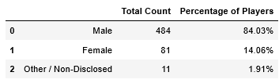

**Figure 4. Gender Purchasing Analysis.**

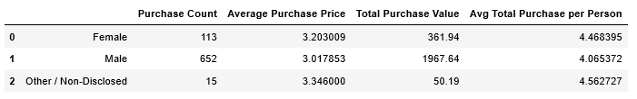

**Figure 5. Age Demographics**

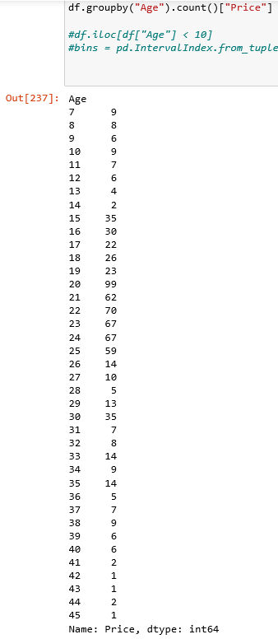

**Figure 6. Age Purchasing Analysis.**

**Figure 7. Top Spenders.**

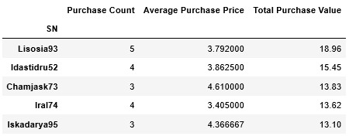

**Figure 8. Most Popular Items.**

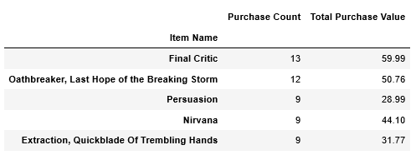

**Figure 9. Most Profitable Items.**

