Pattern Recognition HW1

* Methods
  1. Data Preprocessing

Numerical features are standardized and categorical features are one-hot encoded. All preprocessing steps are integrated into a Pipeline to avoid data leakage.

* 1. Train–Test Split

The dataset is split into **80% training** and **20% testing** using a stratified split to preserve class distribution.

* 1. Model Training and Hyperparameter Tuning

Models are trained using 5-fold cross-validation, and hyperparameters are selected via grid search based on balanced accuracy.

* 1. Model Evaluation

Model performance is assessed using classification metrics and the confusion matrix. For binary tasks, ROC curves and AUC scores are additionally reported.  
Learning curves are used to analyze overfitting and data efficiency.

* Experiments and settings
  1. Datasets
     + [Predict Students' Dropout and Academic Success](https://archive.ics.uci.edu/dataset/697/predict+students+dropout+and+academic+success) (3 classes)

This dataset contains academic and demographic features used to classify students into three outcomes: **Dropout**, **Enrolled**, or **Graduate**.

* + - [Wine](https://archive.ics.uci.edu/dataset/109/wine) (3 classes)  
      This dataset consists of chemical composition measurements of wine samples and aims to classify them into **three distinct cultivars**.
    - [Secondary Mushroom](https://archive.ics.uci.edu/dataset/848/secondary+mushroom+dataset) (2 classes)  
      This dataset includes descriptive features of mushroom characteristics and is used to classify mushrooms as **edible** or **poisonous.**
    - [CDC Diabetes Health Indicators](https://archive.ics.uci.edu/dataset/891/cdc+diabetes+health+indicators) (2 classes)  
      This dataset contains health and lifestyle survey data and is used to predict whether a person is **non-diabetic** or **pre-diabetic/diabetic**.

In the following sections, we refer to these datasets as **Dataset 1**, **Dataset 2**, **Dataset 3**, and **Dataset 4**, respectively.

* 1. Hyperparameter Settings
     + Logistic Regression
       - The **solver** parameter specifies the optimization algorithm, where **lbfgs**, **newton-cg**, and **sag** are suitable for L2-regularized models, while **saga** additionally supports L1 regularization and works well with large or sparse datasets.
       - The **penalty** parameter determines the type of regularization applied to the model, with **L2** providing smooth coefficient shrinkage and **L1** encouraging sparsity by pushing some feature coefficients to zero.
       - The **C** parameter controls the inverse strength of regularization, where **smaller values** imply stronger regularization to reduce overfitting, and **larger values** allow more flexible model fitting.
  2. Results
     + Logistic Regression
       - Dataset 1

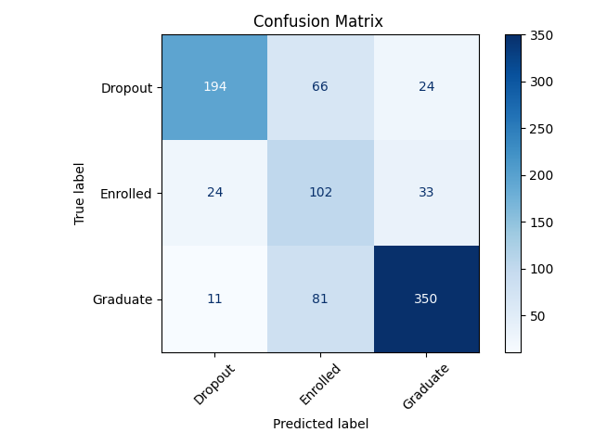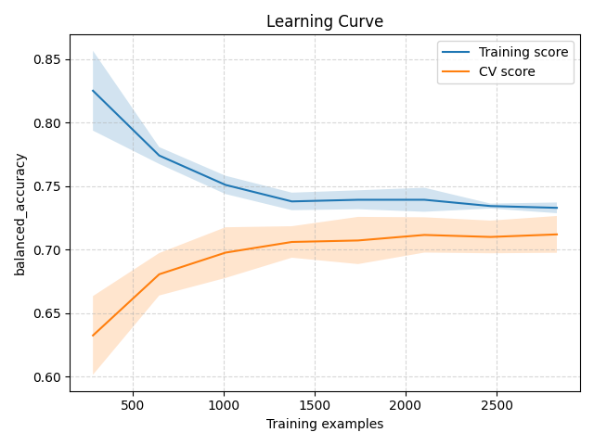

* + - * Dataset 2

