# picasa3-setup.exe (Free)

A picture viewer from Google.

Screen capture.

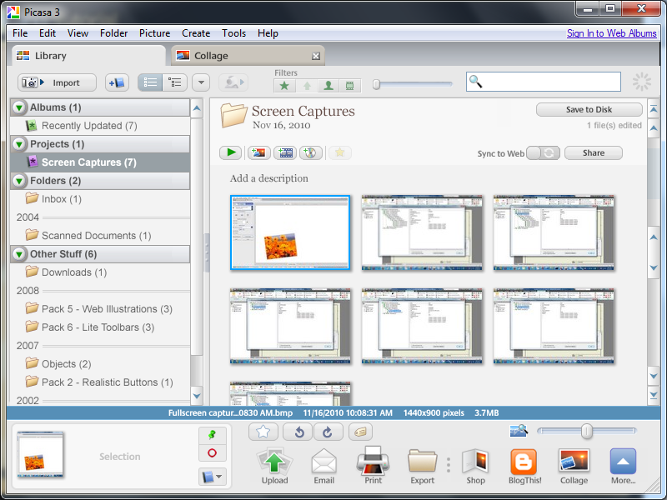

# setupscreenhunterfree.msi (Free)

Powerful screen capture tool

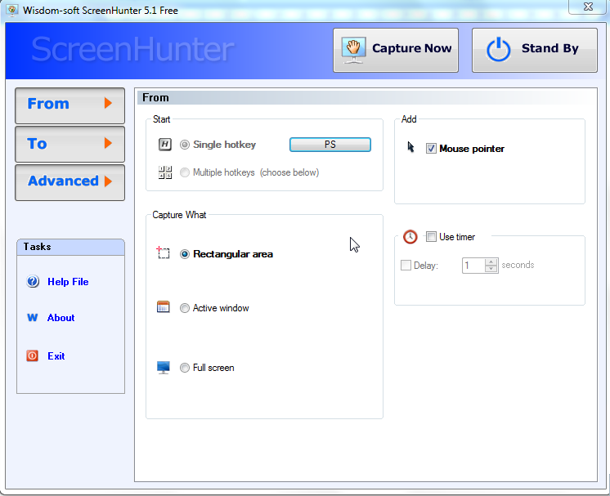

# jing_setup.exe (Free)

Record the video. But it can’t be edited.

Screen Capture

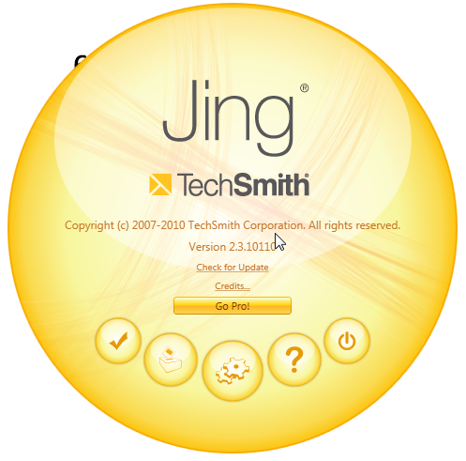

# SynergyInstaller-1.3.1.exe (Free)

Share keyboard and mouse cross computer

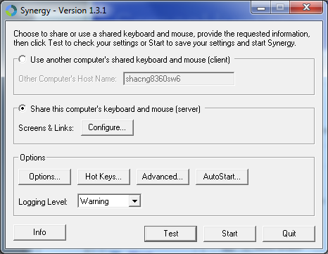

# InputDirector.zip (Free)

Share keyboard and mouse cross computer

An alternative to Synergy.

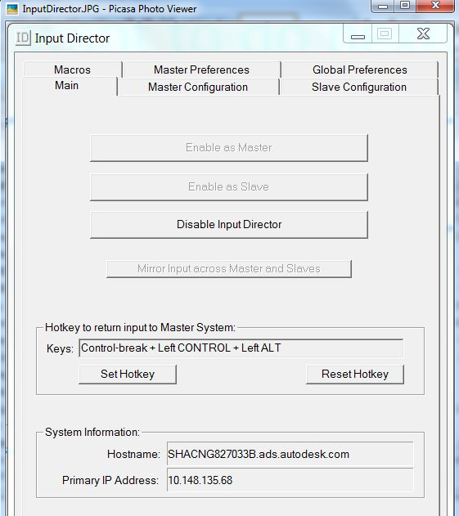

# YoudaoDict.exe (Free)

You dao dictionary. It is better than jinshan.

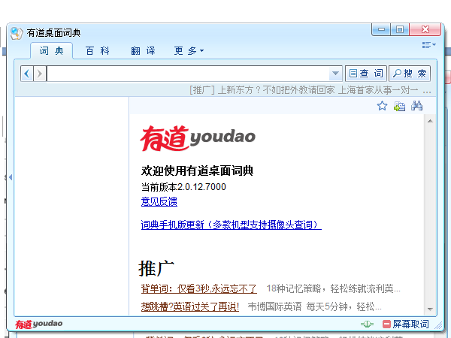

# XobniSetup.exe (Free)

Addin for outlook. Used to search mails.

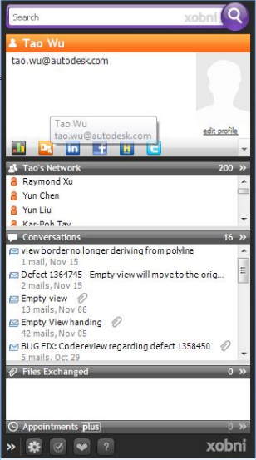

# npp.5.0.3.Installer.exe (Free)

text editor

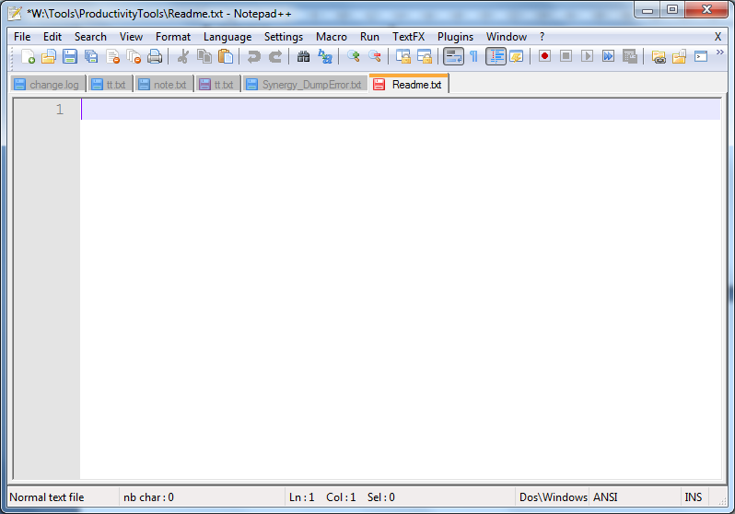

# STViewerSetup.exe (Free)

Lightweight tool to review step/stp model files.

(10.8M) (good performance, don’t support the body color.)

<http://stpviewer.com/Download/Default.aspx>

