**NITTE MEENAKSHI INSTITUTE OF TECHNOLOGY**

(AN AUTONOMOUS INSTITUTION, AFFILIATED TO VISVESVARAYA TECHNOLOGICAL UNIVERSITY, BELGAUM, APPROVED BY AICTE & GOVT.OF KARNATAKA



**PROJECT PHASE 1 REVIEW REPORT**

on

NAVIGATIONAND COLLISION AVOIDANCE SYSTEM FOR THE VISUALLY IMPAIRED

*Submitted in partial fulfilment of the requirement for the award of Degree of*

*Bachelor of Engineering in*

*Computer Science and Engineering*

*Submitted by:*

|  |  |
| --- | --- |
| Jeffrey Sam Joseph  Khanita Taskeen | 1NT14CS066  1NT14CS075 |
| Nireeksha B. Kallianpur | 1NT14CS097 |
|  |  |

Under the Guidance of

Dr. KrishnaraoVenkatesh

Professor

Department of Computer Science and Engineering

**(Accredited by NBA Tier-1)** 2017-18

**NITTE MEENAKSHI INSTITUTE OF TECHNOLOGY**

(AN AUTONOMOUS INSTITUTION, AFFILIATED TO VISVESVARAYA TECHNOLOGICAL UNIVERSITY, BELGAUM

, APPROVED BY AICTE & GOVT.OF KARNATAKA)

Department of Computer Science and Engineering

**(Accredited by NBA Tier-1)**



**CERTIFICATE**

This is to certify that the **“Navigation Assistance and Collision Avoidance for the Visually Impaired”** is an authentic work carried out by **Jeffrey Sam Joseph (1NT14CS066), Khanita Taskeen (1NT14CS075)**and **Nireeksha B. Kallianpur (1NT14CS097)**bon-fide students of Nitte Meenakshi Institute of Technology, Bangalore in partial fulfilment for the award of ***Bachelor of Engineering*** in COMPUTER SCIENCE AND ENGINEERING of the Visvesvaraya Technological University, Belgagavi during the academic year ***2016-2017.*** It is certified that all corrections and suggestions indicated during the internal assessment has been incorporated in the report. This project has been approved as it satisfies the academic requirement in respect of project work presented for the said degree.

|  |  |  |  |  |  |
| --- | --- | --- | --- | --- | --- |
| **Internal Guide** | | **Signature of the HOD** | | **Signature of Principal** | |
|  | |  | |  | |
| Dr KrishnaraoVenkatesh  Professor, Dept. CSE, NMIT  Bangalore | | Dr Thippeswamy M N  Professor, Head, Dept. CSE, NMIT Bangalore | | Dr H C Nagraj  Principal,  NMIT,Bangalore | |
| **Signature of Examiner (**Internals**)** | | **Signature of Examiner (**SEE**)** | |
|  | |  | |
|  | | 2. | |

**ACKNOWLEDGEMENT**

The satisfaction and euphoria that accompany the successful completion of any task would be incomplete without the mention of the people who made it possible, whose constant guidance and encouragement crowned our effort with success. We express our sincere gratitude to our Principal **Dr H. C. Nagaraj**, Nitte Meenakshi Institute of Technology for providing the necessary facilities.

We wish to thank our HOD**, Dr Thippeswamy M.N**. for the excellent environment created to further educational growth in our college. We also thank him for his constant guidance and support.

We take this opportunity to thank our guide **Dr KrishnaraoVenkatesh, Professor**, Department of Computer Science & Engineering for his periodic inspection and evaluation of the project. We express our gratitude for his role in the advancement of the project.

We thank our Departmental Project coordinators.We also thank our friends, teaching and non-teaching staff at NMIT, Bangalore, for all the direct and indirect help provided in the completion of the project.

**ABSTRACT**

The project “Navigation Assistance and Collision Avoidance for the Visually Impaired”, strives to provide an integrated solution combining collision avoidance, pit detection and navigation. We aim to transform the simple white cane into a tool which will detect obstacles, determine approximate distance from obstacles and navigate the user to specific locations.

The system uses a group of ultrasonic sensors to detect obstacles and determine the distance from them. The front end is an Android application which uses auditory output. A more effective alternative which will be implemented, uses tactile technology to warn the users of pits and other obstacles.

Contents

1. INTRODUCTION 7

2. LITERATURE SURVEY 8

3. CORRELATING THEORETICAL CONCEPTS TO PRACTICAL IMPLEMENTATION 11

3.1. Embedded Systems 11

3.2. Android Application 12

4. SYSTEM DESIGN 13

4.1. Schematic Diagram of the System 13

4.2. Circuit Diagram 14

4.3. Flow Diagram 15

4.4. Flow Diagram of the Android Application 16

BIBLIOGRAPHY 20

# 1. INTRODUCTION

According to a recent report of the World Health Organization, 81.7% of all 39 million blind people worldwide are 50 years and older. These people have an inherent risk towards walking disabilities. However, established navigation aids for the blind such as white canes or guide dogs provide limited assistance. A conventional technique for blind people who depend on a walker is to regularly stop and monitor the environment with a cane stick. This is tediously slow and it comes with the inherent risk of missing objects that do not touch the ground, such as table tops. Existing electronic aids for the blind solve this problem to some extent, but most of these devices are able to detect positive obstacles but fail to recognize dangerous negative obstacles, such as road curbs.

A means of independent navigation can make a huge difference in the lives of the visually impaired. It creates a sense of self-sufficiency which goes a long way in boosting confidence and reducing the stigma which we usually associate with visual impairment. Within this context, a system that can provide robust and accurate obstacle detection in urban environments is of utmost importance. In spite of a tremendous increase in research in this field, no solution which combines the capabilities of an obstacle detection as well as a navigational system is currently available. Our project aims to render this amalgamated solution.

The first working prototype uses ultrasonic sensors to detect objects in the path of the users. A high frequency sound pulse in the direction of the sensor and then times how long it takes for the echo of the sound to reflect back. The sensor both transmits and receives sound waves. The program uses the speed of sound along with the time difference between sending and receiving the sound pulse to determine the distance to an object.

An android application which acts as the front end was developed. The application receives sensor information about the distance of the obstacle detected via Bluetooth. Auditory output is used to inform the user that there is an obstacle in his/her path and distance from said obstacle is also similarly transmitted to the user.

# 2. LITERATURE SURVEY

In the literature, there have been different approaches related to localization and navigation assistance for visually impaired people that employ different sensory modalities. Extensive research has been done to provide a navigational aid for the visually impaired. Table 1 lists a few such systems. A few of these solutions which were researched for the project have been discussed below.

Navbelt is developed by Borenstein and his co-workers in University of Michigan[1] as a guidance system, using a mobile robot obstacle avoidance system. The prototype as implemented in 1992 and it is consisted of ultrasonic range sensors, a computer and earphones. The computer receives information from the eight ultrasonic sensors and creates a map of the angles (each for every sensor) and the distance of any object at this angle. Then the obstacle avoidance algorithm (including noise reduction algorithm EERUF) produce sounds appropriate for each mode. The ultrasonic sensors used in this system fail to make accurate judgements and there is absorption of sound leading to inaccurate distance measurements.

According to a study,[2] a device was designed for a hassle-free pedestrian navigation system. It integrates several technologies including wearable computers, image processing, audio processing and sound navigation and ranging. This device focuses on bringing about an approach which would allow a visually impaired person to walk through busy roads and help identify obstacles without any trouble. The device uses a digital camera to capture the image frames directly in front of the user, and the processor implements image processing to determine the obstacle and a set of vibrational motors warns the user. The system also provides audio response. The sonar sensors detect obstacles in the user’s immediate vicinity. Upon detection, the vibrational motors caution him/her regarding the presence of obstacles. Image processing is used to provide the lateral distance between the obstacle and the user, so as to provide distance perception.

John Zelek’s[3] work on this technology gives us “the logical extension of the walking cane,” which provides visually impaired individuals with tactile feedback about their immediate environment. Two small, webcam-sized video cameras wired to a portable computer feed information into a special glove worn by the user. The glove has vibrating buzzers sewn into each finger that send impulses to the user warning of terrain fluctuations up to 30 feet ahead. The bidirectional networking capability generalizes the device to a platform capable of collecting any sensor data as well as providing tactile messages and touch telepresence.

Sunita Ram and Jennie Sharf[4] designed the “People sensor,” which uses pyroelectric and ultrasound sensors to locate and differentiate between animate (human) and inanimate (non-human) obstructions in the detection path. Thus, it reduces the possibility of embarrassment by helping the user avoid inadvertent cane contact with other pedestrians. The system also measures the distance between the user and obstacles.

The work by Peng et al.[5]introduces a monocular approach that employs the embedded camera on a smartphone. This system is capable of detecting on-floor obstacles. The conducted experiments included the participation of five blind users that were aided with vibrations and voice on-demand from the smartphone. The main disadvantage of this system is that the scenario is simulated despite the fact that some performance tests of the proposed algorithm were done indoors. In addition, it imposes the necessity of a 45 degree tilt angle of the phone with respect to the ground plane while the user is holding it for seeking possible hazards on the floor leading to violation of a hands-free condition.

Most of these systems address problems faced by the visually impaired but fail to provide an integrated system. The proposed system aims to provide solutions for collision avoidance, pit detection and an in built navigation system. It overcomes the weaknesses of these individual approaches to provide a solution to common problems faced by the visually impaired.

|  |  |  |  |  |  |  |
| --- | --- | --- | --- | --- | --- | --- |
| System type | System name | Reference | Year | Signal input | Signal output | Disadvantages |
| Sonar systems | NavBelt | [1] | 1998 | Ultrasonic | Auditory display | Cannot provide precise information such as shape and motion state of obstacles, and also cannot make judgments to the travel orientation |
| People sensor | [4] | 1998 | Ultrasonic | Tactile cues |
| 3D space perceptor | [6] | 2003 | Laser | Auditory display |
| Navigation system based on optical beacons | [7] | 2001 | Infrared signal | Auditory display |
| Camera based systems | vOICe | [8] | 1992 | CCD camera | Auditory display | larger size, higher cost relatively, and it needs two cameras as distance detection algorithms are more complex than sonar-based ETAs |
| Tyflos | [9] | 2001 | Camera and laser scanner | Auditory display |
| NAVI | [10] | 2007 | CCD camera | Auditory display |
| Audio  Man | [11] | 2007 | CCD camera | Auditory display |
| Sound  View | [12] | 2009 | CCD camera | Auditory display |

|  |
| --- |
|  |

**Table 1**: Existing navigation aids for the visually impaired

# 3. CORRELATING THEORETICAL CONCEPTS TO PRACTICAL IMPLEMENTATION

## 3.1. Embedded Systems

An embedded system can be thought of as a computer hardware system having software embedded in it. An embedded system can be an independent system or it can be a part of a large system. It offers many benefits such as sophisticated control, precision timing, low unit cost, low development cost, high flexibility, small size, and low weight.Embedded systems contain two main elements:

• ***Embedded system hardware:*** As with any electronic system, an embedded system requires a hardware platform on which to run. The hardware will be based around a microprocessor or microcontroller. The embedded system hardware will also contain other elements including memory, input output (I/O) interfaces as well as the user interface, and the display. The hardware elements used in this project include:

* Arduino Board
* Ultrasonic Sensors (HC-SR04) - HC-SR04 is an ultrasonic ranging module that provides 2 cm to 400 cm non-contact measurement function. The ranging accuracy can reach to 3mm and effectual angle is < 15°. It can be powered from a 5V power supply.

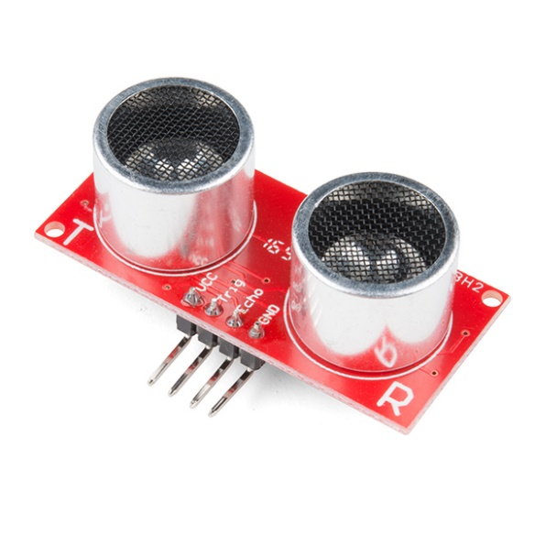

**Fig 3.1:** A HC-SR04 Ultrasonic Sensor

* Bluetooth Device (HC-05) - The Bluetooth module HC-05 is a MASTER/SLAVE module.By default the factory setting is SLAVE.The Role of the module (Master or Slave) can be configured only by AT COMMANDS.The slave modules cannot initiate a connection to another Bluetooth device, but can accept connections.Master module can initiate a connection to other devices.The user can use it simply for a serial port replacement to establish connection between MCU and GPS, PC to embedded project, etc.

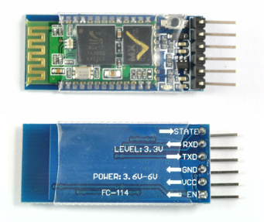

**Fig 3.2:** A HC-04 Bluetooth Module

• ***Embedded system software:*** The embedded system software is written to perform a specific function. It is typically written in a high level format and then compiled down to provide code that can be lodged within a non-volatile memory within the hardware

## 3.2. Android Application

Android applications are usually developed in the Java language using the Android Software Development Kit.Once developed, Android applications can be packaged easily and sold. Android powers hundreds of millions of mobile devices in more than 190 countries around the world. It's the largest installed base of any mobile platform and growing fast. Every day more than 1 million new Android devices are activated worldwide.

# 4. SYSTEM DESIGN

## 4.1. Schematic Diagram of the System

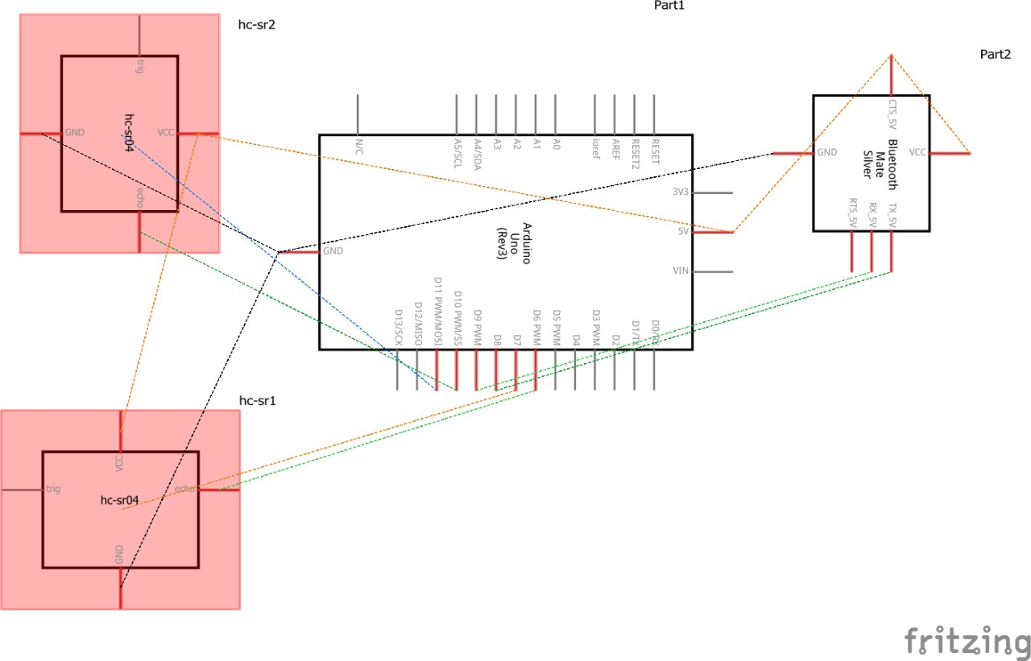

**Fig 4.1:** Representation of the schematic diagram

## 4.2. Circuit Diagram

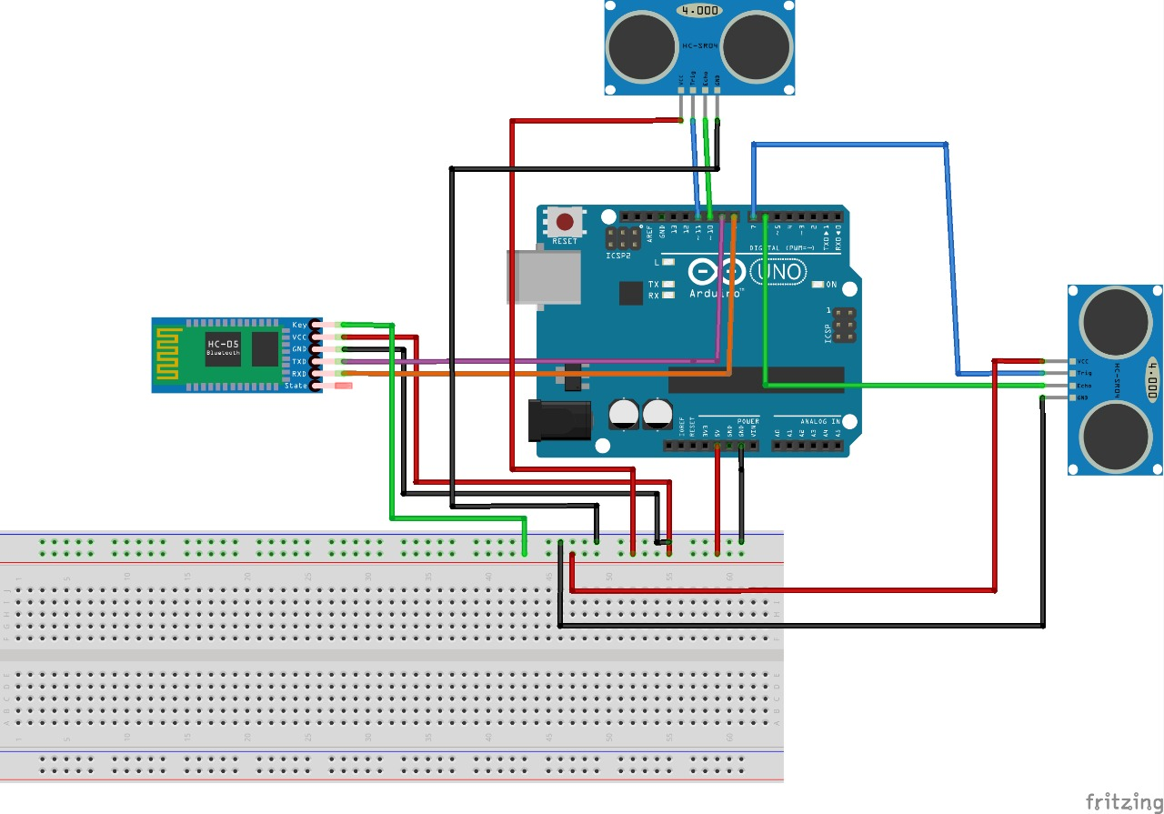**Fig 4.2** Circuit connections

## 4.3. Flow Diagram

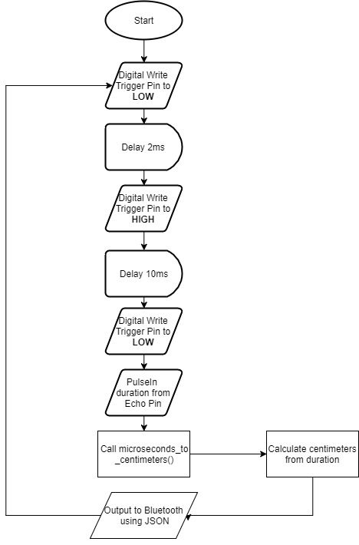

**Fig 4.3:** Flow of control of the application code

## 4.4. Flow Diagram of the Android Application

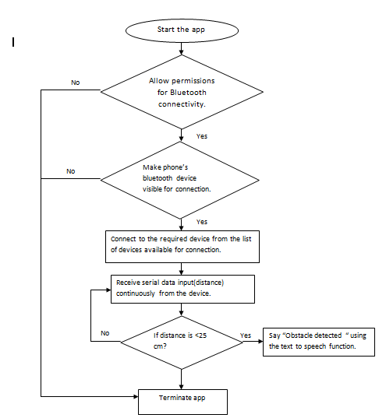

**Fig 4.4:** Flow of control of the Android application

RESULTS/SNAPSHOTS

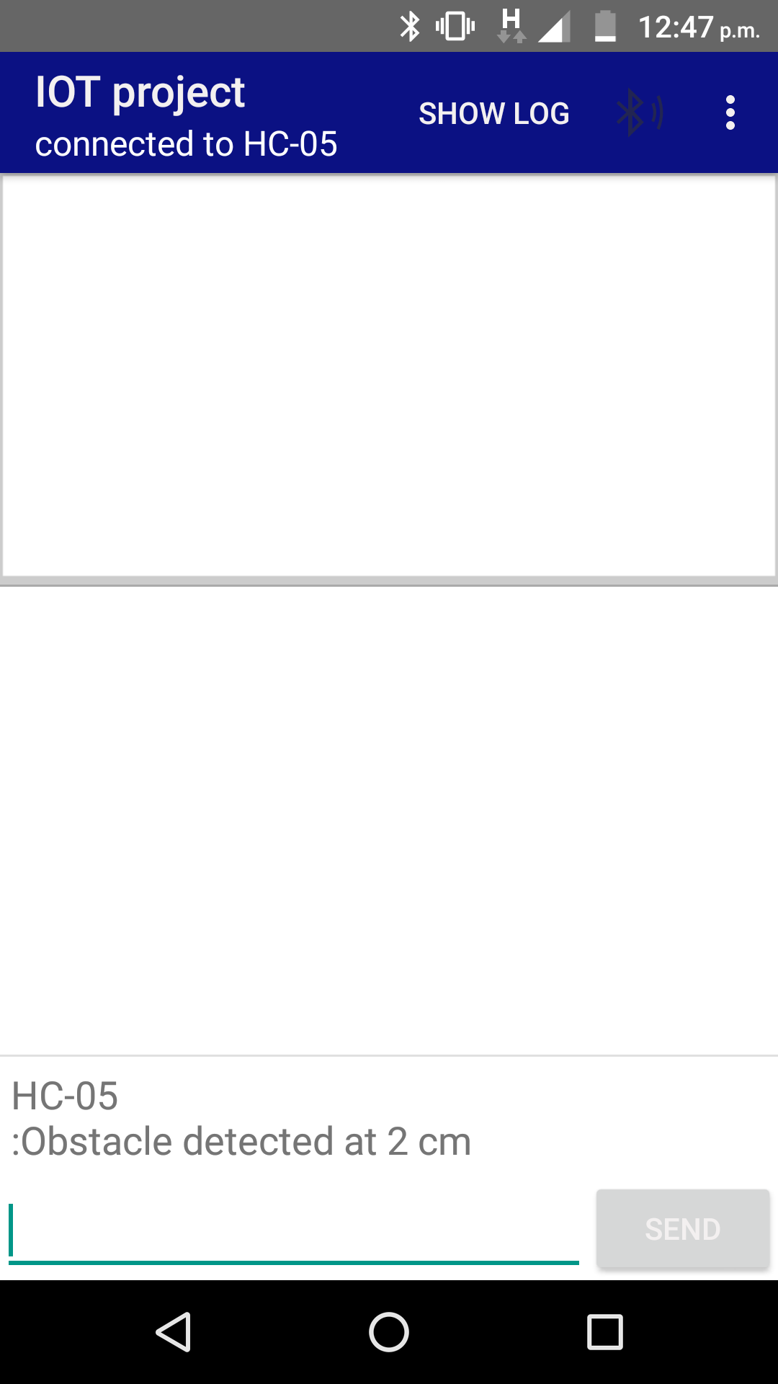

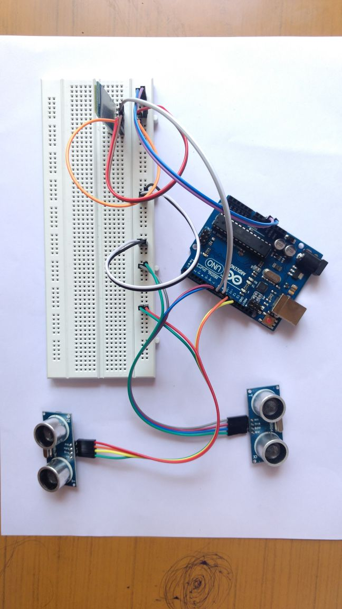

**CONCLUSIONS**

There is no better pleasure than the realization of a noble idea. Our project strives to make the world a better place for the visually impaired and aid them in their day to day activities. The first working prototype of this project has been developed which implements the basic functionality of an obstacle detection unit. The idea is to incorporate a navigational aid as well as a pit detection system in this project. We also aim to improve the user interface by adding tactile responses which will be a better solution.

# BIBLIOGRAPHY

|  |  |
| --- | --- |
| [1] | J. B. a. Y. K. Shraga Shoval, “Mobile Robot Obstacle Avoidance in a Computerized Travel Aid for the Blind,” *IEEE Transactions on Biomedical Engineering,* vol. 45, no. 11, pp. 1376 - 1386, 1998. |
| [2] | P. G. K. D. Kiran G Vetteth, “Collision Avoidance Device For Visually Impaired,” *International Journal of Scientific& Technology Research Volume 2,* pp. 185-188, October 2013. |
| [3] | M. H. John S Zelek, “Wearable tactile navigation system”. United States of America Patent US20130218456 A1, August 2013. |
| [4] | S. R. a. J. Sharf, “The people sensor: a mobility aid for the visually impaired,” in *Proceedings of the 1998 Digest of Papers 2nd International Symposium on Wearable Computers*, 1998. |
| [5] | S. H. S. M. D. M. Q. P. C. K.-G. N. Chandrasekaran, “Visual Impairment Predicts Poor Physical Functioning among Middle-Aged Women,” *Innovation in Aging,* vol. 1, no. 1, p. 1124, 2017. |
| [6] | B. K. A. K. a. S. S. E. Milios, “Sonification of range information for 3-D space perception,” *IEEE Transactions on Neural Systems and Rehabilitation Engineering,* vol. 11, no. 4, p. 416–421, 2003. |
| [7] | K. S. a. K. Y. K. Magatani, “Development of the navigation system for the visually impaired by using optical beacons,” in *Proceedings of the 23rd Annual International Conference of the IEEE Engineering in Medicine and Biology Society*, 2001. |
| [8] | P. B. L. Meijer, “An experimental system for auditory image representations,” *IEEE Transactions on Biomedical Engineering,* vol. 39, no. 2, p. 112–121, 1992. |
| [9] | N. G. B. a. D. Kavraki, “An intelligent assistant for navigation of visually impaired people,” in *Proceedings of the 2001 IEEE 2nd International Symposium on Bioinformatics and Bioengineering Conference*, 2001. |
| [10] | R. N. a. S. Y. G. Sainarayanan, “Fuzzy image processing scheme for autonomous navigation of human blind,,” *Applied Soft Computing Journal,* vol. 7, no. 1, pp. 257-264, 2007. |
| [11] | J. X. F.-l. B. a. L.-H. Z. Z.-G. Fang, ““AudioMan: design and implementation of environmental information data mapping,” *Chinese Journal of Ergonomics,* vol. 2, 2007. |
| [12] | J. R. Z. L. M. Nie, “SoundView: an auditory guidance system based on environment understanding for the visually impaired people,” in *Proceedings of the 31st Annual International Conference of the IEEE Engineering in Medicine and Biology Society: Engineering the Future of Biomedicine (EMBC '09)*, 2009. |