**Develop vector auto regression model for multivariate time series data forecasting**

**EX.No:10**

**DATE:**

**AIM:**

The goal of the AutoReg (AR) model is to use past values of a time series to forecast its future values. The AR model uses the principle of autocorrelation, where future values are predicted as a linear function of their previous values.

**ALGORITHM:**

1. Load and preprocess data by converting the date column to datetime format and handling missing values (e.g., forward fill or interpolation).
2. Visualize electric production over time using a time series line plot to observe trends and patterns.
3. Fit an ARIMA model to the data by selecting appropriate order (p, d, q) for autoregressive, differencing, and moving average components.
4. Forecast electric production for the next 12 months using the fitted ARIMA model.
5. Visualize actual and forecasted values with a combined line plot to compare model performance.

**CODE:**

import numpy as np

import pandas as pd

from statsmodels.tsa.ar_model import AutoReg

from sklearn.model_selection import train_test_split

import matplotlib.pyplot as plt

np.random.seed(42)

n = 100

time = pd.date_range(start='2023-01-01', periods=n, freq='D')

IPG2211A2N = np.random.normal(loc=500, scale=50, size=n)

data = pd.DataFrame({

'IPG2211A2N': IPG2211A2N

}, index=time)

train_data, test_data = train_test_split(data, test_size=0.2, shuffle=False)

model = AutoReg(train_data['IPG2211A2N'], lags=15)

model_fitted = model.fit()

forecast_steps = len(test_data)

forecast = model_fitted.predict(start=len(train_data), end=len(train_data) + forecast_steps - 1)

forecast_df = pd.DataFrame(forecast, index=test_data.index, columns=['IPG2211A2N'])

plt.figure(figsize=(12, 6))

plt.plot(data['IPG2211A2N'], label='Actual IPG2211A2N', color='blue')

plt.plot(forecast_df['IPG2211A2N'], label='Forecasted IPG2211A2N', color='red', linestyle='--')

plt.legend()

plt.title('IPG2211A2N Forecast using AR Model')

plt.xlabel('Date')

plt.ylabel('IPG2211A2N')

plt.show()

print(forecast_df)

**OUTPUT:**

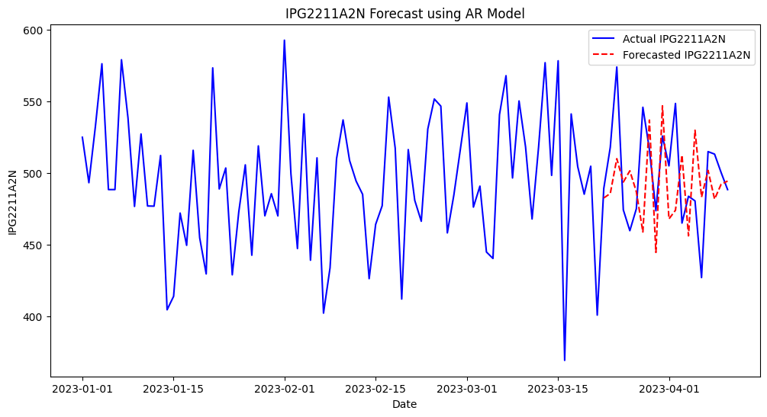

**RESULT:**

Thus the program has been completed and verified successfully.