**Implement Program To Check Stationary of A Time Series**

**EX.No:3**

**DATE: 25/01/2**

**AIM:**

To analyze the stationarity of a time series dataset using the Augmented Dickey-Fuller (ADF) test and visualize the data.

**ALGORITHM:**

1. Load and preprocess the dataset by converting the date column to a datetime format and setting it as the index.
2. Perform the Augmented Dickey-Fuller (ADF) test to check the stationarity of the time series data.
3. Interpret ADF test results using statistical values such as the ADF statistic and p-value.
4. Visualize the original time series to understand trends and patterns over time.
5. Identify the presence of trends or seasonality that may affect stationarity.
6. Provide insights for further time series modeling, such as whether differencing or transformations are required.

**CODE:**

import pandas as pd

import matplotlib.pyplot as plt

import seaborn as sns

from statsmodels.tsa.stattools import adfuller

file_path = "/mnt/data/Electric_Production.csv"

df = pd.read_csv(file_path)

df['DATE'] = pd.to_datetime(df['DATE'])

df.set_index('DATE', inplace=True)

result = adfuller(df['IPG2211A2N'])

print(f"ADF Statistic: {result[0]:.4f}")

print(f"p-value: {result[1]:.4f}")

df.plot(figsize=(10, 5), title='Electric Production Over Time')

plt.xlabel('Year')

plt.ylabel('Production Value')

plt.grid(True)

plt.show()

**OUTPUT:**

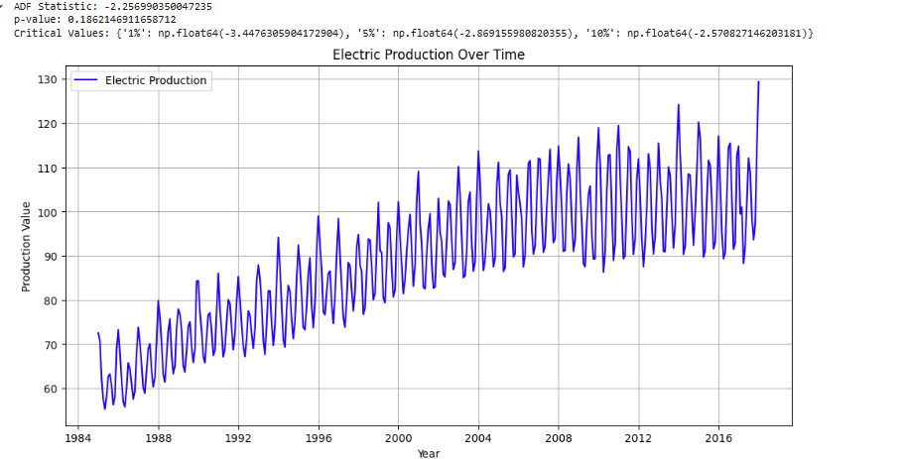

**RESULT:**

Thus the program has been completed and verified successfully.