**Implement Program For Estimating And Eliminating Trends In Time Series Data**

**EX.No:3**

**DATE: 25/01/2**

**AIM:**

To analyze, estimate, and remove the trend from a time series dataset for stationarity assessment and visualization.

**ALGORITHM:**

1. Load the dataset and convert the DATE column to datetime format.
2. Set the Date column as the index.
3. Apply the Augmented Dickey-Fuller (ADF) test to check for stationarity.
4. Compute the moving average over a 12-month window to estimate the trend.
5. Detrend the data by subtracting the moving average from the original series.
6. Plot the original time series with the estimated trend.
7. Plot the detrended time series.

**CODE:**

import pandas as pd

import matplotlib.pyplot as plt

import seaborn as sns

from statsmodels.tsa.stattools import adfuller

file_path = "/content/Electric_Production.csv"

df = pd.read_csv(file_path)

df['DATE'] = pd.to_datetime(df['DATE'])

df.set_index('DATE', inplace=True)

result = adfuller(df['IPG2211A2N'])

print("ADF Statistic:", result[0])

print("p-value:", result[1])

print("Critical Values:", result[4])

window_size = 12

df['Moving_Avg'] = df['IPG2211A2N'].rolling(window=window_size).mean()

df['Detrended'] = df['IPG2211A2N'] - df['Moving_Avg']

plt.figure(figsize=(12, 6))

plt.plot(df.index, df['IPG2211A2N'], label='Original', color='blue', alpha=0.5)

plt.plot(df.index, df['Moving_Avg'], label=f'{window_size}-Month Moving Average', color='red')

plt.title('Original Time Series and Estimated Trend')

plt.xlabel('Year')

plt.ylabel('Production Value')

plt.legend()

plt.grid(True)

plt.show()

plt.figure(figsize=(12, 6))

plt.plot(df.index, df['Detrended'], label='Detrended Data', color='green')

plt.title('Detrended Time Series')

plt.xlabel('Year')

plt.ylabel('Production Value (Detrended)')

plt.legend()

plt.grid(True)

plt.show()

**OUTPUT:**

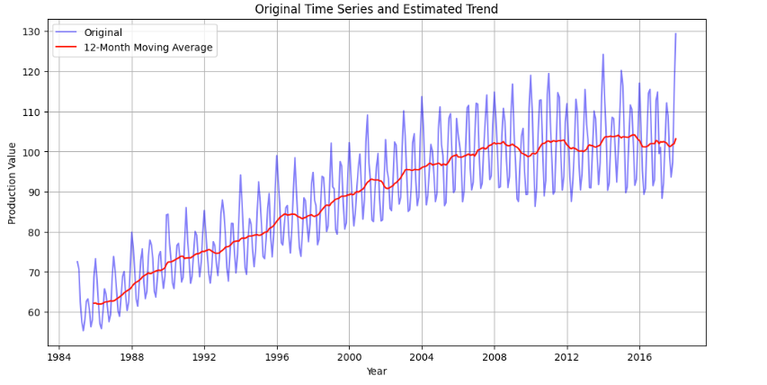

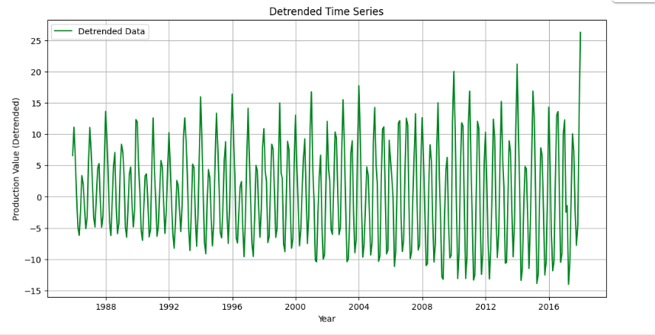

**RESULT:**

Thus the program has been completed and verified successfully.