**Create an ARIMA model for time series forecasting**

**EX.No:8**

**DATE:**

**AIM:**

To implement an ARIMA (AutoRegressive Integrated Moving Average) model in Python for forecasting future values of electric production based on historical time series data.

**ALGORITHM:**

1. Load and preprocess data (datetime conversion, missing value handling).
2. Visualize electric production over time using a time series line plot.
3. Fit an ARIMA model to the time series data with specified order (p, d, q).
4. Forecast electric production for the next 12 months using the fitted model.
5. Visualize actual and forecasted values using a combined line plot.
6. Interpret forecast results to understand future trends in electricity production.

**CODE:**

import pandas as pd

import matplotlib.pyplot as plt

from statsmodels.tsa.arima.model import ARIMA

from pandas.plotting import register_matplotlib_converters

import warnings

warnings.filterwarnings("ignore")

register_matplotlib_converters()

df = pd.read_csv("Electric_Production.csv")

df['DATE'] = pd.to_datetime(df['DATE'])

df.set_index('DATE', inplace=True)

plt.figure(figsize=(12, 6))

plt.plot(df, label='Electric Production')

plt.title('Electric Production Over Time')

plt.xlabel('Date')

plt.ylabel('Production')

plt.legend()

plt.grid(True)

plt.tight_layout()

plt.show()

model = ARIMA(df, order=(5, 1, 0))

model_fit = model.fit()

forecast = model_fit.forecast(steps=12)

plt.figure(figsize=(12, 6))

plt.plot(df, label='Observed')

plt.plot(forecast.index, forecast, color='red', label='Forecast (Next 12 months)')

plt.title('Electric Production Forecast using ARIMA(5,1,0)')

plt.xlabel('Date')

plt.ylabel('Production')

plt.legend()

plt.grid(True)

plt.tight_layout()

plt.show()

**OUTPUT:**

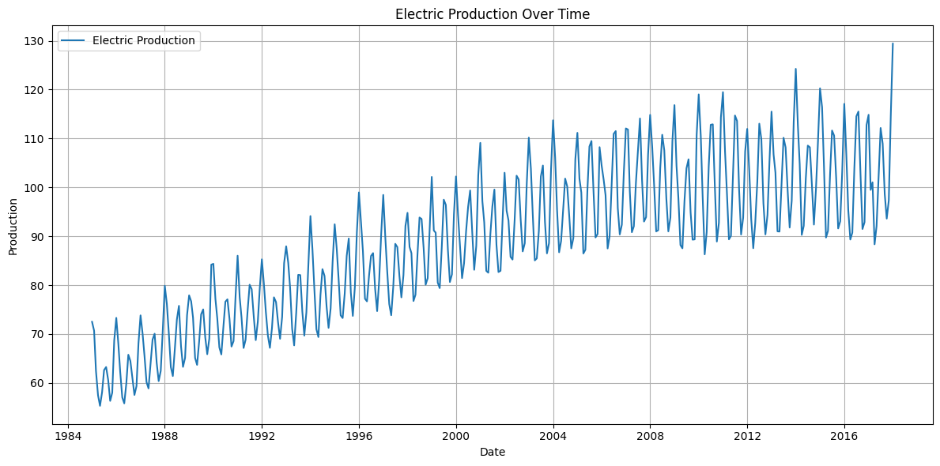

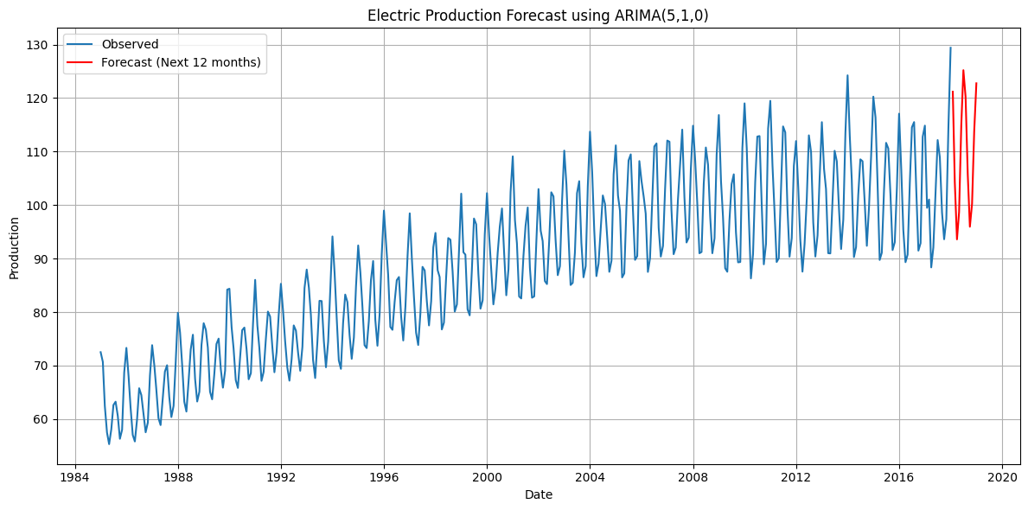

**RESULT:**

Thus the program has been completed and verified successfully.