Implement program to apply moving average smoothing for data preparation and time series forecasting
EX:No.6
DATE:29/03/25

AIM:
To implement a time series forecasting system for electric production data by applying moving average smoothing for data preparation and using the ARIMA model to predict future values. The goal is to enhance forecasting accuracy by reducing noise in the data and modeling the temporal patterns effectively.

ALGORITHM:

- Import required libraries (pandas, numpy, matplotlib, statsmodels) for data handling, visualization, and modeling.
- Load the electric production dataset, convert the date column to datetime format, and set it as the index.
- Handle missing or duplicate data by filling missing values and removing duplicates if any.
- Apply moving average smoothing on the target column using a 12-month rolling window to reduce short-term noise.
- Check for stationarity using the Augmented Dickey-Fuller (ADF) test and apply differencing if the series is non-stationary.
- Fit an ARIMA model to the processed data and forecast future values, then visualize the original, smoothed, and forecasted results using plots.

CODE:

import pandas as pd
import matplotlib.pyplot as plt
from statsmodels.tsa.arima.model import ARIMA
from statsmodels.tsa.stattools import adfuller
from pandas.tseries.offsets import DateOffset
df = pd.read_csv("Electric_Production.csv")
df['DATE'] = pd.to_datetime(df['DATE'])
df.set_index('DATE', inplace=True)
df['Smoothed'] = df['IPG2211A2N'].rolling(window=12).mean()
plt.figure(figsize=(14, 6))
plt.plot(df['IPG2211A2N'], label='Original Data', alpha=0.6)
plt.plot(df['Smoothed'], label='12-Month Moving Average (Smoothing)', color='red')
plt.title('Electric Production: Original vs Moving Average Smoothing')
plt.xlabel('Date')
plt.ylabel('Production Index')
plt.legend()
plt.grid(True)
plt.tight_layout()
plt.show()

adf_result = adfuller(df['IPG2211A2N'].dropna())
model = ARIMA(df['IPG2211A2N'], order=(1, 1, 1))
model_fit = model.fit()
forecast_steps = 12
forecast = model_fit.get_forecast(steps=forecast_steps)
forecast_index = [df.index[-1] + DateOffset(months=i) for i in range(1, forecast_steps + 1)]
forecast_df = pd.DataFrame({
'Forecast': forecast.predicted_mean,
'Lower CI': forecast.conf_int().iloc[:, 0],
'Upper CI': forecast.conf_int().iloc[:, 1]
}, index=forecast_index)
plt.figure(figsize=(14, 6))
plt.plot(df['IPG2211A2N'], label='Original Data')
plt.plot(forecast_df['Forecast'], label='ARIMA Forecast (12 months)', color='green')
plt.fill_between(forecast_df.index, forecast_df['Lower CI'], forecast_df['Upper CI'], color='green', alpha=0.2)
plt.title('Electric Production Forecast using ARIMA (after Moving Average Smoothing)')
plt.xlabel('Date')
plt.ylabel('Production Index')
plt.legend()
plt.grid(True)
plt.tight_layout()
plt.show()

OUTPUT:

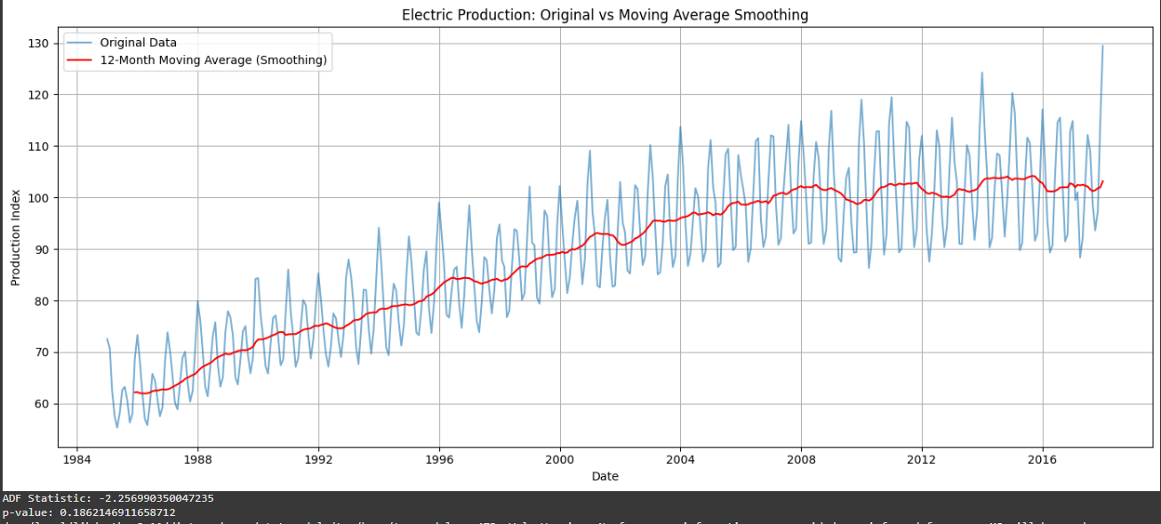
RESULT:
Thus, the program using the time series data implementation has been done successfully.

