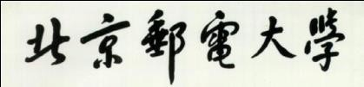

For examiners’ use only

EBU5403 A
1
2
3
4
Total

Joint Programme Examinations 2019/20

EBU5403 Internet Protocols Paper A
Time allowed 2 hours Answer ALL questions

Complete the information below about yourself very carefully.
QM student number
BUPT student number
Class number

NOT allowed: electronic calculators and electronic dictionaries.

INSTRUCTIONS
- You must NOT take answer books, used or unused, from the examination room.
- Write only with a black or blue pen and in English.
- Do all rough work in the answer book – do not tear out any pages.
- If you use Supplementary Answer Books, tie them to the end of this book.
- Write clearly and legibly.
- Read the instructions on the inside cover.
Examiners
Michael Chai, Cunhua Pan

Copyright © Beijing University of Posts and Telecommunications & © Queen Mary University of London 2019
Filename: 1920_EBU5403_A No answer book required

Instructions

Before the start of the examination

- Place your BUPT and QM student cards on the corner of your desk so that your picture is visible.

- Put all bags, coats and other belongings at the back/front of the room. All small items in your pockets, including wallets, mobile phones and other electronic devices must be placed in your bag in advance. Possession of mobile phones, electronic devices and unauthorised materials is an offence.

- Please ensure your mobile phone is switched off and that no alarm will sound during the exam. A mobile phone causing a disruption is also an assessment offence.

- Do not turn over your question paper or begin writing until told to do.

During the examination

- You must not communicate with or copy from another student.

- If you require any assistance or wish to leave the examination room for any reason, please raise your hand to attract the attention of the invigilator.

- If you finish the examination early you may leave, but not in the first 30 minutes or the last 10 minutes.

- For 2 hour examinations you may not leave temporarily.

- For examinations longer than 2 hours you may leave temporarily but not in the first 2 hours or the last 30 minutes.

At the end of the examination

- You must stop writing immediately – if you continue writing after being told to stop, that is an assessment offence.

- Remain in your seat until you are told you may leave.

Question 1

  - The following are all sources of delay in IP networks. Briefly describe each (without using equations).

    - Nodal processing

    - Queueing delay

    - Transmission delay

    - Propagation delay

[4 marks]

(1 marks)

(1 marks)

(1 marks)

(1 marks)

Do not write in this column
i) Nodal processing is the time taking to determine output link, and it is mainly used to check bit errors. Usually the delay caused by this process will be smaller than 1 ms.
ii) Queueing delay is the time waiting at output link for transmission behind other packets, because sometimes packet arrival rate to link exceeds output link capacity, so that packet should queue and wait for turn. The time of queueing delay mainly depends on congestion level of router.
iii) Transmission delay is the time a router takes to write the bits from a packet into an outgoing optical fiber. And it is related to packet length (bits) and link bandwidth (bps).
iv) Propagation delay is the time it takes packets to travel down an optical fiber to the next router. And it is related to physical link length and propagation speed.
4
marks

  - A network link has a capacity of 2Gb/s. The delay is 50ms. Packets are 1500bytes. Assuming no packets are ever lost and the major delay is just propagation:

[4 marks]
    - What is the throughput if a protocol sends 1 packet and waits for a ACK before sending the next?

    - What is the throughput if a protocol sends packets in batches of 100?

(2 marks)

(1 mark)

    - What is the utilisation of the link in the second case?

(1 mark)

Do not write in this column
i) T = 50ms
L = 1500 bytes = 1500 * 8 = 12000 bits.
The throughput = 12000 bits / T = 240 Kbps
ii) we know that when a protocol sends packets in batches of 100,
It means that by using the same total time, the length of packets enlarges to 1200000 bits.
Therefore, the throughput = 1200000 bits / T = 24000 Kbps = 24 Mbps = 0.024 Gbps
iii) utilization = 0.024 / 2 = 0.012
4
marks

  - Say whether the following are features of TCP/UDP or both:

    - Retransmission of lost packets.

    - A checksum to enable detection and discard of corrupted packets

    - Connectionless sockets.

[6 marks]

(1 mark)

(1 mark)

(1 mark)

    - Multiplexing and demultiplexing of connections from and to individual application sockets

(1 mark)

    - A port number in the header.

    - Reliable in order transmission of packets.

(1 mark)

(1 mark)

Do not write in this column
i) TCP
ii) both
iii) UDP
iv) TCP
v) both
vi) TCP
6
marks

  - Draw a diagram that shows how a packet at the application layer is sent via UDP/IP and the MAC layer across a physical network. Show which headers it adds at which layer (no need to add trailers) and how the packet is sent back up again to the application layer at the other end.

[6 marks]

Do not write in this column
(c)
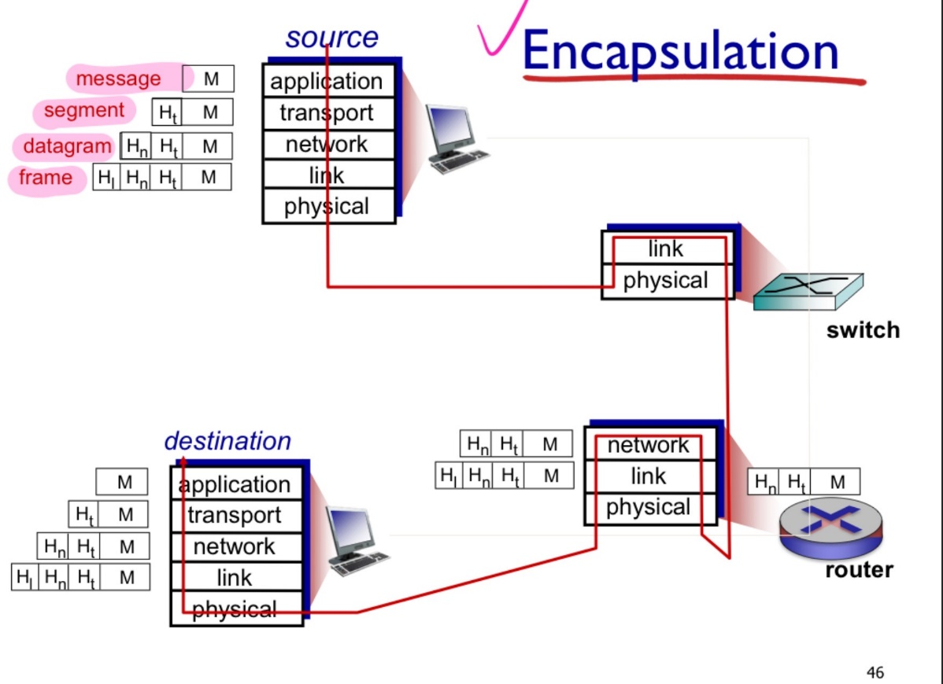
6
marks

  - Name (not just give the number) the layer of the OSI/ISO model responsible for:

    - Ensuring packets are delivered to the correct address within a sub-network.

    - Multiplexing packets from different applications into the network.

    - Ensuring a stream of packets arrive in the correct order if this is required.

    - Carrier Sense Multiple Access/Collision Avoidance.

    - Translating the HTTP protocol.

[5 marks]

(1 mark)

(1 mark)

(1 mark)

(1 mark)

(1 mark)

Do not write in this column
i) data link layer
ii) transport layer
iii) transport layer
iv) data link layer
v) application layer
5
marks

Question marking: 4 + 4 + 6 + 6 + 5 = 25

Question 2

- Compared with rdt2.2, what new issue is rdt 3.0 attempting to handle and what new mechanism is introduced in rdt 3.0?

[2 marks]

Do not write in this column
Handle the loss of packets (data, ACKs), which means packet doesn’t arrive at all.
Introduce timeout, which means sender will wait reasonable amount of time for ACK, if no
ACK received in this time, the sender will retransmit the packet. If the packet just delayed, not
Lost, the retransmission will be duplicate, but the receiver can discard and drop the duplicates.
In order to achieve this goal, the receiver specifies sequence number of packet being ACKed.
2
marks

- Assume there is a 500 byte long packet transmitting over a 5Mb/s connection relying on rdt 3.0. The one-way delay over the connection is 10 ms.

  - What are the throughput in bits/sec and utilisation if there are no losses?

[4 marks]

(2 marks)

  - What are the throughput in bits/sec and utilisation for the same connection using Go-Back- N with a window size 10 with no losses?

(2 marks)

 | Do not write in this column
i) RTT = one-way delay * 2 = 20 ms
L = 500 bytes = 4000 bits
R = 5 Mb/s
Transmission delay = L/R = 4000 bits / 5 Mb/s = 0.8 ms
Total time = RTT + L/R = 20.8 ms
Throughput = 4000 bits / 20.8 ms = 192.3 kbps
Utilization = (L/R) / (total time) = 0.0385
ii) throughput = 10*4000 / total time = 1923 kbps
Utilization = 10 * 0.0385 = 0.385 |  | 4  marks

- What are the purposes of TCP fast retransmission, TCP flow control and TCP congestion control?

[6 marks]

 | Do not write in this column
TCP fast retransmission:
Sometimes the time-out period often relatively long, which means there is a long delay before
Resending lost packet. In that case, the transmission efficiency will be quite low. To deal with
this, TCP fast retransmission utilize duplicate ACKs to detect lost segments, and regulates that
if sender receive 3 ACKs for same data, don’t wait for timeout and just send data. Therefore,
The transmission will be smoother and make use of time effectively.
TCP flow control:
In fact, sometimes if the sender is more powerful than the receiver, there will be too much data
In the buffer so that the receiver cannot handle it and remove some data from TCP socket buffers.
This will cause a serious loss of data and spend lots of cost during useless transmission.
Therefore, in flow control, the receiver defines free buffer space to sender, to control and limit the sender from overrunning the capacity. In this way, data items won’t be discarded at receiver side.
TCP congestion control:  Sometimes too many sources send too much data too fast for network simultaneously, so that the network cannot handle so many data, and lead to packets loss and long delays. In order to prevent this, the congestion control let sender increase transmission rate slowly, probing for usable bandwidth, until loss occur and do multiplicative decrease. In this way, the number of lost packets can decrease. |  | 6  marks

- The following table represents prefixes and exits in a longest prefix first matching table. The slash after the prefix represent the length of the match

[5 marks]

Prefix | Link Interface
129.130.0.0/15 | 0
129.128.0.0/9 | 1
129.130.128.0/17 | 2
129.129.0.0/17 | 2
129.192.0.0/10 | 3
otherwise | 0

Which link interface will packets with the following destination IPs be forwarded to (0, 1, 2 or 3)? i) 129.129.7.6
ii) 2.3.4.9
iii) 129.204.126.144
iv) 129.129.129.129
v) 129.130.132.129

Do not write in this column
i) 2
ii) 0
iii) 3
iv) 1
v) 2
5
marks

- An organisation is granted a classless range 122.125.192.0/20 IP addresses. The administrator wants to create 4 subnets: subnet #1 with 1500 hosts, #2 with 500 hosts, #3 with 28 hosts and #4 with 12 hosts. Assume that very little future growth of the organisation will take place and that variable- length subnet masking (VLSM) is supported. Allocate the largest subnets earliest in the range.

[8 marks]

  - Calculate the network addresses (in slash notation) of the four subnets in dotted decimal notation.

  - Find the address ranges in each subnet.

  - Find the first valid host address and the directed broadcast address for subnet #3.

(4 marks)

(2 marks)

(2 marks)

Do not write in this column
i) subnet 1 needs 11 bits host
Subnet 2 needs 9 bits host
Subnet 3 needs 5 bits host
Subnet 4 needs 4 bits host
Subnet 1: 122.125.192.0/21
Subnet 2: 122.125.200.0/23
Subnet 3: 122.125.202.0/27
Subnet 4: 122.125.202.32/28
ii) range:
Subnet 1: 122.125.192.0 – 122.125.199.255
Subnet 2: 122.125.200.0 – 122. 125. 201.255
Subnet 3: 122.125.202.0 – 122. 125.202.31
Subnet 4: 122.125.202.32 – 122.125.202. 47
iii) first valid host address: 122.125.202.1
Broadcast: 122. 125.202.31
8
marks

Question marking: 2 + 4 + 6 + 5 + 8 = 25

Question 3
- List 3 characteristics of the distant vector routing and 3 characteristics of the link state routing.

[6 marks]

Do not write in this column
Distant vector:
1. router knows physically-connected neighbors, link costs to neighbors.
2. routes change quickly and dynamically in response to link cost changes.
3. iterative, asynchronous, and distributed.
Link state:
1. all routers have complete topology, link cost information.
2. compute least cost paths from one node to all other nodes.
3. iterative.
6
marks

- With reference to the topology shown in Figure 1, use Dijkstra’s algorithm to generate the Shortest Path Tree originating from router U and use it to construct the corresponding routing table. It is important to clearly show how you arrived at your answer.
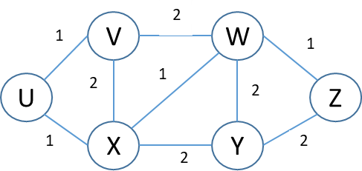
Figure 1

[9 marks]

U’  “known”  nodes | D(V)  p(V) | D(W)  p(W) | D(X)  p(X) | D(Y)  p(Y) | D(Z)  p(Z)
U | 1, U | -- | 1, U | -- | --
UX | 1, U | 2, X | 1, U | 3, X | --
UXV | 1, U | 2, X | 1, U | 3, X | --
UXVW | 1, U | 2, X | 1, U | 3, X | 3, W
UXVWY | 1, U | 2, X | 1, U | 3, X | 3, W
UXVWZ | 1, U | 2, X | 1, U | 3, X | 3, W

Do not write in this column
Fill out your answer in the provided table
(note the table may have more lines than you need)
9
marks

- Software Defined Networking with OpenFlow

  - What is “match-action” in OpenFlow?

[10 marks]

(4 marks)
  - Briefly describe the differences between the routing using match-action in Open Flow and the traditional routing using a link-state protocol.

(6 marks)

Do not write in this column
i) match means matching values in packet header fields, such as destination MAC address, IP address, TCP/UDP port numbers, etc.
Action means for matched packet: drop, forward, modify matched packet or send matched
packet to controller according to the match results.
In this way, different kinds of devices can become one, meaning that the OpenFlow can have various functions as router, switch, firewall and NAT, then let the data plane becomes more flexible.
ii)
a. different actions
Traditional routing is seen as router to forward out a link;
Match-action routing can do many things like dropping, modifying, not just forwarding.
Different process rule:
Traditional routing uses longest destination IP prefix to forward.
Match-action routing uses destination MAC address, IP address, TCP/UDP port numbers, etc. to match. And the algorithm can be programed by ourselves.
Own different tables:
Traditional routing uses forwarding table for each node describing destination and link.
Match-action routing contains flow table for each router describing headers, counters, and actions. And the table is computed and distributed by a logically centralized routing controller.

10
marks

Question marking: 6 + 9 + 10 = 25

Question 4

- Host A has host B’s IP address and wishes to know its MAC (layer 2) address.

  - Name the protocol used.

[6 marks]

(2 marks)

  - Give (in brief) the steps needed for host A to get a reply from B stating which steps are broadcast and which unicast.

  - How will A avoid having to always ask B for its MAC address?

(4 marks)

(1 mark)

 | Do not write in this column
i) the address resolution protocol
ii) A sends out an ARP query packet within a broadcast ethernet frame to MAC address
(FF-FF-FF-FF-FF-FF)
B receives the query packet and sends to Host A a unicast ARP response packet. This ARP
Response packet is carried by a frame with MAC destination address (B’s MAC address).
iii) create an ARP table to link IP address to B’s MAC address until information becomes old. |  | 7  marks

- These questions are about CSMA/CD

  - What does this stand for?

  - Describe (briefly) why CSMA/CD requires frames to have a minimum size.

[15 marks]

(2 marks)

(5 marks)

  - Calculate the size of this minimum frame in bytes, given a maximum one-way propagation delay of 25ms and a bit-rate of 8Mbps.

  - Briefly, why is CSMA/CD most suitable for wired, not wireless environments.

(6 marks)

(2 marks)

Do not write in this column
i) carrier sensing, deferral as in CSMA(carrier sense multiple access)
Collisions will be detected within short time.
So colliding transmissions aborted, reducing channel wastage.
ii) If two frames are transmitted within certain time, collisions will occur. Both senders need
to detect collision. The senders only detect collision during transmission. If transmission is too
short, the sender cannot detect collision. Therefore, it has a minimum size to ensure the
transmitting station is transmitting long enough for a corrupted signal to be detected.
iii) RTT = 50 ms
Minimum frame size = 0.05s * 8,000,000 bits/sec = 400000 bits
iv) in wired environment, the CSMA/CD can measure signal strengths easily and compare the
strength between transmitted signal and received signals. If the strength of received one is higher than the transmitted one, it means there is collision. But in wireless environment, the
received signal is too weak compared with its local signal power due to the severe path loss in
wireless communications. Therefore, wireless environment can’t compare two strengths and judge where there is a collision.

15
marks

- What is meant by “stateful” and “stateless” packet filtering in a firewall?

[3 marks]

Do not write in this column
Stateless packet filtering means that router filters packet by packet and make decision
to forward or drop packet based on much information like IP address, port number, etc.
However, it will need heavy handed tool and admit some unmeaningful packets, which
means the packet entering through firewall may not have any sense and have no effect.
But for stateful packet filtering, it has the same function of the above, but it adds tracking
status of every TCP connection. For instance, it will track SYN and FIN to determine
whether incoming, outgoing packets “make sense”.
Also, if there is a timeout in inactive connections, the filtering no longer admits the packets. Therefore, the stateful packet filtering is more sophisticated than stateless packet filtering.
3
marks

Question marking: 7 + 15 + 3 = 25

Do not write in
this column
2019-2020
Rough Working
Page 20 of 22

Do not write in
this column
2019-2020
Rough Working
Page 21 of 22

Do not write in
this column
2019-2020
Rough Working
Page 22 of 22

