 |  |  | 

Joint Programme Assessments 2022/23

Answer Sheet
(To be used in conjunction with the provided alternative assessment questions and the supplementary instructions)

Complete the information below about yourself very carefully.

QM student number
  2 | 0 | 0 | 9 | 7 | 8 | 9 | 4 | 7
BUPT student number
  2 | 0 | 2 | 0 | 2 | 1 | 3 | 2 | 4 | 8
Class number
  2 | 0 | 2 | 0 | 2 | 1 | 5 | 1 | 0 | 7

Module code
  EBU5403
Word Count
  1720

“I hereby confirm that the submitted work is entirely my own and I have not (i) used the services of any agency or person(s) providing specimen, model or ghostwritten work in the preparation of the work I submit for this open book assessment; (ii) given assistance in accessing this paper or in providing specimen, model or ghostwritten work to other candidates submitting for this open-book assessment.”
Signature
  Tangxun Wu

For examiners ONLY  Do not write in this section
   | Q1 | Q2 | Q3 | Q4 |  |  | Sum
  A
  B
  C
  D
  E
  F
  TOTAL

 | Do not write in this column
  Question | 1
  Section(s) | a
i)
1100 bytes = 8800 bits
delay to first router: 8800/5,000,000= 1.76 ms
delay to first to second router: 8800/40,000,000= 0.22 ms
delay second router to server: 8800/20,000,000= 0.44 ms
so end-to-end delay = 1.76 + 0.22 + 0.44 =2.42 ms
the third packet to arrive at the server: 2.42 + (1.76*2) = 5.94 ms

ii)
from i), we know the end-to-end delay is 2.42 ms
so, the RTT = 2 * end-to-end delay = 4.84 ms

In Linux system, we can use “ss” to get RTT.
For example: the command “# ss -i 'src 1.1.1.1:1234 and dst 3.3.3.3:1234’”
will help to get the RTT from source 1.1.1.1:1234 to destination 3.3.3.3:1234.

iii)
from the diagram, we know that:
Rs = 5 Mb/s
Rc = 20 Mb/s
R/3 = 40/3 Mb/s
Therefore, the bottleneck link is “path from client to router1”,
and the bottleneck is Rs = 5 Mb/s.
the impact to network: will constrain the end-end throughput, lower the transmission efficiency, because it may lead to congestion afterwards.

 | Do not write in this column
  Question | 1
  Section(s) | b
i)
edge network: WiFi router, smartphone, hot spot, switch, BUPT gateway
core network: access router, city router, BUPT server, CERNET, backbone router

ii)
John’s smartphone: application layer, presentation layer and session layer
Backbone router: network layer
The switch in the computer lab: data link layer

 | Do not write in this column
  Question | 1
  Section(s) | c
i) the purpose of port numbers:
source port number: identify the application socket to send the data
destination port number: identify the application socket to receive the data
Therefore, the port numbers are used to identify source and destination applications.

ii)
I don’t know whether this question means choosing from TCP and UDP.
(It is, sending emails should use TCP because it can deal with error and loss then retransmit.
voice over IP should use UDP because it is loss tolerant, and it requires fast transmission in real time.)

but for specific transport protocol:
Sending an email:
SMTP: simple mail transfer protocol
because it regulates the exchange formats and the rules of transmitting via emails.

Voice over IP (real time telephone calls):
RTP/RTCP: real-time transport protocol
because it can realize video or audio communication in real time.

 | Do not write in this column
  Question | 2
  Section(s) | a
i)
too short: the packets are retransmitted needlessly, because maybe packets are delayed not lost. It will cause duplicate and lead to bandwidth waste.

ii)
too long: the connection becomes slow. The retransmission will be taken after a long time, which means the loss or corruption gets late response and reaction.

iii)
I prefer short TCP timeout.
Because when we use short TCP timeout, we can deal with the packet loss quickly, which can lead to higher efficiency and better performance.
Also, many packet loss means the short timeout won’t be unmeaningful but be good compensation.

iv)
setting a higher value:
advantage: the RTT produced will react to changes more quickly, because it contains more weight to new SampleRTT.
Disadvantages: the estimate will be less smoothed and be more fluctuate.

 | Do not write in this column
  Question | 2
  Section(s) | b
i)
for 10000 hosts: need 14 bits host
for 7000 hosts: need 13 bits host
for 253 hosts: need 8 bits host

for subnet A:
range: 132.0.0.0 - 132.0.63.255
for subnet B:
range: 132.0.64.0 - 132.0.95.255
for subnet B:
range: 132.0.96.0 - 132.0.96.255

ii)
broadcast address:
subnet A: 132.0.63.255
subnet B: 132.0.95.255
subnet C: 132.0.96.255

iii) /24 network means 8 bits host
range: 132.0.97.0 - 132.0.97.255

iv) /17 network means 15 bits host
range: 132.0.128.0 – 132.0.255.255
the problems in the future:
1. there will be so many IP addresses allocated, no more space for the new one.
2. the IP address of each subnet is not continuous and recognizable.

 | Do not write in this column
  Question | 2
  Section(s) | c
i)
I will pick go-back-N.
Because when using go-back-N to send packets in batches of N, the throughput and utilisation will increase dramatically by a factor of N.
Also, because the network has high packet loss, go-back-N can directly retransmit the whole unACKed packets to deal with this. If using selective repeat to retransmit so many loss packets, the traffic may cause congestion.

ii)
I will pick selective repeat.
Because now the computer has little processing power, the selective repeat can minimise the number of resending packets, so as to reduce the cost and power during the retransmission.
Also, it receives individual ACKs, which can accurately locate error, so that the computer doesn’t need to maintain state to each network connection.

 | Do not write in this column
  Question | 3
  Section(s) | a
i) table:
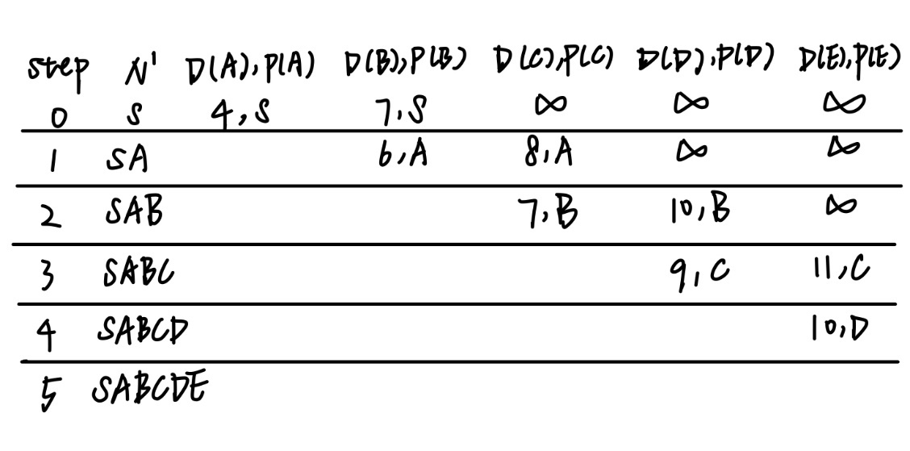
ii) shortest path from S to E:
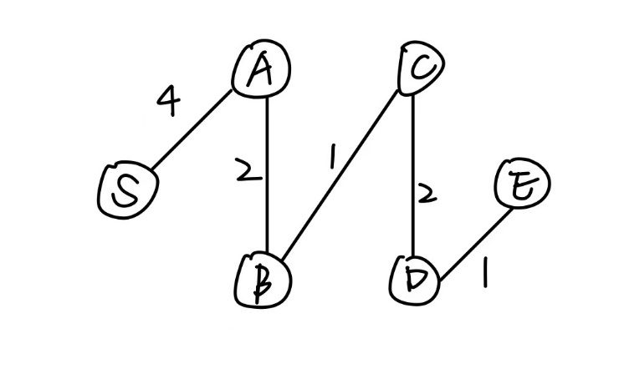

 | Do not write in this column
  Question | 3
  Section(s) | b
i)
three main motivations behind IPv6:
1. for IPv4, 32-bit address space will be completely allocated soon, so IPv6 enlarges the address length and requires less bandwidth.
2. IPv6 header formats helps to speed processing and forwarding.
3. IPv6 header changes to facilitate QoS (quality of service).

ii)
tunnelling allows IPv6 packets to move over IPv4 network, which means IPv6 datagram is carried and copied as the payload in the IPv4 datagram among IPv4 routers.

 | Do not write in this column
  Question | 3
  Section(s) | c
i)
The controller is logically centralized. It will collect information from each local router, then complete computation centrally and distribute a flow table for each router.
In the flow table, there will be headers, counters and actions, indicating different actions like dropping, modifying, etc. when matching packets through MAC address, IP address, port number, etc.
Therefore, SDN controller will maintain network state information, interact with network control applications and switches via API so as to update the information, then implemented as distributed system for performance, scalability, fault-tolerance and robustness.

ii)
southbound protocol: connects controller to switch
northbound protocol: connect controller to applications.

iii)
The flow table is equal to the forwarding table when in SDN.
The table will also utilize IP address to do forwarding as a router, which is equivalent to forwarding table.

 | Do not write in this column
  Question | 4
  Section(s) | a
i)
Slotted:
Means there is a time division which allocate time into equal size slot.
And when implementing, nodes should be transmitted only when slot beginning.
In this way, nodes are synchronized.
Also, when collision, nodes should wait until next time slot to do retransmission.
Unslotted:
Means there is not any time boundary.
Frames can transmit immediately when arriving.
In this way, nodes don’t require synchronization.
Also, when collision, nodes can retransmit immediately.

ii)
Advantage: one single active node can continuously transmit at full rate R of channel. Also, it is highly decentralized.
Disadvantage: need clock synchronization and will suffer idle slots (wasteful).

iii)
Advantages:
1. the fixed number of stations can share the same frequency.
2. we can allocate the time slot flexibly according to the number of stations.
3. it achieves access to channel in “rounds”, meaning that exchanging packets is easy.
4. have less interference.
Disadvantages:
Have limited capacity and reduced rate, which will affect transmitting quality.

 | Do not write in this column
  Question | 4
  Section(s) | b
i)
Host E creates an IP datagram containing its source IP address 192.168.3.001 and B’s IP address 192.168.1.003.
Then, the forwarding table in E determines that the datagram should be routed to 192.168.3.002, which is router2’s gateway IP.
So, A sends a frame containing the MAC address of router2 88-88-88-88-88-88 as the destination address and its source MAC address 77-77-77-77-77-77, containing the IP datagram produced above.
Then, when the frame arrives in router2, and it checks that the destination MAC address is matching its own, it extracts IP datagram first.
Then, router 2 sends a frame via router1’s MAC address 33-33-33-33-33-33 as destination MAC address and its source MAC address 55-55-55-55-55-55, containing the IP datagram extracted before.
Finally, when the frame arrives in router1, it checks that the destination MAC address is matching its own, it extracts IP datagram first.
Then, router 1 sends a frame via B’ MAC address 11-11-11-11-11-11 as destination MAC address and its source MAC address 22-22-22-22-22-22, containing the IP datagram extracted before.
After that, B will receive the packet.

ii)
In that case, host E must know the MAC address of Router 2 gateway. So E sends out an ARP query packet within a broadcast Ethernet frame to MAC address (FF-FF-FF-FF-FF-FF), and wait the response packet from Router 2 which contains its MAC address.

iii)
True.
Because for ARP query packet, the sender doesn’t know the MAC address of the receiver, so it should be sent via broadcast.
However, for the ARP response packet, the sender knows who needs this MAC address, so it just unicast this packet to the required one.

 | Do not write in this column
  Question | 4
  Section(s) | c
Need:
If two frames are transmitted within certain time, collisions will occur. Both senders need to detect collision. The senders only detect collision during transmission. If transmission is too short, the sender cannot detect collision.
Therefore, it has a minimum size to ensure the transmitting station is transmitting long enough for a corrupted signal to be detected.

Calculation:
one-way propagation delay: 1ms
RTT: 1*2 = 2 ms
Bit rate R = 100Mbps = 100,000,000 bps
Minimum frame size: RTT * R = 200000 bits

