Block 1
1. digital image: 2-dimension function f(x,y). x and y are the spatial coordinates while f is the intensity of the image at (x,y). when x, y, f are all finite, it is a digital image.
2. digital image processing focus on: improvement of visual information for human interpretation; processing of image data for storage, transmission, and representation for autonomous machine perception.
3. Laplacian filter: detect sudden intensity transitions in the image and highlight the edges
4. compression: reduce storage; reduce transmission cost/latency/bandwidth
5. inpainting: reconstruct corrupted parts of an image
6. false color image: use suitable colors to highlight edges/important areas. Get illusion information from the image. Can be medical/rainfall and temperature used. Improve recognition.
7. intelligent browsing:
--content based image retrieval: image grouped based on features
--metadata based image retrieval: image grouped based on description and data associated
Content 优点：features can be directly perceived. Better accuracy缺点：fail to group irrelevant images because of similar shape/color. Not very fast.
Metadata 优点：wide range of data 缺点：time consuming. 不一定能找到想找的
8. HDR: high dynamic range: means very bright and dark parts in a single image (very distinct intensity values). The dynamic range may exceed number of available bits to present pixels.
Solution: capture multiple images at different exposures from the same viewpoint. Then combine them using image processing.
9. panoramic distortion: the straight line appears bent. No distortion free way.
10. rendering: change the image focus.
11. depth of field: portion of a scene that appears acceptably sharp.

12. pixel: elements that have a particular location and value
13. image: x,y be spatial coordinate; they have same units; rotation and translation make sense; no special coordinate; no preferred direction.
14. Nyquist theorem
15. sampling definition:
Digitizing the coordinates values.
Divide the time axis into discrete pieces.
Measure the value of an image at a finite number of points.
16. scanline: sample per scanline, then quantize according to grey level
17. low resolution: appear blocky. Sampling rate – spatial resolution – affect accuracy.
18. adaptive sampling: higher sampling frequency in areas with greater details.
19. sampling errors: doubling resolution cannot solve. Cost 4 times memory, bandwidth and time.
20. relationship between pixels: 4-neighborhood: each neighbor shares a edge with the pixel. 8-neighborhood: each neighbor shares an edge or a corner with the pixel.
21. quantization:
Digitizing the amplitude values.
Map each value into one in a set of discrete values.
Quantization level determines the number of grey levels in the digitized image.
22. spatial resolution – sampling – sampling numbers
23. intensity resolution – how accurately a pixel’s grey level represents the brightness of the corresponding point in the original scene. – quantization
24. fewer bits to quantize intensity – cannot accurately represent the gradual intensity variations – appear abrupt discontinuities
25. dithering: add random noise – break up false contour by randomly assigning pixels to higher or lower level – cause spatial offsets -- thus juxtaposing pixels of two colors to create third color
26. halftoning: use black and white pixels – spatial averaging – to give grey scale rendition
27. non-uniform quantization: focus on important; save costs; difference cannot be observed
28. subsampling
29. up-sampling: increase resolution by generating additional pixels from available ones.
30. NN interpolation: pixels generated by nearest available pixels. 优点：simple and efficient 缺点：inaccurate; lack of details (cannot preserve fine details or subtle variations)
31. forward mapping: map input grid to output. Backward: estimate pixels at input by inversing integer output grid
32. bilinear interpolation: use 4 pixels. 适用：when looking into details about the image (intensity) interpolate on horizontal, then in vertical using obtained results.
Bilinear interpolation means estimating the value t a given 2D position (x,y) by interpolating between the surrounding values F(0,0), F(0,1), F(1,0), F(1,1).
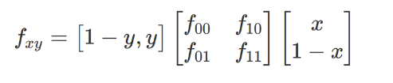
33. Fourier transform: phase more important than amplitude

34. histogram:
-- function that map the quantization level into the frequency of each level
-- count how many times each level appears
-- reflect pixel intensity distribution
35. contrast: amount of difference between average grey level and that of surrounding
36. brightness: range: brightness span of grey scale
37. low contrast: concentrate near a narrow range. High: cover a wide range. Dark: near a narrow range in dark region.
38. histogram is invariant to geometric image, because it doesn’t show spatial distribution.
39. intensity histogram of color image histogram: convert color image into grey scale, then display histogram of grey scale.
40. individual color channel histogram: 3 histograms (R, G, B)
41. histogram application: image segmentation, enhancement, and compression by changing contrast and grey level range. Economic and simple calculations.
42. equalization:
-- produce images with evenly distributed histograms without changing number of grey levels
-- don’t change pixel numbers. Change frequency.
-- map grey level into target image with even distribution of grey levels.
43. p(f) high, P(f) steep – dg is wide, and p(g) is low

Block 2
1. algebraic operations of image
Subtraction: pixel value is obtained by difference. Enhancement of difference—background subtraction, edge detection
Averaging: add uncorrelated and 0-average noise to reduce noise content – higher SNR – noise removal, HDR image
2. clipping: values exceed range of output variables.
Solution: normalization: map f [a, b] to g [c, d] -- g = c + [(f-a) / (b-a)] * (d - c)
3. geometric transformation – modify spatial arrangement by:
-- spatial transformation of coordinates
-- intensity interpolation: assign intensity values to spatially transformed pixels
4. affine transformation: preserve points, straight lines and planes.
-- collinearity
-- ratios of distance
5. scaling: enlarge or shrink
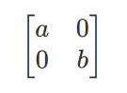
6. rotation:
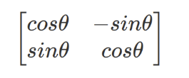
7. shear: if x = x + s*y, y = y, this means x-coordinates are shifted horizontally by an amount of s*y, while y-coordinates are unchanged.
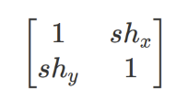
8. mirror
9. 2D translation cannot be represented with 2*2 matrix
10. homogeneous coordinates: add a dimension to working space to perform transformations using matrix. Make graphics operations much easier.
11. rotate around arbitrary point (x0, y0):
Translate from (x0, y0) to (0,0); rotate; then translate back.
12. skew: square to parallelograms, y coordinate skew to the right, 90 –> θ
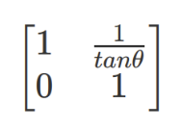
13. inverse warping:
1. loop through all destination pixels
2. find corresponding source position
3. find destination color value by interpolation in source image
14. human can distinguish 7 million color and 128 fully saturated hues.
15. HVS: less discriminating for less saturated light; less sensitive for less bright light.
-- The eye is more sensitive to changes if brightness than color.
-- The eye is unable to perceive brightness levels above or below certain thresholds
-- The eye cannot distinguish minor changes in brightness or color.
-- Certain range of brightness of color are more important visually than others (Green)
-- Sensitivity of the eye is not linear.
16. lightness: perceived intensity of a reflecting light 反射光
brightness: perceived intensity of a self-luminous object 发射光
17. radiance: amount of light source. Lightness: amount of energy. Brightness: amount of intensity
18. trichromatic theory:
-- three cones for color perception
-- any color can be produced by mixing together suitable amount of 3 colors
-- cone receptors: blue, green, red (long-wavelength)
19. retina contain photosensitive cells: -- be rod or cone
Rod: sensitive to light intensities/ luminance. Long and thin
Cones: 3 types for colors (red, green, and blue): short and thick
Rod more than cones: more sensitive to intensity.
20. Definition: specification colors in a standard way by defining a coordinate system & a subspace within the system.
--Hardware-oriented models (not intuitive)
RGB(color monitors and color video cameras)
YUV(the broadcast TV colors system)
CMY(cyan, magenta, yellow)
CMYK
--User-oriented models
HSV (hue, saturation, Value)
CIE L* a* b* (L for light, a* for green-red and b* for blue-yellow) (subsample by 1/4 a and b)
perceptually uniform
21. opponent theory: the cone-signals are re-coded as sums and differences
L = R + G + B
S = G - R
T = B - Y = B - (R + G)
22. primary and secondary color:
在RGB model里，红绿蓝是primary, CMY是secondary
在CMY model里，CMY是primary，红绿蓝是secondary
23. additive and subtractive color:
Additive: primary color of light (RGB) – light emitting – add all to white
Subtractive: primary color of pigment (CMY) – subtract one and reflect two – light absorbing – add all to black e.g., cyan: absorb red and reflect green and blue
24. CIE xy chromaticity diagram
-- spectrum color around the boundary
-- any point: mixture of spectrum color
-- line: different color variation by combing two colors
-- triangle: various combination of corner three colors
25.
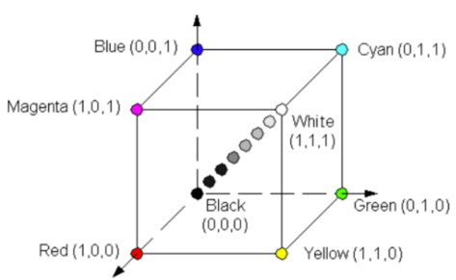
26. HSV:
H: dominate wavelength
S: color’s purity or intensity. Reflect how much white light is added.
V: how light and dark
HSV: more closely to the way humans think about color than RGB.
e.g., the same color can be lighter or darker, as well as more or less saturated.
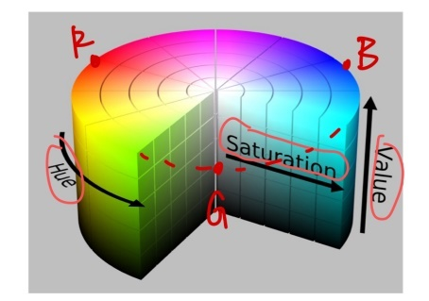
27. 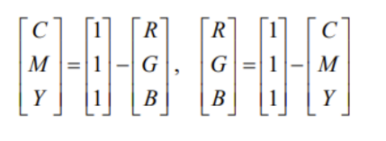
28.
P2 PGM ASCII
P3 PPM ASCII (lines no longer than 70 characters)
P5 PGM Binary
P6 PPM Binary (comments can only occur before last filed of header, only one byte after it)
NOTE1: P6 image files are smaller than P3 and much faster to read.
NOTE2: P6 image file can only be used for single byte color.
29. MSE & PSNR
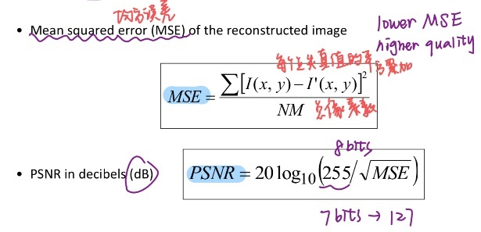
30. image enhancements:
Highlight interesting details; remove noise; make image more appealing.
31. filter: combine pixels’ value by its neighbors’ values through convolution
32. mask:
-- Mask is a small matrix whose value is weight
-- each mask has origin
-- origin of symmetric masks is central pixel position
33. linear filtering: linear combination of pixels in local neighborhood
34. convolution & correlation
Convolution: deconvolution, noise removal, feature enhancement (highpass filter)
-- it needs flipping
-- property
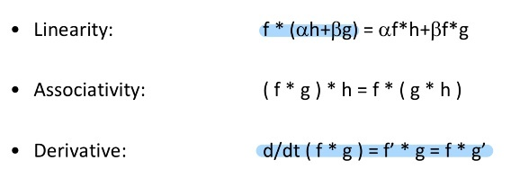
35. border problems’ solution
-- fill with zero
-- periodic extension of image
-- mirror the borders
36. filter category
-- mean filter: equal weight to neighborhood. Need for normalization. Cause severe blur.
-- Gaussian: centered weighted. Weighting values decrease exponentially.
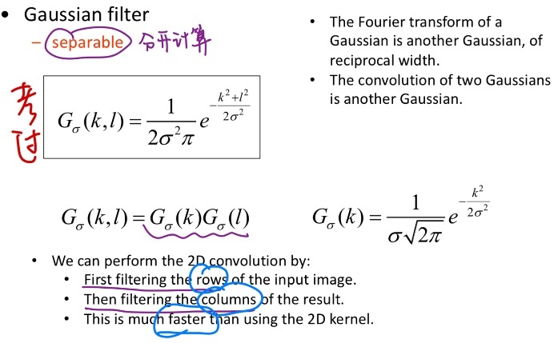
-- linear pyramidal filter: decrease linearly
-- median filter (non-linear): replace each pixel value by the median of grey-levels in the neighborhood of the pixels. Effective for removing salt and pepper noise.
Block 3
1. edge definition:
-- define the shape of objects in a scene
-- correspond to large variations in values of pixels
2. edge detection
Strategy: find points of large variations
Requirement: understand the difference between:
Variations caused by image noise
Variations caused by textures in the object
Variations caused by true edges of object
3. the intensity discontinuities locates in the maxima of 1st derivative of the image. 2nd derivative shows the edge direction.
4. gradient method:
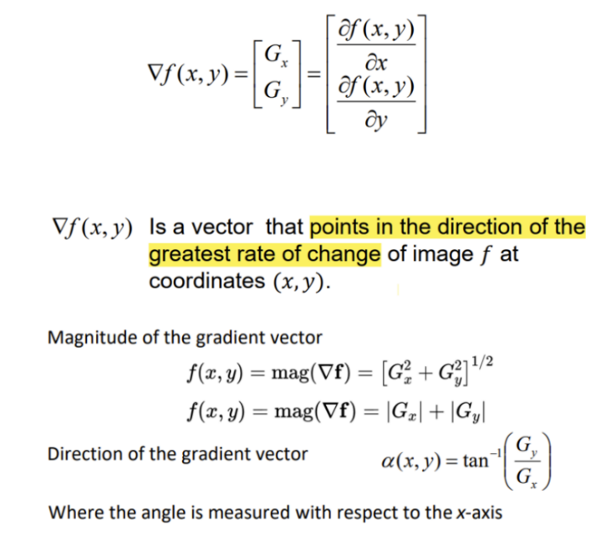
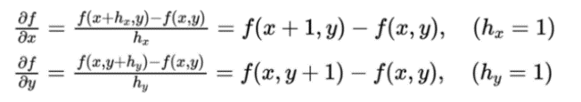
5. Laplacian method
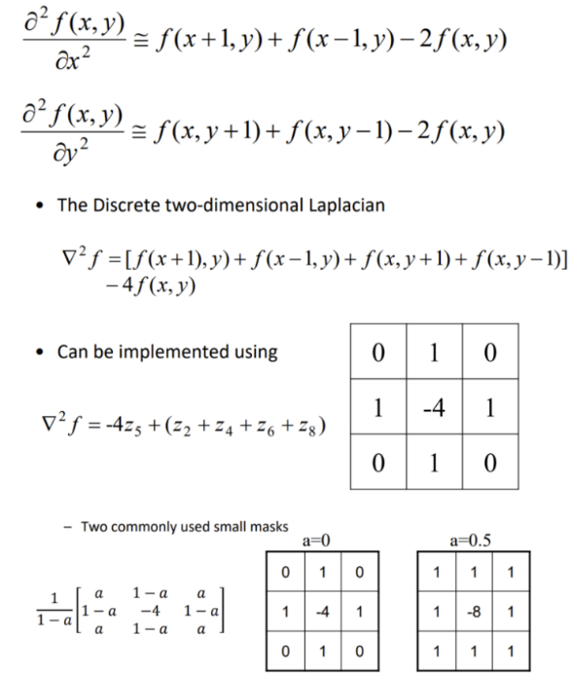
Properties:
--Isotropic operator
--(one mask) cheaper to implement
--no information about edge direction.
--Sensitive to noise
6. template methods
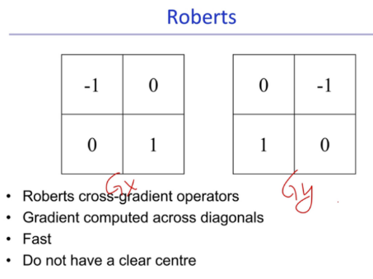
Goods: fast, smallest Problem: lack of detail, do not have a clear center. Miss reference
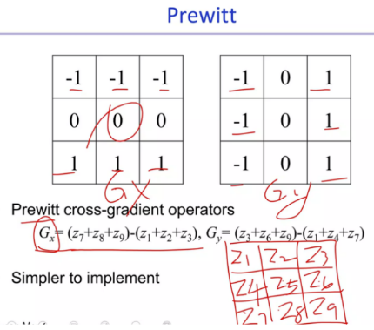
Good: more accurate. Problem: sensitive to noise. Nosier
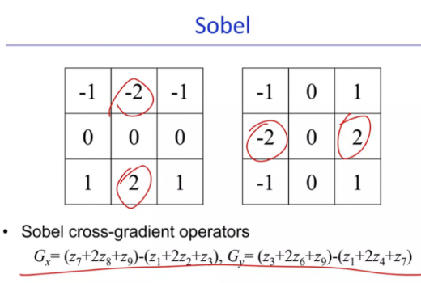
Good: pay attention to the middle one. Intense.
More accurate because it follows Gaussian profile to focus on the center.
Suppress the noise.
(block 3没整完)
Block 4
1. Color representation: 24-bit RGB system
-- 16,777,216 colors
-- 216 safe colors based on limitations on displays and operating systems. Other colors are reproduced in different ways in different systems.
2. 30-bit colors: more bits useful for post-processing
3. intensity slicing: allocating color to grey levels
-- each grey level is considered to be a different slice
-- any pixel value higher than it will be given one color
-- lower than it will be given a different value
-- on the slice will be arbitrarily assigned one of the two
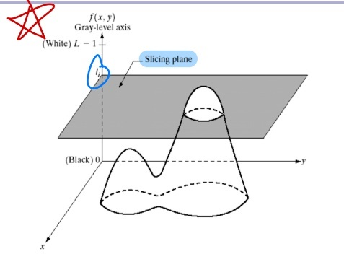
4. full-color image processing: process each color component individually; work with color pixels directly: treat entire pixel as a vector
5. color transformation are operations:
-- changing color intensity
-- replacing color with their complements
-- highlighting a specific range of colors
-- correcting tone
-- correcting color
-- image smoothing and sharpening
-- image edge detection and segmentation
6. changing image intensity: Reduce by 30%: all values are multiplied by 0.7
7. color complement values: new value is calculated for 8-bit color as 255 – current value.
Application: visual effects; negative images; inverse color schemes
8. tone: deal with contrast and brightness
Image key-type: tonal range of an image
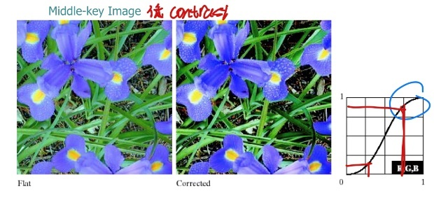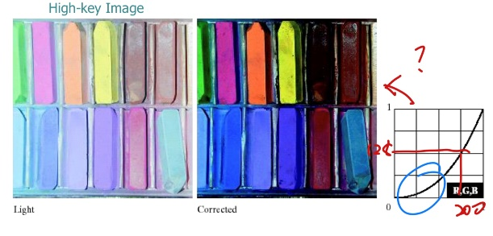
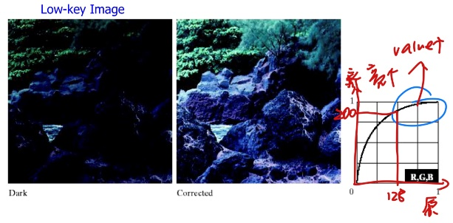
9. color balancing: increase a color:
Way1: decrease the opposite color
Way2: raise two immediately adjacent colors
Way3: decrease two colors adjacent to complement
10. histogram equalization on intensity
用HSV: maintain color balance while allowing the intensities to be adjusted.
Take the median of the intensity value histogram before processing, and draw the curve that makes this 0.5 after processing and goes through 0,0 and 1,1. Use this as a lookup table to adjust pixel V values.
Problems: less perception of color
Solutions: increase saturation value to compensate
11. smoothing: new value is average of surrounding pixels
RGB: 三个平面都用spatial filter 通常用Gaussian提供mask
HSV: 只有V用spatial filter
Result：HSV下平滑滤镜应用于强度分量，每个像素的色调和饱和度保持不变
12. sharpening: Laplacian filter
13. segmentation: performed in HSV as this separate color as a separate component

14. JPEG2000 advantages:
-- very high compression ratios
-- lossy and lossless compression
-- computer-generated images
-- composite images
-- error resilience
-- flexible encoding
15. process
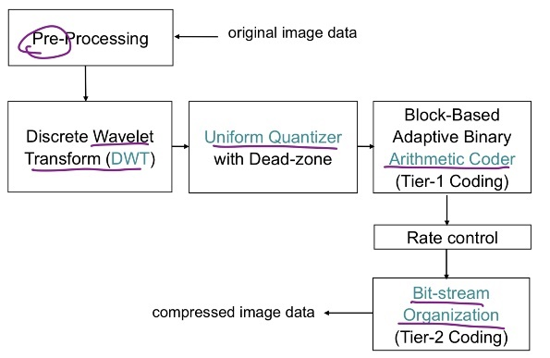
16. pre-processing
Tiling – level offset – ICT
Tile: partition input image into rectangular and non-overlapping tiles. Each tile is compressed independently.
Level offset: data is signed and centered around 0
ICT: use YCbCr (Y = (R+2G+B)/4, Cb = B-G, Cr = R-G)
17. DWT
--wavelets are discretely sampled
-- capture both spatial and frequency information
-- can be reversible and lossless, or irreversible and lossy (higher compression)
-- high coding efficiency; high SNR; high spatial scalability
-- decomposition
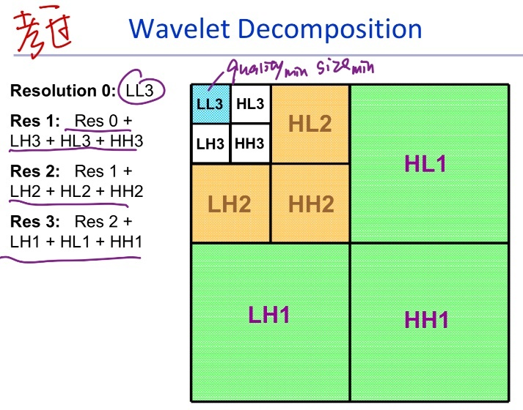
18. quantization: each sub-band b selects a quantizer step sizes based on visual models
-- higher compression ratio
19. code block: each sub-band from each tile component is partitioned into code clocks
20. 4 code clocks into a bit plane
--higher number of bit plane, less is its contribution to the final stage
21. entropy coding: bit plane conversion – fractional bit-plane coding – arithmetic coding
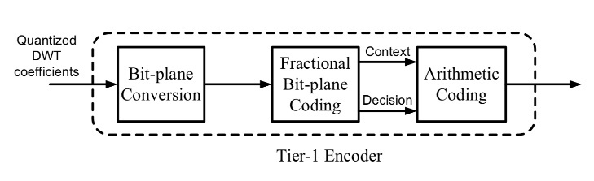
22. fractional bit-plane coding: each bit-plane is encoded in 3 passes.
-- significance propagation pass
-- magnitude refinement pass
-- clean up pass
23. arithmetic coding: binary value is coded as a binary symbol
24. Tier1 and Tier2
Tier1: generate a collection of bit-streams. One independent bit-stream for each code-block
Tier2: multiplex bit-streams for inclusion, signals the ordering. Coded data is easily parsed.
SNR, resolution, spatial, arbitrary progression scalability.
25.
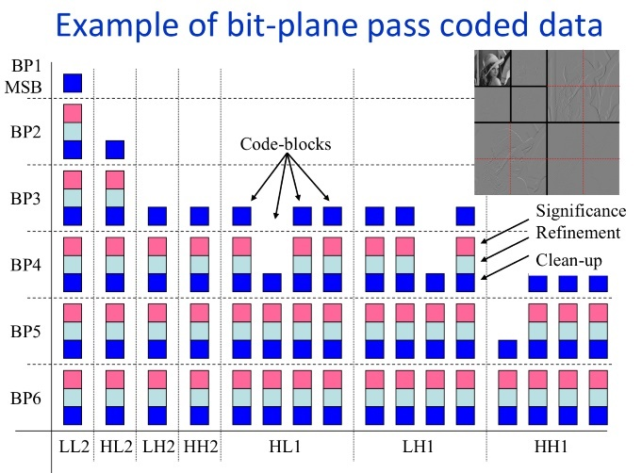
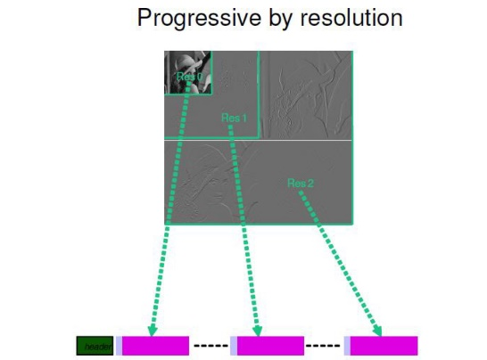
Lowest resolution: LL2
Medium resolution: LL2+HL2+LH2+HH2
Highest resolution: LL2+HL2+LH2+HH2+HL1+LH1+HH1
26. layer
-- is a collection of some consecutive bit-plane coding passes from all code blocks in all sub-bands
-- arbitrary number of bit-plane by each code-blocks
-- more layers, higher image quality
27. evaluating compressed images:
Use PSNR and MSE (和前面的一样，只不过把255换成题目中的MAX)
MSE越低，误差越小，和原图越接近。PSNR越大，图片的质量越高。
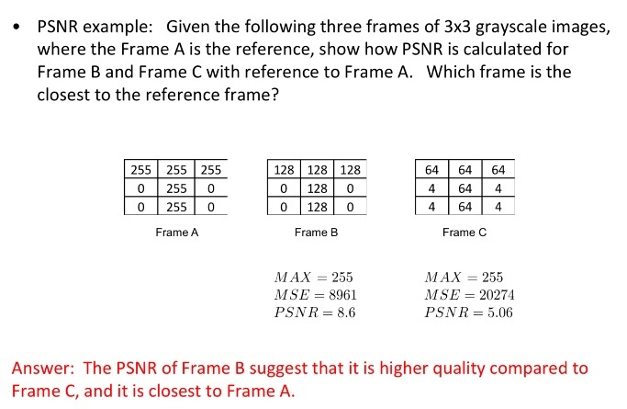

28. motion estimation
-- set of methods aiming at determining the motion of objects in a scene that describe the transformation from one 2D image to another
-- from adjacent frames
·· hypotheses
-- no occlusions
-- rigid objects
-- no illumination changes
-- locally (continuous motion, translational motion)
· methods: Lucas-Kanade estimation; block matching
29. motion compensation:
-- processing algorithm using motion info
-- predict a frame in a video, given the previous and future frames by accounting the motion
30. Lucas-Kanade:
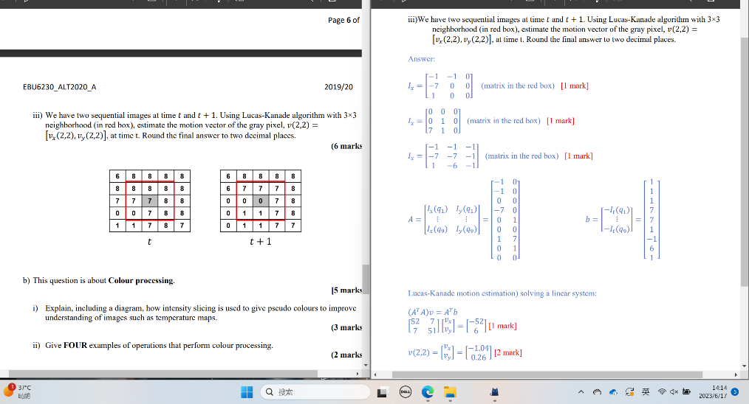
31. block matching
-- divide into small blocks
-- search for a similar block in previous image. Generate motion vector through their relationship.
优点：directly minimize prediction error, regular structure
缺点：high complexity; large prediction error at edge
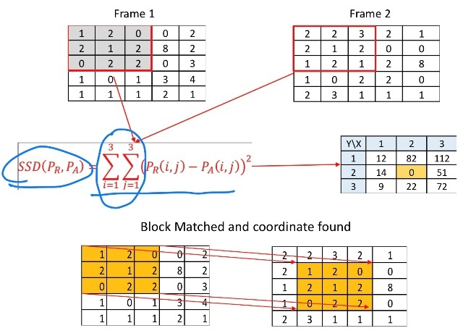
32. SAD: 绝对差之和 SSD: 绝对差的平方之和 MSE: 绝对差的平方之和的平均
33. block matching algorithms:
-- full-search: 每个点都搜索
-- logarithmic: 一个中心点+四个辅助点，二分缩小步长，最后一步8个辅助点
-- n-step：n=3: 一个中心点+八个辅助点，二分缩小步长
n=4: 不缩小步长只到一个中心点被匹配两次

34. MPEG-7
-- well organized XML structure that is instantiated by the values of the features extracted from the multimedia data
-- XML structure is easy to search, especially if it has been standardized
35. applications
-- surveillance (traffic control)
-- e-commerce and tele-shopping
-- journalism (search for events)
-- education, personalized television services

