 | 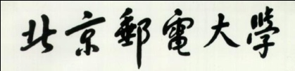 |  | 

Joint Programme Assessments 2022/23

Answer Sheet
(To be used in conjunction with the provided alternative assessment questions and the supplementary instructions)

Complete the information below about yourself very carefully.

QM student number
  2 | 0 | 0 | 9 | 7 | 8 | 9 | 4 | 7
BUPT student number
  2 | 0 | 2 | 0 | 2 | 1 | 3 | 2 | 4 | 8
Class number
  2 | 0 | 2 | 0 | 2 | 1 | 5 | 1 | 0 | 7

Module code
  EBU5303
Word Count
  2137

“I hereby confirm that the submitted work is entirely my own and I have not (i) used the services of any agency or person(s) providing specimen, model or ghostwritten work in the preparation of the work I submit for this open book assessment; (ii) given assistance in accessing this paper or in providing specimen, model or ghostwritten work to other candidates submitting for this open-book assessment.”
Signature
  Tangxun Wu

For examiners ONLY  Do not write in this section
   | Q1 | Q2 | Q3 | Q4 |  |  | Sum
  A
  B
  C
  D
  E
  F
  TOTAL

 | Do not write in this column
  Question | 1
  Section(s) | a.
Question 1
a)
i)
Aliasing means the higher frequency components of the sound signal cannot be captured because of the low sampling rate, and this leads to an overlap in the spectrum. The result of aliasing is that the produced sound will be in poor quality and the original sound cannot be reconstructed well.
Avoid aliasing: we should know the maximum frequency of the sound wave we want to digitize, then set the sampling rate as at least 2 times higher than the maximum frequency of the sound wave.
ii)
for image:
pixels per frame: 700*650 = 455000 pixels
bits per frame: 12 * 455000 = 5460000 bits
video image size per second: 5460000 * 24 = 131040000 bits
total video image size: 131040000 * 20 =2620800000 bits
for video:
audio size per second: 44100*32 = 1411200 bits
total audio size: 1411200 * 20 = 28224000 bits
total video size: (2620800000 + 28224000) / 8 = 331.128 MB
iii)
Choosing a sampling rate higher than Nyquist rate can have following implication:
1. oversampling and there will be a big gap between waveforms in spectrum, so that low-pass filter can recover original signal easily and avoid aliasing.
2. however, it will form bigger files which need more bits to store, and it has more computing requirements.

 | Do not write in this column
  Question | 1
  Section(s) | b.
b)
i)
Because if a colour is bright, there must be at least one value in RGB should be 255. So, if we want to decrease the brightness of a colour, we can decrease the RGB value respectively, especially the value that represents the colour.
However, we cannot reduce any value to 0, because in that case the colour will be fully saturated.
Also, we still need to keep the value that represents the colour bigger than any other value, because hue is the name of the colour, and we shouldn’t change the hue.
For example, if we want to reduce the brightness of an unsaturated bright green (50,255,50), we can decrease G from 255 to 100, but still bigger than R and B. And after that, the colour will be dark unsaturated green.
ii)
In the (C, M, Y) model, we can increase the saturation of a colour by decreasing white into the colour, which means increasing the value that represents the colour.
In this way, the colour represented won’t change, so hue won’t change.
Also, to keep brightness, the value that don’t represent the colour shouldn’t be added.
For example, if we want to increase the saturation of an unsaturated bright red (0,245,245), we can increase both M and Y from 245 to 255, and keep C be 0. And after that, the colour will be fully saturated bright red.
iii)
In the (H, S, V) model, we use large value of V to encode a bright colour and use quite small value of S to show unsaturated.
For example, if we want to encode unsaturated bright orange, we can set V bigger than 45, so V = 100. We can set S = 30 to show unsaturation. So the finally HSV value of the colour should be (30,30,100).
Turn the colour into grey: set S = 0. So, the HSV becomes (30,0,100), and in this case H can choose any value to represent grey.
iv)
The tristimulus theory of colour vision. It shows that human perception of colour comes from the eye’s response to 3 groups of wavelengths, which represent red, green, blue respectively.
Therefore, all colours can be produced by the mixture of these three colours.

 | Do not write in this column
  Question | 2
  Section(s) | a.
Question 2
a)
i)
image resolution: the number of pixels per inch.
Because vector-based image is made of points, lines, and curves that are based upon mathematical equations. It’s scalable when using some software to modify or zoom in the computer. So, it is displayed at high resolution, and when zoom in on the image, it won’t become blocky.
ii)
size of true colour image: 200 * 300 pixels * 24 bits / 8 = 180 kB
size of grayscale image: 200 * 300 pixels * 8 bits / 8 = 60 kB
the method to convert an image from true colour to grayscale:
Greyscale means we should reduce the bits to represent colour from true colour image, so there maybe some colour missing or changed in the image.
In order to prevent that, we have to select most important colours that store the image’s details and appears frequently, or select those attracting viewer’s attention then save those colours. After that, we discard other colours appropriately.
iii)
each represents 8 bits. So RGBA has 32 colour depth.
iv)
In my opinion, no. It depends on the images.
If the index-based format owns small CLUT, or the true colour image shows so many colours differently, we can’t find some original colours from index. In that case, the colour will be changed, and perceived quality loss occurs.

 | Do not write in this column
  Question | 2
  Section(s) | b.
b)
i)
Firstly, the frequency range of sound that humans can hear is 20-20 KHZ. According to Nyquist theorem, the sampling rate should be at least two times larger than the maximum frequency in sounds. Therefore, for good quality sound the sampling rate must be at least 40 KHz.
Secondly, we know that the higher sampling rate, the less possibility of aliasing and overlapping, because in reality we can’t produce the ideal filter and should consider the transition bandwidth. Therefore, we choose the sampling rate of 44.1 KHz larger than 40 KHz.
ii)
Typical bit depths for speech: 8 bits. For music: 16 bits.
As for music, listeners use music to enjoy themselves, so they focus on the quality of music. Therefore, the bigger bit depth for music, the higher quality for music, the more people like listening to it.
But for speech, listeners just want to understand the contents of speech, so the quality of speech sound is not so important compared to music. It doesn’t matter for us to recognize the word through speech when using low bit depth. Therefore, 8 bits is good enough for people to get involved in the speech.
iii)
the answer shown on the following image:
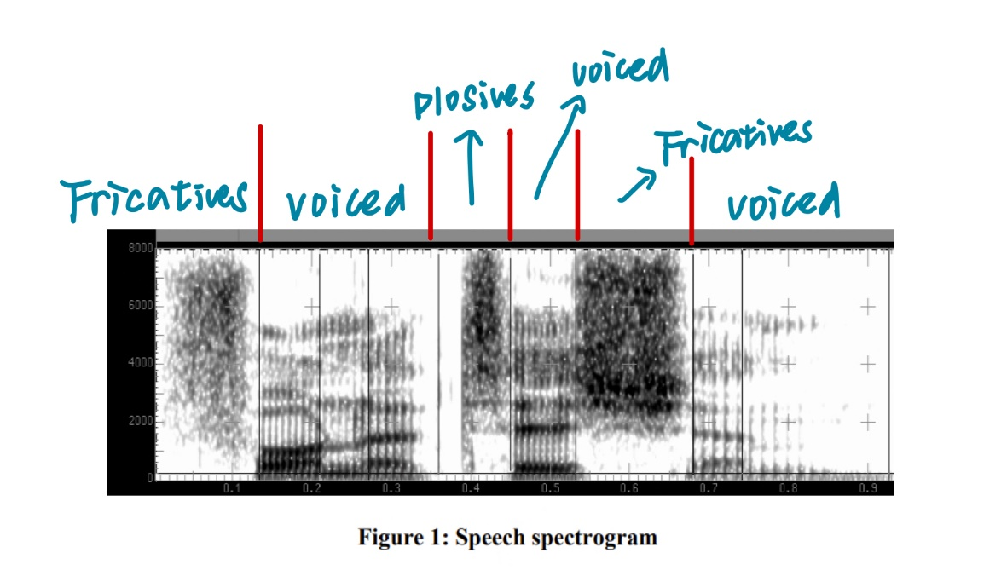

 | Do not write in this column
  Question | 3
  Section(s) | a.
Question 3
a)
i)
Generally speaking, brain will remove and throw large amount of data from enormous information, and group rest of information into meaningful chunks while using short codes.
Example 1: if we want to remember a long sequence of numbers, our brain will divide those numbers into small chunks that may have some regularity or similarity.
Example 2: if we have to deal with many tasks simultaneously, and we wonder which one we have done already. We can use 1 to represent completed tasks, and 0 to represent unfinished tasks. In that case, we can easily find those finished tasks from so many items.
ii)
RLE: spatial property, i.e., the image contains large areas of uniform colour.
Huffman: statistical property, i.e., the fact that some colours appear more often than others.
Both are examples of lossless compression, because they just choose to not encode those redundant data like replicate colour, or encode frequent colour with short code. Therefore, no information is lost and they can create exact original data after reconstruction.
iii)
compressed one: Y(4)B(1)G(5)
original bit value: 10 * 5 bits = 50 bits
compressed bit value: (3 bits + 5 bits) * 3 = 24 bits
so, the compression rate: 50: 24 = 25 :12

 | Do not write in this column
  Question | 3
  Section(s) | b.
b)
i)
JPEG is lossy, because it throws away information during process, like the fine details in high frequency in DCT domain, and the colour information through chroma sub-sampling.
But because of properties of the human vision system:
1. The human eye is more sensitive to changes in light than in colour, the colour information thrown during sub-sampling won’t be captured by human eyes.
2. Those fine details in high frequency components are beyond the acuity of human perception. That is, the quick changes of colours in short space caused by high frequency component aren’t easy to be caught by human eye.
Therefore, although JPEG is lossy, some JPEG images look like the original image after decompression.
ii)
Quantisation works by dividing the 8*8 blocks of DCT coefficients by quantisation table and round off. Those quantisation table store integers depending on which coefficients we want to remove or preserve.
Besides, because the coefficients for high-frequency components are typically small, quantisation process will let them become 0 and throw them away.
choosing a quantisation table with low values: achieve little compression but preserve the quality of image.
iii)
Step 1: convert image from RGB to YCbCr and do the chroma sub-sampling, so as to throw away some colour information while preserving all light information. Divide the image into 8*8 pixel blocks, for preparing the DCT and make DCT more manageable.
Step 2: use DCT to transform the pixel data from spatial domain to frequency domain, and the coefficients are arranged from lowest frequency to highest one, in order to discard high frequency component in the next step.
Step 3: quantise frequency values, rounding off high frequency coefficients into 0.
Step 4: do DPCM to only record the different between consecutive values, and do zigzag order for grouping high frequency coefficients at the end.
Step 5: Do run-length encoding to throw away 0 at the end of zigzag order, so as to compress the data.
(Step 6: do entropy encoding)

 | Do not write in this column
  Question | 4
  Section(s) | a.
Question 4
a)
i)
Motion estimation: it checks the motion as well as movement of data in images, then tries to represent the estimated motion via vectors. And the main goal of motion estimation is to guarantee the minimum difference between prediction macroblocks and current macroblocks.
Motion compensation: it is a technique to predict the frames in the video. It will remove the redundancy found through motion estimation, and just encode difference in matching macroblocks. Also, it encodes difference via motion vector and error terms found in motion estimation.
Motion estimation is done first.
BMA is an example of motion estimation.
ii)
encoding P frames: encoding relies only on previous I or P frames.
encoding B frames: searching for matching blocks in both past and future frames. Encoding relies on previous and future I or P frames.
B frames are smaller: Because they use 2 reference frames to make better predictions, rather than just 1 reference compared to P frames.
iii)
contains many fast-moving objects:
means there will be many changes caused by many I frames in the GOP structure.
Therefore, the structure should have more I frames compared to B and P frames, and the length will be short.
Example:
IBBIBBIBBP

 | Do not write in this column
  Question | 4
  Section(s) | b.
b)
i)
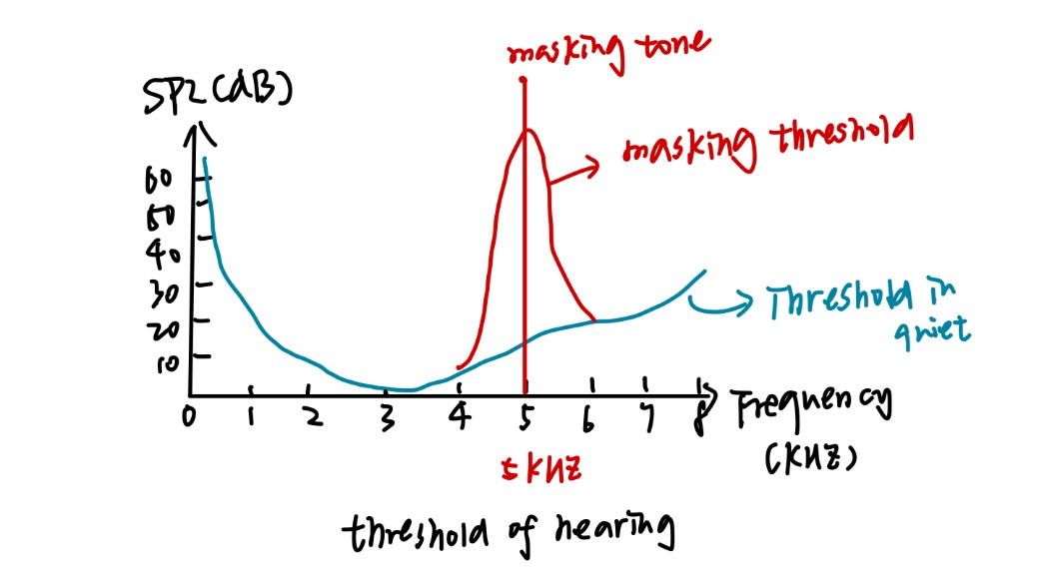
ii)
Scaling factors is used to multiple the part of signal, and those scale factor bands closely match the critical bands of the human ear. In this way, we can reduce the amount of data, and achieve compression.
In a very strong masking tone, the SMR (the ratio between amplitude of a masking tone and the amplitude of the minimum masked frequency) will be high. Therefore, we should use smaller scaling factor, because quantisation error for this kind of signal will have huge impact.
iii)
CD quality mono audio signal:
bit rate = 44100 samples per second * 16 bits = 705600 bit/s
compression rate: 705600: 150000 = 588: 125

 | Do not write in this column
  Question
  Section(s)

 | Do not write in this column
  Question
  Section(s)

 | Do not write in this column
  Question
  Section(s)

 | Do not write in this column
  Question
  Section(s)

