Content
1. Introduction 1
2. Function Design 2
2.1. Overall Design 2
2.2. Respective Design 2
2.2.1. Hardware 2
2.2.2. Software 19
2.2.3. Database 30
3. Business Analysis 33
3.1. Design Concept and Advantages 33
3.2. PESTEL Analysis 33
3.3. SWOT Analysis 34
3.4. Competitive Analysis 35
3.5. 4P Strategy 35
4. Meeting Management 36
4.1. The Timeline 36
4.2. Minutes of Meeting 37
5. Workflow 40
6. Division 42

Introduction
Our company's goal is to let customers have the most comfortable user experience. The development of our intelligent warehousing system will bring users a satisfactory experience. We are mainly engaged in the development of intelligent warehousing products, and our products are highly praised in the industry now. Different from the ordinary intelligent freight system, our products will provide users with the best service and the most accurate goods delivery. Our aim is to let every customer be satisfied with our products.
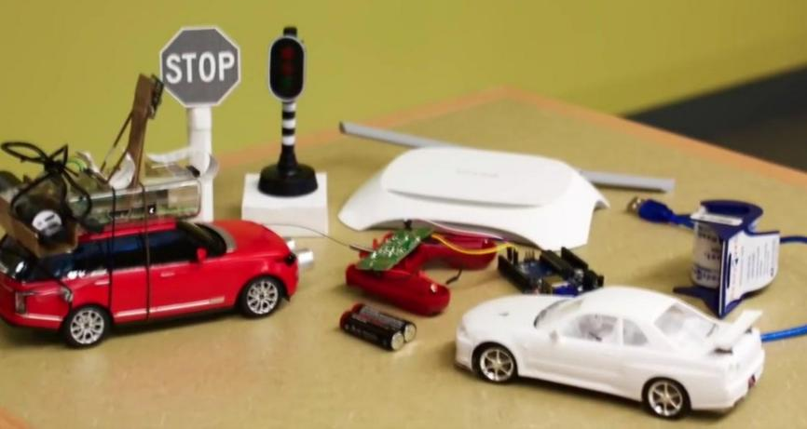
In terms of hardware, the warehouse has realized unmanned and automation, and the intelligent car is used to make all functions be achieved more effectively, such as tracing the warehouse, detecting dangerous situations, etc. The intelligent car can also automatically identify materials and easily get access to them according to computer instructions, improving the efficiency and saving manpower.
In terms of software, the website has realized displaying data intelligently. Administrators and workers can directly log in the intelligent warehousing website to realize online goods query and management. The website system is flexibly configured to solve the problems of multiple products and inventory confusion.

Product advantages
Our intelligent freight management system is simple to operate and highly integrated. Compared with other intelligent freight management systems, our intelligent freight management system has more perfect functions. Users only need to log in to our intelligent freight management homepage to control the freight vehicles, view all the information of workers and administrators, and check the status of each warehouse. In addition, we also provide users with many optional operations to ensure that users can control all aspects of all links they want to know through our system.

Product development prospect
Nowadays, information science is increasingly developed in the world, 5G technology is gradually entering people's lives, and the interconnection of everything has become the trend of the times. The traditional freight transport system with cumbersome processes is gradually eliminated, replaced by an intelligent freight transport system that is easy to operate and has powerful functions. Users can easily master and adjust the situation of each link in the transportation process through our intelligent freight management system, which is a convenience that traditional freight systems cannot bring. In addition, this industry is a new industry, and its potential has not been fully explored, so it has a very broad development prospect.

Function Design

Overall Design
Our company co-designs and builds a warehouse monitoring system that uses automated robots to work on-site and send a status report of the warehouse to a web application for monitoring. At the same time, there are two web programs for workers to manage warehouse goods and for managers to manage workers. Members in our group from 3 different majors first implemented different functions at the same time through division of labor, and then integrated the results. At the beginning, the students of electrical engineering were responsible for the design and construction of the hardware model of the automatic robot, the students of Internet of Things were responsible for the construction of the hardware database interface, database and the client software of the workers, and the students of e-commerce were responsible for the database management and the construction of the management software. After we finished our assigned tasks, we put the different parts together. The connection mode is shown as follows. The data is transferred from the hardware model to the database, which provides the data to the back-end website and finally presents it on the web page.
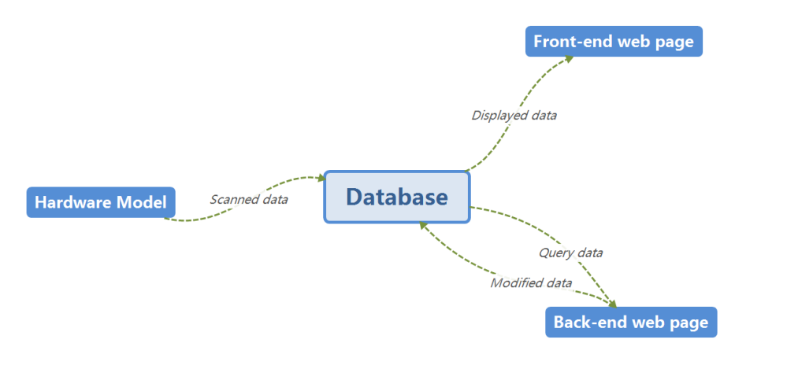

Respective Design

Hardware
- Circuit Diagram Design
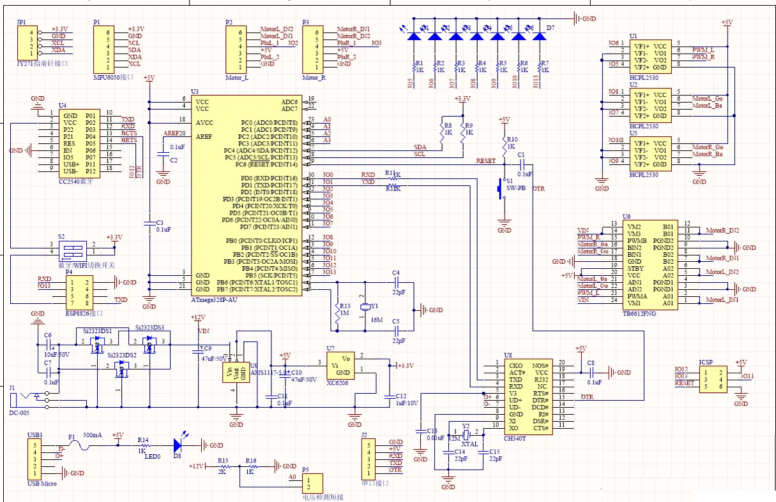
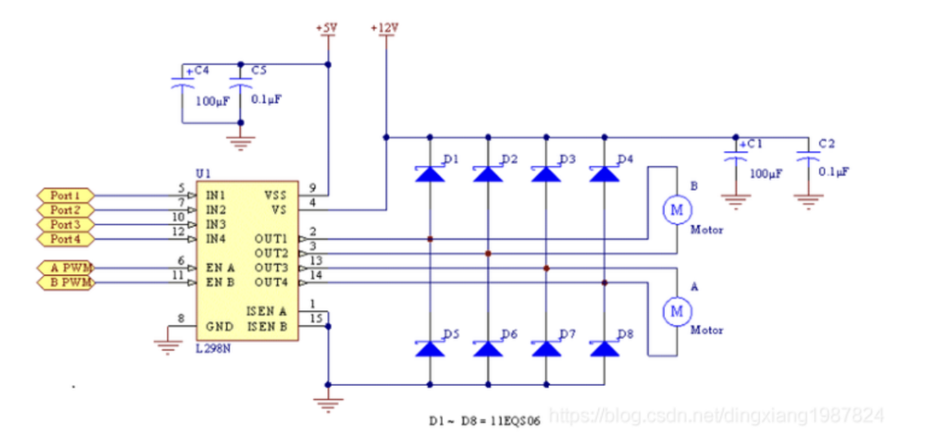
List of The Main Hardware is as follows:
NO. | NAME | NUMBER
1 | Arduino uno | 1
2 | Arduino mega | 1
3 | Arduino extended board | 1
4 | Temperature and humidity sensor | 1
5 | TCRT5000 Infrared sensor | 3
6 | The LCD screen | 1
7 | Flame sensor | 1
8 | ESP8266-01s Wi-Fi-module | 1
9 | Wi-Fi-module downloader | 1
10 | TCS3200 Color sensor | 1
11 | Photosensitive sensor | 1
12 | Buzzer | 1
13 | HC-SR04 Ultrasonic ranging module | 1
14 | L298N Drive motor control module | 1
15 | Motor | 4
16 | Infra-red obstacle avoidance module | 1

- Introduction of Some Main Hardware

- Arduino Mega 2560 & Arduino Extended Board
The Arduino Mega 2560 is a core board with a USB interface. With 54 digital inputs and outputs, it is suitable for designs that require many IO interfaces. The core of the processor is the ATmega2560, which also has 54 digital inputs/outputs, 16 analogue inputs, 4 UART interfaces, a 16MHz crystal oscillator, a USB port, a power socket, an ICSP header and a reset button.
We also choose an Arduino extended board. It provides us with more interfaces for connecting more sensors and achieving more functions. It also reduces conflicts between the different ports. Therefore, it allows all components to work properly and data to be collected and uploaded successfully.
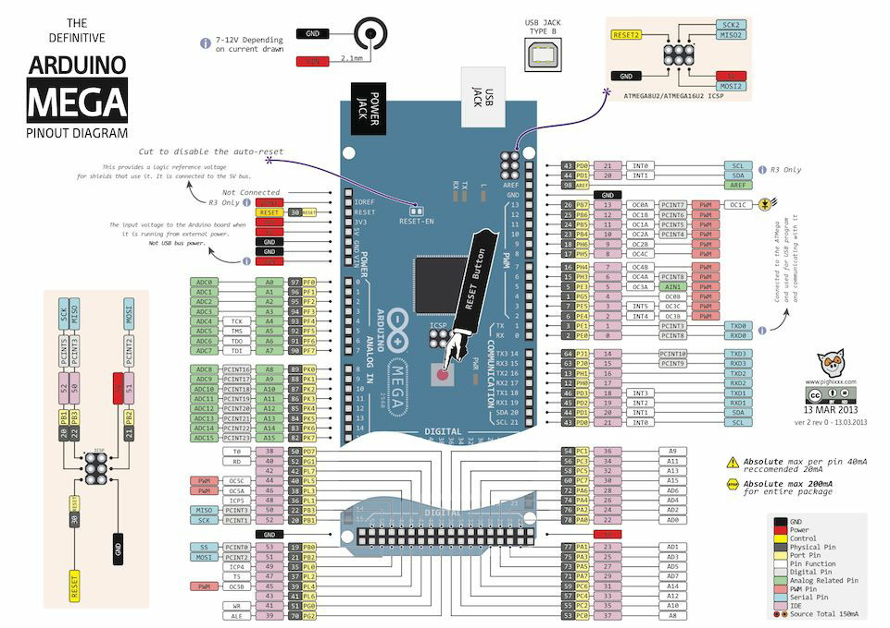
- TCRT5000 Infrared Sensor
The TCRT5000 has an infrared transmitter tube and an infrared receiver tube. When the infrared signal from the transmitter tube is reflected and received by the receiver tube, the resistance of the receiver tube will change.
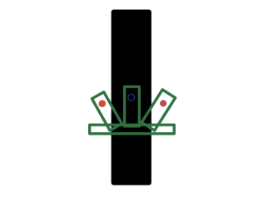
Go Straight Turn Right Turn Left
- Color Sensor
The TCS3200 has a programmable optical and electrical converter with a built-in oscillator that converts the light intensity into a square wave. The output value of the OUT pin of the TCS3200 is proportional to the frequency of the built-in oscillator and their ratio factor is set by its pins S0 and S1.
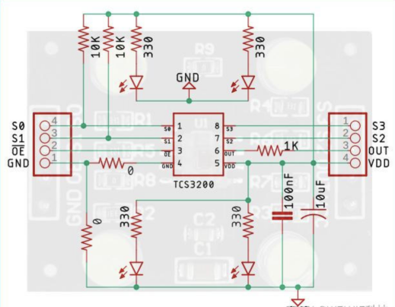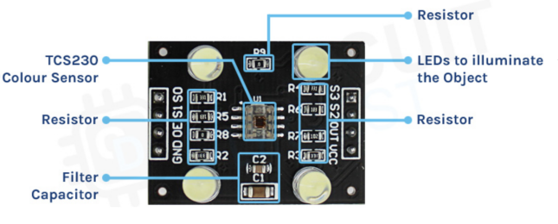
Circuit Diagram of TCS3200 TCS3200 Component Parts
After testing, we found that the optimum distance between the object under testing and the TCS3200 is 1 cm. when detecting objects, it is important to avoid interference from external light, otherwise the results may be affected.
- ESP32 Wi-Fi Module
The ESP32 is an integrated 2.4 GHz Wi-Fi and Bluetooth dual-mode single-chip device using TSMC's ultra-low power 40nm process, offering ultra-high RF performance, stability, versatility, and reliability, as well as ultra-low power consumption to meet different power requirements for a wide range of application scenarios.
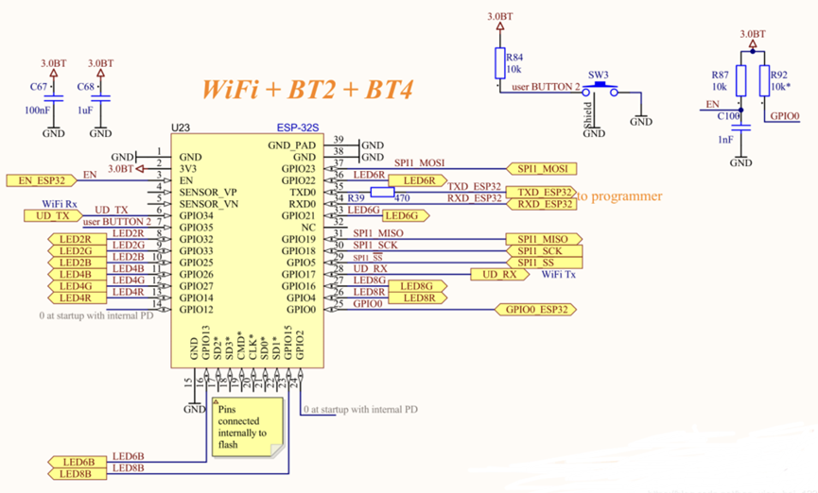

- Appearance
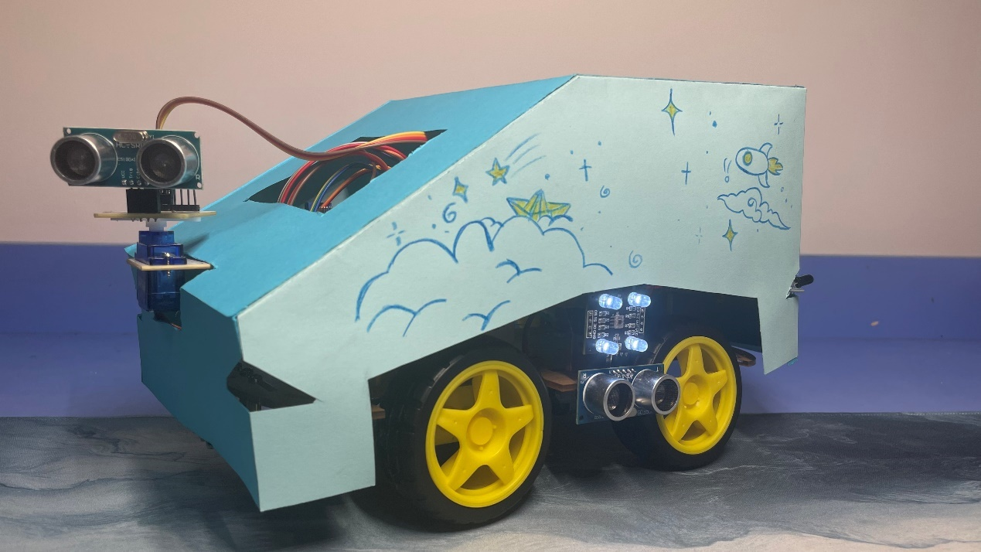
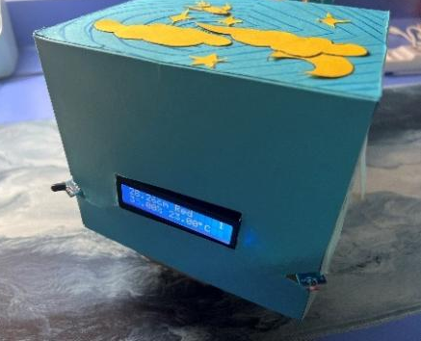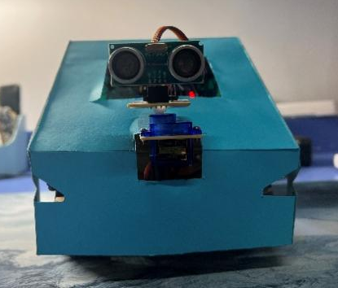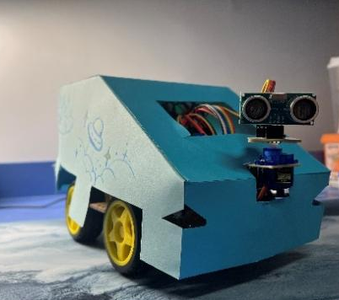 9

- The main body of our car has a rectangular shape. Several windows have been cut in many places to allow the sensors to be placed on the outside of the car which is better for measurement of the data we need. The compactness of the internal components and the appearance of the cart, which hides the tightly packed internal wiring, enhance the aesthetics and resistance to damage.
- The housing of the car is of a top-sleeve construction, making it easier to remove the exterior of the car for internal inspection and repair if problems arise inside.
- The parts left on the outside give the small car the more technological feeling. The use of environmentally friendly materials combined with the production of the cart's exterior not only saves resources, but also facilitates better mass production of this type of cart and helps to upgrade the warehouse management system.

- Systematic Design

- Ideas for System Design
According to the requirement of warehouse managing, we think our car’s system is expected to be well-designed to satisfy the following demands:
- Anomaly detection and reporting
There may be some unexpected situations in the warehouse, such as intrusion by unknown persons, fire, and other abnormal situations. Therefore, there shall be real-time monitoring of abnormal information and timely alarms function so that the warehouse manager can handle the situation as quickly as possible.
- Automate operations
In unmanned warehouses, the trolley needs to be able to automatically cruise along the given path and automatically identify the current cargo-related information by detecting the color of the goods.
- Environmental information monitoring
The car needs to collect the environmental parameters of the warehouse (current temperature, humidity, etc.) and feedback to the computer in time to improve the preservation capacity of the goods.
- Emergency response
The travel route of the car may not be smooth and plain, and occasionally there will even be some obstacles on the path. Therefore, our car should respond to these unexpected situations on time.

- The Main Function Introduction
As the hardware part of the warehouse supervision system, this car is designed with the following functions:

- Environmental parameter acquisition
In modern warehouse management, the environmental information of the warehouse is changeable all the time. Among them, temperature and humidity are of great importance and play a role in the fire, mildew, and moisture resistance in the warehouse.
Therefore, we put a DHT11 temperature and humidity sensor on our car, which can measure the temperature and humidity of the warehouse environment continuously, in order to maintain the quality of stored goods and create an environment suitable for commodity storage.
The code is shown below:
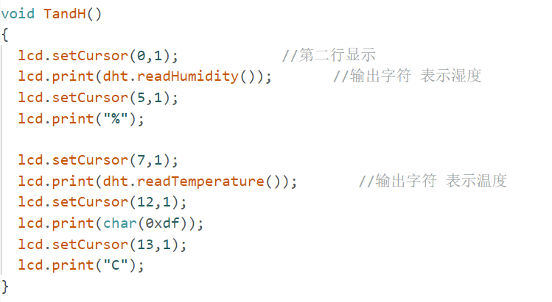

- Fire alarm
Obviously, if there is a fire in the warehouse, not only will it cause a significant loss of goods and damage to the environment, but also the security of nearby constructions and even the warehouse managers are threatened. Therefore, it is necessary to timely detect whether there is a fire in the warehouse or not.
In order to remedy the fire hazard in time, we put a flame sensor on our car, which can sense whether there is a flame around the car and if there is, light up to inform the manager, in order to enhance the fire safety management of the warehouse, respond to the fire situation promptly, and reduce losses as well.
The code is shown below:
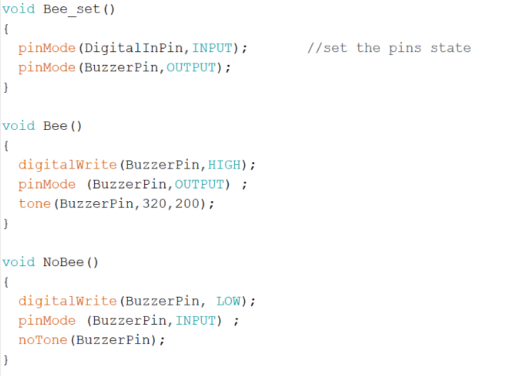
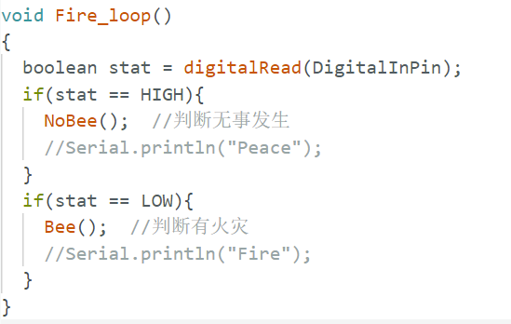

- Photosensitive alarm
Besides fire, the theft of the warehouse also causes the loss of goods and poses a serious threat to the security of the warehouse. So, the monitoring system of the warehouse is essential.
Considering that thieves usually commit theft at night, we install a light sensor on our car, which can detect ambient lighting. If the light intensity is overly strong (possibly caused by the invader), the alarm will sound, in order to help warehouse managers, stop theft and reduce the loss of goods.
The code is shown below:
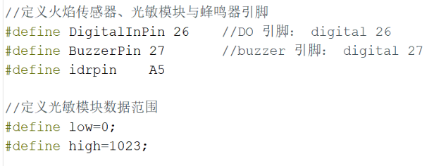
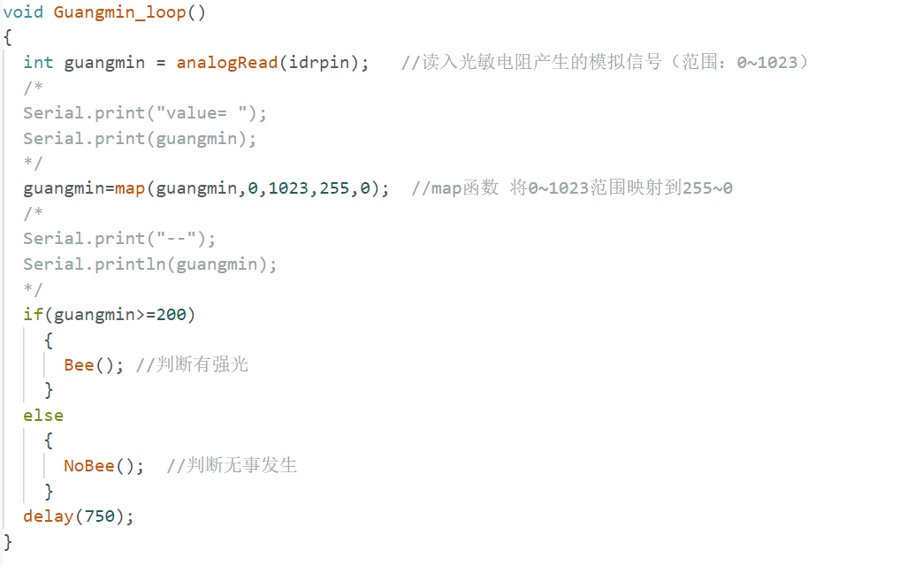

- Cargo identification
For warehouse management, patrolling and inspecting individual goods in the warehouse is the most basic work. Normally, warehouse managers can identify the kinds of goods by their different colors.
Based on this, we choose to use the TCS230 Color Sensor which can sense red, green, yellow and blue light to identify the color (category) of the goods. This color sensor can significantly reduce the workload of warehouse managers and automate warehouse cargo inspection.
It is worth mentioning that, because of the limitation of hardware, we optimize our algorithm which dramatically improves the identification accuracy. We combine our knowledge about HSV on a multimedia basis into coding, transforming RGB into HSV, finally set specific range for hardware to define the color.
The code is shown below:
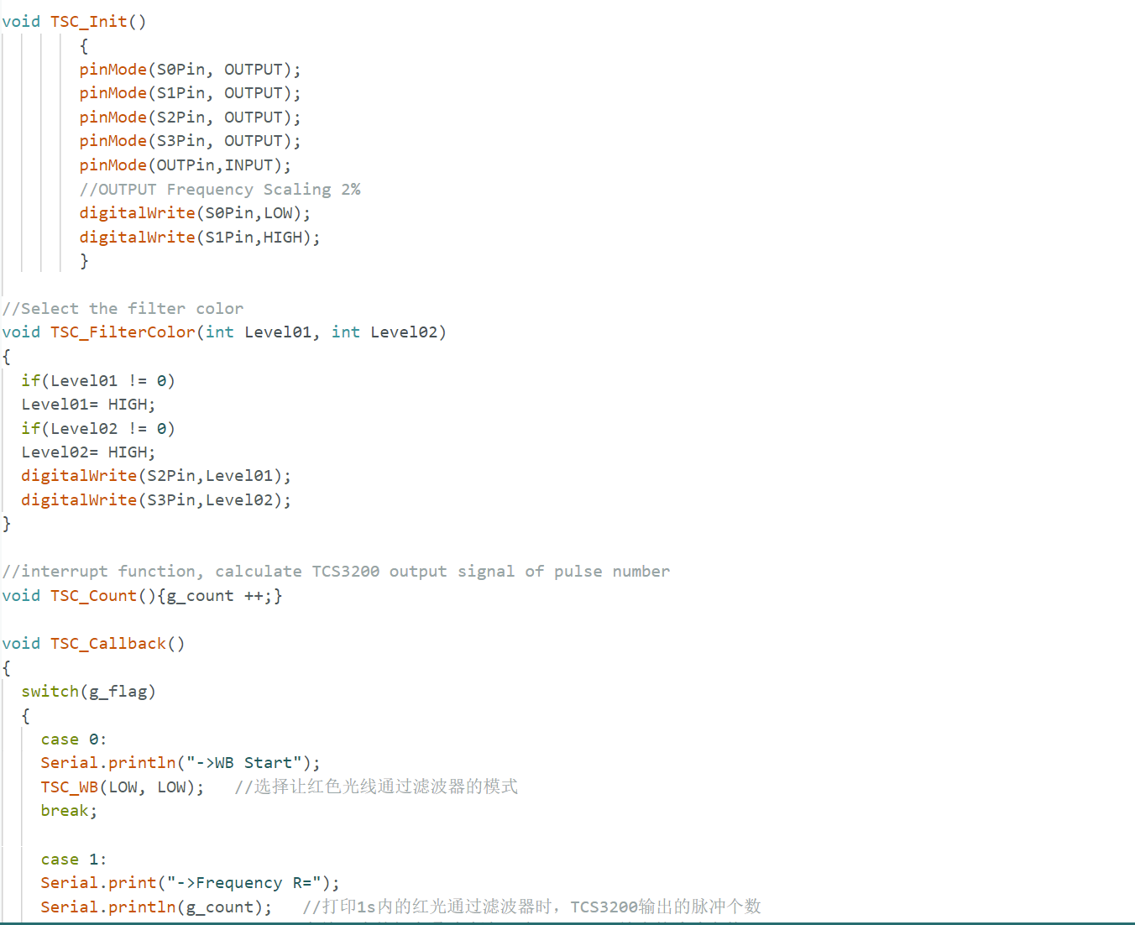
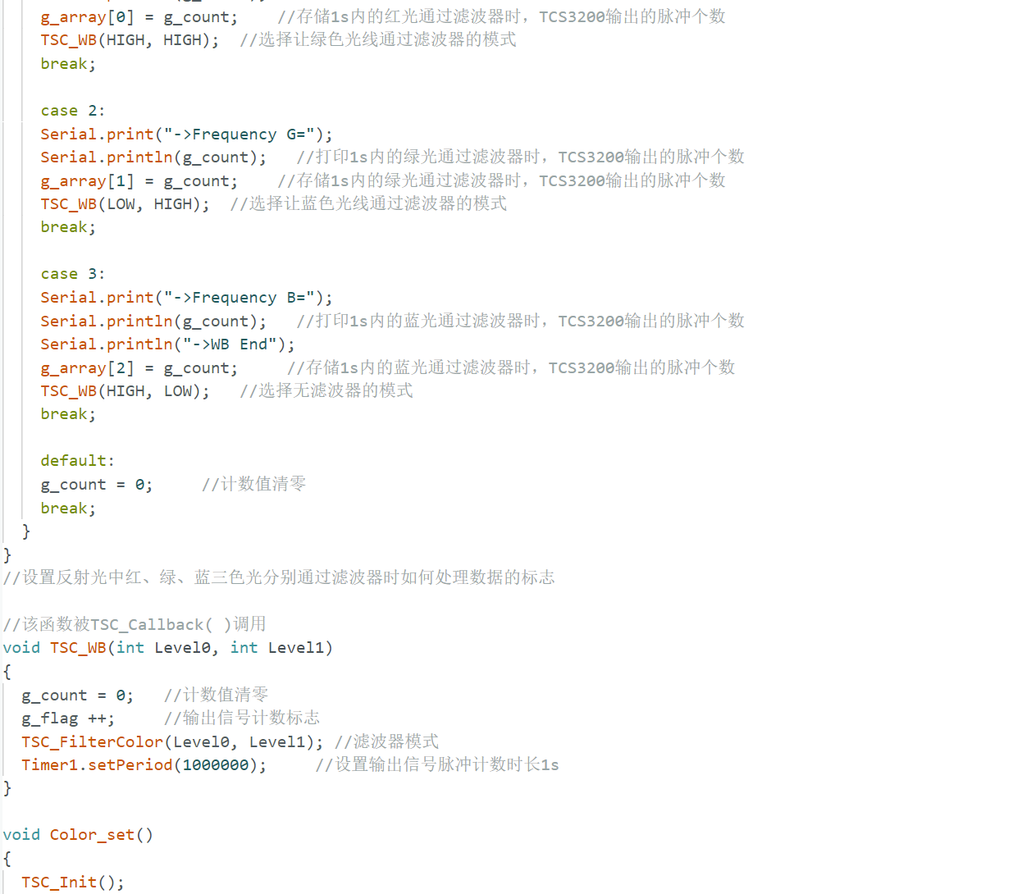
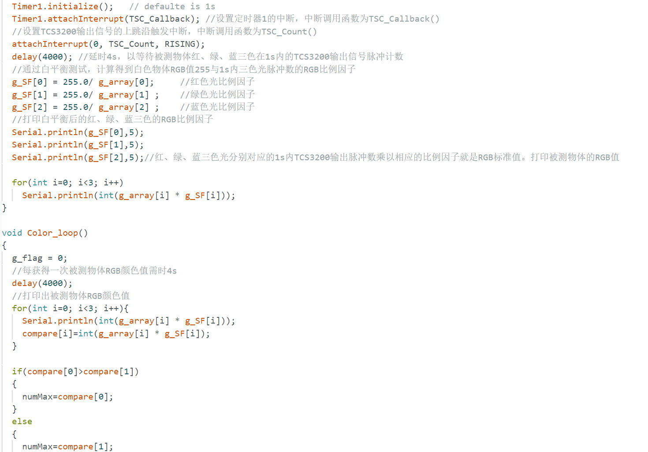
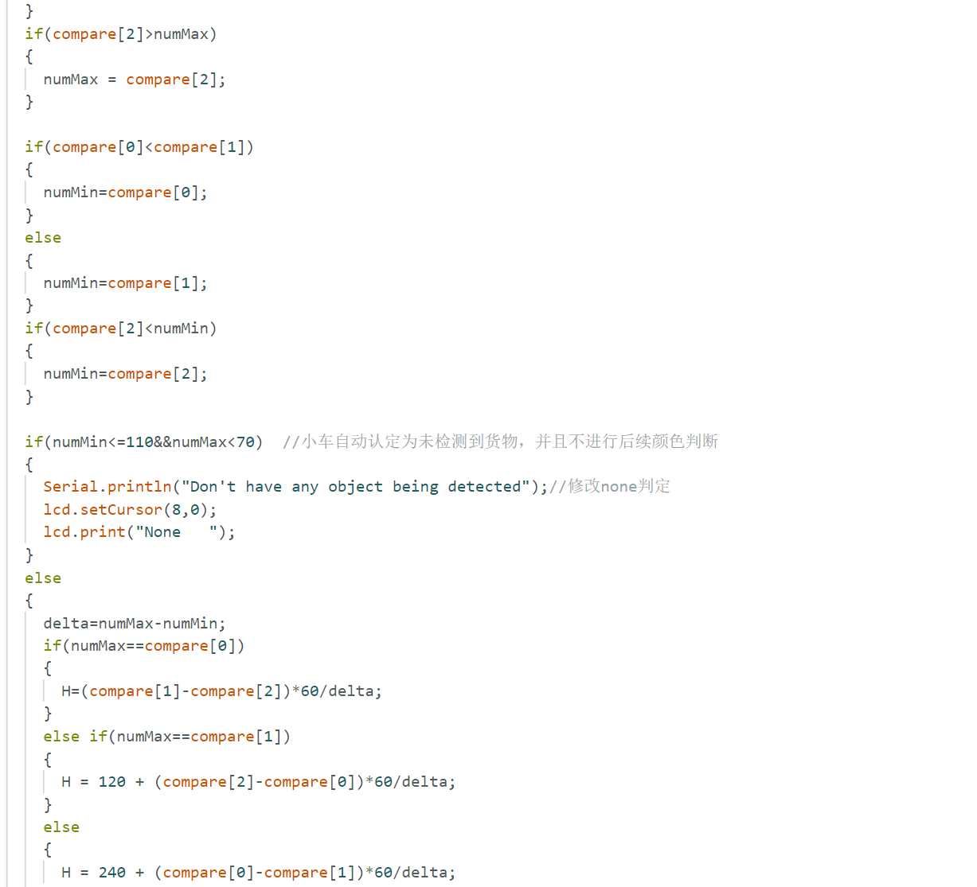
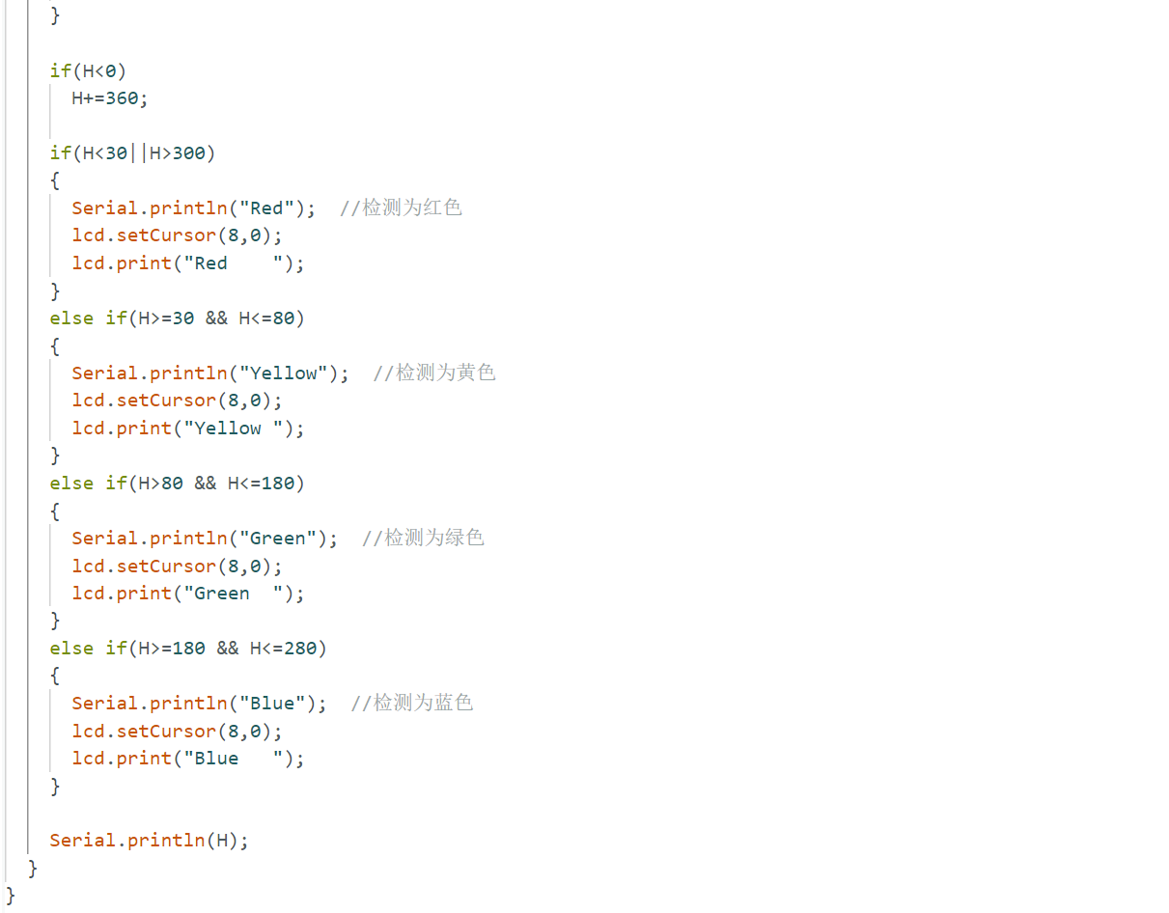

- Infrared tracking
Patrolling warehouses is one of the basic jobs of a warehouse manager. And to automate warehouse inspections, we decide to let our car follow the given path (the black line on the ground) to patrol the warehouse.
To enable the car to sensor the black line around and be able to follow it, an infrared tracking sensor is installed on the car, which helps the car adjust the servo speed according to the recognized path, in order to follow the given road.
The code is shown below:
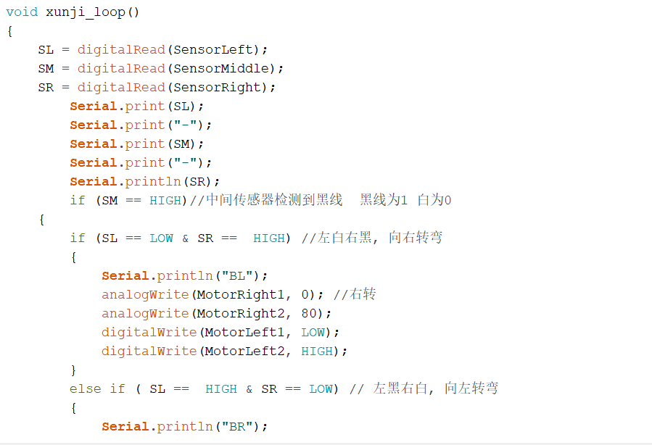
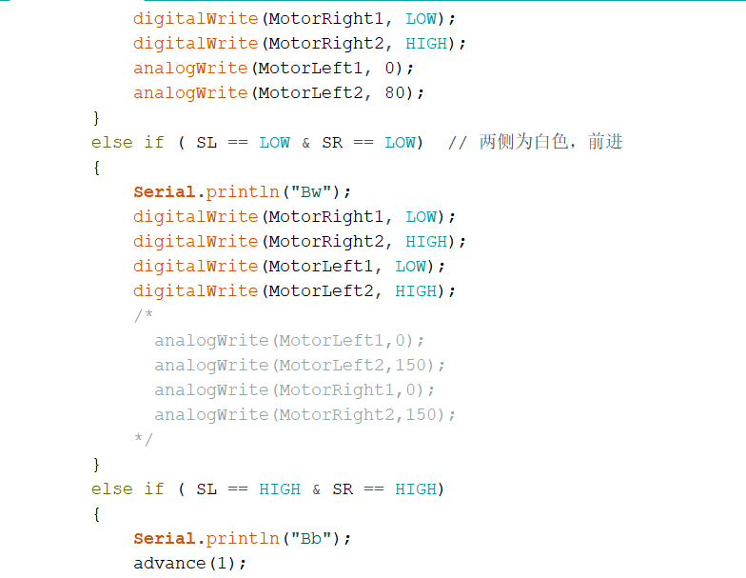
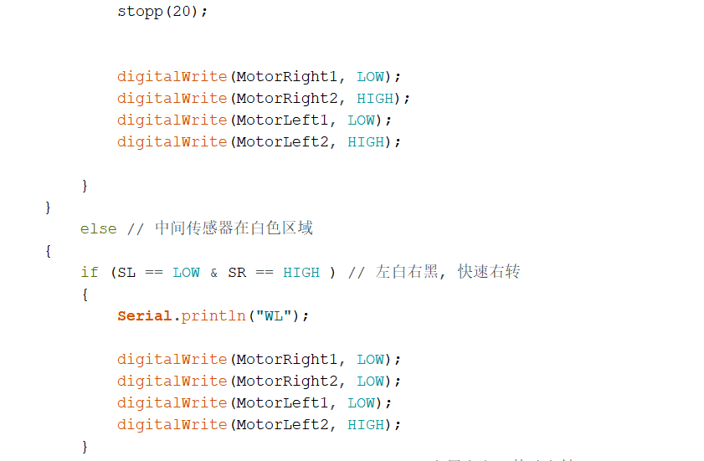
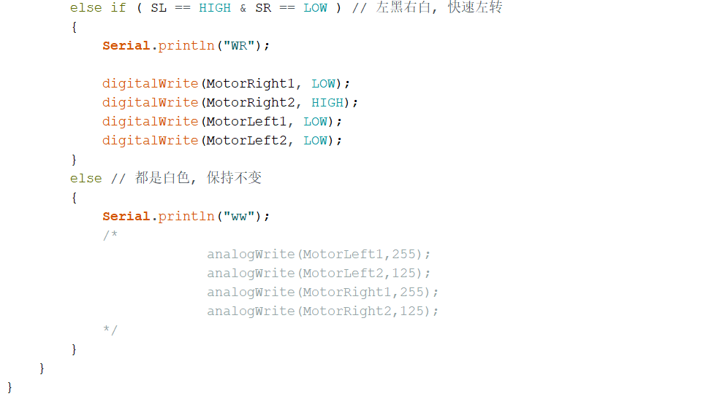

- Infrared obstacle avoidance
In the process of automatically patrolling the warehouse along the path, sometimes there might be some obstacles on the road. Hence, our car should be able to detect obstacles ahead in real-time, control the motor to slow down, then stop. To realize the functions mentioned above, we use Infrared obstacle avoidance, which can ensure the obstacle avoidance ability of the car during the automatic inspection, as well as improve the flexibility and stability of patrols.
The code is shown below:
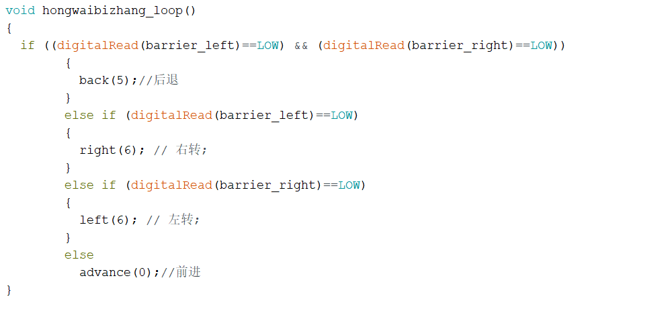
- Ultrasonic ranging and warehouse counting
Whether obstacle avoidance or cargo identification, it is necessary for the car to detect the distance between objects (goods or balks) and count the number of the objects. So we choose HC-SR04, which can emit ultrasonic waves and receive ultrasonic waves reflected back from the object, judging the distance between the trolley and the object according to the time difference. In addition, according to the distance detected, some functions like obstacle avoidance or cargo identification can be triggered automatically.
The code is shown below:
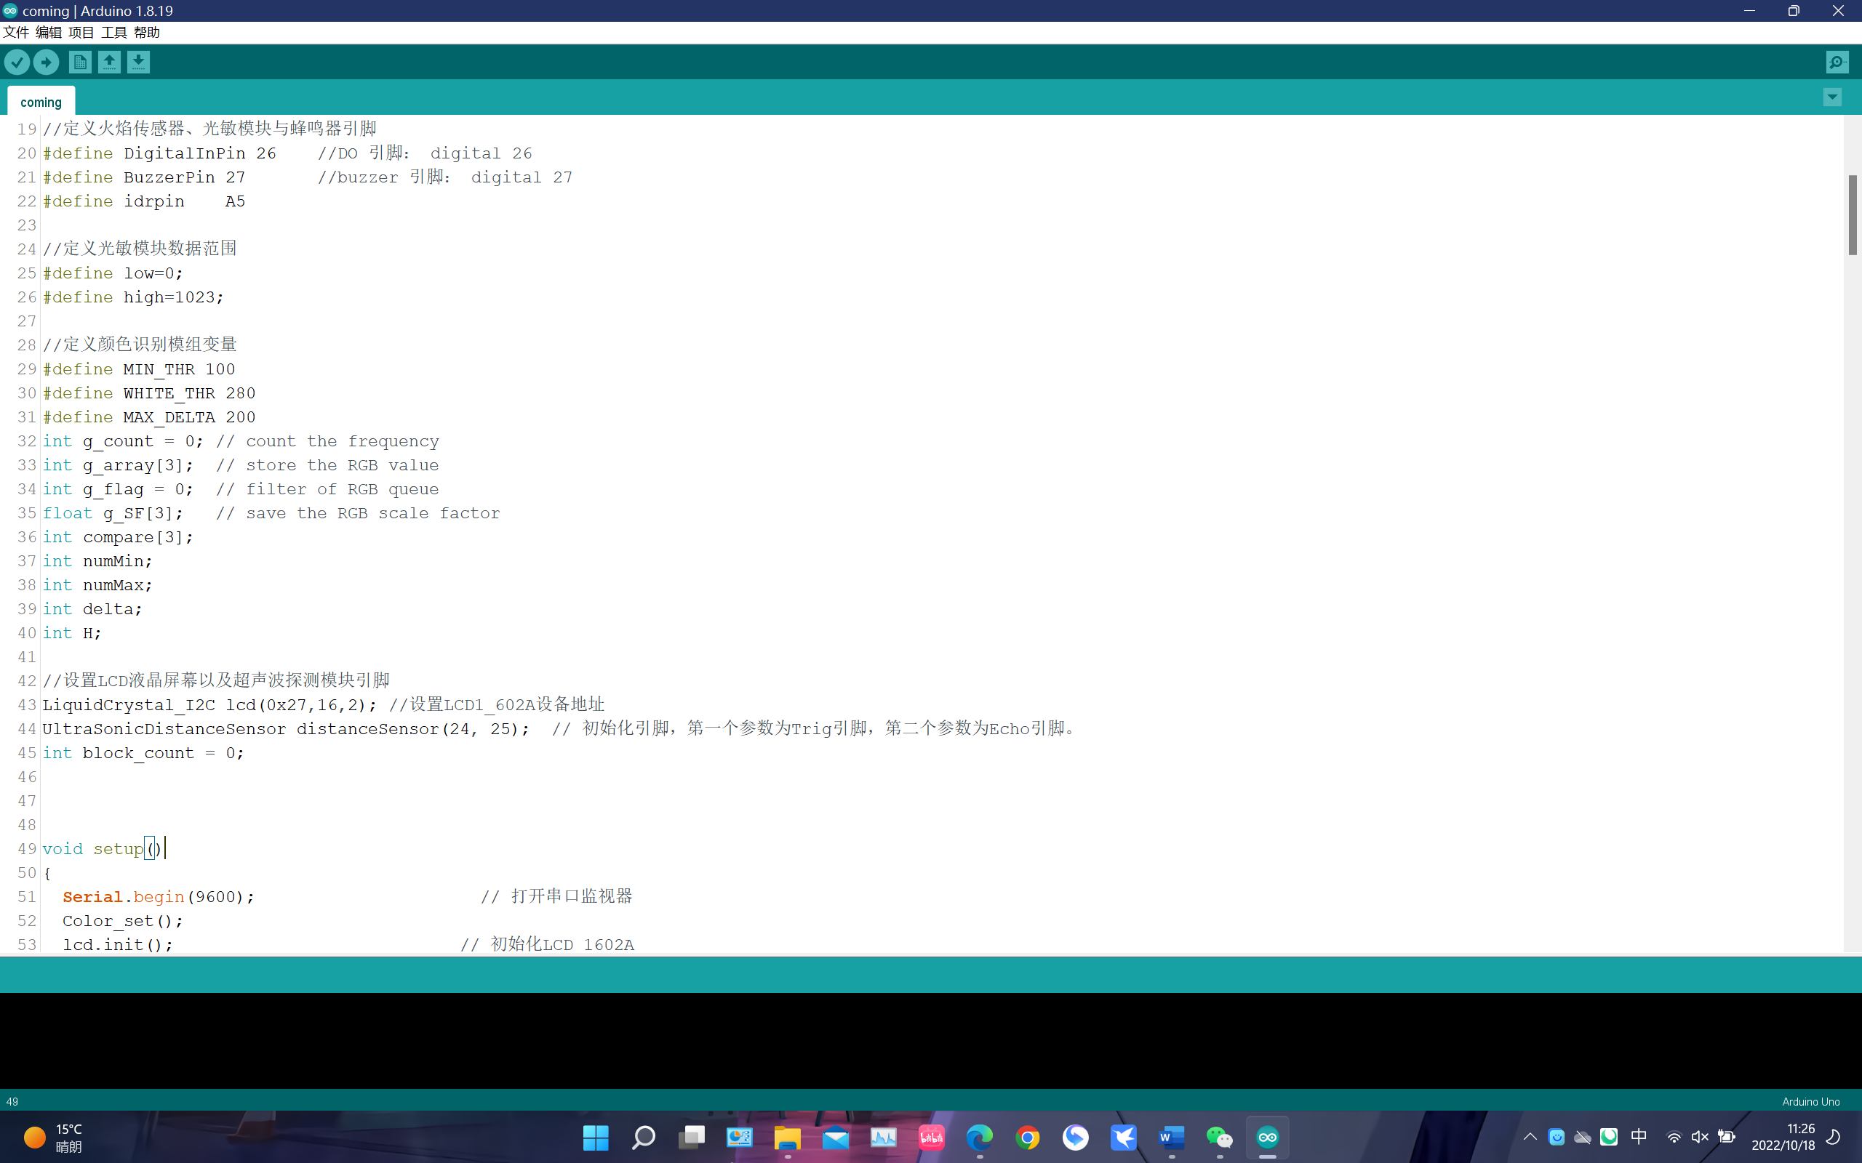
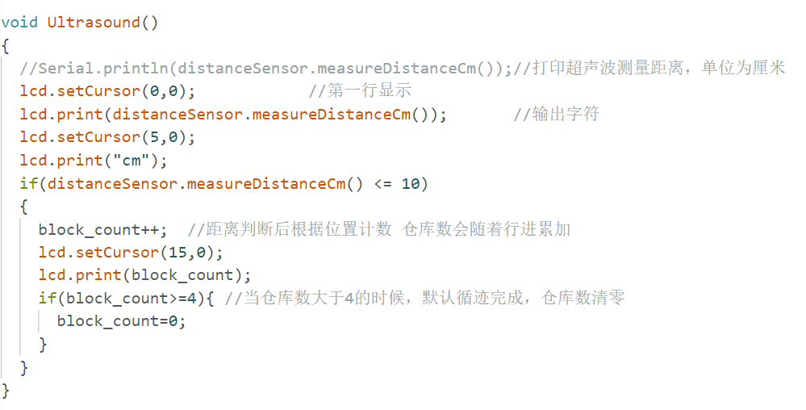
- LCD visualization
To show the comprehensive information about the warehouse to the manager of the warehouse, we display the temperature and humidity detected by the car, the distance from the object, and the color detection results on the LCD screen of the car, which is convenient for the supervisor to gather such information.
The code is shown below:
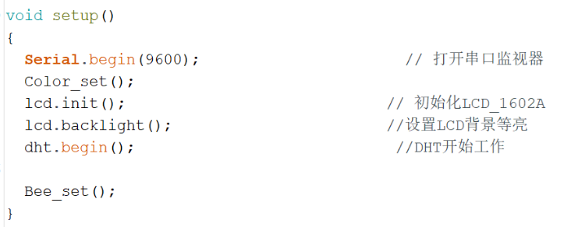
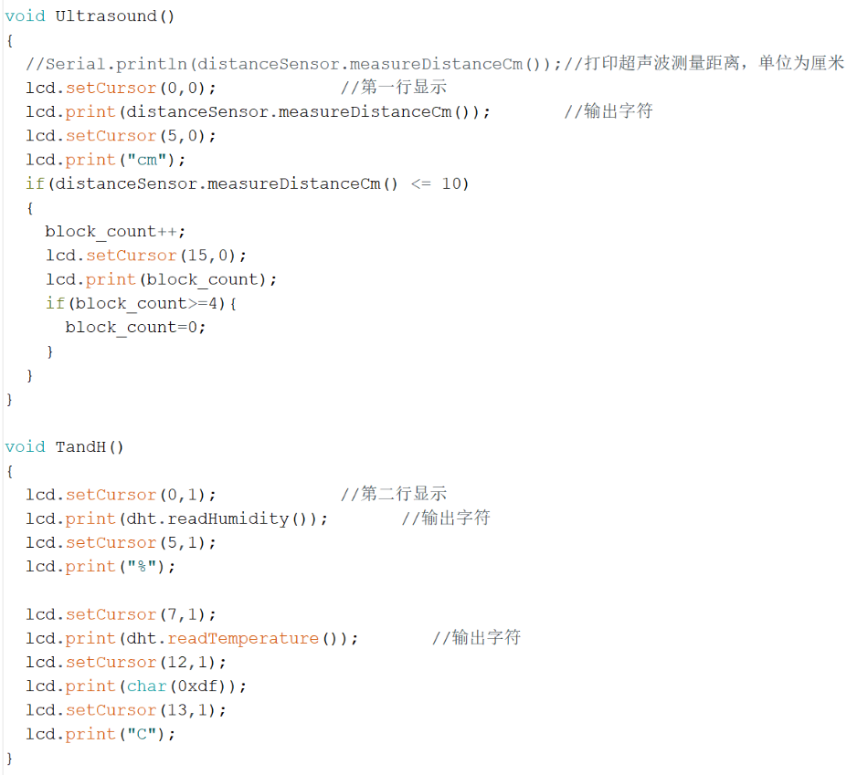
- Wi-Fi connection upload
This part is the most significant one. For further information gathering and warehouse managing, we have designed the Wi-Fi transmission module to upload information like the temperature, humidity, the color of the goods, the distance to the object, and abnormal conditions (fire, light) to the database of cloud platform by the. json format file. Warehouse managers can view such information on the software.
The code is shown below:
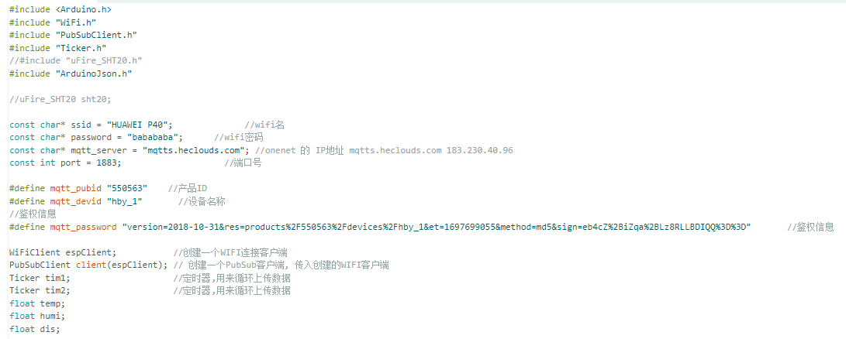
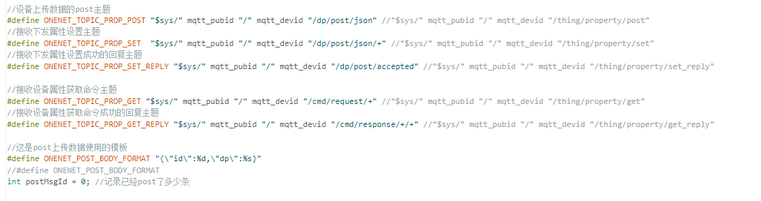
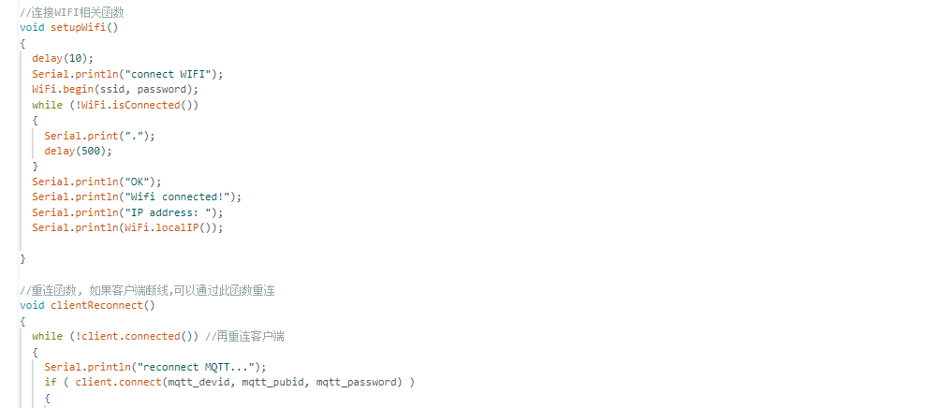
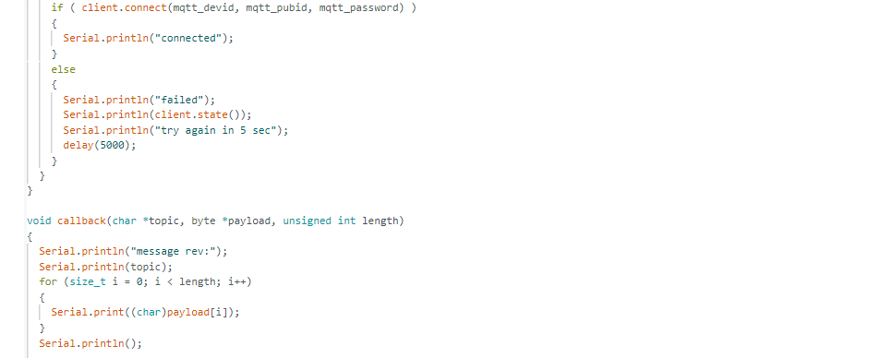
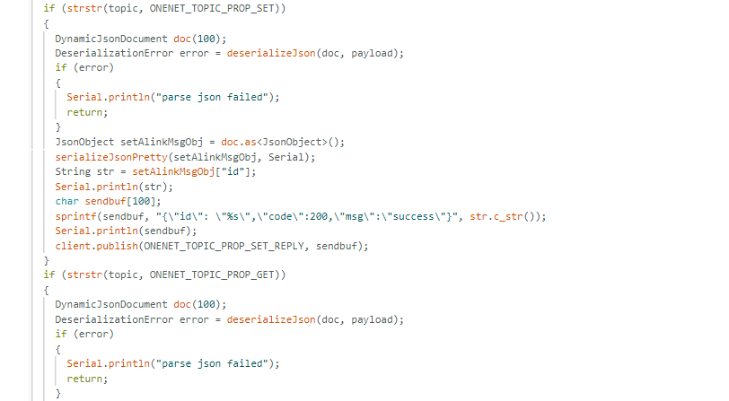
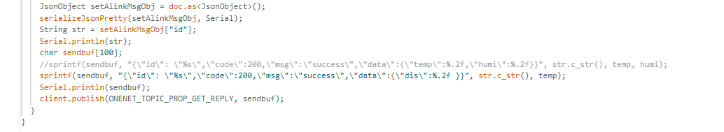
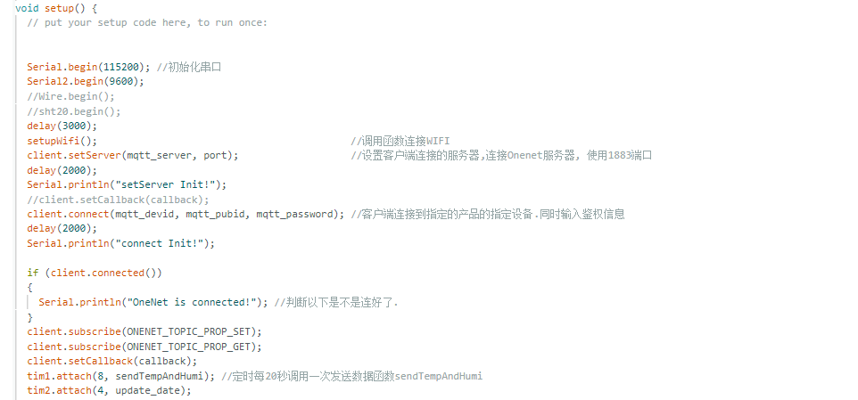
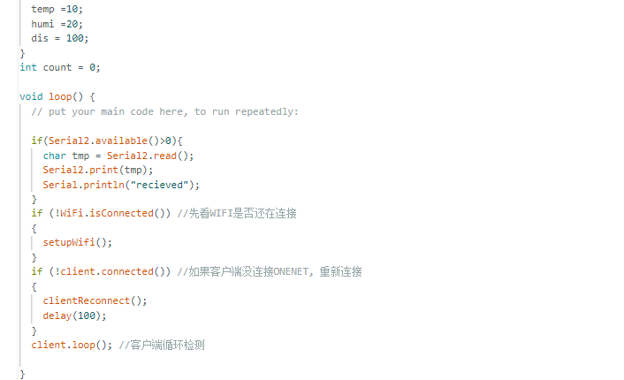

- Other innovative points

- Data transfer platform – OneNET
OneNET is dedicated to building an efficient, stable, and secure application platform between IoT applications and real devices. The platform adapts to a variety of network environments and common transmission protocols, providing fast access solutions and device management services for various hardware terminals. It also provides rich APIs and data distribution capabilities to meet the development needs of various industry applications, enabling IoT enterprises to focus more on their own application development.

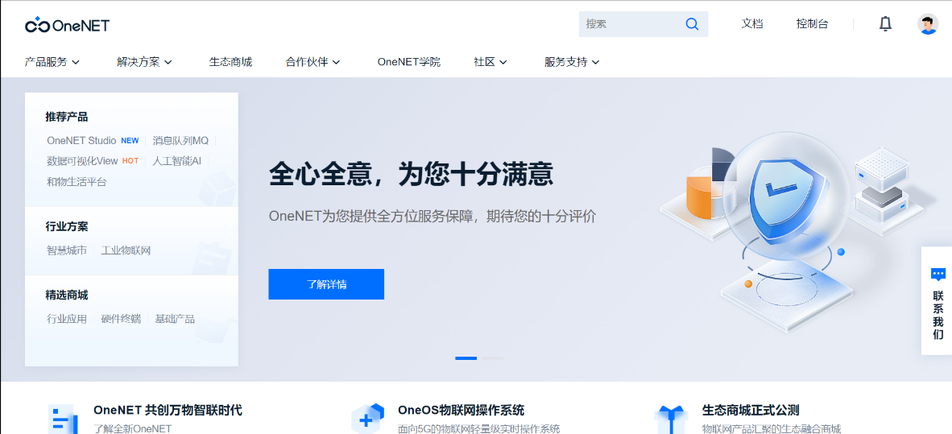

MQTT IoT Suite is a function of OneNET, which provides developers with effective, creative, and safe device access services. While meeting the needs of multiple application scenarios, it ensures reliable data transmission.
We choose the MQTT IoT Suite service as a transit point for data collection and writing to the database. We guarantee stable data transmission while using a more flexible Wi-Fi communication module, reducing the difficulty of interfacing Electronic Engineering and Management with IoT and E-commerce & Law.
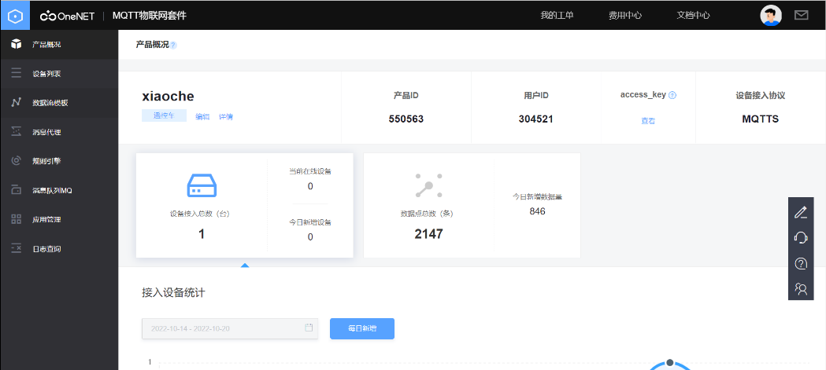
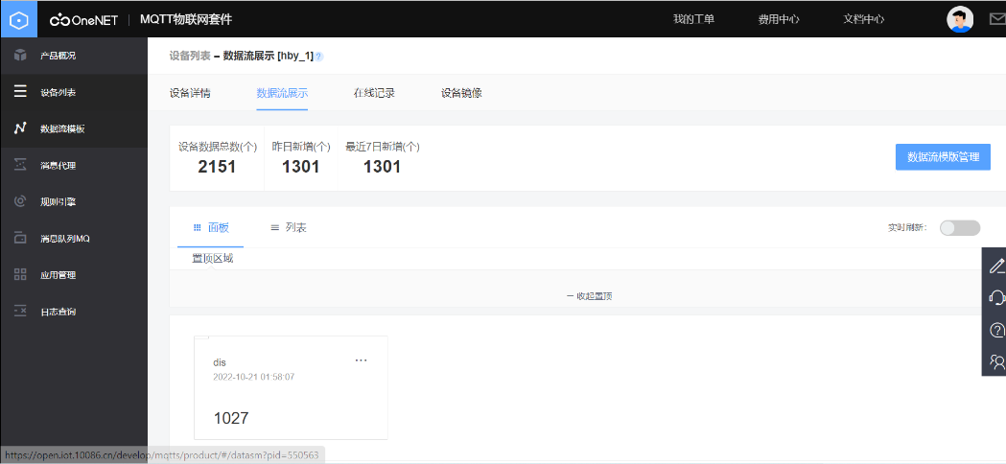
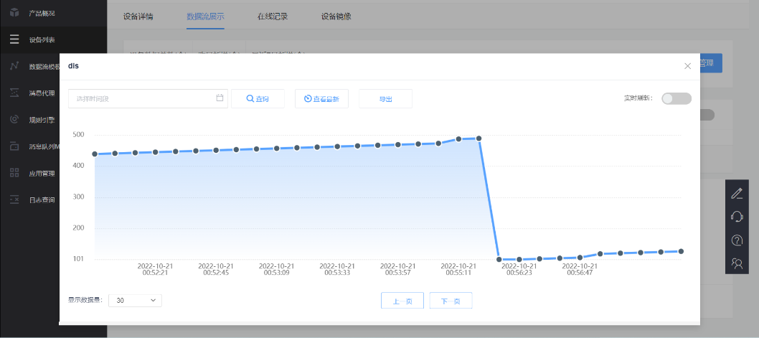
- Summary

All in all, this car has some advantages like a good-looking appearance, multiple comprehensive functions, automatically supervising the warehouse and responding to the manager on time, good data collection and updating, lower cost as well as better commercial use, etc. For the manager of the warehouse, this car just plays the role of a good assistant, like a jack of all trades.

Software
- Environment
Front End
"dependencies": {
"axios": "^0.21.1",
"echarts": "^5.3.3",
"element-plus": "^1.0.2-beta.52",
"vue": "^3.2.4",
"vue-cropperjs": "^5.0.0",
"vue-router": "^4.0.11",
"vue-schart": "^2.0.0"
},
"devDependencies": {
"@vue/cli-plugin-babel": "~4.5.0",
"@vue/cli-plugin-router": "~4.5.0",
"@vue/cli-plugin-vuex": "~4.5.0",
"@vue/cli-service": "~4.5.0",
"@vue/compiler-sfc": "^3.2.4"
},

Back End
<dependencies>
<dependency>
<groupId>org.springframework.boot</groupId>
<artifactId>spring-boot-starter-web</artifactId>
</dependency>
<dependency>
<groupId>org.mybatis.spring.boot</groupId>
<artifactId>mybatis-spring-boot-starter</artifactId>
<version>2.2.2</version>
</dependency>
<dependency>
<groupId>mysql</groupId>
<artifactId>mysql-connector-java</artifactId>
<scope>runtime</scope>
</dependency>
<dependency>
<groupId>org.projectlombok</groupId>
<artifactId>lombok</artifactId>
<optional>true</optional>
</dependency>
<dependency>
<groupId>org.springframework.boot</groupId>
<artifactId>spring-boot-starter-test</artifactId>
<scope>test</scope>
</dependency>
<dependency>
<groupId>com.baomidou</groupId>
<artifactId>mybatis-plus-boot-starter</artifactId>
<version>3.4.3.1</version>
</dependency>
<dependency>
<groupId>cn.hutool</groupId>
<artifactId>hutool-all</artifactId>
<version>5.8.5</version>
</dependency>
<dependency>
<groupId>com.auth0</groupId>
<artifactId>java-jwt</artifactId>
<version>3.10.3</version>
</dependency>
</dependencies>

- Website Function
(1) Home Page
Login as the worker or the administrator.


(2) Login
Enter the correct username and password to log in.
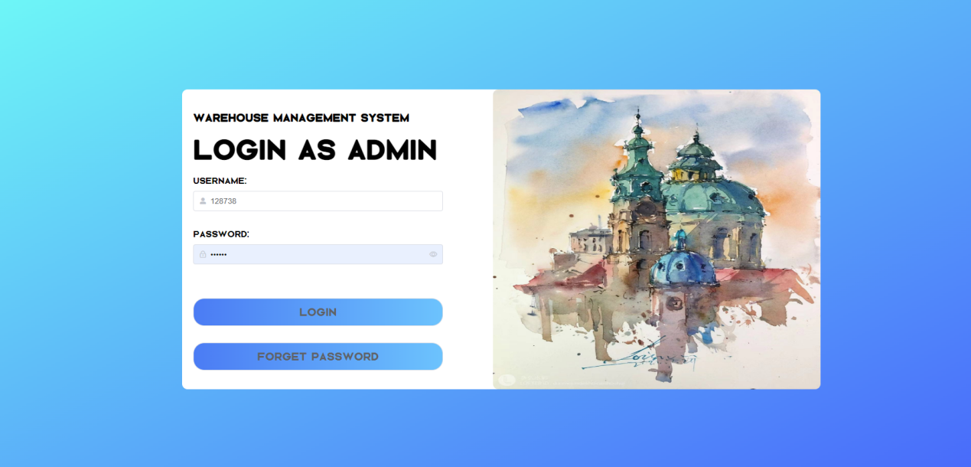
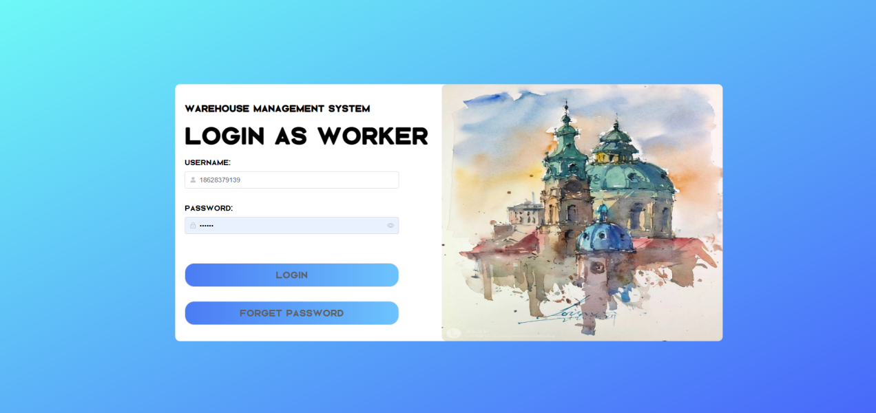

The password is hidden by default. But you can click the little "eye" button on the right to show your password.
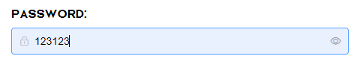
The length of the username should be between 5 and 10.
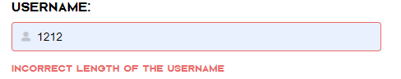
If the username and the password are not matched, you cannot log in.
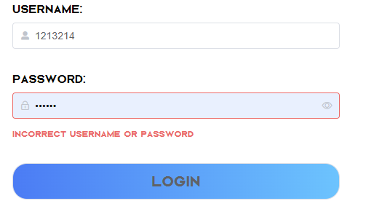

If you login successfully, the website will prompt you that you have successfully logged in.


(3) Change Password
Users can change their passwords by providing the correct telephone numbers.
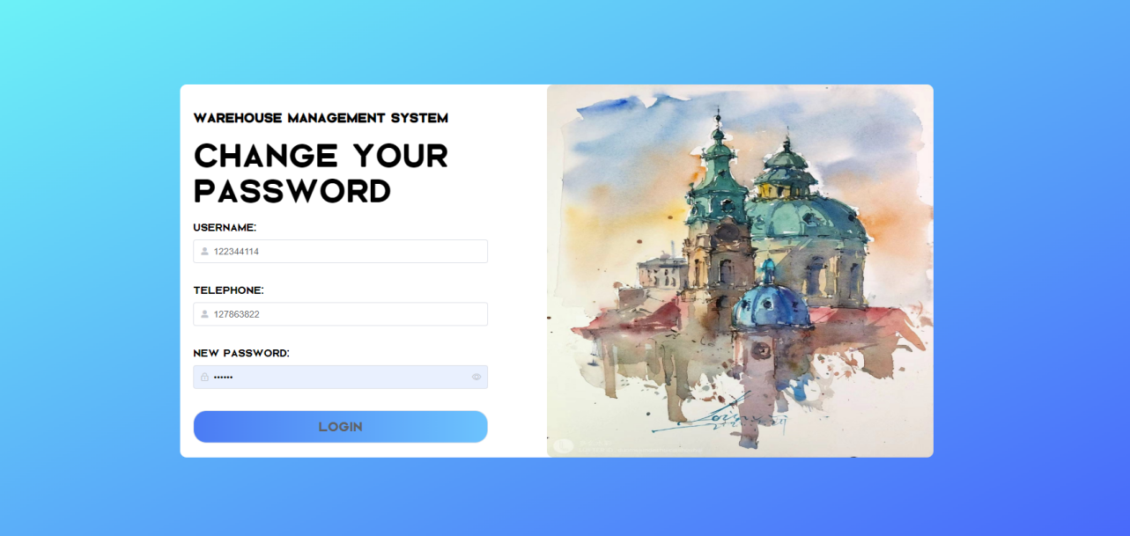

(4) Basic Interface Functions
We provide tags to switch between different pages.

Also, there are "close all" and "close else" functions on the right of the navigate bar.
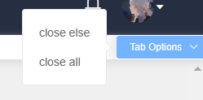

You can sign out by clicking the avatar.
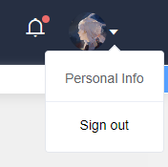

(5) Worker Interface Data Query
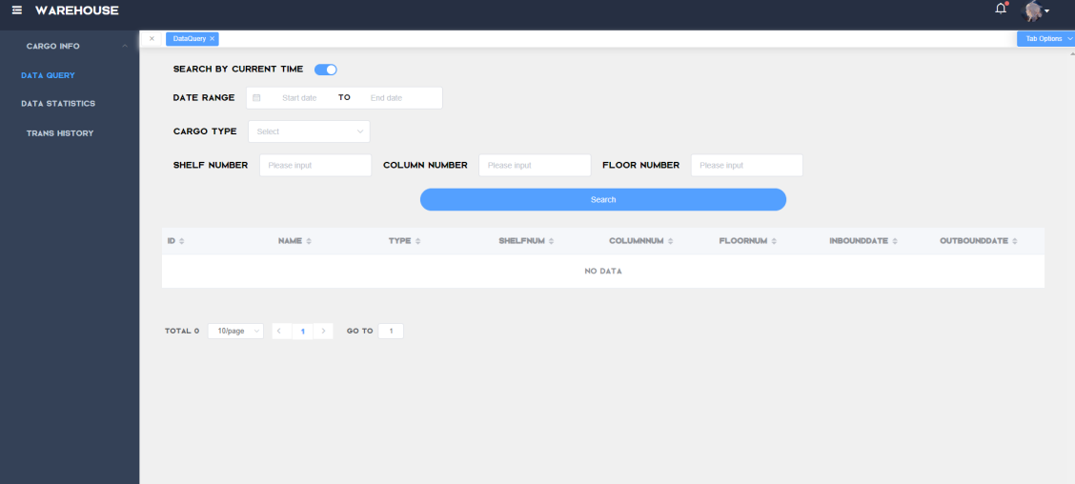
You can query by current date/any time, type of cargo, and location (shelf, column, floor). The query result can be paged, the number of data displayed on each page can be changed, and the page number can be mouse clicked or the specified number of pages can be entered directly to a page. Each column in the query result can be sorted (ascending/descending order).
(6) Worker Interface Cargo Information
When we search for type = red, shelfNum = 1, ColumnNum = 2, FloorNum = 3 during 2022-06-25 ~ 2022-07-01, the webpage can display the following information:
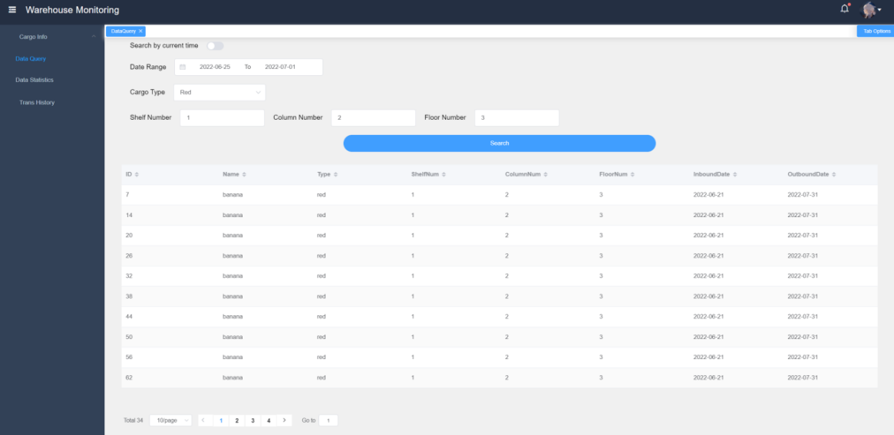
When we search all cargoes with type = green, shelfNum = 3, ColumnNum = 4, FloorNum = 5 by current time, the information will update to:
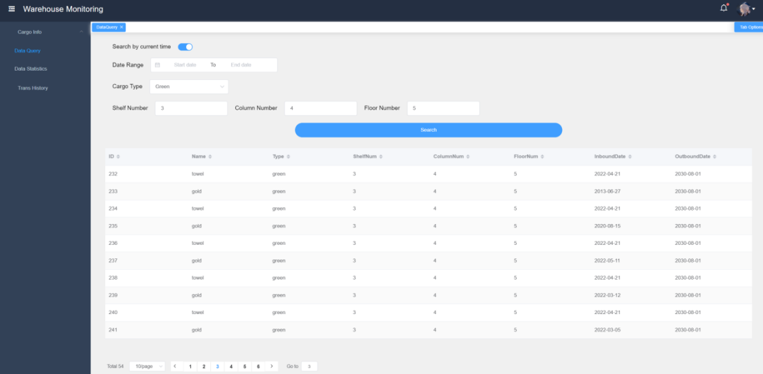
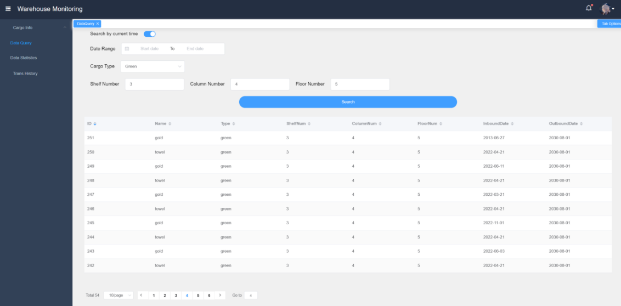

(7) Administrator Interface Create Warehouse
Administrator can edit and create workhouse by entering its ID.
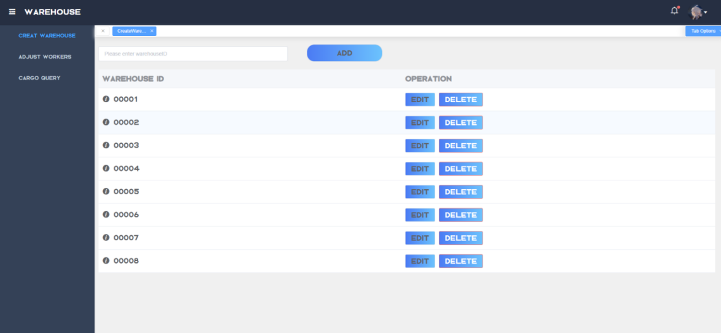

(8) Administrator Interface Adjust Workers
Administrator can add or delete workers, as well as edit their basic information.
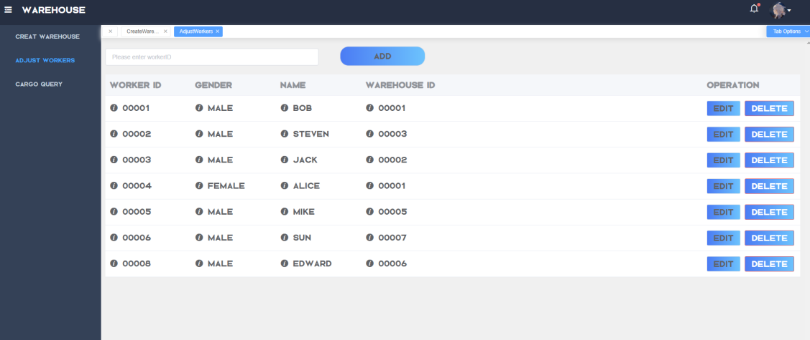
If we want to add a new worker with values (00009, Male, Jason, 00001):
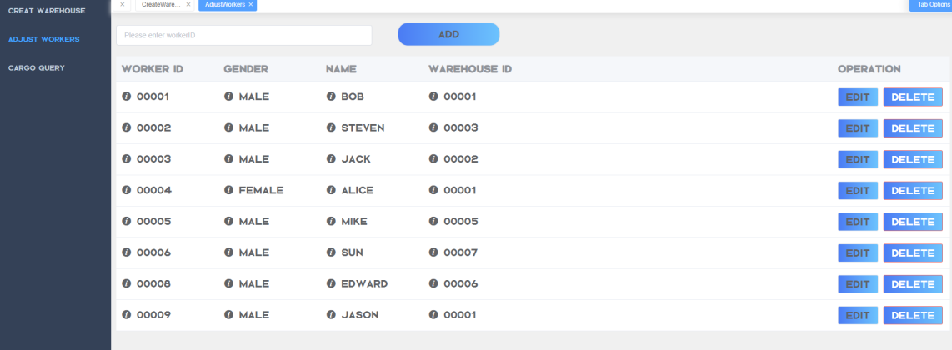
If we want to delete the worker whose ID is 00001:
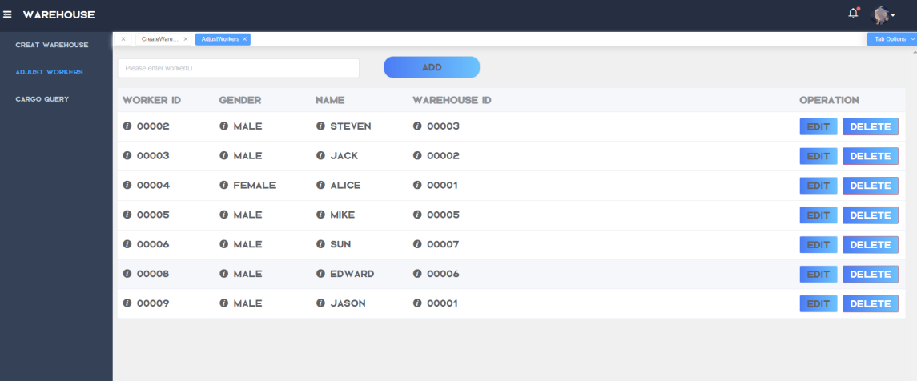

(9) Admin Interface Cargo Query
Same as workers, administrator can query the information of cargoes.
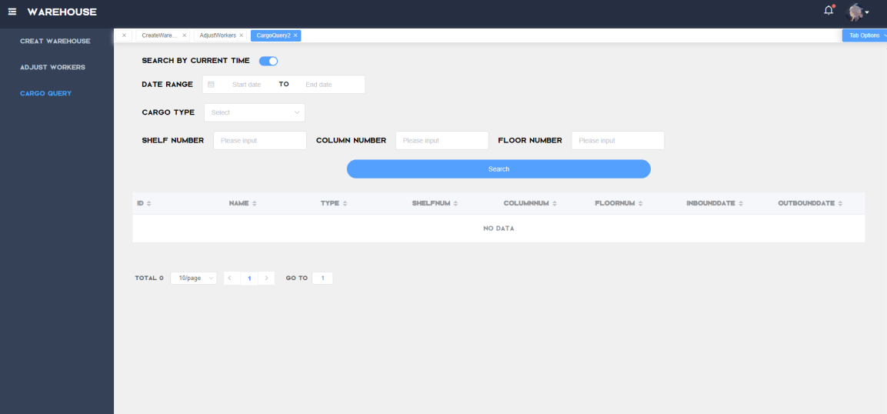

(10) Transmission History
If we want to display all transmission history, we can turn the page through changing the page number, which can be done just by mouse clicking or typing the specified page number to reach a certain page.
The query results can be sorted in each column (ascending/descending).
From the following pictures, 10 items are shown on one page (default).
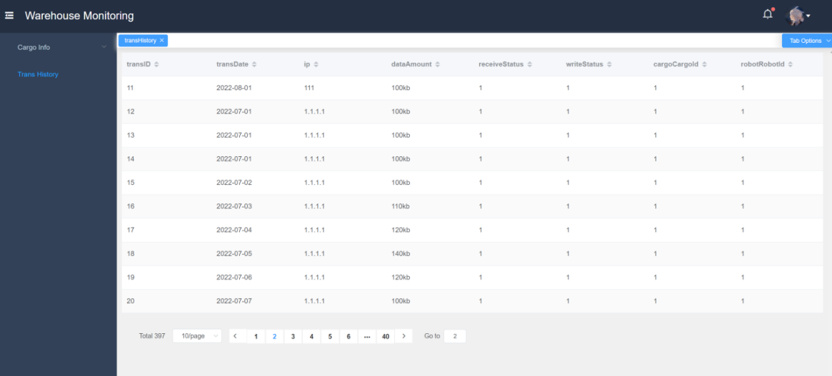
Then when the statistics are sorted by (dataAmount):
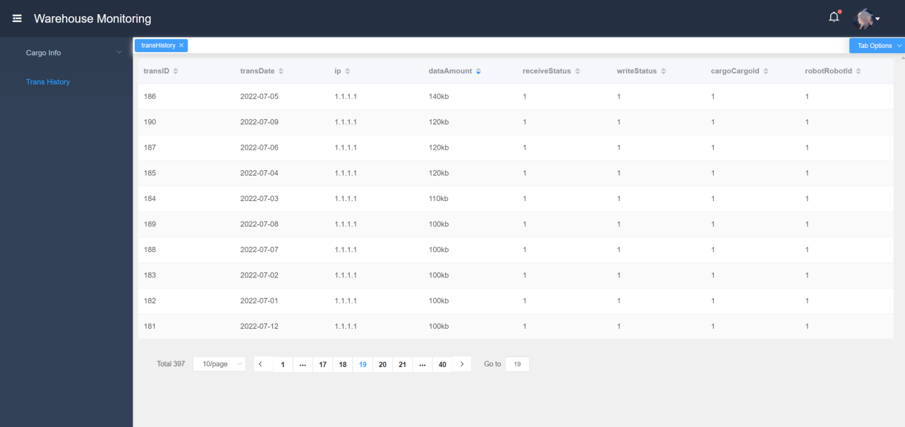

(11) Personal Information
The worker can also change his username, nickname, email, phone, address, and upload the avatar. It’s really personalized and aimed at satisfying all users.
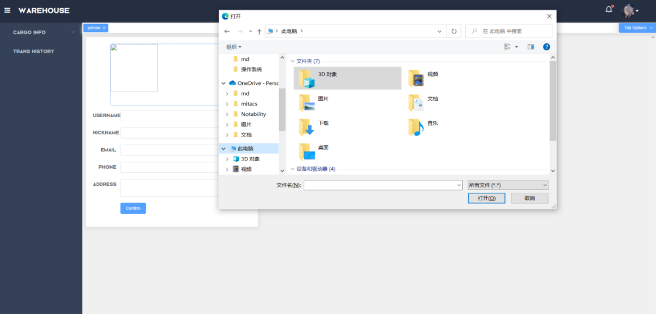

(12) Data Visualization
Workers can get a line chart of the change in the total number of cargoes in the warehouse every day for a specified period, a line chart shown the change in the number of cargoes of a certain category, a pie chart about the proportion of cargoes in different categories (taking the average of the period), and a line chart which displays the shift in the number of cargoes at different locations.

The following picture is a line graph, which visualize the shift about the total quantity of goods in the warehouse clearly when we select date range: 2022-07-07 ~ 2022-07-16.
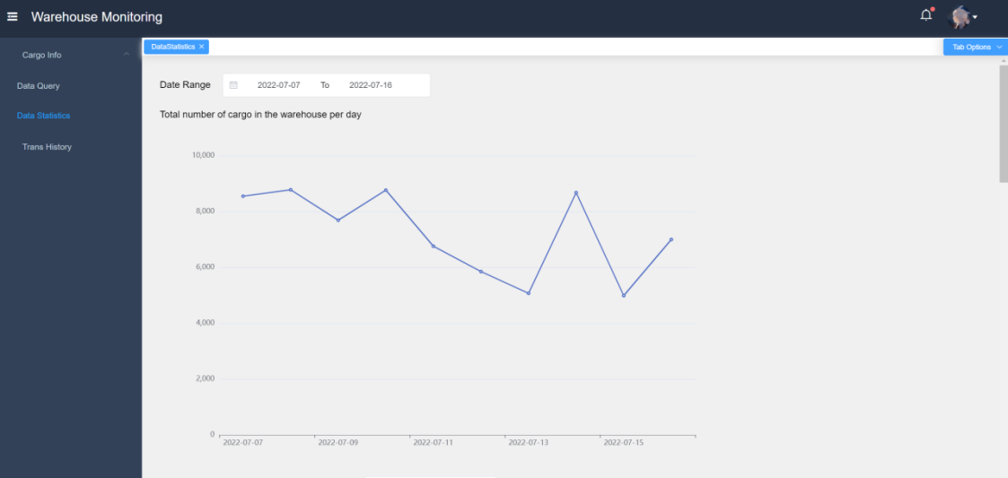
The following picture shows the realization of showing the change in the volume of a category of goods as time goes by.
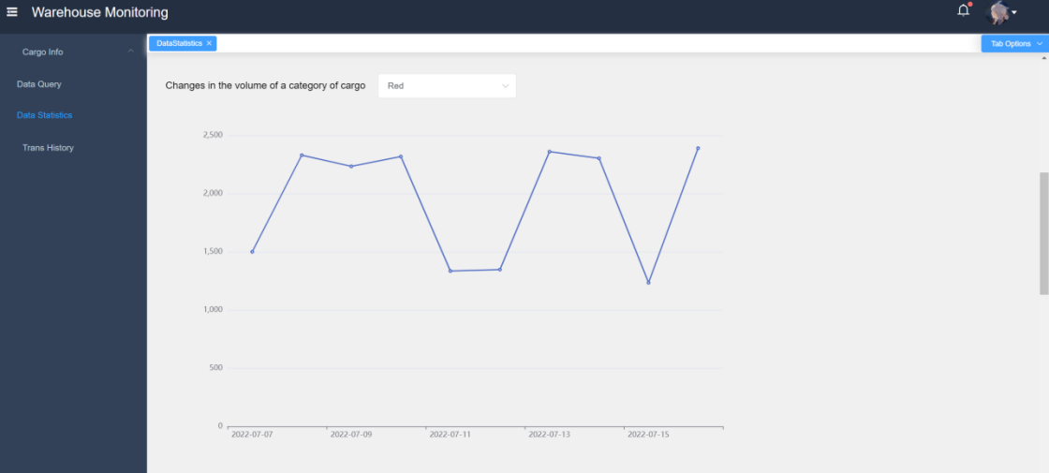
Also, we can still check out a pie chart about the proportion of goods in different categories. The different 5 colors stand for disparate cargoes. It’s definitely convenient for comparation and future plan about storing what kinds of goods.
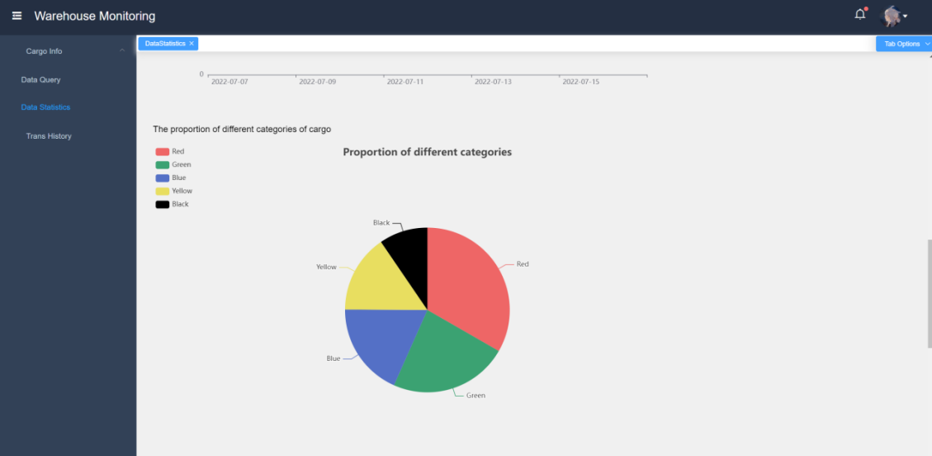
Finally, the change in the quantity of goods at different locations can be seen through the line graph, if typing the shelf number, column number, as well as the floor number.
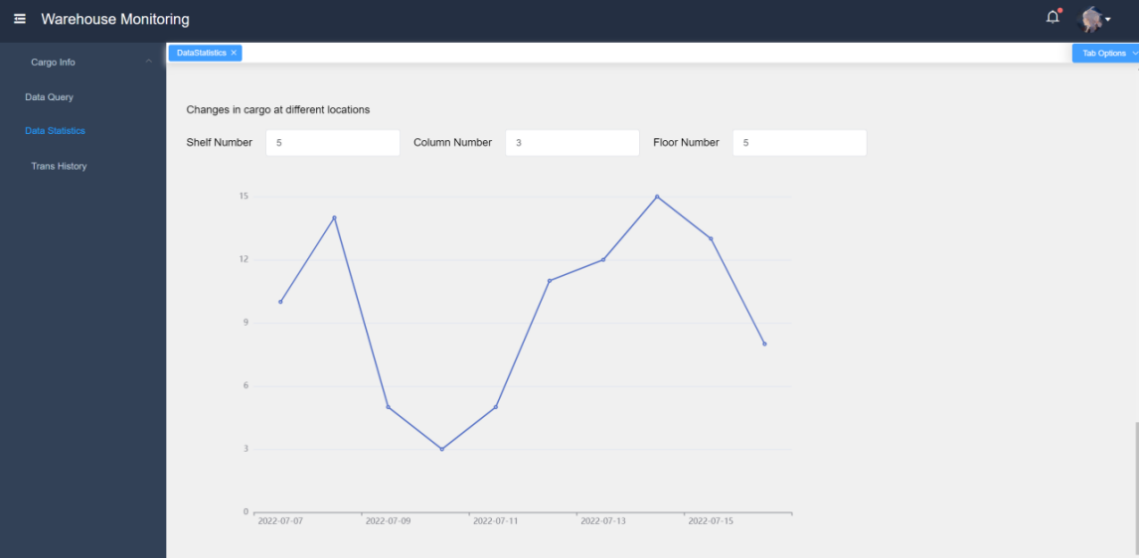

(13) Summary
To sum up, the webpage realizes multiply innovative functions:
- Data visualization by graph, chart, etc.
- Data shifting in real time transmitted by hardware.
- Have the same style of page, whether in login page or in warehouse monitoring page.
- User-friendly. Users can personalize their information, and for some elderly people or someone who has difficulty in remembering passwords, they can change their passwords quickly and use the page as normal.
- The layout is really fascinating and attractive, which can give users a comfortable experience. Also, the division of each module on webpage for workers and administrators is intuitive and clear.

Database
ER Diagram
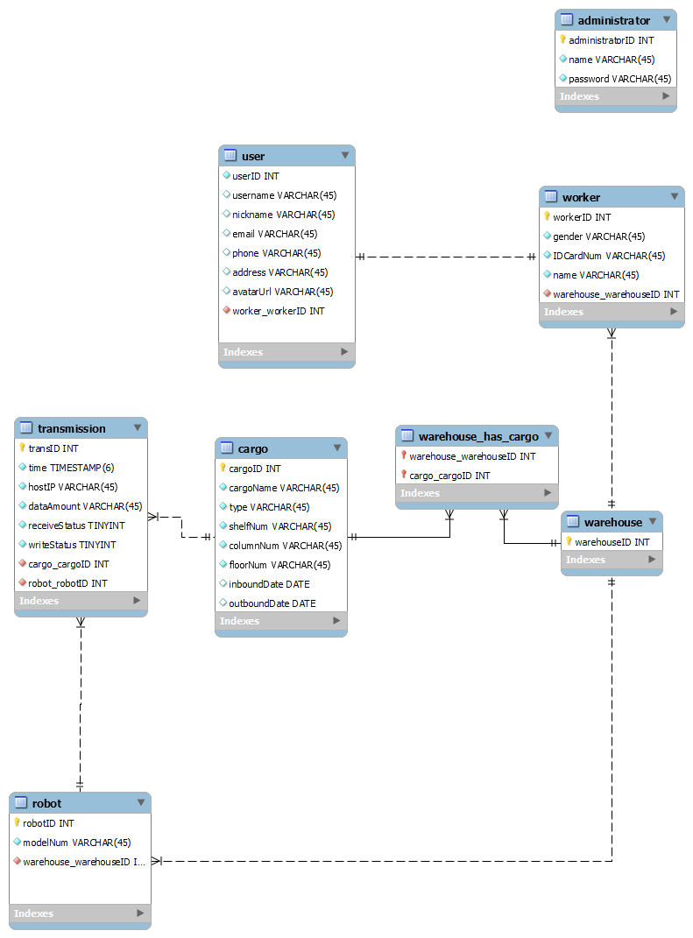

ER Explanation
IDs are primary keys and increase automatically.
(IoT) user: each worker is a user of the warehouse supervision system,
- userID
- username
- password
- nickname
- email
- phone
- avatarUrl
- worker_workerID: foreign keys are used to associate workers

(IoT) cargo: cargoes in the warehouse
- cargoID
- cargoName
- type
- shelfNum: shelf number of cargoes
- columnNum: column number to which the cargoes belong
- floorNum: floor number of cargoes
- inboundDate
- outboundDate

(IoT) transmission: transmission history
- transID: unique identification transmission record
- time: transmission time
- hostIP: IP address of the transmitter
- dataAmount: data size
- receiveStatus: receiving status (1: success, 0: failure)
- writeStatus: write status (1: success, 0: failure)
- cargo_ CargoID: cargo ID associated with foreign key
- robot_ RobotID: the robot ID sent and transmitted by foreign key association

(IoT) robot: robot car
- robotID
- modelNum: robot model number
- warehouse_warehouseID: warehouse ID to which the robot belongs
- warehouse：(e-com) warehouse

(e-com) worker: worker's personal information
- workerID
- gender
- IDCardNUm
- name
- warehouse_warehouseID

(e-com) administrator: administrator’s personal information
- administratorID
- name
- password

Business Analysis

Design Concept and Advantages
- Humanized design
Our web page does not have a miscellaneous installation process, customers just need to visit the link to jump to our page. In addition, our web page also carries on the visualization technology management to the warehouse, which means real-time changes in the warehouse and shelf information changes can be reflected in our web page, so that it is convenient for users and managers to query.
- Simplicity of operator
Our website is aimed at all audiences, including the elderly who are weak in using computers, therefore the operation process needs to be concise and clear, so as to remove the hidden danger that some groups have difficulty in using the web page.

PESTEL Analysis
- Political
In recent years, China has issued "the Implementation Opinions on Internet Efficient Logistics", "the Opinions on Further Promoting the Cost Reduction and Efficiency Enhancement of Warehouse to Promote the Development of the Real Economy", "the Opinions on Promoting the Coordinated Development of E-commerce and Express Logistics", "the Implementation Plan for Promoting the Deep Integration and Innovative Development of the Logistics and Warehouse Manufacturing Industry" and other policies vigorously encourage and support the intelligent logistics equipment industry, with the goal of further reducing the total logistics cost of the whole society and improving the warehouse efficiency, providing a good policy environment for China's intelligent logistics and warehouse equipment industry.

- Economic
The number of newly registered enterprises in China's intelligent warehousing industry has increased from 101 in 2018 to 4015 in 2022. It is expected that the proportion will again increase in the future. The rapid development of China's logistics industry has provided a huge market demand for the rise of the warehousing industry. In addition to the release of outsourcing demand and policy guidance of the manufacturing industry and trade circulation industry, the strategic position of intelligent warehousing will continue to be strengthened. In the future, the demand for intelligent warehousing market will be further released. It is estimated that by 2023, the scale of the intelligent warehousing market will reach 197.5 billion yuan.

- Sociocultural
Intelligent warehouse is the product of warehouse automation and a link in the logistics process. From a social point of view, numerous industries in China have launched intelligent warehouse management systems, such as auto parts, hardware, electronics, machinery, food, medicine and other industries. The application of intelligent warehouse ensures the speed and accuracy of data input in all links of cargo warehouse management, so that enterprises can timely and accurately master the real data of inventory, and reasonably maintain and control enterprise inventory.
Plus, in society, with the increase in land use costs and labor costs, storage costs have also increased significantly. Thus, the cost reduction and efficiency enhancement are the core of the future development of China's storage industry.

- Technological
The development of Internet of Things technology and 5G technology has realized the remote monitoring and maintenance of the logistics equipment system and improved the utilization rate and operation and maintenance efficiency of the intelligent transmission and sorting system. The industrial IoT network will soon become an essential part of efficient warehouse management and will provide the connections and data that intelligent warehouses rely on.
Big data can collect data in real time, improving the automation degree, operation efficiency and accuracy of intelligent transmission and sorting equipment, which is the development direction of future industry technology.

- Environmental
In recent years, China's intelligent warehousing scheme has enjoyed a strong momentum of going to sea, and the first echelon of logistics robot enterprises have made remarkable achievements. Typical countries and regions going to sea include the United States, Europe, Australia, Japan, South Korea, etc., which are mainly concentrated in areas with large demand for warehousing and logistics automation, such as high warehouse rent, commercial development, high labor costs, and low labor efficiency.
Therefore, China's cross-border e-commerce is in the window period of rapid development, and the demand for overseas warehouses is growing rapidly. The demand for warehousing automation market is huge.

- Legal
In recent years, our government and industry competent departments have attached great importance to the development of intelligent logistics and warehousing equipment industry.
The Ministry of Industry and Information Technology and other competent departments have successively issued a series of legal documents to vigorously support the development of the industry. For example, the Guidelines for the Construction of the National Intelligent Manufacturing Standard System, issued in August 2018, provides legal norms for intelligent logistic standards, mainly including intelligent warehousing standards such as material identification, material storage location allocation, operation status and equipment status control, and real-time cargo monitoring.

SWOT Analysis
- Strength
We are a newly established 10-person company with low development costs.
Our system is user-oriented and can distinctly show the goods in the warehouse on the web page, which is easy for customers to use.
Our warehouse management system simulates the real warehouse situation and is professionally designed. We utilize various sensors for goods identification, environmental monitoring, and emergency control.
- Weakness
The stability and creativity of our product still need to be improved.
At present, our system has only developed the web version, without expanding the function into application on cellphones for realizing better convenience.
- Opportunity
In the initial stage of entering the market, we can attract more users with a relatively low price.
In addition to updating and maintaining our system, we can also find investors and sponsors who are interested in our project.
We can combine with major supermarkets and apply the system in supermarket sales, so as to increase the number of customers.​
- Threat
As the number of companies developing warehouse management systems increases year by year, our competitors increase, too.
To win more market share, we need to invest a lot of money and manpower to do the publicity, but it is a huge cost for our tiny company of ten people.
The increase in competitors means that we must be creative as soon as possible or we will lose market competitiveness.

Competitive Analysis
- User Friendly View
Our website is user-friendly. As a user, if you want to view the goods in the warehouse, you can log on the website directly, and follow the information prompt on the web page to operate. You can query the warehouse number, shelf number, price, and additional information about the goods you need easily, which is helpful for you to check every feature about the goods.
- Maintainability View
Our company's website can update and iterate information in real time. If you encounter difficulties in using the website, you can call the consultation number to provide advice or seek help for our company's products. Also, the hardware to detect the goods is stable and durable.
- Prospect View
The tenet of our company is to put customers first. We will uphold the tenet of our company and provide customers with as much help as possible.

4P Strategy
- Product
Our product is the application of an intelligent warehouse management system, which ensures the speed and accuracy of data input in all links of cargo warehouse management, so that enterprises can timely and accurately master the real data of inventory, and reasonably maintain and control cargo warehousing.
- Price
When the enterprise is small and the warehouse area is around 2000 square meters, a customized simple warehousing system can be used. The price of such a warehousing system is commonly tens of thousands to hundreds of thousands of yuan, which can realize the systematic and information-based management of warehouse.
When the enterprise expands to medium scale or above, the price of a customized system usually needs between 100000 and 500000, depending on the functional category, difficulty, development workload, pricing, and positioning of service providers, etc.
- Promotion
Set up offline experience stores to attract more customers to experience our warehousing system on the spot.
Cooperate with e-commerce websites to insert our product links on the website interface.
Offer discounts to customers who purchase products early in the product launch.
Provide VIP service for users who have use our warehousing system for a long time.​
Multiple payment methods are supported. Users can pay by installment or with credit card.
Provide after-sales services, such as door-to-door delivery, free installation, free warranty service and return service within a certain period.
- Place
First of all, we start our business in the first-tier cities with developed logistics and e-commerce industries. Then we expand the business, establishing subsystems in other cities.

Meeting Management

The Timeline
- Electronic Engineering and Management

During the D&B class
8.22 Attend the class to meet with group members and understand project requirements roughly. After taking lessons from professors, group discussion is built to search the detailed information, then learn about Arduino, such as programming language and theory of each sensor. Set clear goals for each day and start assembling the infrastructure of the car.
8.23 Continue to learn about Arduino, implement some of the functions, such as sensing the temperature and humidity, recognizing colors and so on. Achieve initial integration of codes.
8.24 Realize all functions and continue to optimize them, making sure that each function can be well-operated independently.
8.25 Combine all functions and attach them to the hardware together, especially the tracking function. Begin to test and debug. Design a good look for the hardware.
8.26 The Chinese teacher check our car, seeing how it works. Hand in our source codes, video, and slides.
After the summer vacation
9.2 ~ 9.3 Continue learning about Arduino. Purchase innovative components to improve the realization of functions, as well as the steadiness of manufacturing. Email our progress to our Chinese teacher.
10.8 ~ 10.14 Get in touch with teammates in other majors. Ensure the successful operation of all functions in the hardware and enable wireless data transmission using Wi-Fi.
10.15 ~ 10.20 Realize sending information to website in real time. Continue to debug the code and improve the manufacturing. Complete the final report and hand in all materials we have done.

- E-commerce and Law
7.3 Learn relevant theoretical knowledge of html, css and java web.
7.4 Learn to build a simple web project without connecting to the database
7.5 Learn to build a simple web project that connects databases. Design the database together with the IoT major. On this basis, start to realize login, logout, and query functions.
7.6 Realize warehouse information addition, deletion, and modification functions.
7.7 Integrate the code to create a simple website, and the Chinese teacher carried out the mid-term acceptance.
7.8-9.20 Improve site functionality and user experience, improve site quality.
9.20-10.20 Start integrating the components together and produce a complete system.

- IoT
7.3 Discuss what we should do, and elementarily allocate task.
7.4 Decide the EER model.
7.5 Design the relationship.
7.6 Partly decide the port.
7.7~7.20 Start coding.
7.23~9.1 Start to design the website.
9.1~9.10 Do trimming to our code.
9.11~10.20 Combine our result with members in other majors.

Minutes of Meeting
- Electronic Engineering and Management

- First Meeting
Date/Time: 22nd, August 2022, 4:00 p.m.
Location: S1 Teaching Building
Present: All students in our group
Leader: Tangxun Wu
Proceeding:
1. List all the tasks that should be done recently, including programs and hardware.
2. Divide work for individuals and make a clear timeline.
3. Check every component after distribution and see if everything can work normally.

- Second Meeting
Date/Time: 25th, August 2022, 9:30 a.m.
Location: S1 Teaching Building
Present: All students in our group
Leader: Tangxun Wu
Proceeding:
1. Assemble the hardware to form the car and decorate it.
2. Test the codes and see if there is any improvement that can be done.

- Third Meeting
Date/Time: 3rd, September 2022, 3:00 p.m.
Location: WIN basement of BUPT
Present: All students in our group
Leader: Tangxun Wu
Proceeding:
1. Improve the basic functions, especially the tracking function.
2. Determine what should be further accomplished.

- E-commerce and Law

- First Meeting
Data/Time：3rd July 2022, 4:00 pm
Meeting form: online meeting
Present: all e-commerce major students
Major Leader: Jingru Dai
Proceeding:
1. Unified development environment.
2. Define tasks for each phase.

- Second Meeting
Data/Time：4th July 2022, 4:00 pm
Meeting form: online meeting
Present: all e-commerce major students
Major Leader: Jingru Dai
Proceeding:
1. Define the functions to be realized.
2. Clarify the division of labor and assign the functions to be realized by everyone.

- Third Meeting
Data/Time：5th July 2022, 4:00 pm
Meeting form: online meeting
Present: all e-commerce major students
Major Leader: Jingru Dai
Proceeding:
1. Discuss the entity and attribute necessary for the database.
2. Discuss the problems encountered in the realization of functions.

- Final Meeting
Data/Time：6th July 2022, 4:00 pm
Meeting form: online meeting
Present: all e-commerce major students
Major Leader: Xianglong Qin
Proceeding:
1. Introduce the final code, explain the principle of the code and the knowledge used.
2. Prepare for the interim acceptance.

- IoT

- First Meeting
Time: 3rd July 2022, 1:00 pm
Meeting form: Zoom
Present: All IoT students
Leaders: Yifan Yang
Proceeding:
1. Discuss what should we do.
2. Allocate the task into pieces.

- Second Meeting
Time: 5th July 2022, 9:00 am
Meeting form: Zoom
Present: All IoT students
Leader: Zhuoheng Han
Proceeding:
1. Discuss what kind of data should we provide and what we will accept.
2. Discuss the function realization.
3. Solve the problems in coding.

- Third Meeting
Time: 8th July 2022, 9:00 am
Meeting form: Zoom
Present: All IoT students
Leaders: Yifan Yang
Proceeding:
1. Discuss the relationship between variables.
2. Decide the relation between webpages.

- Forth Meeting
Time: 10th July 2022, 9:00 am
Meeting form: Zoom
Present: All IoT Students
Leaders: Zhuoheng Han
Proceeding:
1. Run the entirety code.

- Overall

- First Meeting
Date/Time: 7th, October 2022, 4:00 p.m.
Location: WIN basement of BUPT
Present: All students in 3 groups
Leader: Tangxun Wu
Proceeding:
1. Every group report what have done and what should be done.
2. Listing corporate works, like program docking, advertisement making.

- Second Meeting
Date/Time: 16th, October 2022, 4:00 p.m.
Location: WIN basement of BUPT
Present: All students in 3 groups
Leader: Tangxun Wu
Proceeding:
1. Finish program docking among 3 groups and test the achievement.
2. Allocate the tasks like report writing, appearance designing and program improving to fully prepare for the final check.

Workflow
Electronic Engineering and Management:
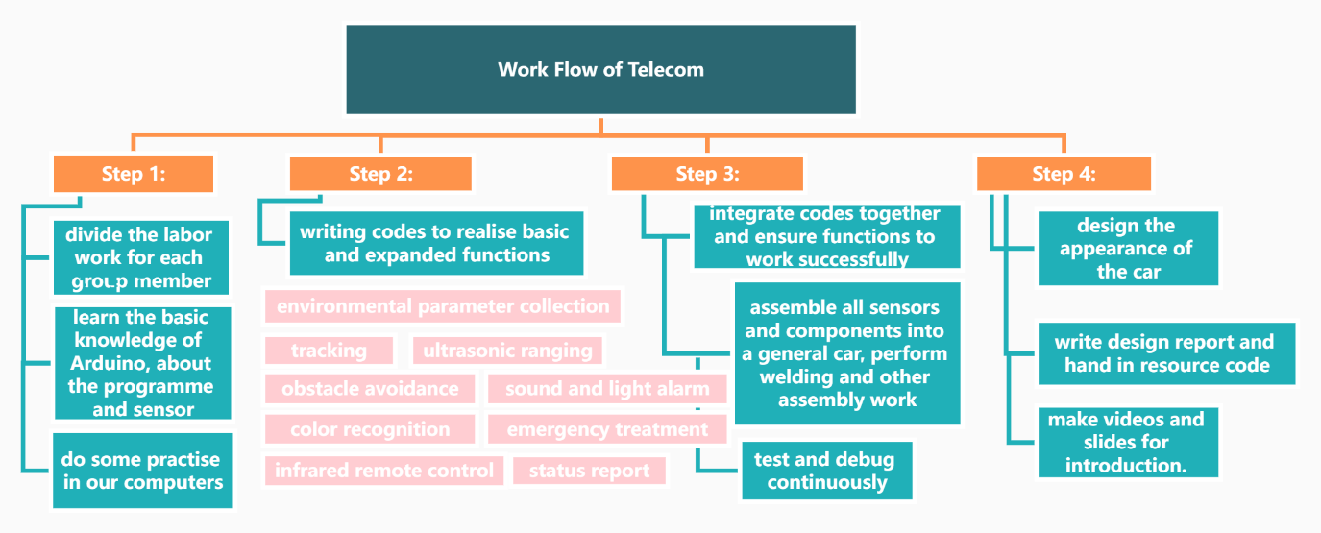

E-Commerce and Law:
Step 1: In the early stage of the project, we learned HTML, JAVA-servlet, eclipse, and MySQL. Step 2: We laid a foundation for the writing of early web pages and used that software to write early versions of web pages, such as the functions of adding, deleting, modifying, and querying warehouse shelves. SQL language (workbench) was used to compile the database.
Step 3: In the later stage, under the premise of realizing the basic functions, the optimization of web page aesthetics.

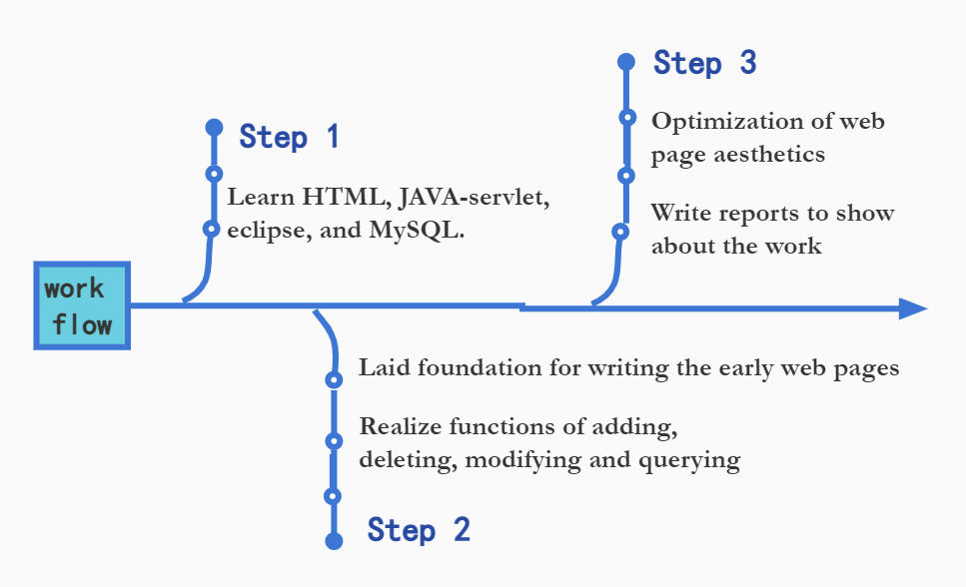

IoT:
Step1: Learn SQL, Spring frame, and even Go (at first we want to use this, but give up later)
Step2: Decide the option we should do
Step3: Initially complete
Step4: Page optimization

Division
- Hardware (Electronic Engineering and Management)

Individual Member 1 Contribution: <Tangxun Wu (Leader)>
Software and hardware realization of temperature and humidity sensor, color sensor, flame sensor; Implementation of infrared obstacle avoidance system; Assist to assemble hardware and code modification debugging; Responsible for hardware appearance and PPT modification; Adjust the working process and assign tasks to group members in three majors; Complete the draft of advertisement and integration of report.

Individual Member 2 Contribution: <Boyang He>
Realizes the ultrasonic ranging module and infrared remote-control module; Integrate ultrasonic and temperature and humidity sensor modules; Use LCD to display information about color, distance, location, humidity, and temperature; Integrate all the sensors into hardware, and connect the codes; Responsible for wireless communication module, transmitting data to the webpage.

Individual Member 3 Contribution: <Dongze Sun>
Software and hardware implementation of the photosensitive module; Combination of photosensitive module and buzzer to realize the over-brightness alarm; Test the vibration module; Debug the driver module and the Bluetooth module; Test the infrared remote control and tracking module.

Individual Member 4 Contribution: <Weiping Kong>
Perform circuit welding and wiring optimization; Debug infrared tracking; Test collision sensor; Debug Bluetooth module to achieve information transmission; Test infrared remote control and tracking module; Appearance design and manufacture; Shoot video materials.

Individual Member 5 Contribution: <Guanyi Lin>
Online using simulation tools to complete ranging and other code writing and wiring; Consult and share relevant data of Bluetooth, infrared remote control, LCD, and buzzer, and assist offline team members in their work; Complete the first version of the PPT report; Make the video for presentation.

- The Website Application (e-Commerce)
The e-commerce major is mainly responsible for designing databases with IoT students and creating web applications with the following functions:
1. Allow administrators to log in and log out.
2. Allows administrators to create warehouses and add/delete workers in the system.
3. Display the goods status (such as goods location) and information (such as goods type) of each warehouse.

Individual Member 1 Contribution: <Jingru Dai>
Design the overall process and framework. Realize login function and employee information query function. Website front-end jsp: login page, management page, worker query page, worker information page. Unified beautification of the overall page.
Individual Member 2 Contribution: <Xinyi Li>
Realize logout function and warehouse information query function. Website front-end jsp: warehouse query page, warehouse information page, and warehouse creation page. Unified beautification of the overall page.
Individual Member 3 Contribution: <Xianglong Qin>
Realize the functions of goods information query and warehouse information addition, deletion, and modification. Create the database. Write the XML file. Website front-end jsp: goods query page, goods information page, warehouse information addition/deletion/modification page. Integration code.

- Internet of Things

Individual Member 1 Contribution: <Yifan Yang>
Create the database, the development of work interface, the transmission history part and the cargo query.

Individual Member 2 Contribution: <Zhuoheng Han>
The design of EER model, log-in interface part, the admin interface part.

