Product design
Hardware
Circuit Diagram Design
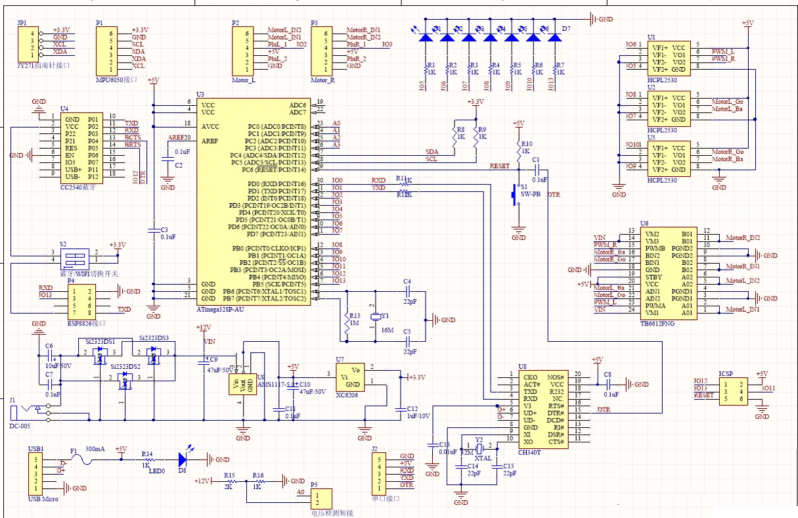
Design of the main body
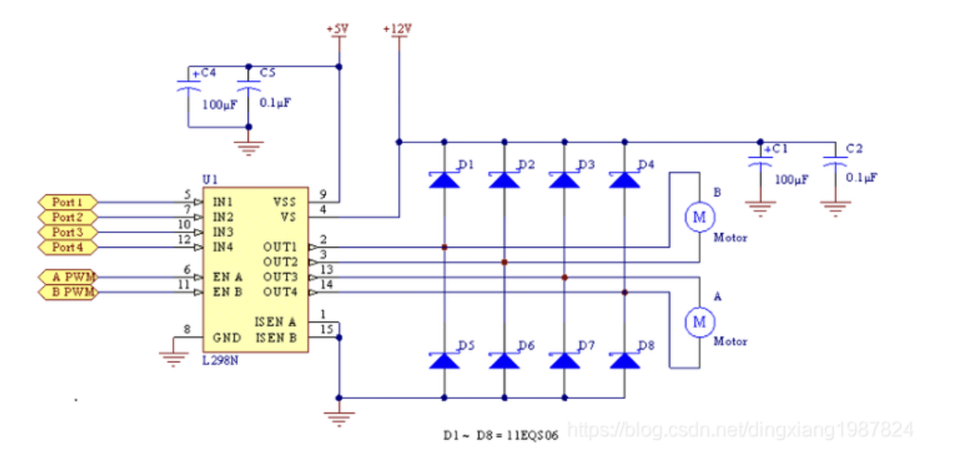
Circuit diagram of L298N Drive motor control module
List of The Main Hardware

NO. | NAME | NUMBER
1 | Arduino uno | 1
2 | Arduino mega | 1
3 | Arduino extended board | 1
4 | Temperature and humidity sensor | 1
5 | TCRT5000 Infrared sensor | 3
6 | The LCD screen | 1
7 | Flame sensor | 1
8 | ESP8266-01s Wi-Fi-module | 1
9 | Wi-Fi-module downloader | 1
10 | TCS3200 Color sensor | 1
11 | Photosensitive sensor | 1
12 | Buzzer | 1
13 | HC-SR04 Ultrasonic ranging module | 1
14 | L298N Drive motor control module | 1
15 | Motor | 4
16 | Infra-red obstacle avoidance module | 1

Main board
- Arduino Mega 2560 & Arduino extended board
The Arduino Mega 2560 is a core board with a USB interface. With 54 digital inputs and outputs, it is suitable for designs that require many IO interfaces. The core of the processor is the ATmega2560, which also has 54 digital inputs/outputs, 16 analogue inputs, 4 UART interfaces, a 16MHz crystal oscillator, a USB port, a power socket, an ICSP header and a reset button.
We also choose an Arduino extended board. It provides us with more interfaces for connecting more sensors and achieving more functions. It also reduces conflicts between the different ports. Therefore, it allows all components to work properly and data to be collected and uploaded successfully.

- ESP8266-01s Wi-Fi-module & Wi-Fi-module downloader
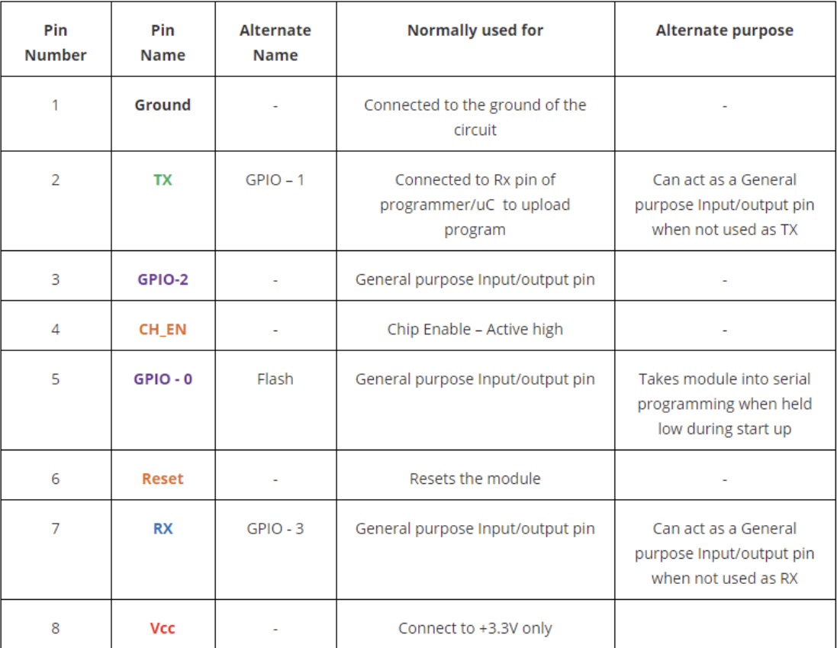
ESP8266 Pin Configuration
We ultimately use it to transmit data (e.g., temperature and humidity, cargo information, fire conditions, light conditions, etc.) to the webpage for information display and visualization in real time.

- TCRT5000 Infrared sensor
The TCRT5000 has an infrared transmitter tube and an infrared receiver tube. When the infrared signal from the transmitter tube is reflected and received by the receiver tube, the resistance of the receiver tube will change.
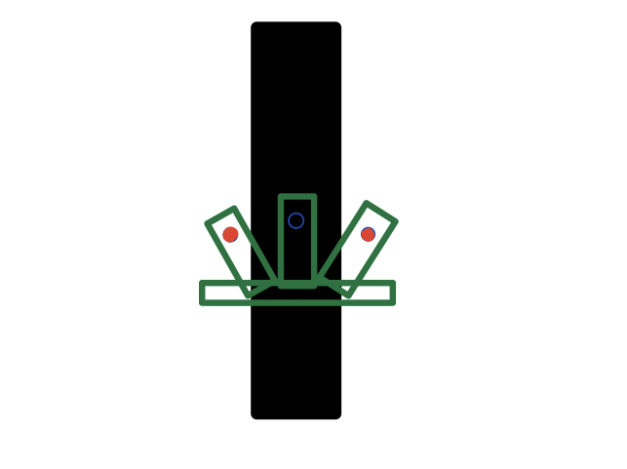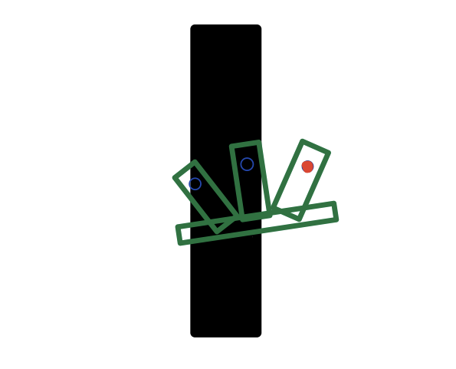
Go straight Turn Right Turn Left
We use three infrared sensors to identify the black lines on the ground and control the motor drive module to complete the tracking motion. By setting the different situations corresponding to the different displays, we specify the control of the L298N Drive motor control module in different situations, so that the car can follow the trajectory of the movement. In this way it is also specified that the car stops when all sensors are recognized as black lines.

- L298N Drive motor control module & Motors
The L298N is a driver chip with two H-bridges inside, so that the operation of the motor is controlled with only three signals: two direction signals and an enable signal.
The L298N chip requires two operating voltages.
First circuit: output to supply the motor circuit with operating power
Second circuit: input logic control circuit power supply 5V (power out/in)
DC motor | Rotation method | IN1 | IN2 | IN3 | IN4 | Enabling side A | Enabling side B
 | Positive spin | 0 | 1 | / | / | 1 | /
M1 | negative spin | 1 | 0 | / | / | 1 | /
 | stop | 0 | 0 | / | / | 1 | /
M2 | Positive spin | / | / | 0 | 1 | / | 1
 | negative spin | / | / | 1 | 0 | / | 1
 | stop | / | / | 0 | 0 | / | 1
L298N access port for DC motors

The L298N is connected to the motor to drive the car with the drive module. At the same time the car is programmed to perform several functions such as tracing, obstacle avoidance and stop detection.

- Color sensor
The TCS3200 has a programmable optical and electrical converter with a built-in oscillator that converts the light intensity into a square wave. The output value of the OUT pin of the TCS3200 is proportional to the frequency of the built-in oscillator and their ratio factor is set by its pins S0 and S1.
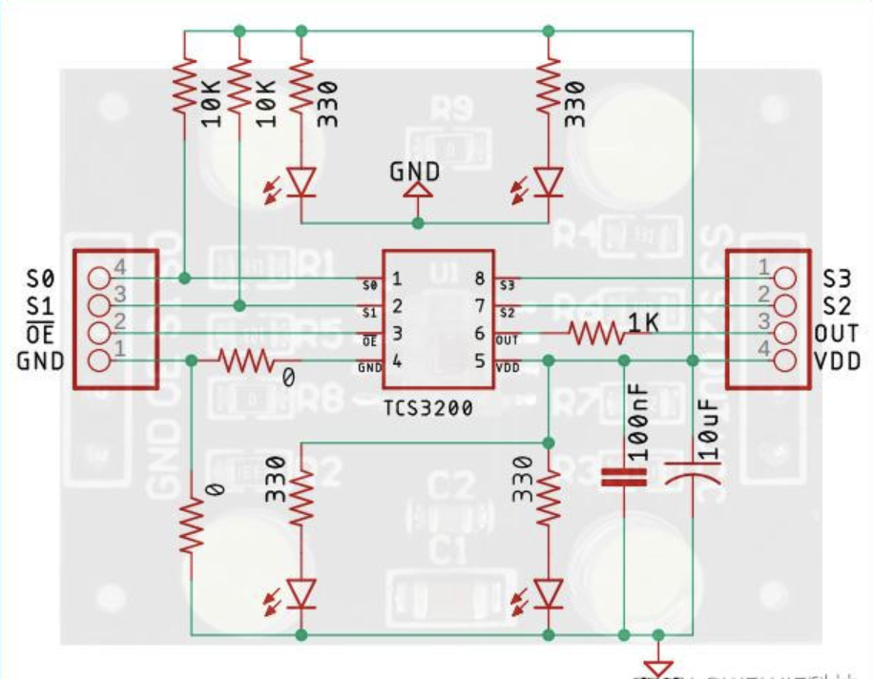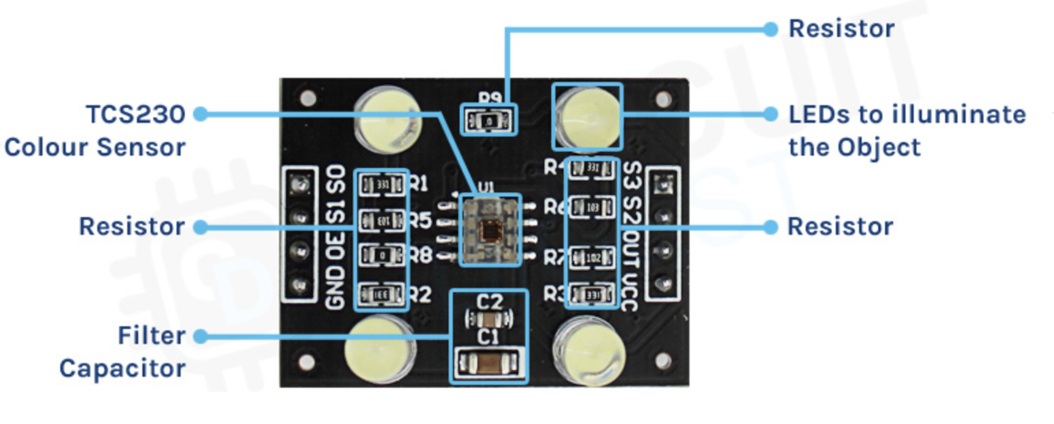
Circuit diagram of TCS3200 TCS3200 component parts
After testing, we found that the optimum distance between the object under test and the TCS3200 is 1 cm. when detecting objects, it is important to avoid interference from external light, otherwise the results may be affected.

- The other sensors and modules
DHT11 Temperature and humidity sensor
The DHT11 is a temperature and humidity sensor that can be used to measure temperature and humidity. over a temperature range of 0 to 50°C with an error of 2 °C.
HC-SR04 Ultrasonic ranging module
This module will automatically send 8 square waves of 40KHz and detect whether there is a signal return; if there is a signal return, through the IO the duration of the high level is read out to give the time between the transmission and the return of ultrasound. The resulting time can be used as a function to calculate the distance between the obstacle and the sensor to achieve the distance measurement function.
LCD screen
The backlight pins can be powered or disconnected. In the 14 pins, there are 8 data pins (7-14 or D0-D7), 2 power pins (1 & 2 or VSS & VDD or GND & + 5v), a third pin for contrast control (VEE controls the thickness of the characters) as shown) and 3 control pins (RS & RW & E). We only need to control the ENABLE and RS pins to send characters and data accordingly.
The temperature and humidity, the color of the cargos, the distance between the car and the cargos, all this information is not only transmitted to the website via the Wi-Fi module but is also transmitted to the LCD screen at the same time, making it easier for us to know the information of goods and the surrounding environment.
Photosensitive sensor & buzzer
The photoresistor is an analogue sensor that acts similarly to a variable resistor. When the sensor is exposed to light, the resistance of the sensor decreases. We can use the analogue input pin to read the voltage across the photoresistor, which is directly related to the resistance of the photoresistor. When the intensity of the light is greater than a certain value we set, the buzzer will alarm to warn that some light-proof goods may be damaged by the intense light and indicate there may be a thief entering the warehouse.
Flame sensor & buzzer
The flame sensor works based on infrared radiation. The infrared photodiode will detect the infrared radiation from any hot component. This value is then compared with the set value. Once the radiation reaches the threshold value, the sensor will change its output accordingly. The buzzer will sound an alarm when a flame appears.
Infra-red obstacle avoidance module
The infrared obstacle avoidance module uses the principle of light reflection, the front of the module has an infrared transmitter tube and an infrared receiver tube. When the module is powered on, the infrared transmitter tube continuously transmits infrared rays of a certain frequency to the front, when the infrared rays meet the obstacles in front, the rays return to be received by the receiver tube, and at this time output is in low level. If there is no obstacle in front of you and the rays are not reflected, the output goes high. If there is an obstacle in front of the car, the car will stop immediately.

Appearance
- The main body of our car has a rectangular shape. Several windows have been cut in many places to allow the sensors to be placed on the outside of the car which is better measurement of the data we need. The compactness of the internal components and the appearance of the cart, which hides the tightly packed internal wiring, enhance the aesthetics and resistance to damage.
- The housing of the car is of a top-sleeve construction, making it easier to remove the exterior of the car for internal inspection and repair if problems arise inside.
- The parts left on the outside give the small car more technological feel. The use of environmentally friendly materials combined with the production of the cart's exterior not only saves resources, but also facilitates better mass production of this type of cart and helps to upgrade the warehouse management system.

