 | 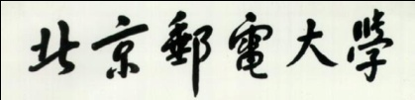 |  | 

Joint Programme Assessments 2022/23

Answer Sheet
(To be used in conjunction with the provided alternative assessment questions and the supplementary instructions)

Complete the information below about yourself very carefully.

QM student number
  2 | 0 | 0 | 9 | 7 | 8 | 9 | 4 | 7
BUPT student number
  2 | 0 | 2 | 0 | 2 | 1 | 3 | 2 | 4 | 8
Class number
  2 | 0 | 2 | 0 | 2 | 1 | 5 | 1 | 0 | 7

Module code
  EBU5302
Word Count
  690

“I hereby confirm that the submitted work is entirely my own and I have not (i) used the services of any agency or person(s) providing specimen, model or ghostwritten work in the preparation of the work I submit for this open book assessment; (ii) given assistance in accessing this paper or in providing specimen, model or ghostwritten work to other candidates submitting for this open-book assessment.”
Signature
  Wu Tangxun

For examiners ONLY  Do not write in this section
   | Q1 | Q2 | Q3 | Q4 |  |  | Sum
  A
  B
  C
  D
  E
  F
  TOTAL

 | Do not write in this column
  Question | 1. 2. 3.
  Section(s)
Question 1
The binary values: 110100101

Question 2
Data rate R = 3.2 Gb/s
l = 8 bits/level
therefore, D = R/l = 0.4 * (10^9) symbols/s
minimum B = 1/2*D = 0.2 GHz

Question 3
Firstly, we can see the equation of R(k) is:
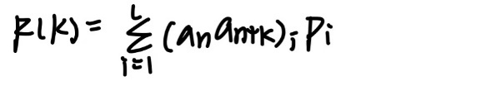
And for bipolar RZ signalling the possible levels are +A, -A, 0 V.
Then, we can discuss as follows:
Assuming that the data are independent from bit to bit.
If k = 0, the possible products of a_n*a_n = 0, 0, A^2, (-A)^2
So R(0) = (1/2)*A^2
If k =1, the possible products of a_n*a_(n+k) = 0, 0, 0, -A^2
So R(1)= (-1/8)*A^2 + (-1/8)*A^2 = (-1/4)*A^2
If k>1, the possible products of a_n*a_(n+k) = 0, 0, 0, -A^2, A^2
So R(k)= (-1/16)*A^2 + (1/16)*A^2+ (-1/16)*A^2 +(1/16)*A^2 = 0
Overall,
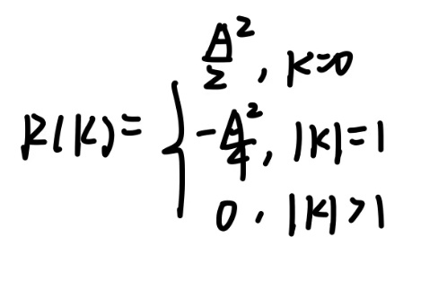

 | Do not write in this column
  Question | 4. 5. 6. 7.
  Section(s)
Question 4
Bit rate R = 0.8 Mbits/s
Level L = 16
So l = log2(16) = 4 bits/level
Bandwidth B = 175 KHz
Because D = R/l = 200000 symbols/s
And D= 2B/(1+r), where r is the roll-off factor
Therefore 1+r = 2B/D = 1.75
And r = 0.75

Question 5
For thermal noise, Eb/N0=8.4dB
Temperature = 2900 K
Data rate = 2400bps
Because Eb/N0 = S dBW – 10lgR– 10lgK– 10lgT
So received signal level S = Eb/N0 + 10lgR + 10lgK + 10lgT
S = 8.4 + 10lg(2400) – 228.6 + 10lg(2900) = -151.774 dBW

Question 6
d = 1000m
f = 1 GHz
so λ = c/f = 0.3m
therefore, L(dB) = 20lg(4πd / λ) = 92.442 dB

Question 7
There are 4 ways of combining signals for diversity in cellular system.
1. switch diversity: when one diversity of signal is too low, just try another.
2. selection diversity: when we want to combine signals, select and choose the largest signal for diversity.
3. Equal gain: all signals are equally weighted for combination and are added in phase.
4. Maximal ratio: weigh the power in the branches in proportion to their signal amplitude and add in phase.

 | Do not write in this column
  Question | 8
  Section(s)
FDMA: different frequency bands are assigned to different users.
Application scenarios: All 1G systems
Diagrams:
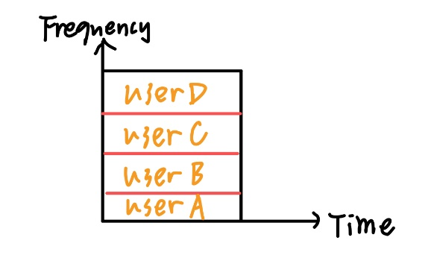

TDMA: different time slots are assigned to different users.
Application scenarios: Most 2G systems
Diagrams:
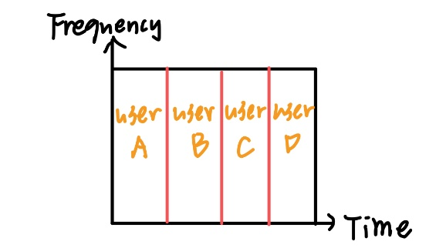

CDMA: different codes are assigned to different users.
Application scenarios: some 2G systems and most 3G systems
Diagrams:
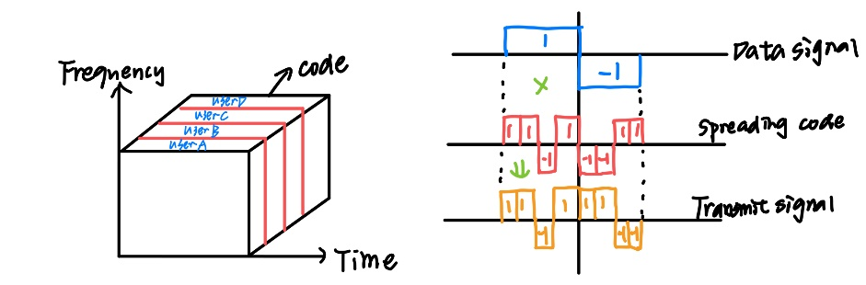

OFDMA: means orthogonal frequency division multiple access. It is a multi-user version of the popular OFDM digital modulation scheme. Multiple access is achieved in OFDMA by assigning subnets of subcarriers to individual users.
Application scenarios: 4G systems and 5G systems

 | Do not write in this column
  Question
  Section(s)

 | Do not write in this column
  Question
  Section(s)

 | Do not write in this column
  Question
  Section(s)

 | Do not write in this column
  Question
  Section(s)

 | Do not write in this column
  Question
  Section(s)

 | Do not write in this column
  Question
  Section(s)

 | Do not write in this column
  Question
  Section(s)

 | Do not write in this column
  Question
  Section(s)

 | Do not write in this column
  Question
  Section(s)

