Explain why it is desirable for a transform to have orthogonal basis functions, and explain what needs to be done if they are not orthogonal.

Any vector in a vector space can be represented by a combination of other vectors in that space [1 mark]. If this set of vectors for the vector space is orthogonal, then any other vector in that space can be represented by a unique set of coefficients [1 mark]. This set of vectors then forms a basis function [1 mark]. This is then used to perform the transform (l mark). The same set of orthogonal vectors can then be used to invert the transform [1 mark]
if they are not orthogonal, then another set of vectors that are mutually orthogonal to the first must be found to allow the inverse transform [1 mark]. These two sets of vectors are referred to as a biorthogonal set [l mark]

Sampling a signal in the time domain results in multiples of the baseband frequency spectrum
separated by integer multiples of the sampling frequency.
Briefly explain how aliasing can be prevented.

1. A bandlimiting filter must be used prior to sampling [1 mark]. This is a lowpass filter [1 mark]
2. Sampling frequency must be greater than twice the bandwidth of the signal to give a gap between spectra [1 mark].
3. The filter cutoff frequency should be set at the upper limit of the baseband spectrum [1 mark].
4. The roll-off rate of the filter must be sufficiently great to provide adequate attenuation at the lower end on the first replicated spectrum [1 mark].

List the steps involved in performing a STFT.

The steps are:
1. Choose a window of finite length.
2. Place the window on top of the signal at t=0.
3. Truncate the signal using this window
4. Truncate the signal using this window
5. Incrementally shift the window to the right
6. Repeat from step 3

What’s lossless compression and lossy compression?

i) Lossless compression is where fewer bits are required to store the data but no information is discarded. [l mark]. This is achieved by eliminating redundancy [l mark]
ii) Lossy compression results in a loss of information [l mark]. This is achieved by discarding marginally important information [1 mark].

Describe the process of implementing an FFT. Refer to radix-2 decimation in time. State how the reverse process is carried out.
[3, -4, 8, -2, -7, 9, 13, 6]

A radix-2 sequence is one whose number of elements is a power of 2 [1 mark]. A sequence is
split into two [1 mark], one of which is the even numbered elements and one the odd numbered
elements [1 mark]. This process is continued till we have individual elements [1 mark].
For example, for the 8-point signal as follows:
[3, -4, 8, -2, -7, 9, 13, 6]
This is split into:
[3 8 -7 13] and [-4 -2 9 6]
And so on:
[3 -7] [8 13] [-4 9] [-2 6]
[3] [-7] [8] [13] [-4] [9] [-2] [6] [3 marks, 1 for each row]
Re-ordering the sequence in this way can be performed using bit-reversal, as each position is the reverse of the binary value of the original position. Element values are swapped accordingly, e.g., the value in position 3 (binary 011) [-2] is swapped with the value in position 6 (binary 110) [13] [1 mark].
Each 1-point signal is then transformed to the frequency domain, nothing is required to do this step [1 mark].
The individual frequency values are then combined by reversing, in steps, the decomposition process: [1 mark]
In the above case, the 16 individual frequency points are grouped into 8 groups of 2 points each. This is carried out by shifting, adding zeroes in the gaps and then adding. [1 mark]

Explain in what context the Discrete Cosine Transform (DCT) is suitable for lossy data compression.

In the DCT, most of the signal information tends to be concentrated in a few low frequency components. [1 mark] The amount of information that can be allowed to be lost during compression depends on the application. [1 mark] In visual images, much of the high frequency information can be discarded because the human eye is far less sensitive to them than the lower frequency information. [1 mark] The DCT itself is not lossy [1 mark]. But it does separate the frequency components to allow compression to take place.

Why is the DCT more efficient than the Discrete Fourier Transform (DFT).

Because the DCT is based on the cosine function, it is the real part of the DFT and complex arithmetic is not required in carrying out the DCT [1 mark]. The FT of a real and even function is real and even, meaning the DCT is efficient for real data with even symmetry [1 mark].

Explain what effect in the frequency domain of sampling a signal in the time domain.

Sampling in the time domain is multiplication of the signal with a comb of Dirac delta functions [1 mark]. This is equivalent to convolution with a comb of delta functions in the frequency domain. [1 mark].
The result of this is that sampling replicates the frequency spectrum of the continuous time signal in the frequency domain at inter multiple of the sampling frequency [1 mark].
There is a gap between spectra if the signal is oversampled [l mark], spectra are adjacent if the signal is critically sampled (Nyquist sampling rate) [l mark], spectra overlap if the signal underdamped[1 mark].
Aliasing occurs when the signal is sampled at less than the Nyquist limit [l mark]. Aliasing is when an unwanted signal is mistaken for a wanted one [l mark]. Once aliasing occurs it is not possible to remove it [1 mark].
The baseband spectrum can be obtained from the bandpass spectrum by using a low-pass filter [1 mark].

Wavelet Filterbanks are used for Multiresolution Analysis. Briefly explain what is meant by wavelet packets and explain two advantages of them.

Wavelet packets are a generalization of wavelets. They are a family of orthonormal bases for discrete functions of any space of order N [1 mark]. In the wavelet filterbank for dyadic wavelet decomposition only the low pass filtered subband is decomposed, but the wavelet packet allows decomposition to be carried out using any combination of filters [1 mark].
Advantages:
Flexibility [1 mark]. the best wavelet basis to satisfy any requirement can be used [1 mark]
Low computation requirement [1 mark] because the decomposition can be optimized using fast filterbanks.

With the aid of relevant diagrams, explain what is meant by the term “chirplet”.

A chirp signal is a signal whose frequency increases or decreases with time (l mark). The frequency may change linearly with time or may not be linear [l mark]. A chirplet is a short duration “windowed” chirp [1 mark]. Because the chirplet is limited in time, it has a limited frequency range so is bounded in both time and frequency [l mark].

With reference to a two-band subband coding and decoding system, explain the relationship between the analysis and synthesis filters.

The analysis filterbank is used to split the input sequence into two half-length sequences [1 mark]
Synthesis filterbanks combine the high and low pass subbands to produce the output [1 mark]
If the output and input are identical, then we have used perfect reconstruction filters. [1 mark]
The synthesis filters are modulated versions of the analysis filters [1 mark].
Picture:
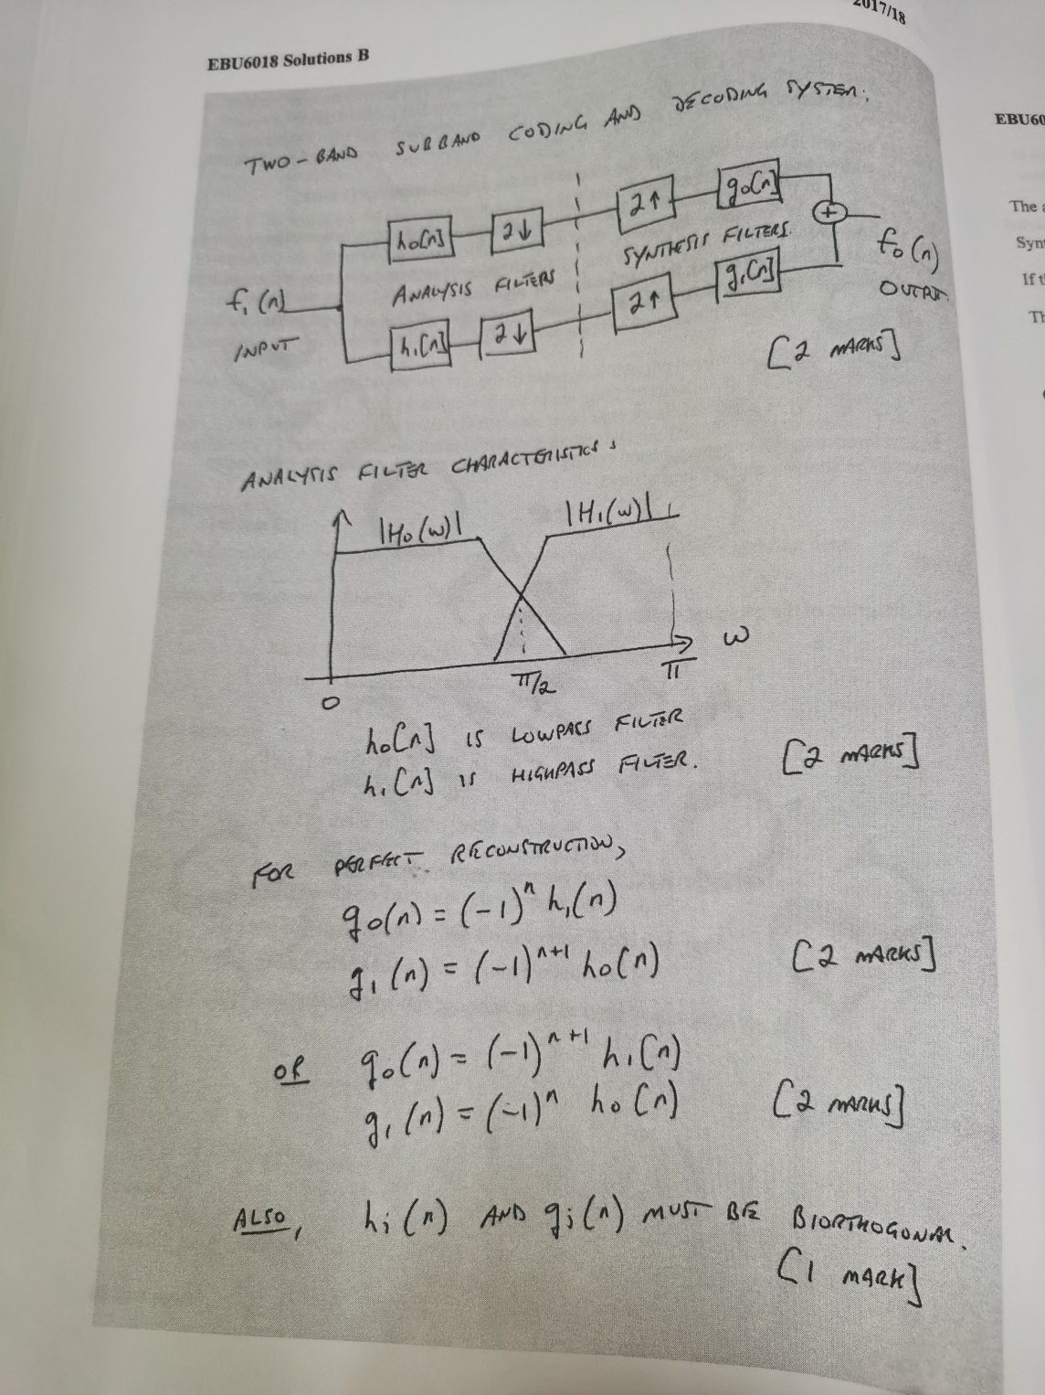

The Discrete Cosine Transform (DCT) transforms functions of time (discrete signals) and functions of position (images) into functions of frequency. Explain how it does this.

The DCT correlates the input data [l mark] with a series of cosine functions of increasing frequency, starting with dc [l mark]. These discrete cosine functions are the basis functions.
Correlation gives a large value of output when there is a similarity between the input data distribution and a particular basis function [1 mark]. Therefore, the output sequence from the DCT is related to the frequency of the distribution of data in the input sequence [l mark].

A signal can be filtered into its coarse and fine detail (analyzed) by using these wavelet function and scaling function. Sketch and explain the block diagram for one stage of a dyadic wavelet transform. How could this process be used for a non-dyadic sequence?

Dyadic means that the number of values in the sequence being transformed is a power of 2 [1 mark]. The inputs to this stage are the coarse details from the previous stage [1 mark]. H0 is a low pass filter to obtain the next level of coarse detail [l mark]. H1 is a high pass filter to obtain the next level of fine detail [l mark]. Downsampling is carried out so that at each level there is half the number of values of each as at the previous stage [l mark]. If the sequence length was not a power of 2, it can be zero padded to make it so [l mark].

What condition is required to ensure that the original signal can be synthesized by reversing the process?

If the wavelet functions are orthogonal, then the same filters can be used as in the analysis [1mark]. If the wavelet functions are not orthogonal, then filters that are biorthogonal with the analysis filters must be used for synthesis [1 mark].

Wavelet transforms can be used for many applications. Briefly describe each of the following:
i) Resolving a signal into its component sinusoids
ii) De-noising
iii) Detecting discontinuities
iv) Detecting self-similarity
v) Compressing images.

Resolving a signal into its frequency component: MRA separates a waveform into its coarse and fine detail till only the average value is left. [1 mark] The detail that has been separated out are the frequencies in the signal with the highest ones being separated out first [1 mark]
De-noising: if all the noise is high frequency it can be removed by compression or by discarding the first levels of detail in the MRA [l mark]. However, if the noise is broadband or has different components at different frequencies then denoising can be carried out by identifying the features in the signal that we are looking for and ignoring the rest. This can be achieved by using wavelet function of the same shape as the features t be identified [l mark]
Detecting discontinuities: if the discontinuity is between bursts of different frequencies, then at some level of decomposition the discontinuity will be obvious because the higher frequency will disappear from the coarse level [l mark]. It will also detect an abrupt change in the rate of change [1 mark].
Detecting self-similarity: wavelets can be used to detect fractal signals (i.e. similar to itself at different scales) then the wavelet coefficients will also be similar at different scales [l mark]. This generates a set of characteristic lines on the scalogram [1 mark].
Compression of images: This is carried out by performing the MRA and then setting a threshold value [1 mark]. values lower than the threshold value are discarded resulting in compression [l mark].

Briefly explain the uncertainty principle an discuss its implications in the design of transforms for time-frequency analysis.

