Block1
What is RFID
➢ RFID (Radio Frequency Identification) is a technology that uses radio waves to transfer energy and data between a reader and a movable item to identify, categorize, track, …
➢ The item can be an object, a person, an animal, etc.
o RFID is fast, reliable, and does not require physical sight or contact between reader/scanner and the tag.
o RFID, dates back to the invention of RADAR, where, during the Second World War, fighter pilots cleverly maneuvered their planes to be remotely identified by friendly radar operators, who distinguished them from their foes (Identify Friend or Foe).

What Makes an RFID System
o RFID Tag (Transponder):
➢ Role: Devices that store and transmit information to the reader. Tags can be active, passive, or semi-passive.
➢ Microchip: Stores data (e.g., unique identifier).
➢ Antenna: Allows for communication with the reader.
➢ Passive vs. Active tags:
❖ Passive Tags: No battery, rely on energy from the reader.
❖ Active Tags: Contain a battery and can transmit signals over a longer range.
o RFID Reader (Interrogator):
➢ Roles: Transmit and receive signals between the reader and the tag.
➢ Reader Types: Fixed, handheld, and mobile readers.
o Antenna:
➢ Role: Allows the exchange of data between the tag and reader.
➢ Types: Directional, omni-directional, near-field, and far-field antennas.
o Software (Middleware)
➢ Role: Software used to process data between the RFID system and enterprise
applications.

How Does RFID Work?
o Basic Workflow:
1. Reader: The RFID reader sends a radio signal to the tag, which powers it and causes the tag to respond with its stored data.
2. Tag: The tag, powered by the reader's signal (for passive tags), emits a unique ID or data when it comes into range.
3. Communication: The data is sent back to the reader, which transmits it to the system for processing.
o No Line of Sight Needed:
➢ Unlike barcodes, RFID does not require a direct line of sight between the reader and the tag.
o Multiple Tags:
➢ Multiple RFID tags can be read simultaneously, making RFID more efficient for tracking large quantities of items.
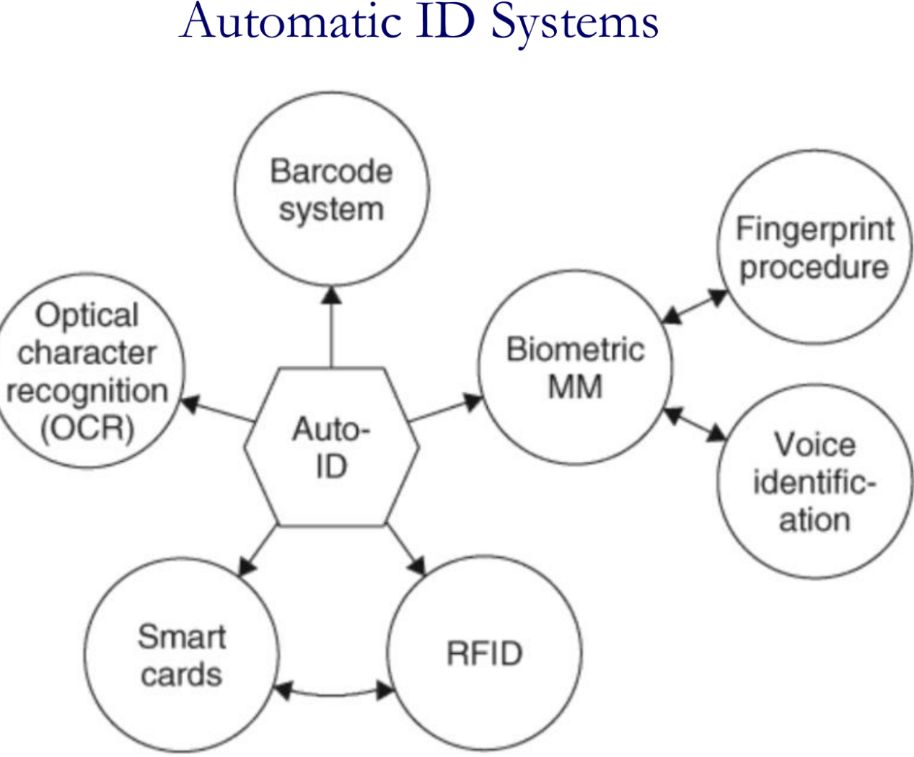
Automatic identification systems
1.Biometric Procedures
o is defined as the science of counting and (body) measurement procedures involving living beings.
o In the context of identification systems, biometry is the general term for all procedures that identify people by comparing unmistakable and individual physical characteristics.
o In practice, there are various biometric procedures:
▪ Fingerprinting procedures: uses the uniqueness and stability of fingerprint to verify user identity by comparing the collected fingerprints with the pre-sampled fingerprints.
▪ Voice identification(Speech Recognition): uses the difference between each person's tone and timbre to identify different people.
Steps: Feature extraction module, Statistical acoustics model, Pronunciation dictionary, Language model, Decoder
Technical Features: Easy to use, and easily accepted by the user. Cheap sound equipment, and not involve user's privacy. Due to the lack of international standards, there are some difficulties in promoting
▪ Face recognition: is based on human face features. It performs identity authentication by analyzing the input face image.
Steps: Face acquisition, Face positioning, Face recognition preprocessing(Local Feature Analysis), Look up the identity, Identity confirmation
Technical Features: Surroundings, hair ornaments, age can affect the recognition rate. Fast recognition speed, not easy to be aware of it
▪ Retina identification: distinguish each person by analyzing the vascular pattern on the retina.
▪ Heartbeat recognition technology: identify the user identity by collecting heartbeat signal pulse through a specific instrument and then identify the inherent characteristics of each person heartbeat.
- Bar Codes
o a binary code comprising a field of bars and gaps arranged in a parallel configuration
- 1D Barcode Recognition is a combination of lines and blanks in accordance with certain coding
Limited storage capacity, need to combine with the database. The barcode size is relatively large, the space utilization is low. Fault tolerance is poor, cannot restore the information after the corruption.
- 2D code uses black and white graphics on the two-dimensional plane to record data, these geometric patterns express specific information through a certain regulation of distribution.
Large storage capacity. Up to 32KB. High information density. Can store text, sound, pictures and other information. Powerful error correction capability. 2D code can still be identified in the case of 50% defacement. Support for encryption. Multiple security features.
- Card Technologies
o Magnetic cards: containing either a magnetic strip or a magnetic object in the card, encoded with digital data
o Smart cards: credit card-sized pieces of plastic containing a data storage system. Two type: memory cards and microprocessor cards
o Optical cards: use a technology similar to the one used for music CDs or CD ROMs

RFID vs Barcode
o Three advantages of using RFID compared to bar code scanning are:
▪ More efficiency: you can scan multiple items at once
▪ More durability: tags can handle exposure to weather conditions like sun and rain
▪ More security: you can encrypt RFID tags so only your reader can get the data

RFID vs NFC
Near-field communication (NFC) is a subset of the RFID technology family. The big difference is that NFC is used for two-way communication. Instead of the scanner receiving or sending data, both ends can receive and send information.

The main features of RFID
1.Non-contact automatic and rapid identification
The RFID tag returns data by backscattering the energy, with an effective communication range of 6-10 m. The RFID system uses an effective anti-collision mechanism to read tags, enabling rapid identification of a large number of tags.
2.Permanently store a certain amount of data
RFID tag has a user storage area, which can store 1KB-10KB of user data.
3.Simple logical processing
RFID has a very limited number of internal logic gates, so only a simple logical processing can be made. But the RFID system can use the basic logic processing ability of tags to achieve some effective protocols and algorithms to improve the system operating efficiency and security performance.
4.Reflection signal strength is affected by the distance and other factors significantly
Since the RFID tag itself is a passive device, the feedback signal must be modulated by backscatter. Therefore, the strength of the RFID tag reflection signal is susceptible to the surrounding environment, including distance, reader power, signal interference, and tag deployment density.
5.Low cost, can be deployed at a large scale
RFID tags tend to large-scale mass production using printed circuits, so manufacturing costs can be significantly reduced. At present, the cost of an RFID tag can be controlled at around 10 cents.

RFID Challenges: Anti-collision transmission mechanism, Positioning and mobile behavior sensing, Information storage, retrieval and mining, Security certification and privacy protection

In 2003, EPCGlobal systems came to being and they started standardizing RFID from all possible directions.

o RFID typically consists of
▪ A computer, A database, RFID software. A reader, which receives signals from the RFID and identifies and processes the information contained in one of more tags. RFID middleware. an antenna, used to transmit signals between the reader and the RFID tag. An RFID tag (transponders), which contains the data of the element to identify

Reader’s Function
o As the bridge connecting the application layer (middleware) and RFID tags, the reader plays a significant role.
o Generally, in RFID system the functions provided by a reader are usually summarized as follows:
Energy Supply：A reader provides energy for RFID tags’ work.
Communication：Communication between reader and tag; Communication between reader and application layer (middleware)
Security Assurance：Security assurance in communication, such as encryption and decryption
Ad - hoc networking ability；Multiple antenna management；Interface of middle components；Connecting peripherals

Reader Classifications: By Operating Frequency
RFID system’s working principle is related to the frequency of RF signals it used. The higher the work frequency, the further the identification range, the higher the data transferring speed, the faster the signal attenuation, the more sensitive to obstacles.
Reader Classifications: By Appearance
Fixed, Portable, Industrial

RF Module
2 Types :
o Inductively Coupled RF Modules: Ideal for short-range applications, using magnetic fields for communication.
o Electromagnetic Backscatter Coupled RF Module: Suitable for longer ranges, leveraging reflected signals for data transfer.

Reader Antenna
▪ Omnidirectional antennas: such as dipole antennas, will have lower gain than directional antennas because they distribute their power over a wider area.
▪ Parabolic antennas: usually have the highest gain of any type of antenna but not really useable in typical RFID applications, except maybe for microwave RFID readers where a long-range and narrow radiation pattern is required.
▪ A half-wave dipole antenna: will have a gain of near unity or nearly equal the isotropic antenna.

Tag Function
The main function of RF tags is to store a certain amount of data, and send it to the reader in a contactless manner. Generally speaking, tags’ functions are concluded as:
Data Storage: Tags store goods-related information, e.g. identifier, production date, manufacturer, etc.
Energy Harvesting: Tags can absorb energy from electromagnetic field generated by the reader, and generate electricity for themselves.
Contactless R&W: Tags can be identified from a certain distance to the reader.
Security Encryption
Collision Concessions

Classification by Package Form
Card-like Tag
Labellike Tag
Implantabl e Tag
Accessories-like Tag

Classification by Work Frequency
LF Tags (30kHz-300kHz)
Usually passive. Inductively coupled. Strong penetration
HF Tags (300kHz-30MHz)
Usually passive. Inductively coupled. Fast transmission rate, large storage
UHF Tags (0.3GHz-3GHz)
Passive or active. Electromagnetic backscatter coupled. Long distance, high speed, mobile scenario, good multiple. tag r&w performance

Classification by Read/Write Capability
Read-only Tags
• Only readable, unique serial number. Low price. Simple structure
Read & Write Tags
• Readable, writable. Complex structure. High cost. No database related

Classification by Power Source
Active Tags • Rely on its own battery
Passive Tags • Rely on the carrier signal sent from reflection reader to gain energy
Semi-passive Tags • The battery is integrated on the board, but as an auxiliary backup

Active and Passive Tags Comparison
- Passive RFID: is most appropriate where the movement of tagged assets is highly consistent and controlled, and little or no security or sensing capability or data storage is required.
2. Active RFID: is best suited where business processes are dynamic or unconstrained, movement of tagged assets is variable, and more sophisticated security, sensing, and/or data storage capabilities are required.

Tag Antenna
o An antenna is a conductive structure specifically designed to couple or radiate electromagnetic energy.
o Antenna structures, often encountered in RFID systems, may be used to both transmit and receive data-modulated energy:
▪ In the low-frequency (LF) range with short read distances, the tag is in the near field of the reader antenna, and the power and signals are transferred by means of a magnetic coupling. In the LF range, the tag antenna therefore comprises a coil (inductive loops) to which the chip is attached.
▪ In the UHF range with larger read distances, the tag is located in the far field of the reader antenna.

Tag Antenna Types
o There are various types of antennas available: dipole, folded dipole, printed dipole, printed patch, squiggle, and log-spiral.
▪ Omnidirectional antennas: can be read in all possible tag orientations. Among these are the dipole, folded dipole, and squiggle antennas.
▪ Directional antennas: have good read range due to their radiation patterns.
o Four major considerations when selecting an antenna type are as follows:
▪ Antenna impedance;
▪ Antenna radiation pattern;
▪ Nature of the tagged object;
▪ Vicinity of structures around the tagged object.

Coil Antenna
Simple process, low cost, widely used in LF, HF close-range RFID system. Work by inductively coupled, whose principle similar to transformer. The reader antenna is equivalent to transformer primary coil, tag antenna as secondary coil, generating voltage at a varying magnetic field.
Microstrip Patch Antenna
A microstrip patch antenna is usually attached to the surface of a conductor sheet, with a metal foil ground plane on the other side. Light weight, small size, low cost, easy to mass production. Suitable for scenario of which the communication direction doesn’t change.

Dipole Antenna
A dipole antenna consists of two straight wires with the same length and thickness put in a straight line. Suitable for UHF tags

Tag Chip
o The RFID chip is is an integrated circuit implemented in silicon consisting of an RF front end, a control unit consisting of some additional basic signal processing circuits, logic circuitry to implement the algorithms required, and EEPROM for data storage.

RFID Middleware
◆ One of the primary benefits of using RFID middleware is that it standardizes ways of dealing with the flood of information these tiny tags produce.
o Three primary motivations for using RFID middleware:
1. Providing connectivity with readers (via the reader adapter),
2. Processing raw RFID observations for consumption by applications (via the event manager),
3. Providing an application-level interface to manage readers and capture filtered RFID events.

𝑇𝑁 = (𝑇𝑐 + 𝑇𝑑)𝑁𝑡𝑎g
$λ=\frac{c}{f}$ c=3x${10}^{8}$
$$f=\frac{1}{2π\sqrt{LC}}$$
GdB=10lg$\frac{P_{2}}{P_{1}}$​​$dBm=10lg\frac{P}{1×{10}^{−3}}$
$E_{dBμV/m}$=20lg($E_{V/m}$×${10}^{6}$)
$$P_{Tag}=P_{R}+G_{R}+G_{T}−∑_{Losses}−FSL$$
$$r={10}^{\frac{FSL−31.75}{20}}$$
$$P_{REC}=P_{Tag}+G_{R}+G_{T}−∑_{Losses}−FSL−E_{T}$$
LRC Procedure
Data1:0100 1001
Data2:1101 0001
LRC:1001 1000

CRC Procedure
data block is F7h=11110111
$X^{4}$ + X + 1 = 10011
The starting value : 0000B
111101110000
10011
011011
10011

Coding in the Baseband
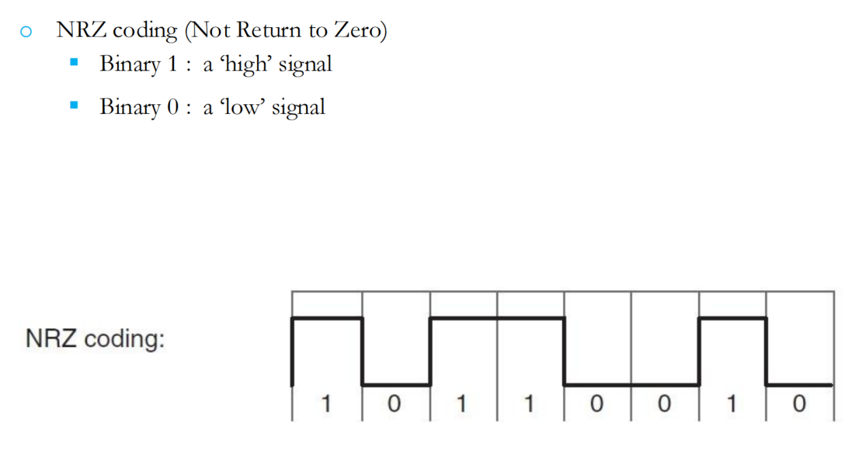
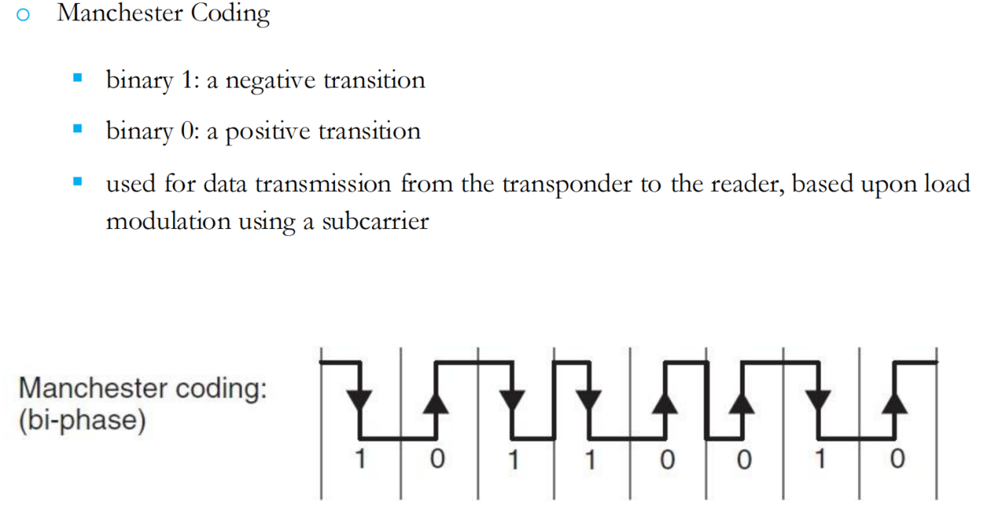
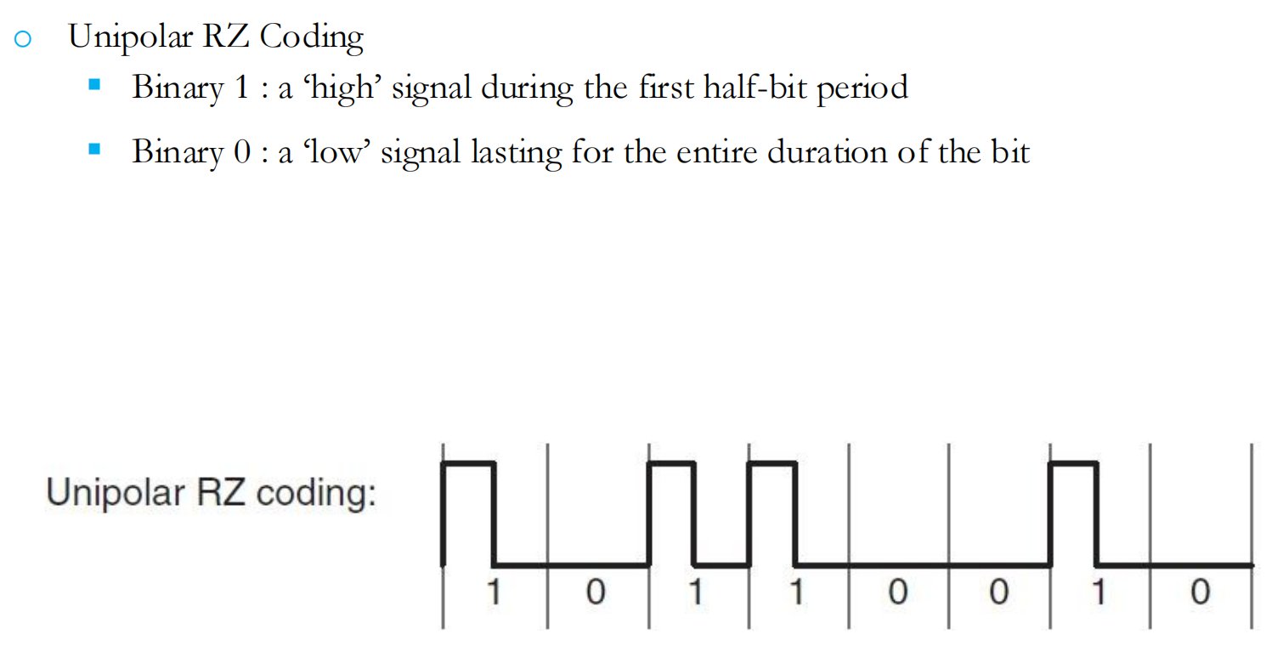
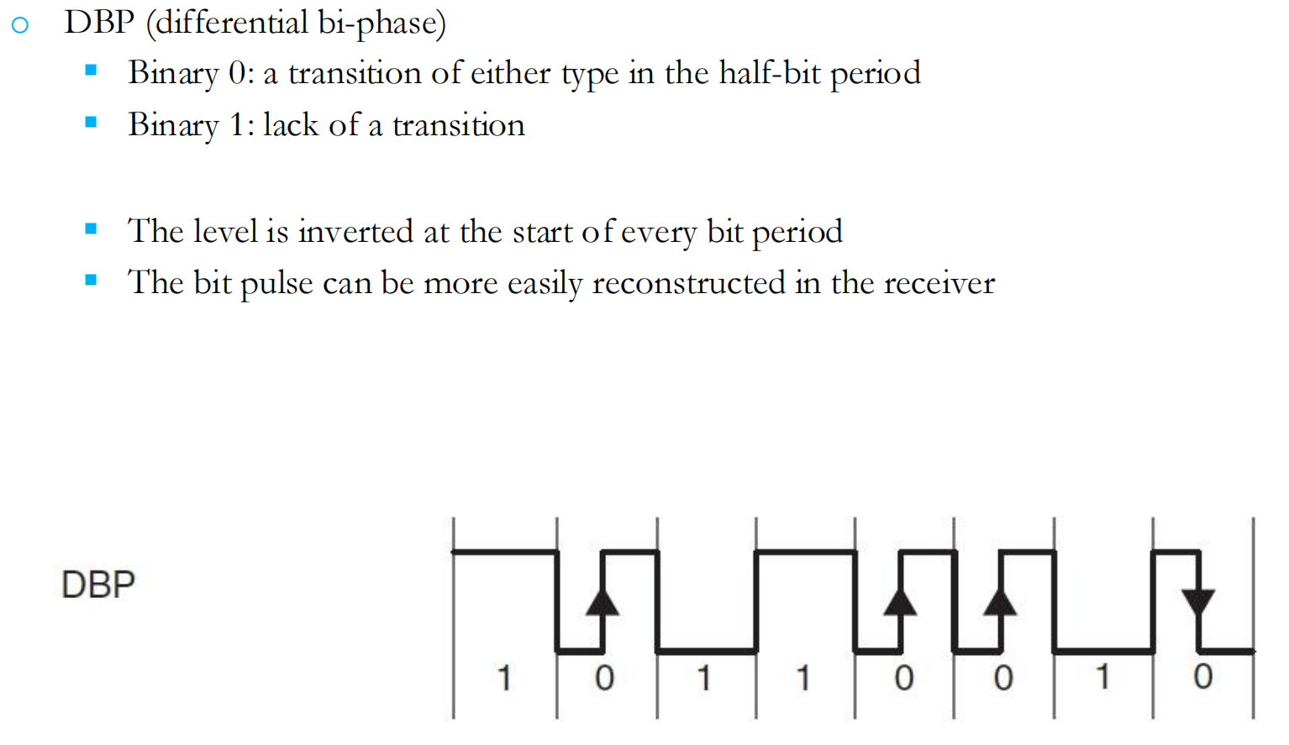
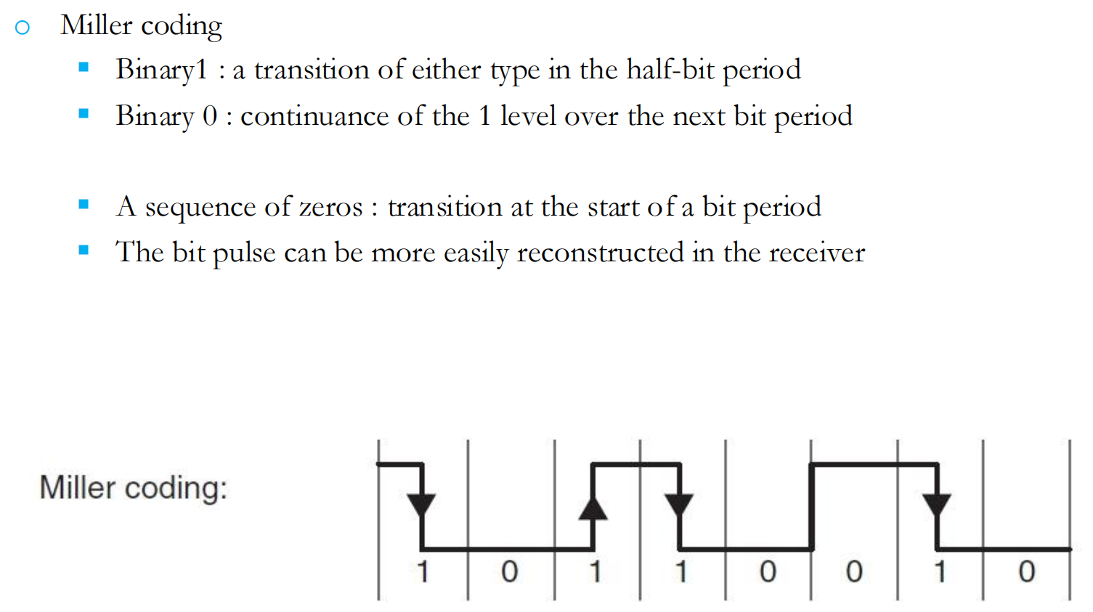
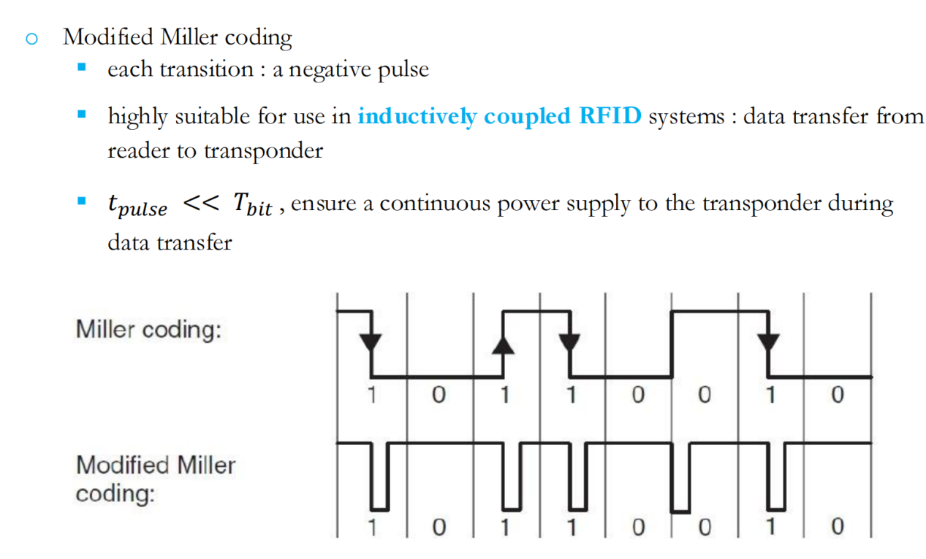
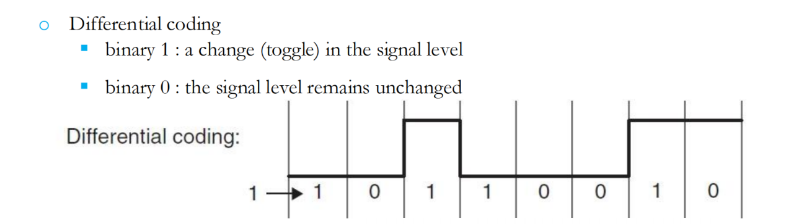
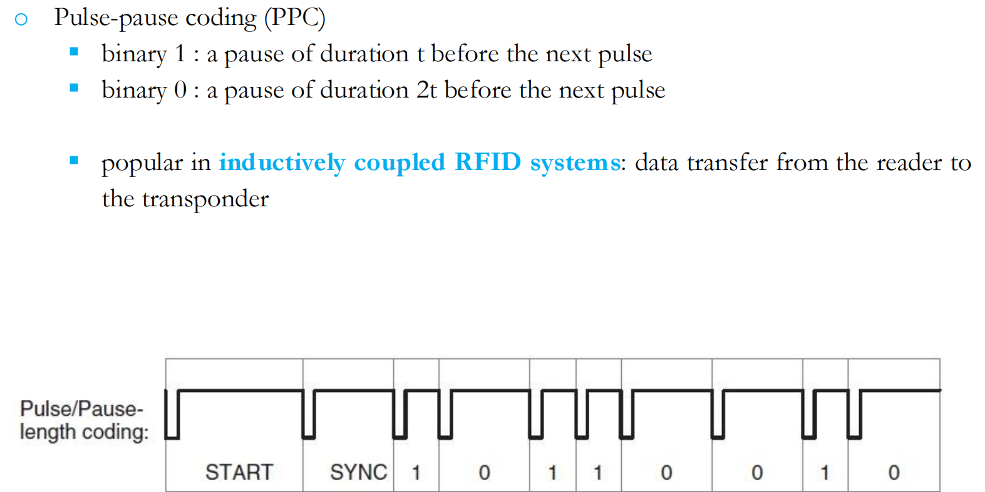
2FSK
$$∆f_{CR}=\frac{|f_{1}{+f}_{2}|}{2}$$
Anti-Collision Algorithms
Space division multiple access (SDMA), Frequency division multiple access (FDMA), Time division multiple access (TDMA), Code division multiple access (CDMA)
Two main types of signal interference:
1.Conflict interference among readers(Multiple tags respond to the reader simultaneously)
2.Conflict interference among tags(Multiple readers send signals simultaneously )
There are three typical anti-collision protocols to address conflicts among readers:
Time division multiple access(TDMA), Frequency division multiple access(FDMA), Carrier sense multiple access(CSMA)
RFID systems: numerous transponders (tags), a single interrogator (reader)
Two main forms of communication：Broadcast, Multi-access
Broadcast Communication Mode
Transmit data from a reader to the transponders. Received by all transponders simultaneously
Multi-Access Communication Mode
Data transmission: from many individual transponders in the reader’s interrogation zone to the reader
Multi-access/anticollision procedures:Space (SDMA), Time (TDMA), Frequency (FDMA), Code (CDMA)
Pure ALOHA Algorithm: If the tag receives a success acknowledgment message, its identifier is no longer sent. Otherwise after a period of time it will be sent again until the success of transmission.$S = G ∙ e^{(−2G)}$. S reaches a maximum of 18.4% at G=0.5. An anticollision procedure only for read-only tags.
Slotted ALOHA algorithm: The S-ALOHA algorithm divides the time of the pure ALOHA algorithm into several time slots, each slot is greater than or equal to the time length to send tag identifier, and each tag can only send an identifier at the beginning of the slot. Due to the time synchronization of the system, the channel utilization of the S-ALOHA protocol is 36.8%, which is twice of the pure ALOHA. $S = G ∙ e^{(−G)}$
maximum of 36.8%: offered load G=1
Reader:transmits a REQUEST command
Transponders:Recognize the REQUEST command, Randomly select one of the three available slots, Send its own serial number to the reader.
Frame Slotted ALOHA Algorithm: Three slot states of FSA algorithm:Conflict slot: more than one tag response, Single slot: only one tag response, Idle slot: no tag response
Advantages:simple logic, simple circuit design, less memory requirement, and the only one randomly sent in the frame further reduces the probability of conflict.
Limitations of FSA algorithm: fixed frame length
1.When the number of tags is much larger than the frame length, conflict probability of tags increases, and the time to identify tags will greatly increase
2.When the number of tags is much smaller than the frame length, we waste too many slots, and the identification time will increase
3.When the frame length is equal to the number of tags in the reader field, FSA has best identification performance, and the max channel utilization rate is 36.8%.
Dynamic Frame Slotted ALOHA Algorithm
It can solve the limitation of FSA by dynamically and adaptively adjust the frame length.
Commonly used frame length adjustment method:
1.According to the number of idle slots, the number of conflicted slots, and the number of single slots (success in tag identification) acquired by the previous frame, estimate the current number of tags and set the optimal length of the next frame
2.According to the feedback of the previous slot, dynamically adjust the frame length as an integer multiple of 2.
Binary Tree: Algorithm for dividing subsets:
(Random) Binary Tree (BT) algorithm: Let tags randomly select the sets to which they belong. (Binary) Query Tree (QT) algorithm: Divide subsets according to tags’ identifier
The received bit sequence 1X1X001X : eight possibilities for the serial numbers
Standardization :What is standard? ▪ Mandatory or discretionary rules, requirements, or conditions ▪ Performance, design, operation, or measurements of quality
Why do we need standards? ▪ Better interoperability ▪ Lower costs
The essence of RFID standards ▪ ‘air interface’ protocol
Standardization Types
1.Animal identification 2.Contactless smart card
3.ISO/IEC 10374 – Container identification 4.Item management – ISO/IEC 18000 series
EPCGlobal Standard
In 1999, EPCs started. Goal: ▪ create a cost-efficient, global and open-source system
▪ Develop less complex original standards for the communication between transponder and reader ▪ Can be implemented more cost-efficiently than existing RFID standards
A partnership between almost 100 global companies and seven of the world's leading research universities: ▪ The University of Cambridge in the UK ▪ Keio University in Japan ▪ Fudan University in China
In 2003, European Article Number (EAN) and the Uniform Code Council (UCC) founded EPCglobal. o Mission: ▪ Develop and oversee the standards of electronic product codes (EPC) by using the RFID technology ▪ Provide registry service of the codes
▪ Coordinate with ISO for their review and ratification
The EPCglobal Network defines and uses the following five basic services:
1.Electronic product code (EPC): a unique number for identifying individual objects
2.The identification system • Transponder: attached to products , contains the EPC
• Reader: read out the EPC, route it via EPC middleware into the network
3. EPCglobal Middleware: administrates the information made available by readers, a software interface 4. Discovery Service (DS): a group of services • Allow users to find data regarding a certain EPC in the EPCglobal Network • Object Naming Service (ONS)
EPC Information Services (EPCIS) • Allow users to exchange EPC-related data via EPCglobal Network with their trading partners
EPC 01 0000A89 00016F 000169DC0
Version number Domain manager Object class serial number
Gen2 Protocol
▪ A uniform, globally valid protocol
▪ Not backwards compatible with the previous Auto-ID-Center standard
The Gen2 protocol has several advantages
▪ A specific dense reader mode: prevents adjacent readers from interfering
▪ An improved segmentation of the memory supplied by the transponder: four independent sectors
▪ Migration of barcode applications to transponders is facilitated: several transponders can get an identical EPC, treat transponders virtually as barcodes
▪ A changed bit coding on the RF interface: improves the detection rate of transponders
EPCGlobal Classes
o Transponders: classified according to functionality
1.Class 0 Passive read-only transponder with 64-bit or 96-bit EPC.
2.Class 1 Passive transponders, write once read many with 64-bit or 96-bit EPC.
3.Class 2 Passive transponders with the following anticipated features above and beyond those of Class 1 tags
4.Class 3 Semi-passive transponders with the following anticipated features above and beyond those of Class 2 tags
5.Class 4 Active transponders with the following anticipated features above and beyond those of Class 3 tags
1.EPCglobal Class 0 tags are read-only. The EPC code (Electronic Product Code) includes 64 bits and 96 bits.
2.EPCglobal Class 1 Generation 1: ▪ The EPC C1G1 tag is a passive tag, can reflect a unique ID to the reader. ▪ In the EPC C1G1 standard, it is assumed that all tags can be rewritten at least once. ▪ The EPC C1G1 tag may have 64 bits or 96 bits, and supports the LOCK and KILL commands. ▪ The EPC CIG1 standard uses a packet-based half duplex protocol. ▪ The EPC C1G1 and EPCglobal Class 0 standards are not compatible, whether in tag symbols, media access control, command sets, or in state diagrams.▪ The EPC C1G1 standard provides commands to improve the media access control process and has commands that can directly access the tag EPC code.▪ PingID: A mask filter is provided that specifies the starting position of the traversal process and the access to the tag.
3.EPCglobal Class 1 Generation 2:▪ The operating frequency of the RFID system which complies with the EPCglobal Class 1 Generation 2 (EPC G1G2) standard is at 860MHz ~ 960MHz. ▪ The EPC C1G2 standard is dedicated to providing a unified approach to reading data from RFID tags, writing data to tags, and the tag communication.▪ There are two communication links in the EPC C1G2, namely, a reader-to-tag communication link and a tag-to-reader communication link. The two links are independent and have different data encoding schemes, data rates and data modulation modes▪ The EPC C1G2 protocol standard is a half-duplex protocol that allows only one reader or one tag to send a signal in a single transmission.▪ The EPC C1G2 uses dynamic frame slotted ALOHA anti-collision algorithms to reduce data corruption caused by collisions.▪ Session mechanism: In the EPC C1G2 standard, up to four readers can be allowed to communicate with the tag in the same time frame.
GID-96 contains 4 fields: Head Head Domain manger Domain manger Object class Object class Serial number Serial number
RFID Hardware Configuration
Library Management System Solution 1: one reader antenna for each bookshelf grid
Advantage: A large number of antennas are deployed, helpful to achieve accurate positioning. Strong Robustness.
Disadvantage: High cost of reader antenna devices, and large deployment cost
Library Management System Solution 2: A reader antenna is placed on each side of shelves
Advantage: Reduce the hardware and deployment overhead of readers and antennas
Reducing potential interference of a large number of reader antennas
Disadvantage: Lack of robustness
Energy Budget in Communications
Tag-Tag Collision: There are two main classes of collision avoidance protocols: ▪ Deterministic protocols ▪ Probabilistic protocols
Reader-Tag Collision: o Reader-tag collision occurs when the signal from a neighboring reader interferes with tag responses being received at another reader.
Reader-Reader Collision: Several collision problems might occur when multiple readers are used in close proximity to each other.
Protocol and Software Configuration: Software Configuration: • Readerpower• Initial length of the frame• Coding and Modulation of tags• User area information of tags, reader frequency hopping mode, tag’s return information, and so on.
External Environment
• Energy absorption • Multipath effect • Polarization losses • Impedance mismatch
Ghost reads: When an RFID reader performs a read operation in a noisy environment, it is possible for the reader to collect a report of a tag that is not in the read area, which is called Ghost reads.
Solution: • Gen 2 provides five sequential tests that serve as checks for a tag’s validity:
1.Tag response time 2.Preamble 3.EPC format check 4.Bit match 5.CRC
External environment – Solution :
1.Tag redundancy solution2.Multi-antenna redundancy solution
3.Due to multipath effect and other external environment, fixed antenna often has blind angle. You can better solve the blind angle problem through moving and reading.
4.Adjusting the appropriate reading power can change the reading range and improve the efficiency.
Advantages of RFID Reusable, Can be read simultaneously, Low cost,can be deployed in large-scale, Strong penetration, Physical Characteristics of Traditional Wireless Technology, High confidentiality
Application patterns of RFID
1.Tag identification o This involves identifying tagged items uniquely.o Best RFID Setup: ▪ RFID Tag: Passive, Read-Only or Read/Write, HF or UHF ▪ RFID Reader: Fixed or Portable, HF or UHF. Application: logistics industry and intelligent transportation
2.Information retrieval and integration o This involves reading and sometimes updating data from/to the tag and integrating with a system. o Best RFID Setup: ▪ RFID Tag: Passive (most of them)/active (real-time), Read/Write, HF or UHF ▪ RFID Reader: Fixed (for high-volume areas) or Portable (for flexibility), HF or UHF. Applications: Smart poster, Electronic business card
3.Object detection and tracking o This involves tracking items as they move or detecting their presence/location. o Best RFID Setup: ▪ RFID Tag: Passive or Active, Read/Write, UHF ▪ RFID Reader: Fixed, UHF. Application: RFID personnel real - time positioning system of prison, Medical applications to control the activity range of infectious patient
