Lab 1 – Liquid Crystal Display (LCD) and Push Buttons

For this lab exercise, you will develop a sample application for our STM32F401RE lab board that dynamic display different information based on the user input on the push buttons. The objective is to understand how to use Keil uVision software to edit and build (cross-compile), and to (cross-)debug your program on the lab board.

Important note:
- This lab contributes to 2% of your final grade.
- If you have obtained any assistance from someone or AI services to complete this lab, please complete the declaration form in the end of this lab sheet.
- Any source code(s) that you submit are subject to be checked against Internet sources and other students’ submissions for potential plagiarism.
- This lab is an individual work. When you submit, you also confirm that the submission is entirely your own work and agree to have your work checked again plagiarism.

Useful references / sources for this lab practice
- Keil uVision project (QMPlus)
- Debugging Programming in Keil (with Lab Board) tutorial video (QMPlus)

Exercise 1

Download and extract the given project to a folder that contains NO Chinese characters.

Open the project in Keil uVision software

Navigate to design sources on the left pane and open “main.c”.

Study the given function main_sample().

Build the project.

Connect the lab board to your laptop using the USB cable.

Download the image to the lab board.

Write down what you see on the LCD in the box below. Please be reminded that you may need to adjust the brightness intensity until you see some words.

When I run the main_sample() function, the LCD display:
- "QMUL-BUPT JP/JEIWelcome!"
- "EBU5477 Embedded Systems"
In two lines.

Now, copy the content from main_sample() to main1().

Modify the statements in main1() such that
- Your first name (Pinyin) is printed on the first line, your last name (Pinyin) is printed on the second line for approximately 3 seconds, then
- Your BUPT student ID is printed on the first line, your QMUL student ID is printed on the second line for approximately 3 seconds, then repeat

Update main() to run main1() instead of main_sample().

Then test your program by building and downloading to the lab board. If the result is correct, proceed to the next exercise; if not, go back to the source code.

Exercise 2

RIGHT button on the LCD shield is connected to the pin PA_0 of the Cortex-M4 processor on the lab board.
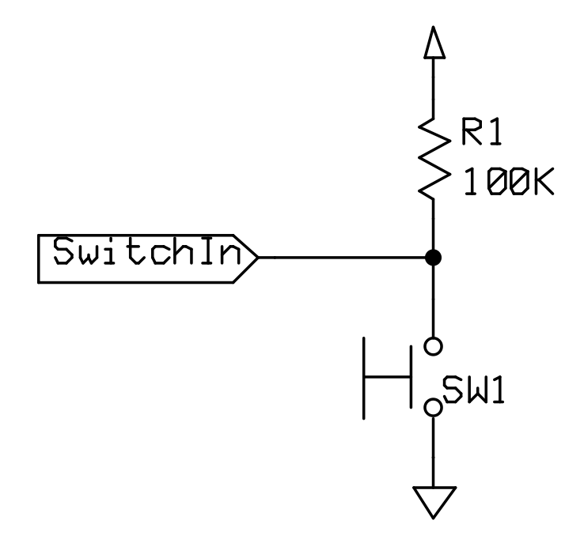
In the software using the GPIO drivers, it can be set up as an input with the internal pull-up resistance using this driver function.

gpio_set_mode(PA_0, PullUp);

When the button is pressed, the pin reads a low voltage, and the driver returns 0.
When the button is not pressed, the pin reads a high voltage, and the driver returns 1.

To read the value of a pin, use

gpio_get(PA_0)

Now, inside main2(), write a program that counts the number of presses on the RIGHT button. You may add a small delay after every button press to ignore button bounces.

Print the number of presses on the LCD. You may find system functions like sprintf() useful.

Change main() to run main2() instead.

Build the project and download the image to the lab board.

Verify your program on the lab board.

Return to Keil uVision and start debugging.

Set a breakpoint to the line where you call gpio_get(). Run the program until it pauses.

Step over this function. Then write down the values of registers R0, R1, R2 and R15 (PC) in the box below.

R0: 0x00000001
R1: 0x00000000
R2: 0x40020000
R15(PC):0x08000C9C

You may now proceed to the next exercise.

Exercise 3

Based on the new skills in previous exercises, write in main3() the following application:

- LCD shows your first name and last name in Pinyin initially.
- A press of RIGHT button changes the display to your BUPT and QMUL ID.
- Another press changes it back the names.

In this box, explain briefly how your program work.

In main3(), the program initially displays my first and last name on the LCD screen. When the RIGHT button is pressed, the display toggles to show my BUPT and QMUL student IDs instead. A subsequent press of the button switches the display back to my name.
The program uses a toggle variable to keep track of the display state. When the button is pressed, the value of toggle is flipped (from 0 to 1, or 1 to 0). If toggle is 0, the LCD displays your name, and if toggle is 1, the LCD displays your student IDs.
A small delay after each button press ensures that button bouncing is avoided, so only one press is registered each time. The process continues in a loop, allowing the user to switch between displaying names and IDs as they press the button.

You have now completed this lab practice. Well done! Get ready your files and submit them to QMPlus.

Declaration

Please declare any form of assistances from persons or AI services that you used to complete this lab practice. If none, please it empty.

Submission

- Word document of this lab sheet with your answers
- main.c (only) with all functions completed

Please submit the above documents to the corresponding QMPlus assignment pages. The deadline is usually a week after the lab session and will be stated clearly on QMPlus.

- End of Lab Practice -

