Lab 2 – UART/Serial Interface

For this lab exercise, you will develop a sample application for our STM32F401RE lab board that receives and transmits ASCII characters over a UART/serial connection (using the same USB cable). The objective is to understand how to call the standard UART driver and set up a terminal connection using PuTTy software.

Important note:
- This lab contributes to 2% of your final grade.
- If you have obtained any assistance from someone or AI services to complete this lab, please complete the declaration form in the end of this lab sheet.
- Any source code(s) that you submit are subject to be checked against Internet sources and other students’ submissions for potential plagiarism.
- This lab is an individual work. When you submit, you also confirm that the submission is entirely your own work and agree to have your work checked again plagiarism.

Useful references / sources for this lab practice
- Lab 2 Keil uVision project (QMPlus)
- “Using PuTTy for serial” tutorial video

Exercise 1

Download and extract the given project to a folder that contains NO Chinese characters.

Open the project in Keil uVision software

Navigate to design sources on the left pane and open “main.c”.

Study the given function main_sample().

Build the project.

Connect the lab board to your laptop using the USB cable.

Download the image to the lab board. Reset the board.

Start PuTTy software on your laptop and open the COM port for the lab board (usually COM3 or COM4).

Type your own name in Pinyin on the terminal slowly (because the BAUD rate of the serial connection is not too fast).

Record what do you see in the LCD display.

When I typed my name in Pinyin slowly, I saw my name Zecheng Zuo being printed on the LCD screen as I typed it. The LCD displayed each character one by one, with a slight delay between characters because the baud rate was not very fast. This process happened in real time as I typed on the PuTTy terminal.

Now, copy the content from main_sample() to main1().

Modify the statements in main1() such that
- If the character is a full-stop (.) is received, the LCD will be cleared.
- If the character is a comma (,), move the cursor to the top or bottom. Function lcd_set_cursor() is useful here.
- Otherwise, print the character on the LCD display.

Update main() to run main1() instead of main_sample().

Then test your program by building and downloading to the lab board. If the result is correct, proceed to the next exercise; if not, go back to the source code.

Exercise 2

In this exercise, you will work with the RIGHT button on the LCD shield, which is connected to the pin PA_0 of the Cortex-M4 processor on the lab board. If required, refer to your own answer in lab 1 exercise 2.

Study the driver function uart_print().

To read the value of a pin, use

gpio_get(PA_0)

Now, inside main2(), write a program that sends your name in Pinyin when someone presses the RIGHT button. You may add a small delay after every button press to ignore button bounces.

Change main() to run main2() instead.

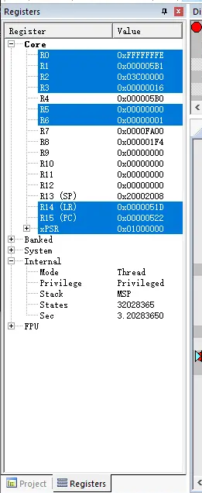
Build the project and download the image to the lab board.

Verify your program on the lab board.

Return to Keil uVision and start debugging.

Set a breakpoint to the line where you call uart_print(). Run the program and press RIGHT button once.

Mark the time (left window pane > Internal > Sec) now, then step over this function. Check again the time . Write the time (in secs) required to run this function in the box below.

First time(after pressing RIGHT button):2.7076
Second time(after stepping over):2.6891
So the time required to run this function is 2.7076-2.6891 = 0.0185 secs

You may now proceed to the next exercise.

Exercise 3

Based on the new skills in previous exercises, write in main3() the following application:

- Pick a short secret password, e.g. cake
- In a loop, keep reading characters from the serial port and match it against your chosen secret password
- If the whole word is matched, print “BINGO!” to the serial port (such that one can see it on the PuTTy terminal).

Example: if the input is “haucakeiicacakex”, then your program should print “BINGO!” two times.

In this box, explain briefly how your program work.

My program continuously listens for characters over the UART. It compares each received character with the characters of the pre-defined password (in my case is "cake").
- As each character is received, it is compared with the corresponding character in the password string.
- If the character matches, the index is incremented, and the program checks the next character.
- If there is a mismatch, the index is reset to 0, and the program starts checking from the first character of the password again.
- Once the entire password is matched, the program prints "BINGO!" to the serial port and resets the index to start the process again.

You have now completed this lab practice. Well done! Get ready your files and submit them to QMPlus.

Declaration

Please declare any form of assistances from persons or AI services that you used to complete this lab practice. If none, please it empty.

Submission

- Word document of this lab sheet with your answers
- main.c (only) with all functions completed

Please submit the above documents to the corresponding QMPlus assignment pages. The deadline is usually a week after the lab session and will be stated clearly on QMPlus.

- End of Lab Practice -

