Student: Jefté Munoz

***Project Proposal***

**Project Purpose**

This project is intended to be a website for basketball fans, specifically for fans of the San Antonio Spurs. It is intended that the content will show the team’s schedule, roster, results, and if possible highlights of each game. If it is possible the website will help users find tickets for the games.

**The Audience**

The users that I plan for are of any age and gender, and their income can be of any level. They should preferably be fans of the San Antonio Spurs and will be searching for their games’ time and date, scores and if they wish buy tickets to watch them play. This website will provide them with what they’re searching for.

**Persona**

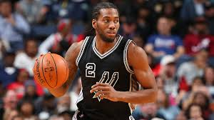Kawhi James-Irving is 24 years old; he was born in France, but has lived most of his life in the United States, he is single and is a college student at BYU-Idaho majoring in Accounting. Kawhi currently lives in San Antonio, Texas, as he does his internship. He is a big basketball fan and a Spurs fan. He wants to watch as many live games as possible before he returns to Rexburg. He uses his laptop to navigate, more than his other devices, and search for the San Antonio Spurs results on a weekly basis. Kawhi spends most of his free time playing basketball and wearing his Spurs jersey.

**Web Pages**

About – This will contain information about the team (history), stadium address and other contact info.

Schedule – This area will contain the schedule of the team and locations of the games.

Roster – This part will contain a current roster of the team.

Results – The results of each game and the video of the highlights will appear in this area.

Awesomeness – The best highlights of each game will appear here.

Buy Tickets – Websites to buy tickets online for their games will show in this area.

**Wireframe Sketches**

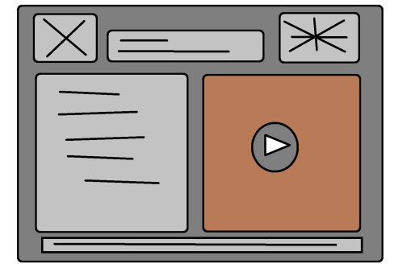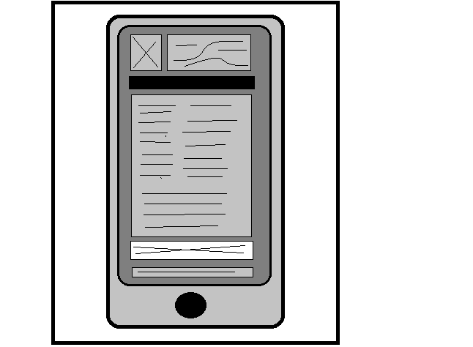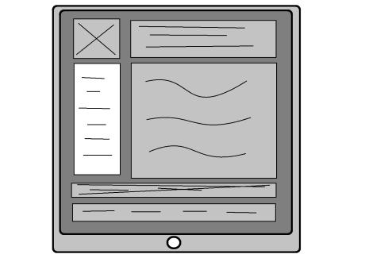

**Usability Concepts**

Font size/spacing is easy to read – I will understand this concept the best I can and use guides to apply it during the creation of my website to avoid poor readability.

Images have appropriate ALT tags – I will make sure the ALT tag contains exactly what the image is, in few words.

Links are consistent & easy to identify – I will avoid marking my links with different colors and be consistent with whatever thing I do to them, this will make them easier to identify.

Major headings are clear & descriptive – Heading will describe their content perfectly. I think it will not be hard with the type of website I’m creating and will help users find what they search when they skim the website.

Main copy is concise & explanatory – I will ensure the content contained in each page is concrete, and avoid all wordiness.