**Deployment using ANT MIGRATION TOOL :**

**Step 1 : TOOLS INSTALLATION**

From Setup 🡪 Quick Find 🡪 type “Tools”🡪 click “[**Lightning Platform Tools and Toolkits**](https://developer.salesforce.com/page/Tools)**”**

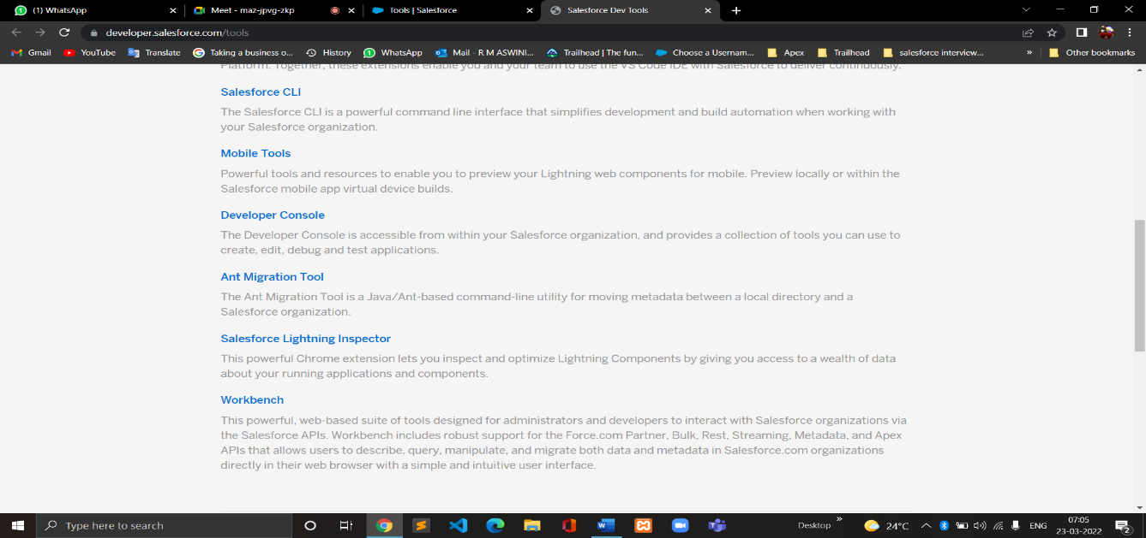



Click on🡪 **Ant Migration Tool**

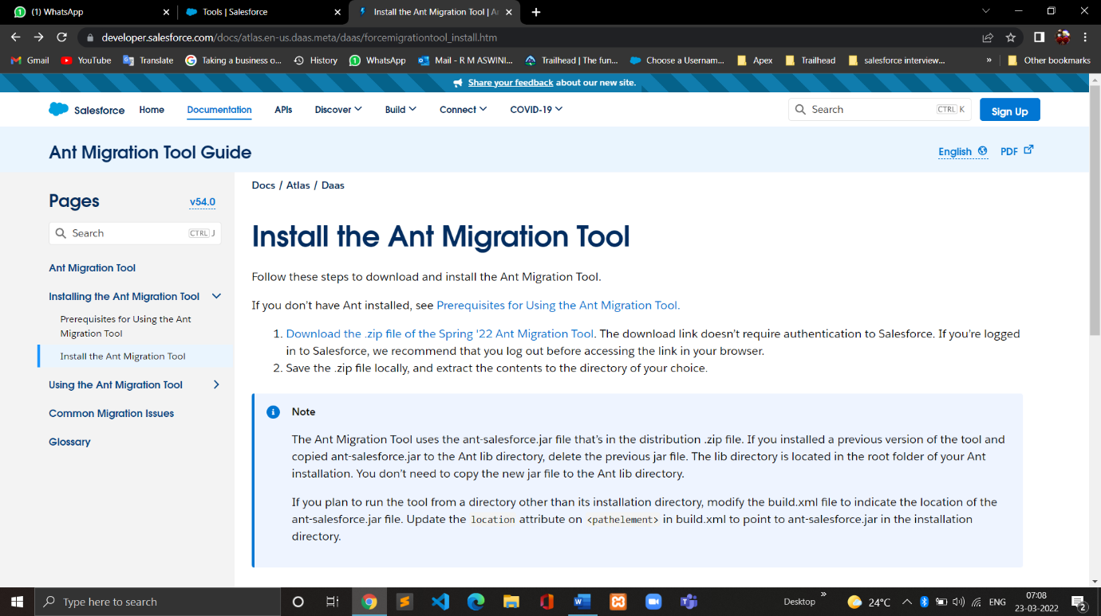



Click 🡪 **Prerequisites for Using the Ant Migration Tool**

Click on the link to install java as shown in the below picture

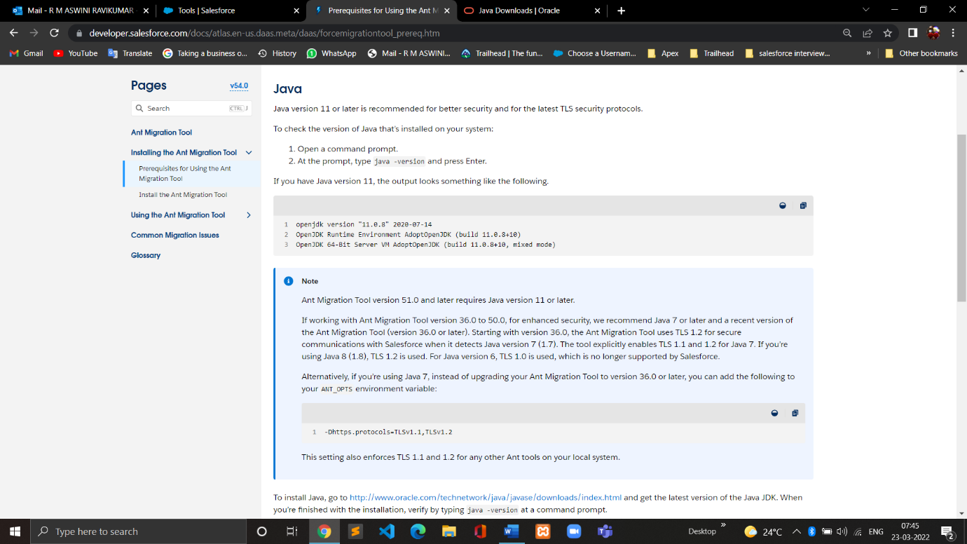



Click on Windows platform and choose **x64 Installer** to download;

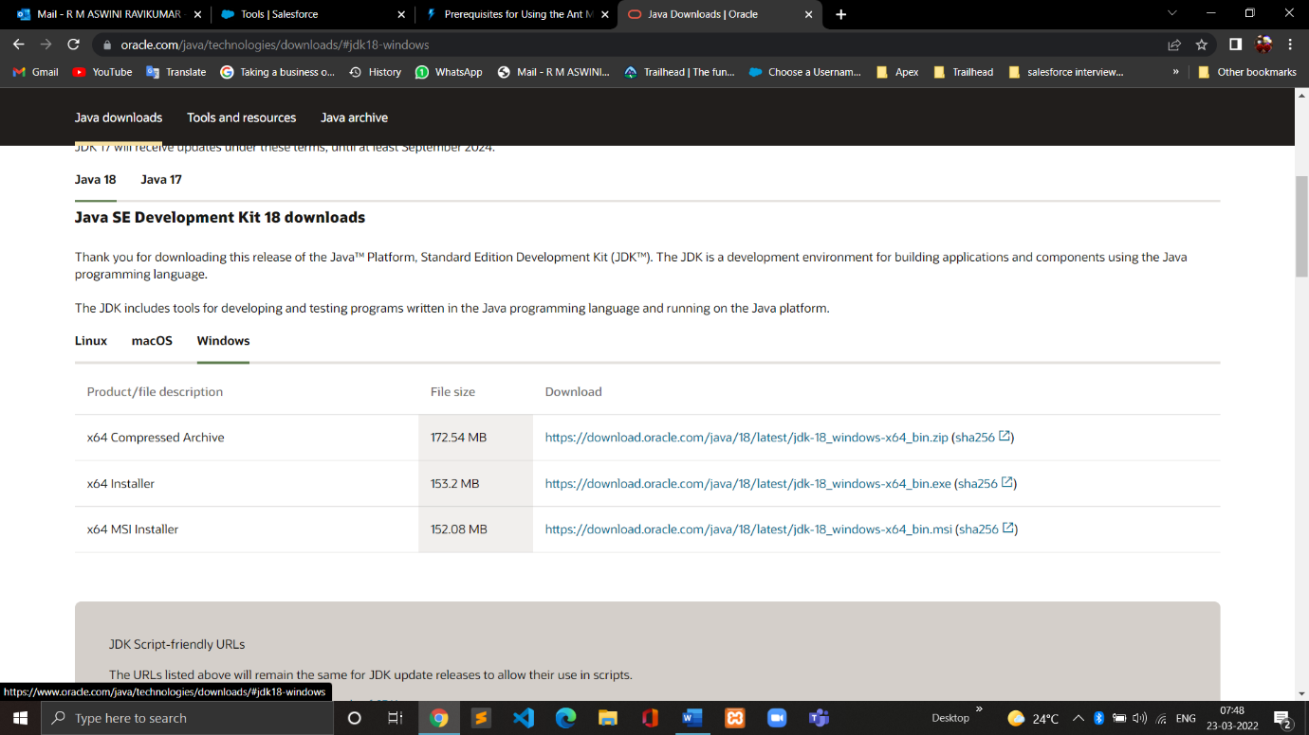To download the ANT Migration Tool, Click on the Link as shown below;



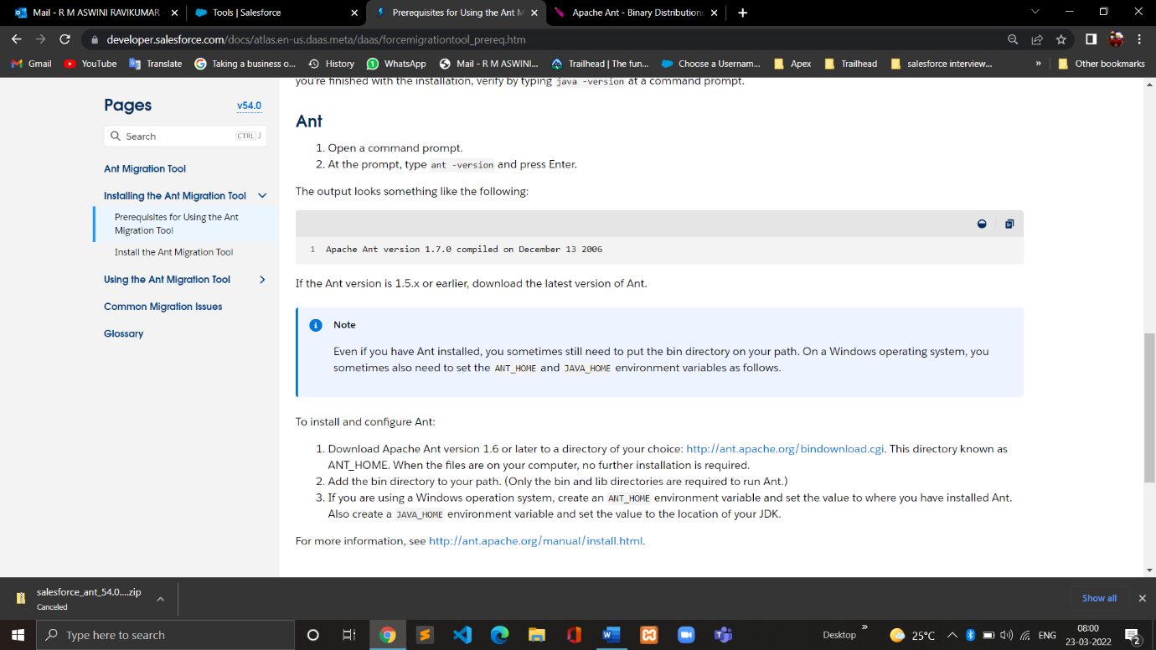



* Next Click on the link as shown below;

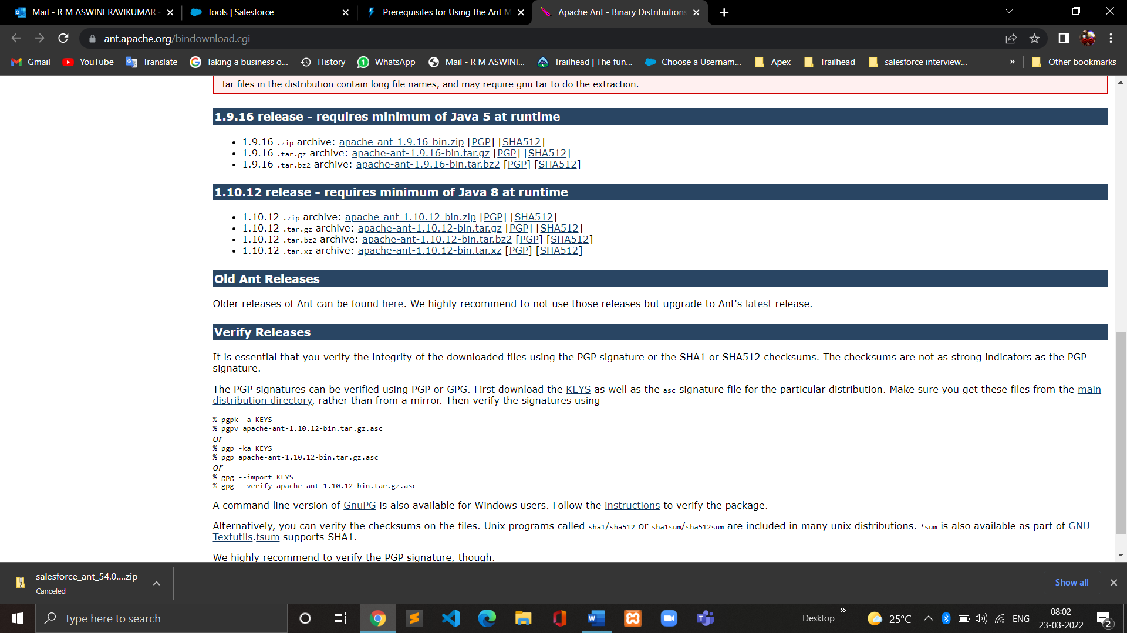



* Also download the Zip file as shown below ,





**Step 2: FILE SETUP**

* In File Manager , create a New Folder in Windows:C drive and rename as “Ant Migration Tool”.
* Copy the below Downloaded two zip files and paste it in **Ant Migration Tool** folder.

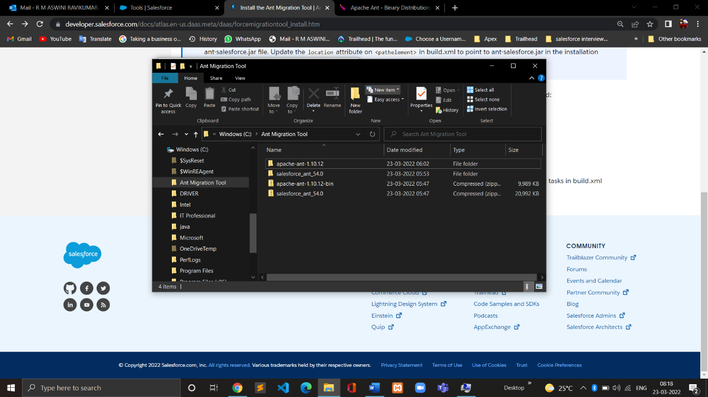

* Extract the zip files in the same **Ant Migration Tools** folder

**Step 3: PATH SETTINGS**

* Type Advanced System Settings in Windows Search and open **Environment Variables**
* Type New on User Variables and

Variable Name : JAVA_HOME

Variable Path : ( Browse Directory and choose the path of your Java jdk)

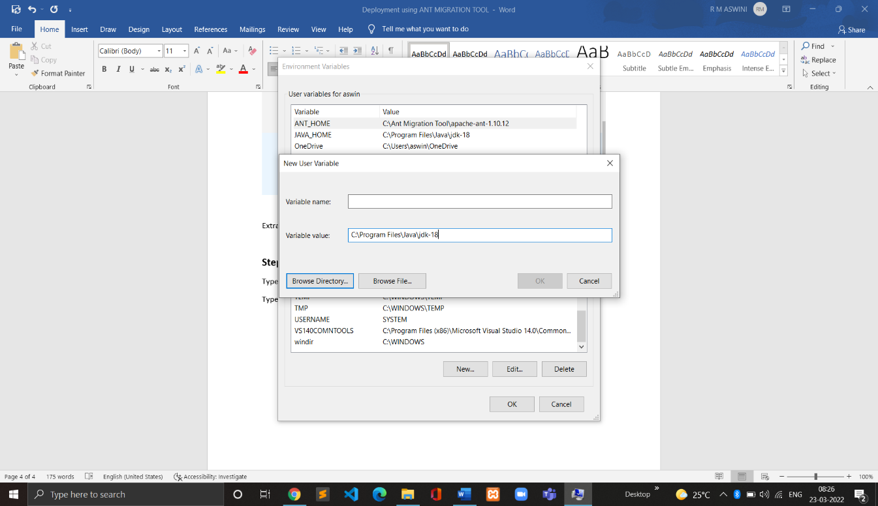

* Again, create New User variable;

Variable Name : ANT_HOME

Variable Path : ( Browse Directory and choose the path of your ANT)

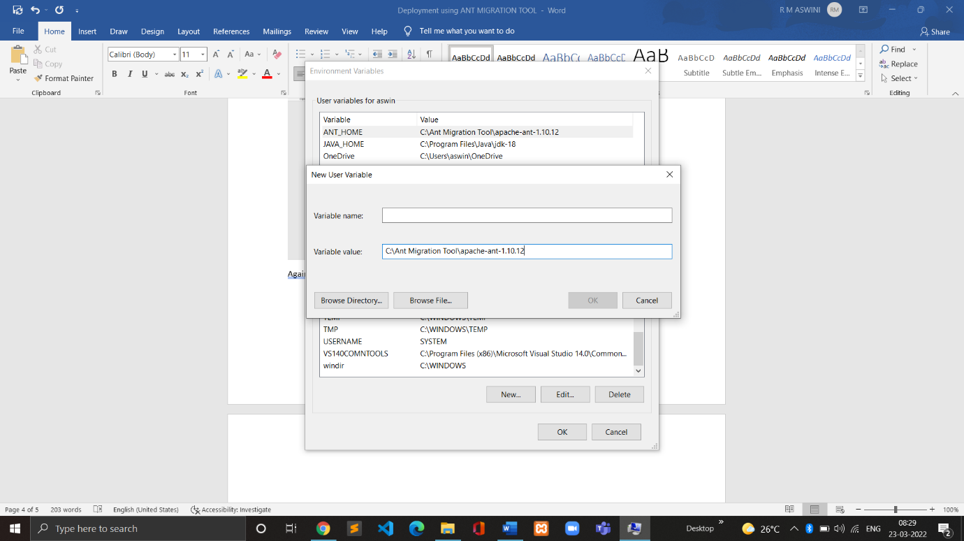

* And , Click on Path in User Variables 🡪 Browse the path for both jdk and ant bin



* And then move them in the order so that “ant bin” path is set below the “jdk bin” path as shown below;

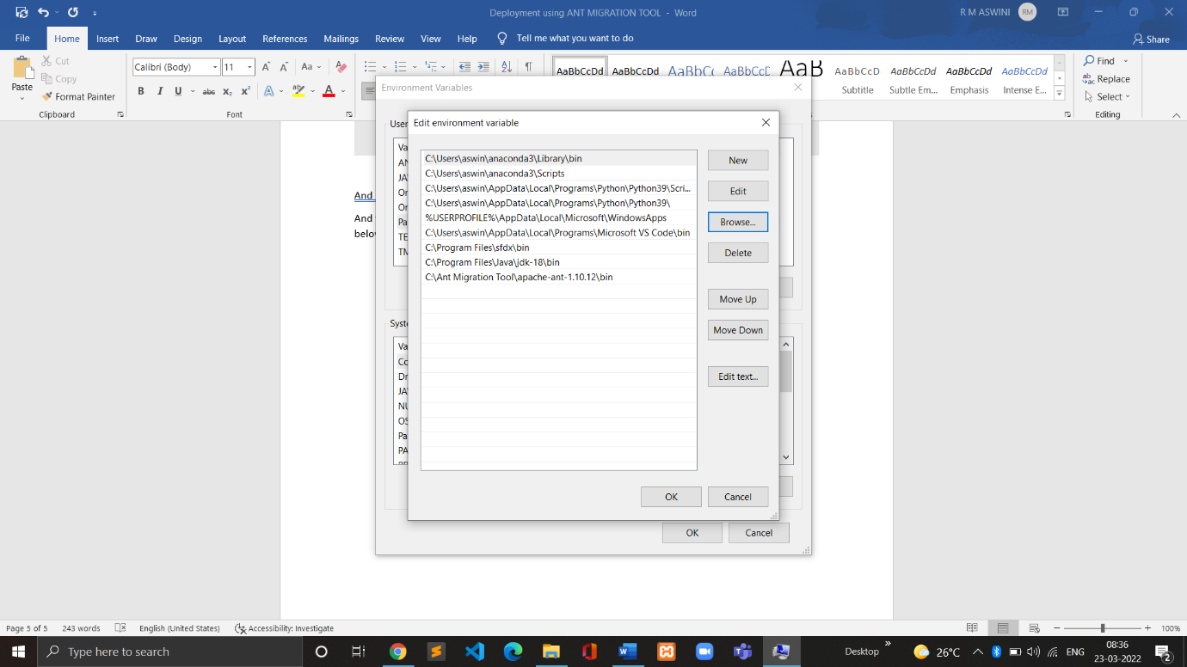



**Step 4: DEPLOYMENT**

* In File Manager, Open “Ant Migration Tool” 🡪 salesforce_ant_54.0 🡪 sample 🡪 open the two “build” files using notepad++
* In “build.properties”,

sf.username = //Your org username//

sf.password = //Your org password followed by security token//

Note: To generate security token, click on settings in the top right bottom on your org under profile image; then click on reset security token.

* In “build.xml”,
* Under **<target name="deployUnpackaged"> ,**
* Change the **deployRoot="codepkg"**
* To deploy, In File Manager Open “Ant Migration Tool” 🡪 salesforce_ant_54.0 🡪 sample

Then (Shift+Right Click) 🡪 Click on “Open Windows power shell here”

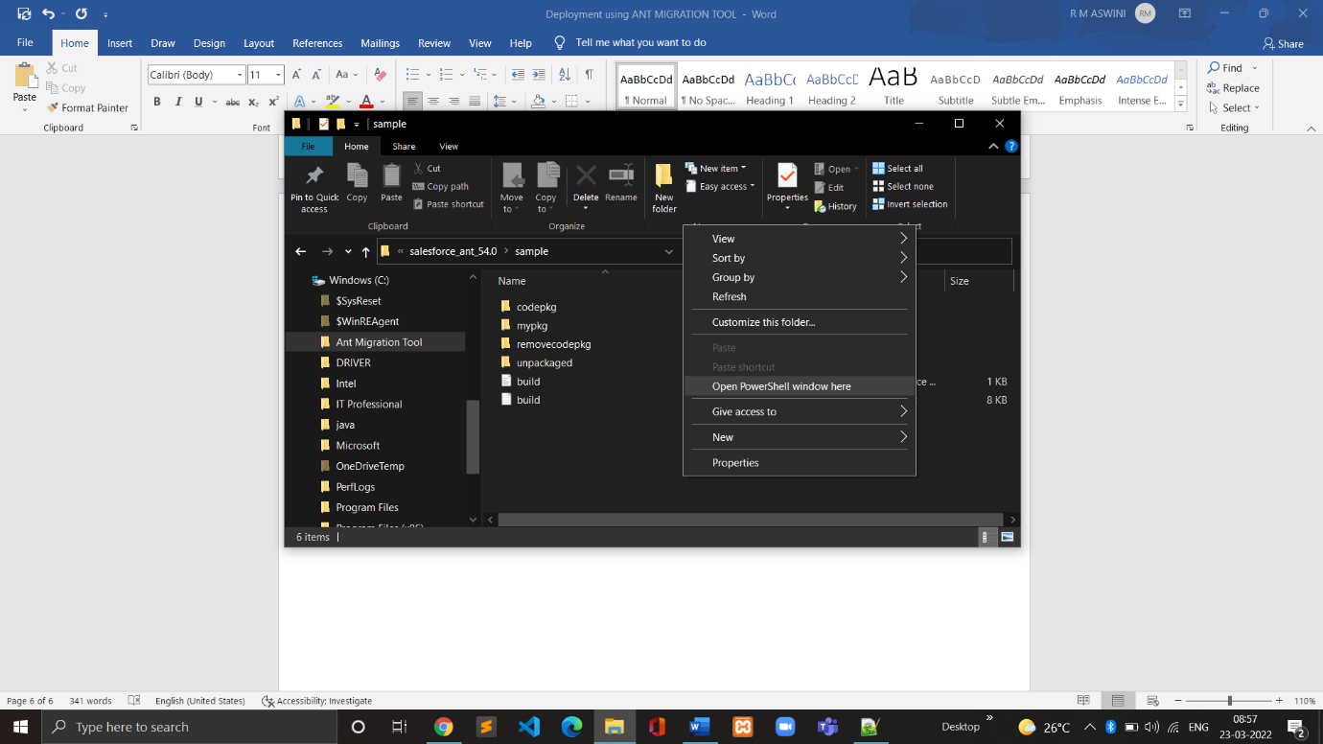

* Type **ant deployUnpackaged** in Powershell and click enter;

