**1.Perform all types of Joins, and explain how its different**

Inner join:

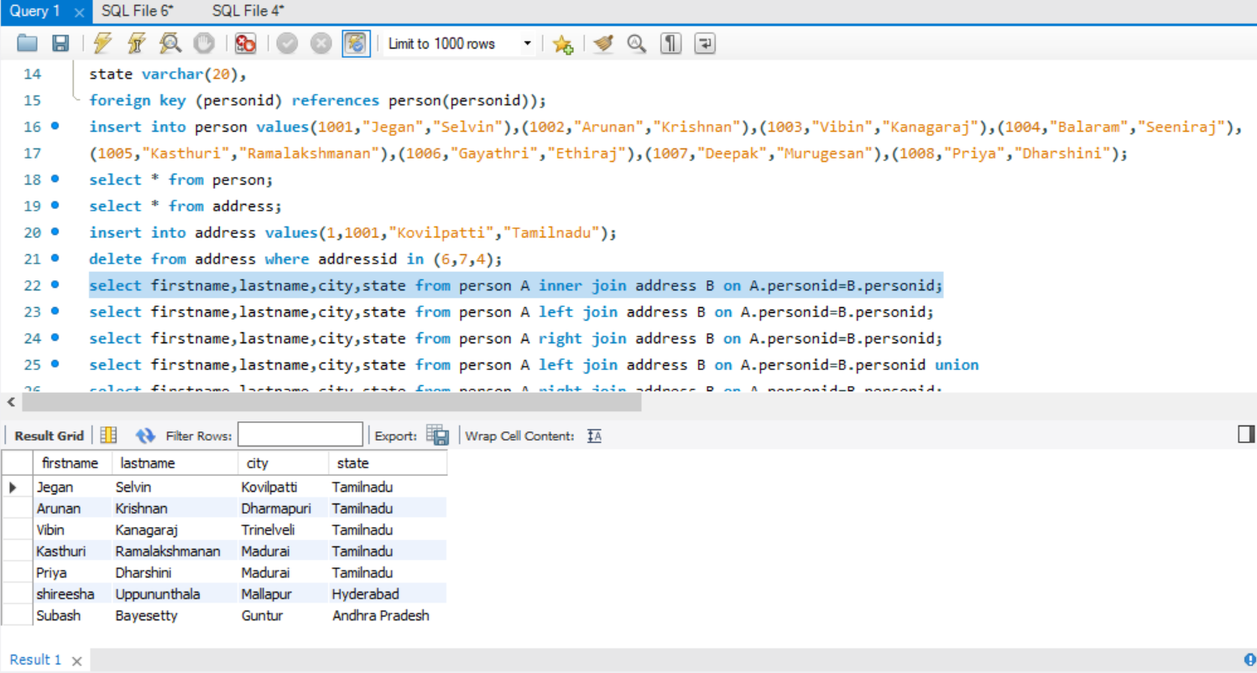

Left Join:

Right Join:

Full Join:

**2.Write an SQL query to find employees who have the highest salary in each of the departments.**

**3.Write an SQL query to report all customers who never ordered anything.**

