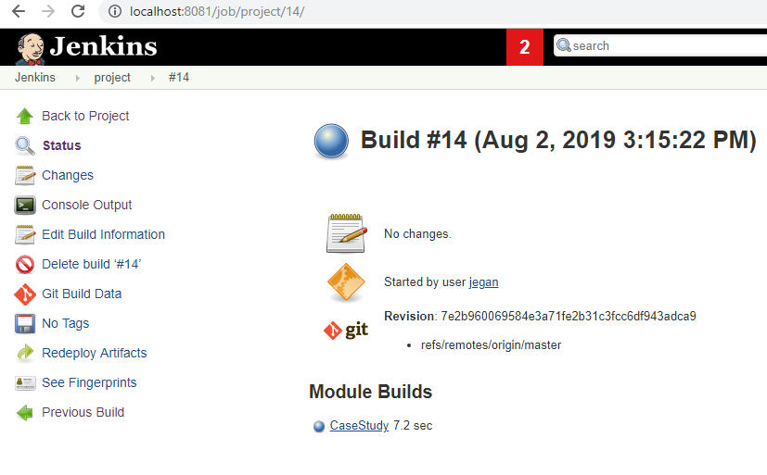

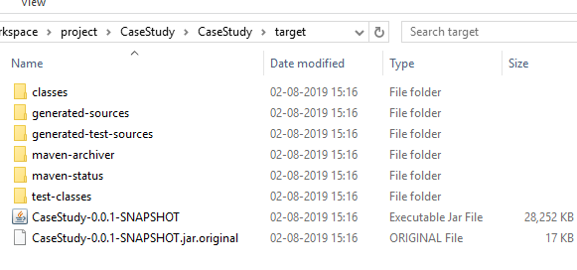

Console :-

Started by user jegan

Building in workspace C:\Users\Admin\.jenkins\workspace\project

[WS-CLEANUP] Deleting project workspace...

[WS-CLEANUP] Deferred wipeout is used...

[WS-CLEANUP] Done

No credentials specified

Cloning the remote Git repository

Cloning repository https://github.com/JeganSakthivel/ProjectManagerApp.git

> git.exe init C:\Users\Admin\.jenkins\workspace\project # timeout=10

Fetching upstream changes from https://github.com/JeganSakthivel/ProjectManagerApp.git

> git.exe --version # timeout=10

> git.exe fetch --tags --progress https://github.com/JeganSakthivel/ProjectManagerApp.git +refs/heads/*:refs/remotes/origin/*

> git.exe config remote.origin.url https://github.com/JeganSakthivel/ProjectManagerApp.git # timeout=10

> git.exe config --add remote.origin.fetch +refs/heads/*:refs/remotes/origin/* # timeout=10

> git.exe config remote.origin.url https://github.com/JeganSakthivel/ProjectManagerApp.git # timeout=10

Fetching upstream changes from https://github.com/JeganSakthivel/ProjectManagerApp.git

> git.exe fetch --tags --progress https://github.com/JeganSakthivel/ProjectManagerApp.git +refs/heads/*:refs/remotes/origin/*

> git.exe rev-parse "refs/remotes/origin/master^{commit}" # timeout=10

> git.exe rev-parse "refs/remotes/origin/origin/master^{commit}" # timeout=10

Checking out Revision 7e2b960069584e3a71fe2b31c3fcc6df943adca9 (refs/remotes/origin/master)

> git.exe config core.sparsecheckout # timeout=10

> git.exe checkout -f 7e2b960069584e3a71fe2b31c3fcc6df943adca9

Commit message: "controller"

> git.exe rev-list --no-walk 7e2b960069584e3a71fe2b31c3fcc6df943adca9 # timeout=10

Parsing POMs

Established TCP socket on 51343

[CaseStudy] $ "C:\Program Files\Java\jdk1.8.0_144/bin/java" -cp C:\Users\Admin\.jenkins\plugins\maven-plugin\WEB-INF\lib\maven35-agent-1.13.jar;C:\Users\Admin\.jenkins\tools\hudson.tasks.Maven_MavenInstallation\pom\boot\plexus-classworlds-2.6.0.jar;C:\Users\Admin\.jenkins\tools\hudson.tasks.Maven_MavenInstallation\pom/conf/logging jenkins.maven3.agent.Maven35Main C:\Users\Admin\.jenkins\tools\hudson.tasks.Maven_MavenInstallation\pom C:\Users\Admin\.jenkins\war\WEB-INF\lib\remoting-3.29.jar C:\Users\Admin\.jenkins\plugins\maven-plugin\WEB-INF\lib\maven35-interceptor-1.13.jar C:\Users\Admin\.jenkins\plugins\maven-plugin\WEB-INF\lib\maven3-interceptor-commons-1.13.jar 51343

<===[JENKINS REMOTING CAPACITY]===>���channel started

Executing Maven: -B -f C:\Users\Admin\.jenkins\workspace\project\CaseStudy\CaseStudy\pom.xml clean package -DskipTests=true

[INFO] Scanning for projects...

[INFO]

[INFO] -----------------------< com.example:CaseStudy >------------------------

[INFO] Building CaseStudy 0.0.1-SNAPSHOT

[INFO] --------------------------------[ jar ]---------------------------------

[INFO]

[INFO] --- maven-clean-plugin:2.6.1:clean (default-clean) @ CaseStudy ---

[INFO]

[INFO] --- maven-resources-plugin:2.7:resources (default-resources) @ CaseStudy ---

[INFO] Using 'UTF-8' encoding to copy filtered resources.

[INFO] Copying 1 resource

[INFO] Copying 10 resources

[INFO]

[INFO] --- maven-compiler-plugin:3.1:compile (default-compile) @ CaseStudy ---

[INFO] Changes detected - recompiling the module!

[INFO] Compiling 10 source files to C:\Users\Admin\.jenkins\workspace\project\CaseStudy\CaseStudy\target\classes

[INFO]

[INFO] --- maven-resources-plugin:2.7:testResources (default-testResources) @ CaseStudy ---

[INFO] Using 'UTF-8' encoding to copy filtered resources.

[INFO] skip non existing resourceDirectory C:\Users\Admin\.jenkins\workspace\project\CaseStudy\CaseStudy\src\test\resources

[INFO]

[INFO] --- maven-compiler-plugin:3.1:testCompile (default-testCompile) @ CaseStudy ---

[INFO] Changes detected - recompiling the module!

[INFO] Compiling 1 source file to C:\Users\Admin\.jenkins\workspace\project\CaseStudy\CaseStudy\target\test-classes

[INFO]

[INFO] --- maven-surefire-plugin:2.18.1:test (default-test) @ CaseStudy ---

[INFO] Tests are skipped.

[INFO]

[INFO] --- maven-jar-plugin:2.6:jar (default-jar) @ CaseStudy ---

[INFO] Building jar: C:\Users\Admin\.jenkins\workspace\project\CaseStudy\CaseStudy\target\CaseStudy-0.0.1-SNAPSHOT.jar

[INFO]

[INFO] --- spring-boot-maven-plugin:1.5.21.RELEASE:repackage (default) @ CaseStudy ---

[INFO] ------------------------------------------------------------------------

[INFO] BUILD SUCCESS

[INFO] ------------------------------------------------------------------------

[INFO] Total time: 7.701 s

[INFO] Finished at: 2019-08-02T15:16:30+05:30

[INFO] ------------------------------------------------------------------------

Waiting for Jenkins to finish collecting data

[JENKINS] Archiving C:\Users\Admin\.jenkins\workspace\project\CaseStudy\CaseStudy\pom.xml to com.example/CaseStudy/0.0.1-SNAPSHOT/CaseStudy-0.0.1-SNAPSHOT.pom

[JENKINS] Archiving C:\Users\Admin\.jenkins\workspace\project\CaseStudy\CaseStudy\target\CaseStudy-0.0.1-SNAPSHOT.jar to com.example/CaseStudy/0.0.1-SNAPSHOT/CaseStudy-0.0.1-SNAPSHOT.jar

channel stopped

Finished: SUCCESS