**Tutorial PreProcB:**

PreProcB is a Matlab App to perform preprocessing and processing on SEEG data. The main idea is to prepare the data and be able to imported this process into other software as AnyWave and Brainstorm. The preprocessing panel is the most important because it allows us to align the Behavior data with the SEEG and knowing what the patients have done during the tasks. The markers are saved in AnyWave format that can be imported in AnyWave and in Brainstorm. The user can also do a High-pass filter, and/or notch filter and select the bad channels. If there is an analysis done, the new SEEG file is saved in EDF format. The processing panel performs simple analysis of the SEEG that can help the user to see some information, and then determined what complete analysis to perform. More details will be given in this tutorial on the type of analysis.

# I – Getting started

The project PreProcB can be found on GitHub of the lab named CorsyLab. If you do not have access, please ask Steven or Aude to be added as member. (<https://github.com/CorsyLab/PreprocB>)

There are two ways to use ccc, as Matlab code or as Apps.

1. Requirements

Matlab is required to use it; in case you don’t have access to Matlab an .exe can be created on request. If you don’t use the Apps but the code, the toolbox Fieldtrip is required.

1. Installation

# II – How to Use it

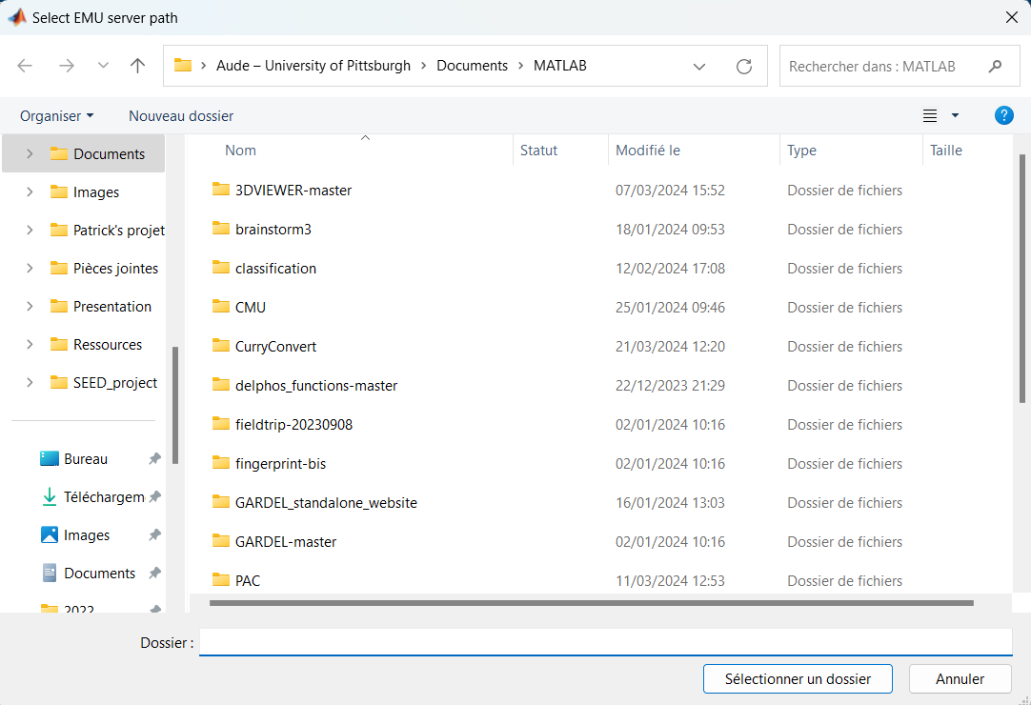When opening the Apps, a “get folder” will open to ask the user to select the path of the EMU server if he wants to work on this directory. EMU server is specific to CorsyLab, whereas if the user clicks on cancel, the Apps will work locally.

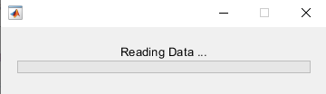Then, PreProcB will appear with the preprocessing panel. Before explaining the different process, I would like to describe a common features appearing at each process. When you push the button to do any processing, a progress bar window will appear. You must wait until the bar is totally green and the window closed before trying to interact again with the interface.

1. Preprocessing Panel

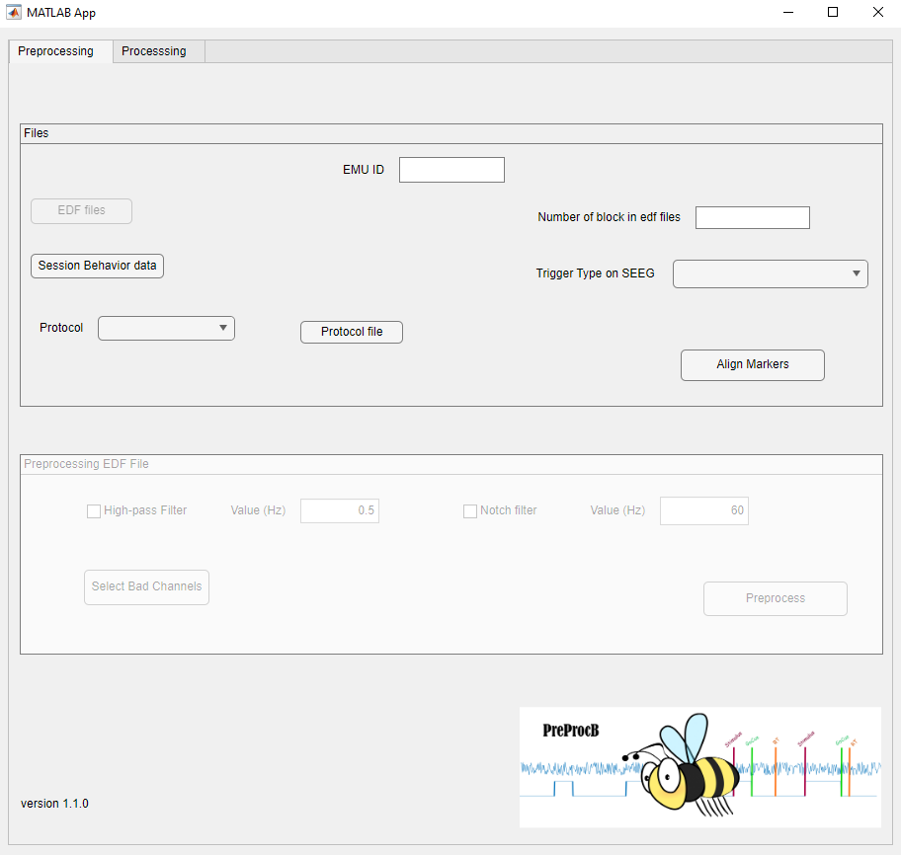

5

4

3

7

6

2

1

8

As you can see, there are two frames. The second one is enabled once an EDF file has been selected. The first frame named “Files” (blue) represents the alignment of the behavior data with the SEEG. Let me describe the different buttons:

1. EMU ID: it is the ID of the patient in the research database. It must be maximum three digits. It will enable the EDF files button.
2. EDF files: You must select the EDF files (SEEG data) corresponding to the behavior tasks that you want to use. For one behavior task, you can have multiple files that must be all selected there. PreProcB will ask you if you want to concatenate them (see below)
3. Number of Blocks: represents the number of blocks that have been done during the acquisition. This number will be compared to the one given in the Protocol file.
4. Session Behavior data: You have to select the excel (or csv) file corresponding to the scoring done during behavior process. This file contains the different triggers/markers that will be added to the SEEG.
5. Trigger type: You have to select the channel on the SEEG representing the trigger of your experiment.
6. Protocol: If you have selected the EMU server, this drop down list will show you the possible protocol saved in EMU server that you can use here. Select the one corresponding to your experiment (i.e., SMA, DelayedNaming, etc.)
7. Protocol file: Use this button only if you don’t want/can use the protocol from the EMU server. You have to select the excel file containing your Protocol. WARNING: The protocol must be in a specific format (see xx), if not PreProcB will warn you that it can’t proceed.
8. Align Marker: It run the process and create the require files, i.e. the markers file and the the SEEG file. It is saved in the folder “SEEGpreprocessing”.

### Concatenate Data:

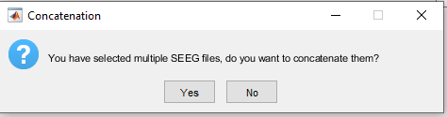 If you select multiple files for EDF, the interface will ask you if you want to concatenate them because it cannot work with multiple files. (The question will appear when you give the number of block or when you try to select the trigger or when you want to align the data). The question is:

* 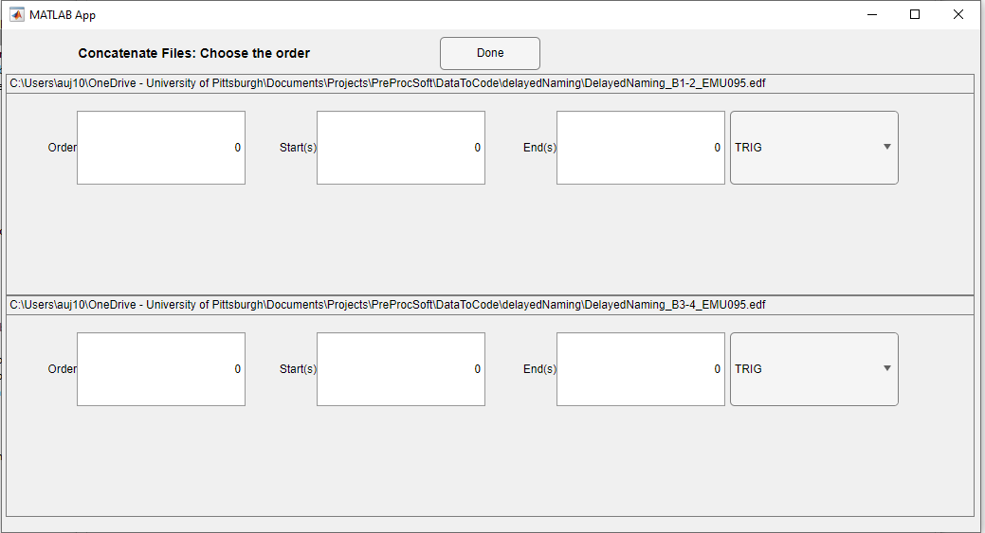Click-on yes to concatenate the data. A window will open to ask you to choose the order of the files, the start and the end, and the trigger channels to use. If start and end are let at 0, the software will take all the file.
* Click on no to keep only one file. PreProcB cannot have multiple files as input.

Select the file that you want to keep and click on OK.

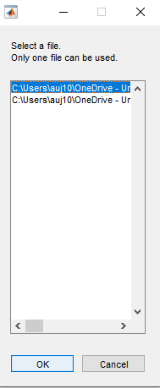

The second frame should now be enabled. This frame allows you to filter your data and to select the Bad Channels.

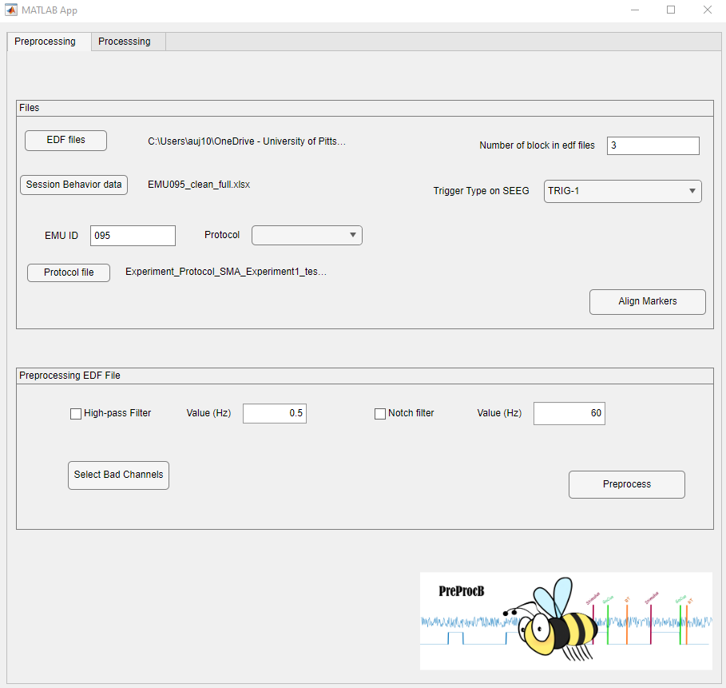

11

12

10

9

1. High-Pass Filter: If you check this box it will apply a High-pass filter to your seeg signal at the frequency indicates (by default 0.5 Hz)
2. Notch Filter: It will apply a notch filter to remove the powerline interference and its harmonics. In America, this powerline is at 60Hz but in Europe it is 50Hz, so it is why you can change the value of the filter.
3. Bad Channels: It open a new interface which allow you to select the channels that you considered as Bad. Don’t underestimate this steps, due to the lack of information in edf format, your data also have channels that are not seeg, it can be EKG, Pleth, DC, etc. Doing this step will allow to remove them of your analysis, if not it will be keep it.

### Bad Channels Interface: The interface represents the SEEG signal, each line corresponding to a channel and the x-axis representing the Time in second.

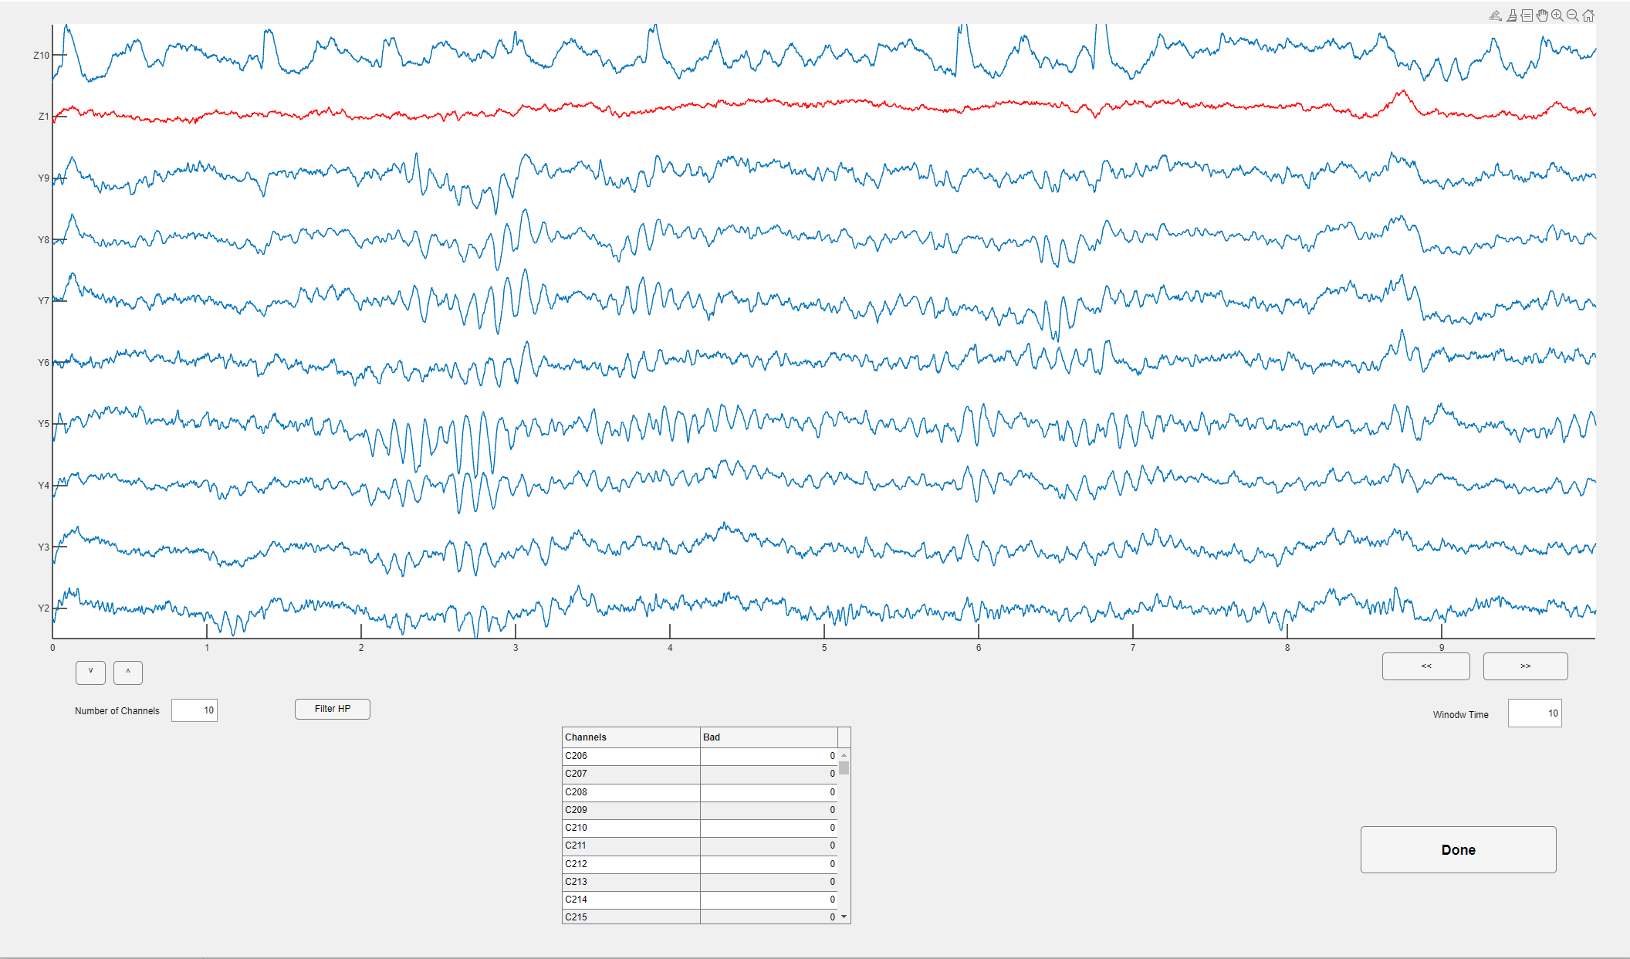

h

g

f

e

d

c

b

a

1. It is the visualization figure. Y-axis represents the channels and X-axis represents the time. You can interact with it. If the signal is blue, it means good channel, else if it is red, it means bad channel. You can change it by clicking close to the signal. It will also update the table (e).
2. This button allows you to scroll the channels.
3. By default, it displays 10 channels on (a) but you can changing this number by updating this case.
4. For visualization purposes, you can apply a High Pass filter at 0.5Hz. It takes some times to adjust.
5. This table represents the channels and the bad/good value associated. In the right column (Bad), the value 0 means the channel is considering as good and 1 means the channel is considered as bad. You can update this value directly on the table.
6. This button allows you to browse through time.
7. By default, the time window is 10 seconds but it can be changed by updating this case.
8. Once you are satisfied with your selection, click on Done it will go back to the main Apps.

Back to the main interface, the last step is to push the button Preprocess (12). It will perform the filtering, and save the Bad channels in a text file. However, before to save the new signal in edf format, it will ask you if you want to save the new signal without the Bad channels, meaning keeping the signal of only the good channels in the edf file.

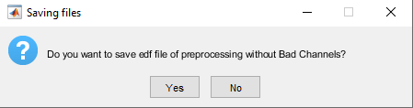

1. Processing panel

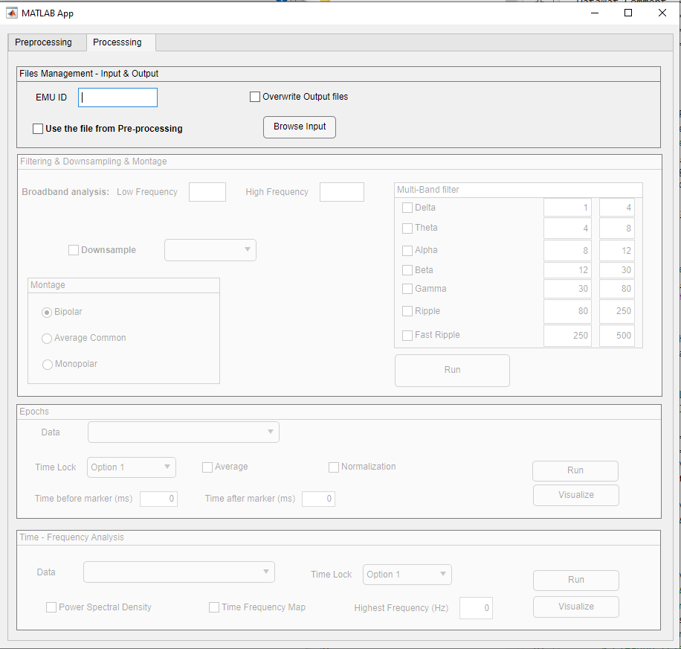At the beginning, the three-processing parts are not enabled until the user gives the input file (i.e., the edf file) to analyze.

There is two options, if you just did the preprocessing part, you can use the file coming from it by checking the box “Use the file from Pre-processing”. Otherwise, Browse the input by clicking on “Browse Input” to select the edf file to analyze. PreProcB will automatically detect the marker file associated to the edf file, if it cannot find it a new button will appear (orange box) and you will have to select the csv file (output of preprocessing).

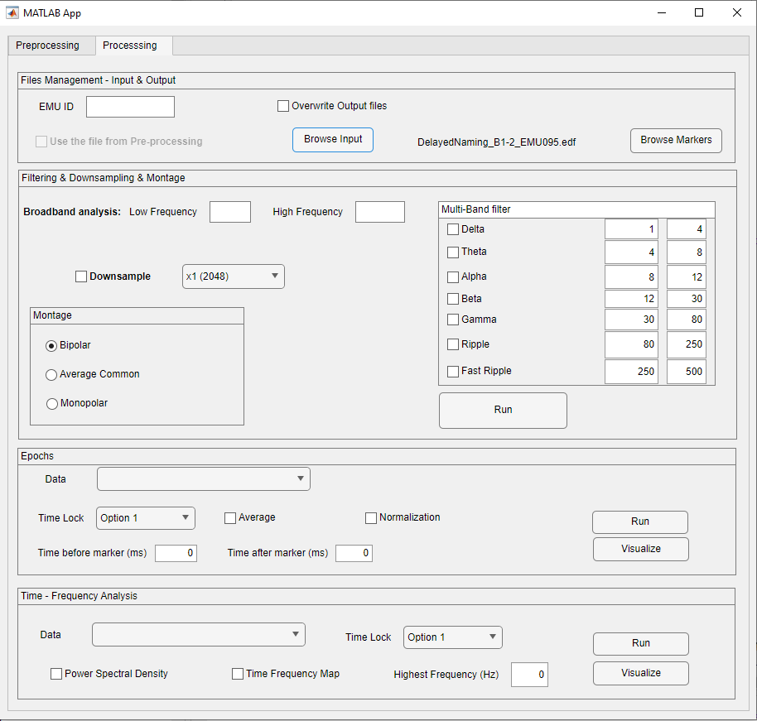

Filtering & Down sampling & Montage:

To filter your data, there are multiple options. The first one is Broadband, you just have to give the low and high frequency. The other option is to do multi-band filter, you can select different frequency range and modify the frequency value if you are not satisfied with the one by default. You can do multiple selection for the filtering, a separate file will be saved for each type, and the down sampling and montage will be applied to each of them.

Be careful with the down sampling because it will restrain the frequency range for the time-frequency analysis. To do a down sample, check the box and choose the option on the drop down menu. The options are determined according to the edf file given as input. The lowest sampling frequency that you can select is 256Hz.

For the montage, there are three possibilities. The first one is to do a bipolar montage, the most common when analyzing SEEG. The second option is average common, the signal of all channels is averaged and then subtracted at each channel, this is more common for EEG analysis. (Be careful because if you did not remove the bad channels or the channels not corresponding to EEG, they will be also used for the average, so the results will be wrong). The last option is to keep a monopolar montage.

Epochs:

* Data: Select the data of the purple box, it can be Broadband, NoFilter, or a specific frequency range.
* Time Lock: Select the marker name to extract the epochs.
* Average: Check this box if you want to have the average signal of all the trials by channels.
* Normalization: Check this box to normalize the data, the baseline selected is the one before the first marker of the signal (30s is taken).
* Time before marker: Write the time in milliseconds, it will be used to extract the trials before the marker.
* Time after marker: Write the time in milliseconds, it will be used to extract the trials after the marker.
* Run: Click this button to perform the analysis.
* Visualize: Click this button to visualize the results of the epoching.

Time – Frequency Analysis:

* Data: Select the data of the green box, it can be Broadband, NoFilter, or a specific frequency range.
* Time Lock: Select the marker name used in epochs
* Power Spectral Density: Check this box to perform power spectral density (psd), the Matlab function pwelch is used for this process.
* Time Frequency Map: Check this box to perform time frequency map, the fieldtrip function ft_freqanalysis is used for this process.
* Highest frequency: It is the highest frequency value to perform the Time Frequency map. If it is 0, PreProcB determine the value by itself depending on the data.
* Run: Click this button to perform the analysis.
* Visualize: Click this button to visualize the results of the TFmap.

### Visualize:

This window can also be called separately of PreProcB too. To do that, you can type in Command Window Matlab: visualize(filename, type).

Filename = mat-file saved by PreProcB, epochs or frequency.

Type = ‘epochs’ if you want to visualize epochs, or ‘TF’ to visualize Time frequency analysis.

Epochs visualization:

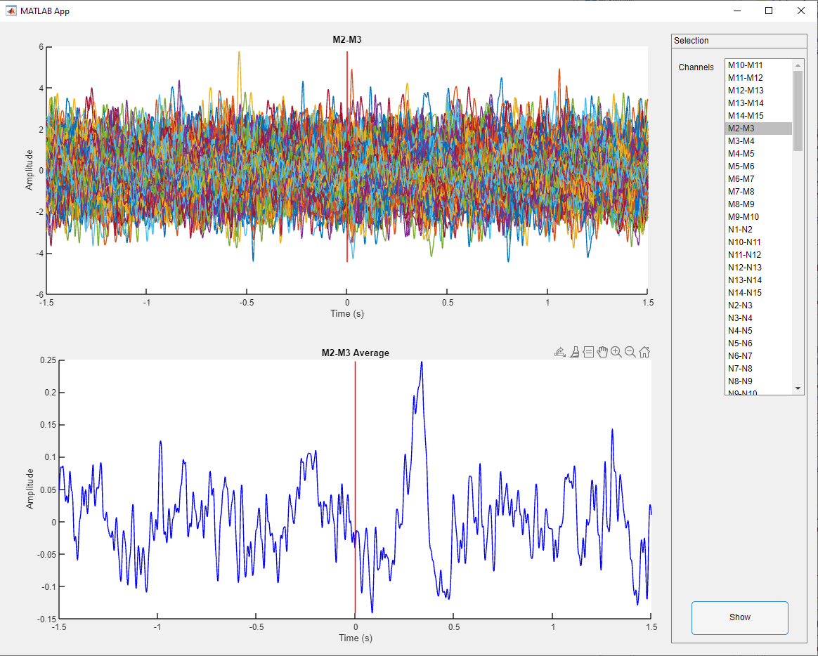

1

2

3

4

1. Select the channel to visualize
2. Click-on Show to visualize the trials of the selected channel
3. Plot the different trial (one color by trial), with x-axis time in second and y-axis the amplitude. There is a vertical red line to indicate the marker.
4. Plot the trials average of the selected channel, with x-axis time in second and y-axis the amplitude. There is a vertical red line to indicate the marker.

Time-Frequency Visualization:

1. Select the channel to visualize
2. Select if you want to visualize PSD or TFmap
3. Click-on Show to visualize the trials of the selected channel
4. Plot the PDS foe each trial, with x-axis the frequency in Hz and y-axis PSD value in dB/Hz
5. Plot the PSD of the average trials, with x-axis the frequency in Hz and y-axis PSD value in dB/Hz
6. Show the Time Frequency map, with x-axis the time in seconds and y-axis the frequency in Hz and the colorbar showing the intensity

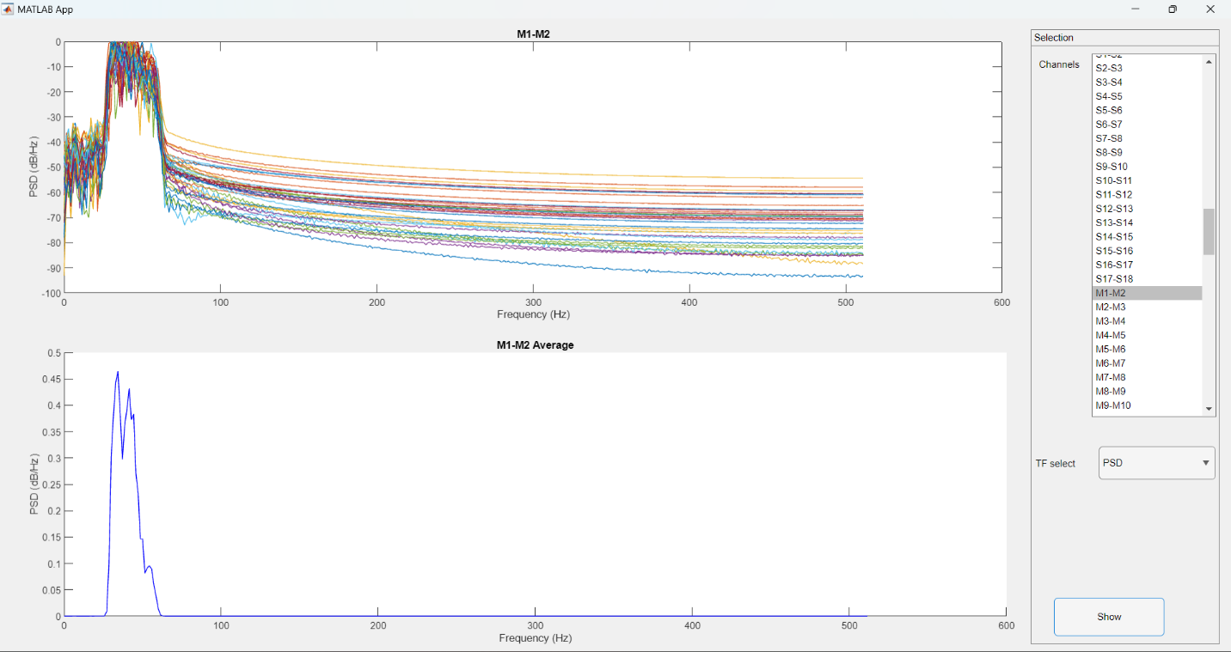

1

2

3

4

5

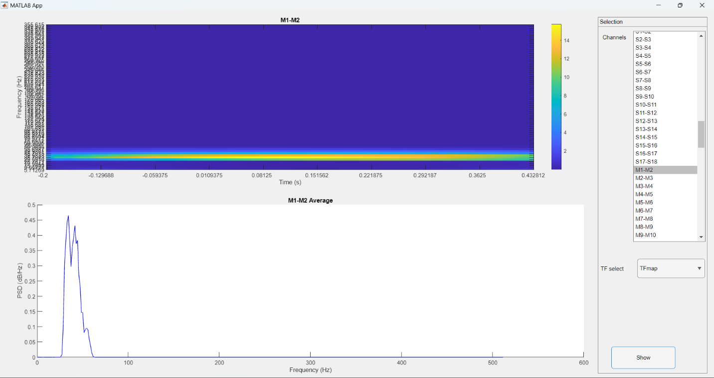

6

IMPORTANT

From processing, the mat-file are fieldtrip structures, however in order to import the epoch in brainstorm, I had to change a little bit.

Normal fieldtrip structure :

data.label % cell-array containing strings, Nchan*1

data.fsample % sampling frequency in Hz, single number

data.trial % cell- array containing a data matrix for each trial (1*Ntrials),

% each data matrix is a Nchan*Nsamples matrix

data.time % cell-array containing a time axis for each trials (1*Ntrials),

% each time axis is a 1*Nsamples vector

Structure for epochs to import in brainstorm:

data.label % cell-array containing strings, Nchan*1

data.fsample % sampling frequency in Hz, single number

data.trial % cell- array containing a data matrix for each trial (1*Ntrials),

% each data matrix is a Nchan*Nsamples matrix

data.xtime % cell-array containing a time axis for each trials (1*Ntrials),

% each time axis is a 1*Nsamples vector

data.avg % Nchan*Nsamples matrix averaging the trials

data.time % 1*Nsamples vector containing time in sec for avg

So, if you load the mat-file epochs in Matlab to then use fieldtrip, you will have to rename the field “xtime” in time ad the “time” one in xtime.