**Assignment Report**

**Chanutda Manosorn (s5313405)**

**Jehyun Kim (s5332936)**

Big Data Analysis – 3803ICT

Trimester 1 2025

**Table of content**

Part 1 – Data Preparation and Preprocessing 1

(1) Describe the dataset 1

(2) Describe the steps for data preparation and preprocessing 2

Part 2 – Data Analysis and Interpretation 4

(1) Relevant information in job metadata 4

(2) Job market by location 6

(3) Job market by sector 9

(4) Visualize the results on an interactive visualization 11

Part 3 – Evaluation 13

(1) Findings in the job market’s data 13

(2) Suggested actions for balancing the market 13

(3) Data analytics refinement 14

(4) Implications for employees and employers based on findings 14

Part 4 – Case studies 15

(1) Case study 1 15

(2) Case study 2 15

**Appendix 1 – GitHub repository** 16

**Appendix 2 – Top 15 keywords per sector** 17

**Table of figures**

Figure 1 Sample Data Frame and Data type 1

Figure 2 Missing Values per Column 2

Figure 3 Numbers of missing values after infering CompanyGroupID 2

Figure 4 Skewed distribution in salary bins chart 3

Figure 5 Number of jobs by sector (classification) 4

Figure 6 Top 20 sub-sectors by number of jobs 4

Figure 7 Number of jobs by state 5

Figure 8 Distribution of Highest salary 5

Figure 9 Proportion of jobs by state 6

Figure 10 Top 3 job hub cities by state 6

Figure 11 Major city hubs by state 7

Figure 12 Lowest and Highest salaries comparison amongst top 5 companies 7

Figure 13 Average salary ranges by state 8

Figure 14 Job advertisement behaviors by state 8

Figure 15 Top 20 requirement keywords by state and salary ranges 8

Figure 16 Top 10 job sectors by job advertisement 9

Figure 17 Box plot for salary ranges by sector 9

Figure 18 Skills required in each sector by state (for example in Information & Communication Technology sector) 10

Figure 19 Ploty interactive visualisation for 4 topics requirement keywords by state and sector 11

Figure 20 Interactive visualisation for average salary by state and sector 12

# **Part 1 – Data Preparation and Preprocessing**

## **(1) Describe the dataset**

The dataset contains job advertisements with a variety of features including job titles, companies, locations, descriptions, and salary ranges. It appears to have been extracted from a job portal or employment listings. It contains 318,477 job postings, each represented as a row with various features such as job title, company, salary range, location, and classification (Figure 1). The data was provided in CSV format and includes over 13 columns, consisting of both categorical and numerical data types.

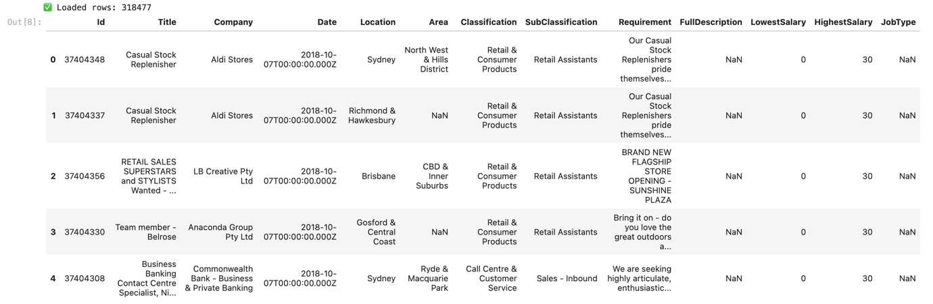

Figure 1 Sample Data Frame and Data type

According to the data type distribution, most of the columns are of type **object**, which includes textual or categorical data like Title, Company, Location, and Requirement. Only two columns, LowestSalary and HighestSalary, are of type **int64`, representing numerical salary ranges.

A missing value analysis reveals that certain fields contain significant amounts of missing data (Figure 3). In particular:

* Area has over **190,000** missing values,
* Location, Classification, and SubClassification each have over **100,000** missing values,
* FullDescription, JobType, and Company have relatively smaller but still notable numbers of missing   
  entries,
* Requirement is mostly complete with minimal missing data.

The visual insights justify the decision to retain only the most relevant and complete columns for core analysis: **Title, Company, Requirement, LowestSalary, HighestSalary**. Meanwhile, other fields such as Location, Area, Classification, SubClassification, FullDescription, and JobType are used only for descriptive summaries or optional visualization and are not included in modeling due to their high proportion of missing values or limited predictive value. However, there’s no need to drop those missing rows using df_clean = df.dropna() as it would affect the overall data shape. Therefore, they can benefit in key analyses but could benefit inference for some missing value in Company**.**

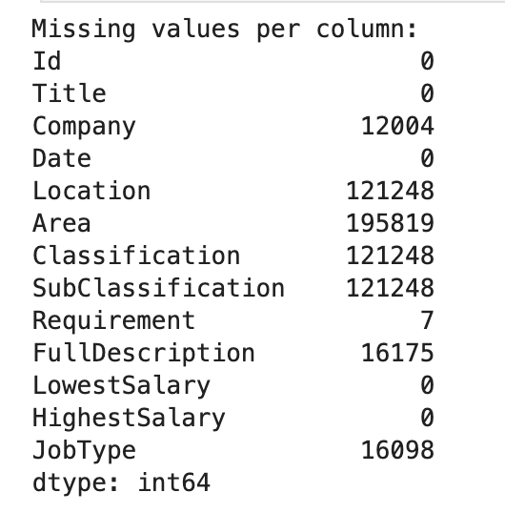

Figure 2 Missing Values per Column

## **(2) Describe the steps for data preparation and preprocessing**

The dataset was initially loaded using Pandas with error handling for malformed rows. Following initial exploration using .shape, .info(), and .describe(), the author adopted a flexible missing data strategy. Instead of discarding rows, important fields such as Title, Company, Requirement, and salary fields were retained even when incomplete. Meanwhile, columns with high missingness (like Area and SubClassification) were excluded from core analyses but preserved for potential inference. A key enhancement was the creation of the CompanyGroupID column. This was primarily derived from the Company field, and missing values were inferred using a custom function leveraging related columns (Requirement, Classification, and Location). Inference included state abbreviation mapping and general category labelling, effectively reducing missing rates for company-related information (Figure 3).

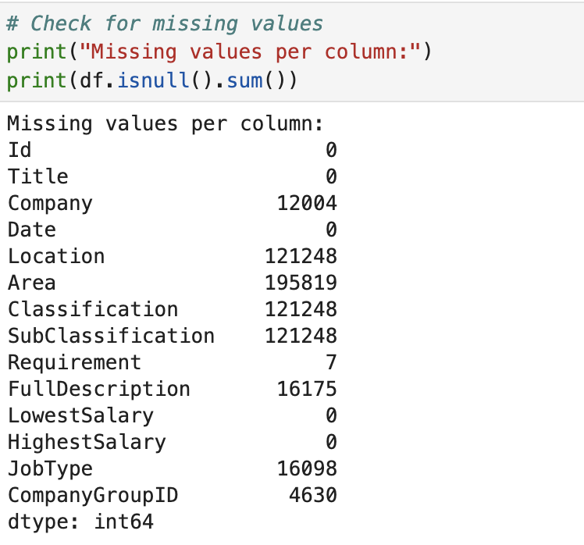

Figure 3 Numbers of missing values after infering CompanyGroupID

Textual normalization was applied instead of numerical scaling. This included standardizing state names and binning salary ranges into five categories: 'Very Low' (0–39k), 'Low' (40–69k), 'Medium' (70–99k), 'High' (100–149k), and 'Very High' (150k+), to support clearer analysis and visualization (Figure 4). To verify the nature of the salary distribution, a Shapiro-Wilk test was conducted on the LowestSalary field. The extremely low p-value (< 0.05) confirmed non-normality, which aligned with the observed right-skewed distribution—characterized by a cluster between 30–120k and rare but extreme outliers near 999k. The pre-processed dataset was saved for use in Task 2.

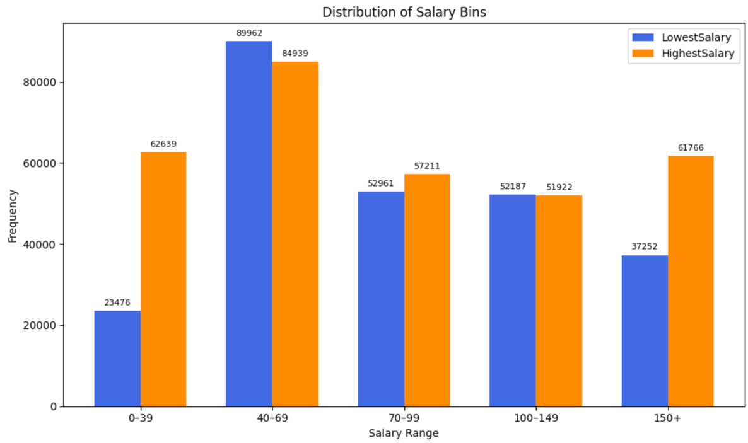

Figure 4 Skewed distribution in salary bins chart

**(3) Hypotheses about the analysis outcome**

1. Job titles and company identities are expected to serve as significant predictors of salary ranges, reflecting industry-specific compensation standards and hierarchical job structures (e.g., higher salaries typically found in IT or Mining compared to Retail or Customer Service).
2. The Requirement field may reveal patterns of qualification expectations when analysed alongside job titles, potentially identifying skill-level groupings, educational preferences, or experience benchmarks commonly associated with certain roles or companies.
3. Despite high missingness in geographic fields, aggregate-level location trends (e.g., distribution of postings across states or regions) may still offer useful insights, particularly in identifying job market concentrations and regional disparities in employment offerings.

**Part 2 – Data Analysis and Interpretation**

**(1) Relevant information in job metadata**

Based on the exploratory data analysis and visualizations, most job listings fall under the "Information & Communication Technology" sector, followed by Healthcare & Medical, Trades & Services, and Hospitality & Tourism (Figure 5). Among the sub-sectors, "Other", "Management", and "Chefs/Cooks" are the most frequently occurring (Figure 6), indicating a wide variety of job types within these categories. This suggests a strong demand for IT professionals, healthcare workers, service staff, and managerial roles across industries.

Figure 5 Number of jobs by sector (classification)

Figure 6 Top 20 sub-sectors by number of jobs

In terms of job location, most listings are based in New South Wales (NSW), followed by Victoria (VIC) and Queensland (QLD) (Figure 7). This distribution reflects the population and economic concentration in Australia's eastern states. Regarding salaries, most jobs offer a highest salary between $30K and $200K, with a sharp peak around $30K and $100K. A smaller number of listings report unusually high values (e.g., $999K), likely due to placeholder or data entry anomalies (Figure 8). Overall, the salary range indicates a broad spectrum of job types from entry-level to senior positions.

Figure 7 Number of jobs by state

Figure 8 Distribution of Highest salary

**(2) Job market by location**

The Australian job market displays a strong geographic concentration, particularly within the eastern states of New South Wales, Victoria, and Queensland. Figures 9 and 10 highlight that NSW alone recorded over 73,000 job postings, with Sydney accounting for the majority. Melbourne and Brisbane also serve as central hubs in VIC and QLD respectively. These three cities dominate their regional markets, while in contrast, states like WA and SA present a more distributed job structure. Despite 38% of the data labelled as "Unknown," the remaining dataset reliably captures consistent trends in market concentration, job centralization, and regional employer clustering.

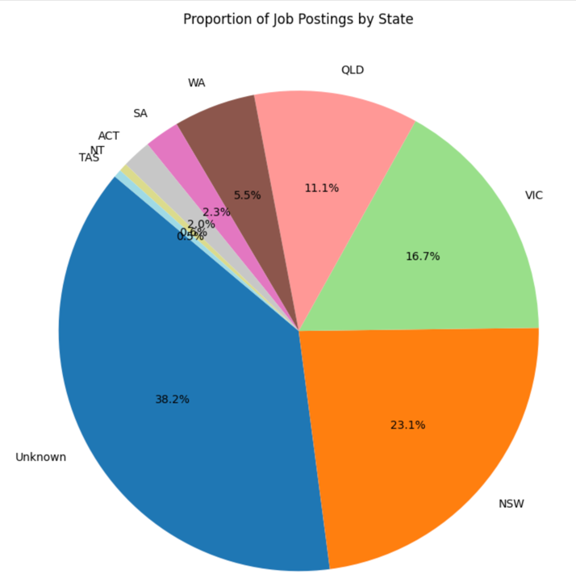

Figure 9 Proportion of jobs by state

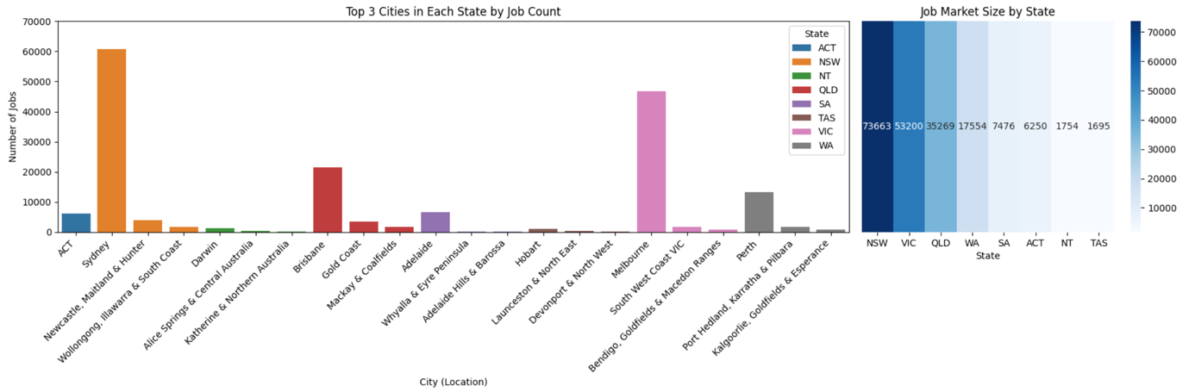

Figure 10 Top 3 job hub cities by state

Figures 11 explores salary differences by state and employer. While ACT shows the highest overall average salary when considering all job postings, Figure 12 reveals that NT features extreme outliers—most notably, Paxus—offering exceptionally high salaries likely due to specialized or high-demand roles. These outliers in NT contrast with ACT’s more consistent salary range across top companies. These findings reinforce that salary levels are influenced by both geographical context and specific employer practices.

Figure 11 Major city hubs by state

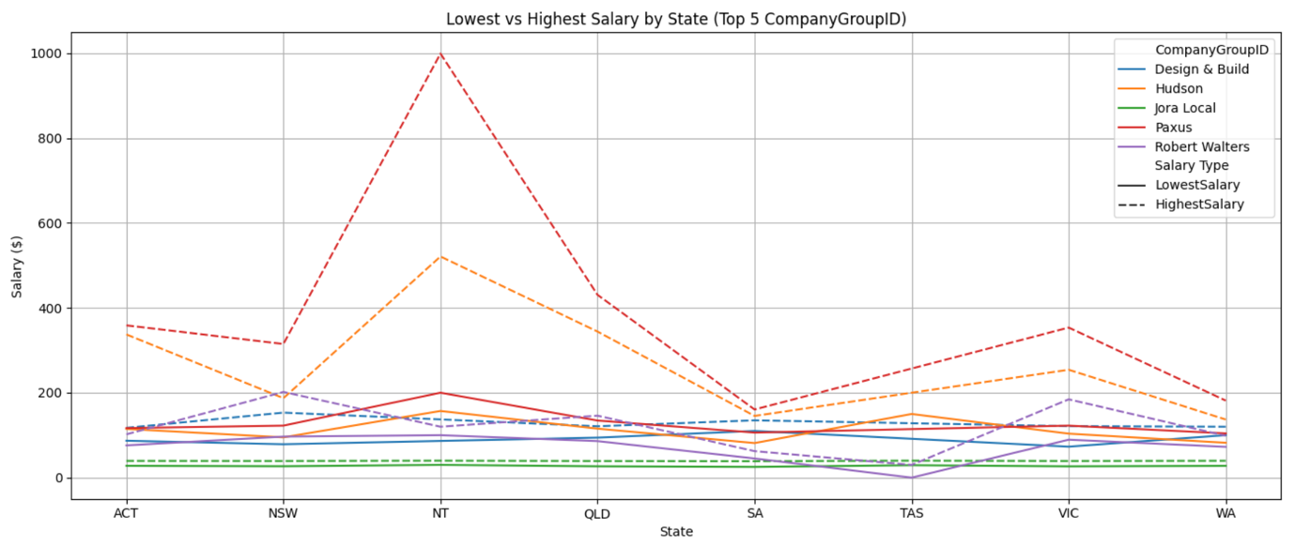

Figure 12 Lowest and Highest salaries comparison amongst top 5 companies

Figures 13 to 15 shift focus to salary distributions and requirement language. Salaries across states were compared using salary bins, revealing that high-paying roles (over 150K) consistently yield the highest averages, particularly in ACT and NT. These positions are often associated with government, healthcare, and project-based roles, as suggested by frequent keywords such as “contract”, “project”, and “health.” This aligns with earlier findings showing high salaries in NT being driven by specific companies like Paxus. Time-series analysis of job postings (Figure 10) shows consistent spikes at the beginning of each month (red dash-line), reflecting structured recruitment cycles. Finally, TF-IDF analysis of requirement keywords (Figure 11) indicates that terms like “team”, “opportunity” and “role” are common nationwide, while high-salary bins tend to feature more specialized or formal terms, suggesting a strong link between job description language and salary expectations.

Figure 13 Average salary ranges by state

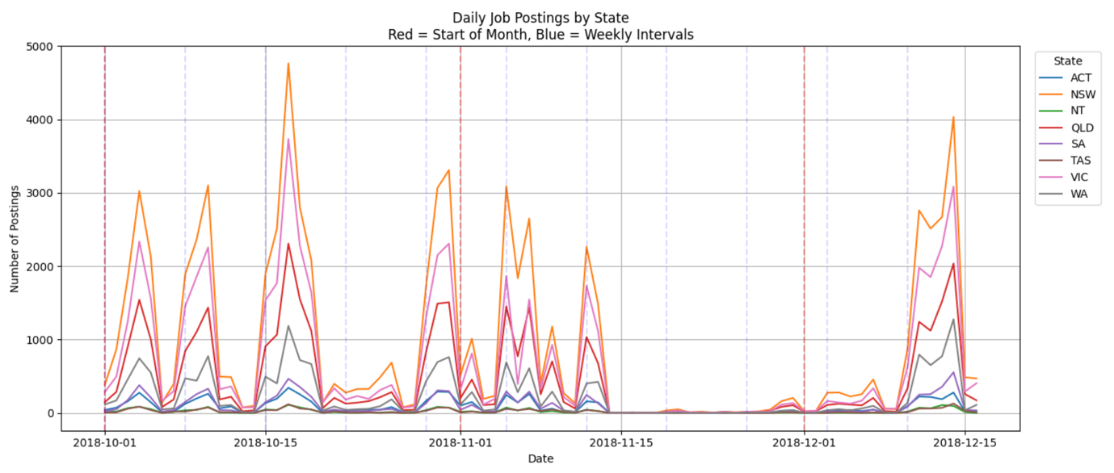

Figure 14 Job advertisement behaviors by state

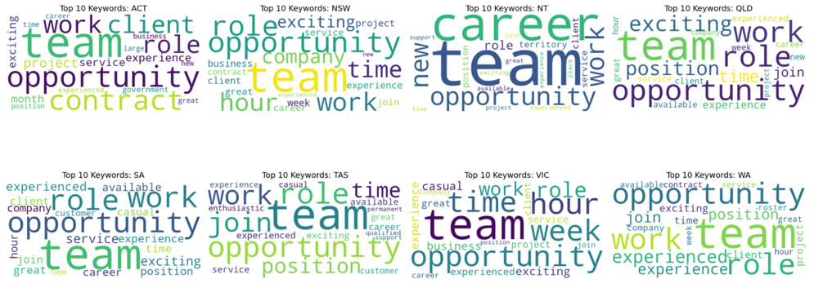

Figure 15 Top 20 requirement keywords by state and salary ranges

**(3) Job market by sector**

The job market sectors with the largest market share include Information & Communication Technology (ICT), Trades & Services, and Healthcare & Medical, respectively, based on job advertisement posting volume (Figure 16). Within each sector, key sub-sectors or specializations were identified — for example, Administrative Assistants and Receptionists in Administration, or Electricians and Labourers in Trades & Services. Salary analysis showed that ICT, Mining, and Engineering sectors consistently offer higher average salaries across most states. Figure 17 presents a boxplot comparing earnings across sectors, revealing that these three sectors tend to offer higher median salaries, while fields like Retail, Hospitality, and Customer Service fall toward the lower end. This visual insight underscores that high job demand does not always equate to high compensation, highlighting the importance of considering both salary and volume when choosing a career path. Notably, CEO & General Management appears as a strong outlier with unusually high salaries — likely reflecting a small number of top-level executive roles rather than broad accessibility.

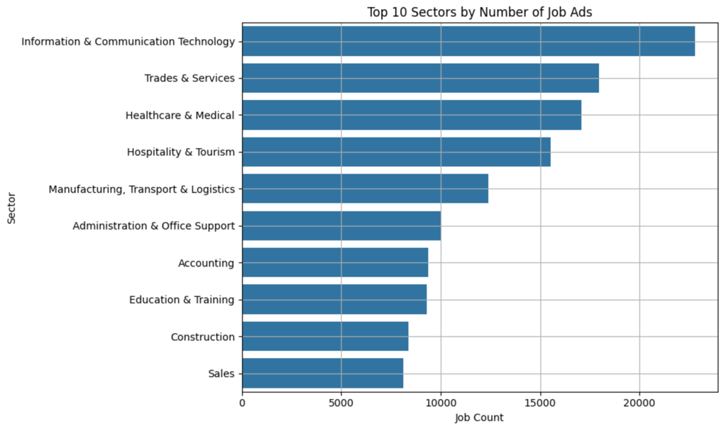

Figure 16 Top 10 job sectors by job advertisement

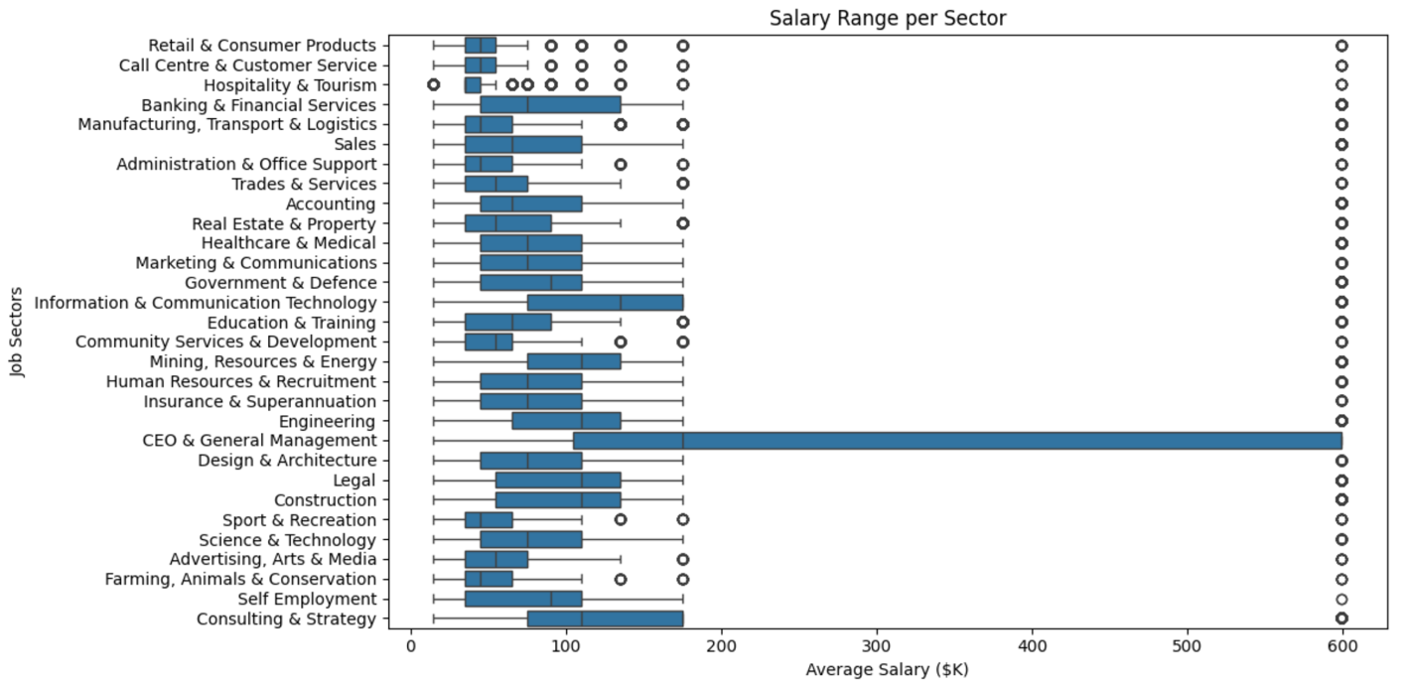

Figure 17 Box plot for salary ranges by sector

To explore future job trends and provide academic guidance, we analysed sector-wise skill requirements using keyword extraction from job requirement texts. Each sector revealed a unique skill profile: ICT emphasized technical keywords like developer, analyst, and project, while Healthcare & Medical focused on care, nurse, and practice. Sectors such as Education & Training prioritized terms like teaching and learning, while Construction highlighted project, manager, and builder. These findings were consistently supported by keyword frequency across hundreds or thousands of postings per sector. This NLP-based skill profiling allows students to align their university programs with real-world expectations in their desired fields. It also offers regionally tailored advice — for example, a student in Queensland may benefit more from studying Engineering or ICT, while one in Tasmania may consider Government, Healthcare, or Education. By matching sectors, skills, while New South Wales and Victoria tend to have high demands for tech jobs, and salary trends, students can make informed, evidence-based decisions about their future academic and career paths.

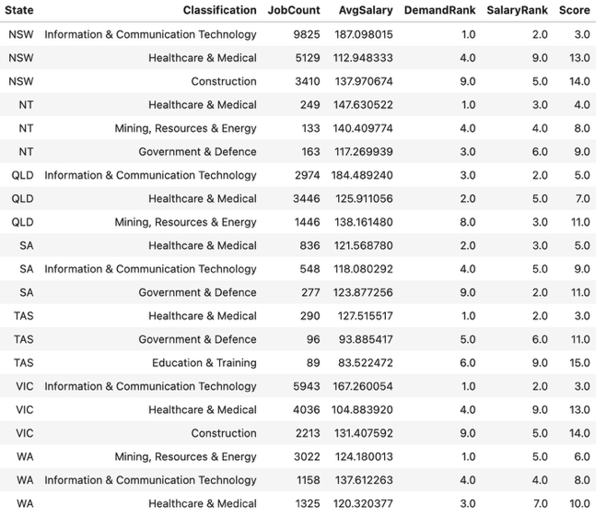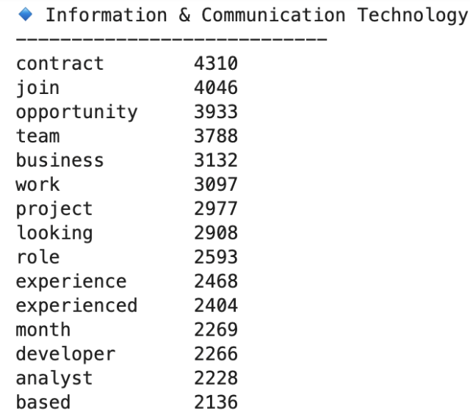

Figure 18 Skills required in each sector by state (for example in Information & Communication Technology sector)

**(4) Visualize the results on an interactive visualization**

The interactive topic modelling visualization (Figure 19) provides a powerful way to explore the latent themes within job postings based on user-selected filters such as state and sector. In this example, filtering for 'Information & Communication Technology' in NSW reveals key topics and top 30 relevant terms, highlighting frequent keywords like “software,” “security,” “engineer,” and “team.” This enables to quickly grasp common role expectations and responsibilities in a specific geographic and sectoral context. The inter-topic distance map further aids interpretation by showing how distinct or overlapping topics are, offering deeper insights into the thematic structure of the job data.

Figure 19 Ploty interactive visualisation for 4 topics requirement keywords by state and sector

In addition, the histogram plot from the same visualisation (Figure 20) allows for comparative salary analysis across different roles within the selected sector and location. The chart illustrates the salary distribution of ICT jobs in NSW, indicating that the majority of roles cluster in the $100k–$200k range, while fewer extend towards higher-end salaries. This visualization can help users assess earning potential and job concentration, enabling informed career planning or recruitment decisions. Together, these two interactive plots support multi-dimensional exploration of the job market, integrating thematic analysis and salary insights in a user-friendly format.

Figure 20 Interactive visualisation for average salary by state and sector

# **Part 3 – Evaluation**

## **(1) Findings in the job market’s data**

The job market data reveals clear geographic and sector-based disparities. Overall job advertisement posting behaviours are similar across all states. New South Wales (NSW), Victoria (VIC), and Queensland (QLD) emerge as the dominant job hubs, concentrating most job advertisements, especially within Sydney, Melbourne, and Brisbane. In contrast, states such as South Australia (SA) and Western Australia (WA) show more distributed but smaller-scale job activity. While 38% of job postings have unknown locations, the remaining data is sufficient to establish reliable spatial trends. Sector-wise, ICT (Information and Communication Technology), Healthcare, and Trades & Services consistently hold the highest market share by job volume.

Salary distributions also differ significantly across both states and sectors. The Australian Capital Territory (ACT) shows consistently high average salaries, while the Northern Territory (NT) reveals extreme salary outliers driven by high-demand roles (such as CEO & General management) or specific employers (such as Paxus and Hudson companies). Sectors such as ICT, Engineering, and Mining tend to offer higher average salaries, while Retail, Hospitality, and Administration are positioned on the lower end. Interestingly, high-volume sectors do not always correlate with high pay, reinforcing the importance of considering both demand and compensation. This is further supported by keyword analysis from job requirement texts (see Appendix 1): for instance, ICT job posts frequently include “contract”, “developer” and “analyst” while Healthcare emphasizes “care”, “nurse” and “practice”. Retail and Hospitality postings are more likely to highlight soft skills and flexible work terms using words like “join”, “hours”, “team” and “casual”. These patterns suggest that salary expectations and skill demands are indeed sector-specific, reflecting not only job function but also work environment and employment structure.

The analysis results support most of the initial assumptions according to the hypotheses. First, job sectors and titles clearly relate to salary ranges. For example, roles in ICT and Mining generally offer higher pay than those in Retail or Customer Service. In terms of using reference keywords to infer the required skills in each sector, the Requirement text is useful for identifying skill levels in relation to salaries. For instance, technical roles often include specific terms like “developer” or “contract”, while customer-facing roles use more people-focused language like “team” or “support”. Moreover, even though many job postings don’t include full location data, we can still observe meaningful trends at a broader level when grouping them by state. Overall, this shows that even partial job ad data can provide valuable insights into what different industries are looking for and how the job market is structured.

## **(2) Suggested actions for balancing the market**

To reduce imbalances in the job market, targeted education and workforce strategies should be implemented at both state and sector levels. States with lower job concentrations and fewer job postings (Figure 7), such as South Australia (SA), Tasmania (TAS), and the Northern Territory (NT), are currently dominated by health-related industries (Figure 11). These regions could benefit from investments to grow other sectors, particularly ICT, Engineering, and Commercial company.

Improving the transparency of job postings—especially around skill requirements and role expectations—could help bridge the gap between job seekers and employers. Promoting standardized job descriptions and clearer career pathways would empower individuals to make more informed decisions about their education and training. Partnering with universities and vocational institutions to expand access to programs in high-demand fields would further help align local skill sets with emerging market needs. Additionally, reskilling initiatives for workers in low-paying but high-volume sectors (such as Retail and Hospitality) could create pathways into more stable and higher-paying roles. Strategic policies aimed at attracting large employers or fostering startup ecosystems in underrepresented states could diversify employment opportunities and stimulate regional development. Another promising approach is to establish these states as internship or placement hubs—drawing students and early-career professionals to the area. This could promote long-term workforce growth, and over time, even encourage workers from major job hubs like NSW or VIC to consider job opportunities in these smaller states.

## **(3) Data analytics refinement**

In terms of techniques, the analysis could be improved by using more structured approaches to interpreting job requirement texts. Rather than relying solely on keyword frequency, grouping the extracted terms into broader skill categories such as technical skills, soft skills, and qualification levels could provide a clearer understanding of what different sectors value. For example, instead of simply noting how often words like developer or team appear, the analysis could highlight that information technology roles often prioritise technical ability, while retail positions tend to emphasise communication and adaptability. This approach would support more meaningful comparisons across job types and industries.

Additionally, identifying clusters of similar jobs based on features such as location, salary range, and required skills could reveal hidden relationships within the labour market. For instance, jobs that share similar pay levels and qualifications might be more interchangeable or reflect emerging career paths. Applying simple forecasting methods could also help identify shifts in demand across sectors or regions, allowing educators and policymakers to plan more effectively for future workforce needs. These refinements would enhance the analysis by making the results more interpretable, forward-looking, and practically useful for decision making.

## **(4) Implications for employees and employers based on findings**

The findings provide actionable insights that can directly inform how employers and employees interact with the job market. Employers can use this information to benchmark salary offers, tailor job descriptions to align with competitive language, and adjust their recruitment focus based on geographic or sector-specific gaps. For example, if a company in South Australia wants to attract ICT talent, they might use common high-performing keywords like “developer”, “cloud”, and “project delivery” to increase the visibility and relevance of their listings. Employers can also identify skill shortages in their region and design internal training programs or partnerships with local education providers to close those gaps.

Employees can also benefit significantly from these insights by aligning their job-seeking strategies with data-informed decisions. Someone working in Retail or Hospitality, for example, might look to transition into higher-paying and more stable fields like ICT or Engineering by pursuing targeted certifications. The requirement text analysis highlights what skills or qualifications appear most frequently in desirable roles, helping job seekers tailor their resumes or learning pathways. Additionally, understanding regional salary differences allows individuals to consider relocating or exploring remote opportunities in states that offer better compensation for their skill set. Overall, this kind of analysis empowers both groups to act strategically in a changing job environment.

# **Part 4 – Case studies**

## (1) Case study 1

Mathew is a first-year Computer Science student with the ambition of becoming an expert in the future. To support that goal, he should develop a skillset that not only aligns with core Computer Science roles but also extends across multiple sectors that increasingly demand digital and data-oriented capabilities. Based on the job market analysis and keyword data in the report (Appendix 1); Computer Science is no longer confined to just the "Information & Communication Technology" sector. Sectors like Banking & Financial Services, Science & Technology, Marketing & Communications, and Advertising, Arts & Media frequently list keywords such as "data", "project", "analyst", "support" and "digital", showing that skills from a Computer Science degree can blend into various fields.

Therefore, Mathew should not limit himself to a narrow technical path. Becoming an expert means being able to apply knowledge with flexibility and efficiency across different contexts. For instance, understanding how programming or data analysis fits into financial modelling, digital marketing. While it is still important to prioritise subjects strongly tied to computer science, such as software development, databases, systems analysis, and algorithms; he should also explore areas like project management, data communication, and user-centred design, which are valued across diverse sectors.

The top 15 keywords across relevant sectors further support this approach. In the Information & Communication Technology sector, frequent terms such as “developer”, “analyst” and “project”, indicate high demand for strong technical and collaborative skills. Meanwhile, in the Science & Technology sector, words like “data”, “research” and “(technical) support” indicate that analytical thinking, scientific computing, and experimental problem-solving are highly valued. These keywords reinforce the importance of both deep technical competence and cross-functional adaptability. To become an expert, Mathew should develop skillset not only coding and engineering proficiency, but also the ability to contribute in team-based environments, manage real-world projects, and communicate effectively across different professional contexts.

## (2) Case study 2

To address the task of matching a candidate’s CV with relevant job opportunities, a data-driven recommendation system can be developed based on the job market dataset analysed in previous sections. The system should begin by extracting key features from a candidate’s profile, such as preferred job sectors, listed skills, past job titles, and level of experience. These features can then be compared with job postings across fields like Information and Communication Technology, Healthcare, and Trades and Services, which were identified as the most active sectors in the dataset. By focusing on job attributes such as classification, salary range, location, and keyword frequency, the system can assess how well each job posting aligns with the candidate’s background.

A ranking mechanism can be used to shortlist the top 10 job matches for the candidate. This ranking can consider multiple factors, including how closely the keywords in the job advertisement match the candidate’s skills, whether the job is located in a region with strong employment activity, and if the expected salary range aligns with the candidate’s qualifications. For example, if the candidate profile includes collaborative and technical skills, the system might prioritise roles in the technology or science sectors, where terms such as developer, analyst, project, and data are commonly used. Additionally, the system can incorporate regional information, such as job availability by state and average salary levels, to personalise recommendations based on location preference. By integrating job demand indicators, keyword matching, and contextual information from the dataset, this recommendation system can provide tailored suggestions that reflect current labour market conditions and support more effective employment matching.

### **Appendix 1 – GitHub repository**

**Link:** [**https://github.com/JehKimChanGroup/3803ICT**](https://github.com/JehKimChanGroup/3803ICT)

**A group GitHub repository includes assignment code for each part to break the long code to subtasks in part 1 and part 2. There are progresses of each task on report show on Assignment_Report files for each part. It also provides Assignment_Report_Final document (docx, pdf) in the main.**

### **Appendix 2 – Top 15 keywords per sector**

| Sector | Keyword | Count |
| --- | --- | --- |
| Accounting | join | 2464 |
| Accounting | opportunity | 2373 |
| Accounting | team | 2324 |
| Accounting | business | 1736 |
| Accounting | role | 1663 |
| Accounting | accountant | 1534 |
| Accounting | finance | 1409 |
| Accounting | financial | 1208 |
| Accounting | accounts | 1168 |
| Accounting | experienced | 1150 |
| Accounting | firm | 1128 |
| Accounting | looking | 1062 |
| Accounting | officer | 1031 |
| Accounting | work | 959 |
| Accounting | seeking | 924 |
| Administration & Office Support | team | 2760 |
| Administration & Office Support | join | 2273 |
| Administration & Office Support | opportunity | 1976 |
| Administration & Office Support | administration | 1781 |
| Administration & Office Support | support | 1627 |
| Administration & Office Support | role | 1610 |
| Administration & Office Support | seeking | 1513 |
| Administration & Office Support | office | 1441 |
| Administration & Office Support | assistant | 1334 |
| Administration & Office Support | looking | 1321 |
| Administration & Office Support | experienced | 1310 |
| Administration & Office Support | time | 1163 |
| Administration & Office Support | administrator | 1070 |
| Administration & Office Support | service | 1058 |
| Administration & Office Support | work | 978 |
| Advertising, Arts & Media | join | 186 |
| Advertising, Arts & Media | team | 183 |
| Advertising, Arts & Media | looking | 150 |
| Advertising, Arts & Media | media | 144 |
| Advertising, Arts & Media | opportunity | 139 |
| Advertising, Arts & Media | digital | 131 |
| Advertising, Arts & Media | agency | 116 |
| Advertising, Arts & Media | seeking | 93 |
| Advertising, Arts & Media | role | 92 |
| Advertising, Arts & Media | work | 90 |
| Advertising, Arts & Media | manager | 81 |
| Advertising, Arts & Media | account | 79 |
| Advertising, Arts & Media | exciting | 76 |
| Advertising, Arts & Media | content | 76 |
| Advertising, Arts & Media | based | 73 |
| Banking & Financial Services | team | 1197 |
| Banking & Financial Services | join | 1137 |
| Banking & Financial Services | opportunity | 1062 |
| Banking & Financial Services | financial | 960 |
| Banking & Financial Services | business | 778 |
| Banking & Financial Services | role | 727 |
| Banking & Financial Services | manager | 601 |
| Banking & Financial Services | looking | 534 |
| Banking & Financial Services | services | 529 |
| Banking & Financial Services | risk | 510 |
| Banking & Financial Services | bank | 492 |
| Banking & Financial Services | leading | 459 |
| Banking & Financial Services | experienced | 442 |
| Banking & Financial Services | work | 428 |
| Banking & Financial Services | seeking | 414 |
| CEO & General Management | opportunity | 172 |
| CEO & General Management | manager | 161 |
| CEO & General Management | role | 144 |
| CEO & General Management | leadership | 133 |
| CEO & General Management | team | 127 |
| CEO & General Management | business | 124 |
| CEO & General Management | lead | 124 |
| CEO & General Management | services | 95 |
| CEO & General Management | executive | 93 |
| CEO & General Management | join | 91 |
| CEO & General Management | management | 86 |
| CEO & General Management | operations | 86 |
| CEO & General Management | organisation | 85 |
| CEO & General Management | based | 78 |
| CEO & General Management | general | 76 |
| Call Centre & Customer Service | customer | 1736 |
| Call Centre & Customer Service | service | 1528 |
| Call Centre & Customer Service | team | 1112 |
| Call Centre & Customer Service | join | 917 |
| Call Centre & Customer Service | opportunity | 730 |
| Call Centre & Customer Service | sales | 630 |
| Call Centre & Customer Service | looking | 570 |
| Call Centre & Customer Service | role | 556 |
| Call Centre & Customer Service | career | 501 |
| Call Centre & Customer Service | centre | 471 |
| Call Centre & Customer Service | great | 457 |
| Call Centre & Customer Service | work | 447 |
| Call Centre & Customer Service | seeking | 432 |
| Call Centre & Customer Service | experience | 367 |
| Call Centre & Customer Service | exciting | 365 |
| Community Services & Development | support | 1525 |
| Community Services & Development | team | 1040 |
| Community Services & Development | care | 930 |
| Community Services & Development | join | 884 |
| Community Services & Development | community | 824 |
| Community Services & Development | people | 727 |
| Community Services & Development | seeking | 590 |
| Community Services & Development | work | 576 |
| Community Services & Development | services | 551 |
| Community Services & Development | opportunity | 550 |
| Community Services & Development | disability | 532 |
| Community Services & Development | role | 475 |
| Community Services & Development | time | 451 |
| Community Services & Development | experienced | 439 |
| Community Services & Development | provide | 437 |
| Construction | project | 2587 |
| Construction | projects | 1898 |
| Construction | manager | 1673 |
| Construction | join | 1589 |
| Construction | experienced | 1588 |
| Construction | opportunity | 1465 |
| Construction | work | 1360 |
| Construction | construction | 1329 |
| Construction | team | 1304 |
| Construction | commercial | 1082 |
| Construction | builder | 1051 |
| Construction | seeking | 972 |
| Construction | company | 957 |
| Construction | looking | 932 |
| Construction | site | 908 |
| Consulting & Strategy | business | 259 |
| Consulting & Strategy | opportunity | 252 |
| Consulting & Strategy | join | 216 |
| Consulting & Strategy | team | 204 |
| Consulting & Strategy | role | 174 |
| Consulting & Strategy | senior | 152 |
| Consulting & Strategy | change | 151 |
| Consulting & Strategy | seeking | 141 |
| Consulting & Strategy | manager | 133 |
| Consulting & Strategy | strategy | 124 |
| Consulting & Strategy | management | 121 |
| Consulting & Strategy | experienced | 114 |
| Consulting & Strategy | work | 113 |
| Consulting & Strategy | project | 110 |
| Consulting & Strategy | looking | 102 |
| Design & Architecture | design | 559 |
| Design & Architecture | join | 465 |
| Design & Architecture | team | 433 |
| Design & Architecture | designer | 398 |
| Design & Architecture | opportunity | 377 |
| Design & Architecture | projects | 305 |
| Design & Architecture | work | 252 |
| Design & Architecture | looking | 239 |
| Design & Architecture | architect | 220 |
| Design & Architecture | role | 214 |
| Design & Architecture | experience | 212 |
| Design & Architecture | seeking | 209 |
| Design & Architecture | senior | 195 |
| Design & Architecture | experienced | 185 |
| Design & Architecture | practice | 163 |
| Education & Training | join | 1683 |
| Education & Training | team | 1670 |
| Education & Training | school | 1630 |
| Education & Training | seeking | 1585 |
| Education & Training | teacher | 1531 |
| Education & Training | opportunity | 1194 |
| Education & Training | early | 1177 |
| Education & Training | centre | 1151 |
| Education & Training | time | 1055 |
| Education & Training | looking | 982 |
| Education & Training | experienced | 958 |
| Education & Training | work | 952 |
| Education & Training | education | 902 |
| Education & Training | learning | 888 |
| Education & Training | teaching | 740 |
| Engineering | engineer | 1705 |
| Engineering | team | 1349 |
| Engineering | projects | 1333 |
| Engineering | opportunity | 1311 |
| Engineering | project | 1260 |
| Engineering | join | 1254 |
| Engineering | engineering | 1049 |
| Engineering | work | 949 |
| Engineering | design | 753 |
| Engineering | civil | 732 |
| Engineering | experienced | 727 |
| Engineering | seeking | 718 |
| Engineering | role | 701 |
| Engineering | consultancy | 606 |
| Engineering | senior | 585 |
| Farming, Animals & Conservation | team | 197 |
| Farming, Animals & Conservation | opportunity | 167 |
| Farming, Animals & Conservation | join | 165 |
| Farming, Animals & Conservation | experienced | 142 |
| Farming, Animals & Conservation | farm | 122 |
| Farming, Animals & Conservation | seeking | 115 |
| Farming, Animals & Conservation | looking | 105 |
| Farming, Animals & Conservation | work | 96 |
| Farming, Animals & Conservation | time | 90 |
| Farming, Animals & Conservation | role | 83 |
| Farming, Animals & Conservation | manager | 71 |
| Farming, Animals & Conservation | exciting | 70 |
| Farming, Animals & Conservation | animal | 64 |
| Farming, Animals & Conservation | experience | 59 |
| Farming, Animals & Conservation | hand | 59 |
| Government & Defence | team | 1396 |
| Government & Defence | opportunity | 1240 |
| Government & Defence | join | 1067 |
| Government & Defence | role | 807 |
| Government & Defence | seeking | 801 |
| Government & Defence | services | 763 |
| Government & Defence | time | 758 |
| Government & Defence | officer | 703 |
| Government & Defence | work | 697 |
| Government & Defence | exciting | 638 |
| Government & Defence | support | 637 |
| Government & Defence | management | 627 |
| Government & Defence | government | 595 |
| Government & Defence | experienced | 590 |
| Government & Defence | health | 546 |
| Healthcare & Medical | join | 3687 |
| Healthcare & Medical | team | 3627 |
| Healthcare & Medical | care | 3402 |
| Healthcare & Medical | time | 3127 |
| Healthcare & Medical | health | 2659 |
| Healthcare & Medical | opportunity | 2551 |
| Healthcare & Medical | work | 2363 |
| Healthcare & Medical | experienced | 2356 |
| Healthcare & Medical | seeking | 2090 |
| Healthcare & Medical | looking | 1947 |
| Healthcare & Medical | nurse | 1651 |
| Healthcare & Medical | registered | 1595 |
| Healthcare & Medical | practice | 1570 |
| Healthcare & Medical | aged | 1453 |
| Healthcare & Medical | role | 1374 |
| Hospitality & Tourism | team | 9305 |
| Hospitality & Tourism | join | 8837 |
| Hospitality & Tourism | seeking | 7891 |
| Hospitality & Tourism | hours | 6738 |
| Hospitality & Tourism | week | 6596 |
| Hospitality & Tourism | cafe | 4328 |
| Hospitality & Tourism | time | 4239 |
| Hospitality & Tourism | casual | 3864 |
| Hospitality & Tourism | restaurant | 3730 |
| Hospitality & Tourism | cook | 2341 |
| Hospitality & Tourism | looking | 1811 |
| Hospitality & Tourism | experienced | 1635 |
| Hospitality & Tourism | chef | 1564 |
| Hospitality & Tourism | bar | 1505 |
| Hospitality & Tourism | barista | 1450 |
| Human Resources & Recruitment | team | 1142 |
| Human Resources & Recruitment | hr | 1118 |
| Human Resources & Recruitment | opportunity | 1023 |
| Human Resources & Recruitment | join | 1020 |
| Human Resources & Recruitment | recruitment | 905 |
| Human Resources & Recruitment | role | 747 |
| Human Resources & Recruitment | business | 594 |
| Human Resources & Recruitment | experienced | 515 |
| Human Resources & Recruitment | seeking | 439 |
| Human Resources & Recruitment | looking | 432 |
| Human Resources & Recruitment | work | 431 |
| Human Resources & Recruitment | career | 430 |
| Human Resources & Recruitment | exciting | 365 |
| Human Resources & Recruitment | manager | 325 |
| Human Resources & Recruitment | support | 315 |
| Information & Communication Technology | contract | 4310 |
| Information & Communication Technology | join | 4046 |
| Information & Communication Technology | opportunity | 3933 |
| Information & Communication Technology | team | 3788 |
| Information & Communication Technology | business | 3132 |
| Information & Communication Technology | work | 3097 |
| Information & Communication Technology | project | 2977 |
| Information & Communication Technology | looking | 2908 |
| Information & Communication Technology | role | 2593 |
| Information & Communication Technology | experience | 2468 |
| Information & Communication Technology | experienced | 2404 |
| Information & Communication Technology | month | 2269 |
| Information & Communication Technology | developer | 2266 |
| Information & Communication Technology | analyst | 2228 |
| Information & Communication Technology | based | 2136 |
| Insurance & Superannuation | claims | 528 |
| Insurance & Superannuation | team | 455 |
| Insurance & Superannuation | join | 361 |
| Insurance & Superannuation | opportunity | 350 |
| Insurance & Superannuation | insurance | 343 |
| Insurance & Superannuation | role | 267 |
| Insurance & Superannuation | looking | 182 |
| Insurance & Superannuation | management | 162 |
| Insurance & Superannuation | career | 153 |
| Insurance & Superannuation | work | 152 |
| Insurance & Superannuation | manager | 150 |
| Insurance & Superannuation | leading | 138 |
| Insurance & Superannuation | new | 134 |
| Insurance & Superannuation | portfolio | 133 |
| Insurance & Superannuation | exciting | 130 |
| Legal | firm | 1467 |
| Legal | join | 1202 |
| Legal | law | 1120 |
| Legal | team | 1099 |
| Legal | legal | 1021 |
| Legal | opportunity | 1016 |
| Legal | work | 826 |
| Legal | role | 739 |
| Legal | lawyer | 727 |
| Legal | leading | 593 |
| Legal | senior | 509 |
| Legal | commercial | 495 |
| Legal | practice | 450 |
| Legal | career | 443 |
| Legal | tier | 419 |
| Manufacturing, Transport & Logistics | experienced | 2774 |
| Manufacturing, Transport & Logistics | team | 2238 |
| Manufacturing, Transport & Logistics | join | 2213 |
| Manufacturing, Transport & Logistics | seeking | 2178 |
| Manufacturing, Transport & Logistics | work | 1898 |
| Manufacturing, Transport & Logistics | opportunity | 1792 |
| Manufacturing, Transport & Logistics | looking | 1602 |
| Manufacturing, Transport & Logistics | start | 1398 |
| Manufacturing, Transport & Logistics | forklift | 1330 |
| Manufacturing, Transport & Logistics | driver | 1279 |
| Manufacturing, Transport & Logistics | drivers | 1267 |
| Manufacturing, Transport & Logistics | company | 1253 |
| Manufacturing, Transport & Logistics | based | 1230 |
| Manufacturing, Transport & Logistics | role | 1193 |
| Manufacturing, Transport & Logistics | currently | 1172 |
| Marketing & Communications | marketing | 1704 |
| Marketing & Communications | team | 905 |
| Marketing & Communications | opportunity | 895 |
| Marketing & Communications | join | 870 |
| Marketing & Communications | role | 652 |
| Marketing & Communications | manager | 592 |
| Marketing & Communications | digital | 560 |
| Marketing & Communications | communications | 507 |
| Marketing & Communications | looking | 459 |
| Marketing & Communications | exciting | 430 |
| Marketing & Communications | brand | 388 |
| Marketing & Communications | work | 364 |
| Marketing & Communications | experienced | 358 |
| Marketing & Communications | media | 353 |
| Marketing & Communications | seeking | 347 |
| Mining, Resources & Energy | experienced | 1798 |
| Mining, Resources & Energy | seeking | 1602 |
| Mining, Resources & Energy | join | 1197 |
| Mining, Resources & Energy | team | 1162 |
| Mining, Resources & Energy | mining | 1075 |
| Mining, Resources & Energy | currently | 876 |
| Mining, Resources & Energy | roster | 861 |
| Mining, Resources & Energy | opportunity | 856 |
| Mining, Resources & Energy | fifo | 757 |
| Mining, Resources & Energy | work | 721 |
| Mining, Resources & Energy | required | 665 |
| Mining, Resources & Energy | role | 630 |
| Mining, Resources & Energy | perth | 604 |
| Mining, Resources & Energy | operators | 573 |
| Mining, Resources & Energy | based | 571 |
| Real Estate & Property | property | 1371 |
| Real Estate & Property | team | 1077 |
| Real Estate & Property | manager | 1011 |
| Real Estate & Property | opportunity | 823 |
| Real Estate & Property | join | 751 |
| Real Estate & Property | real | 529 |
| Real Estate & Property | estate | 528 |
| Real Estate & Property | looking | 512 |
| Real Estate & Property | work | 496 |
| Real Estate & Property | management | 495 |
| Real Estate & Property | role | 490 |
| Real Estate & Property | career | 471 |
| Real Estate & Property | experienced | 464 |
| Real Estate & Property | sales | 463 |
| Real Estate & Property | portfolio | 416 |
| Retail & Consumer Products | team | 2491 |
| Retail & Consumer Products | store | 2137 |
| Retail & Consumer Products | join | 2063 |
| Retail & Consumer Products | retail | 1931 |
| Retail & Consumer Products | sales | 1500 |
| Retail & Consumer Products | looking | 1368 |
| Retail & Consumer Products | manager | 1325 |
| Retail & Consumer Products | opportunity | 1258 |
| Retail & Consumer Products | customer | 1066 |
| Retail & Consumer Products | career | 984 |
| Retail & Consumer Products | service | 922 |
| Retail & Consumer Products | seeking | 798 |
| Retail & Consumer Products | work | 766 |
| Retail & Consumer Products | great | 752 |
| Retail & Consumer Products | assistant | 752 |
| Sales | sales | 4122 |
| Sales | join | 1889 |
| Sales | team | 1795 |
| Sales | opportunity | 1653 |
| Sales | business | 1616 |
| Sales | manager | 1196 |
| Sales | role | 1065 |
| Sales | looking | 1052 |
| Sales | company | 929 |
| Sales | new | 911 |
| Sales | career | 862 |
| Sales | seeking | 780 |
| Sales | experienced | 775 |
| Sales | work | 733 |
| Sales | development | 687 |
| Science & Technology | join | 191 |
| Science & Technology | opportunity | 187 |
| Science & Technology | team | 177 |
| Science & Technology | role | 124 |
| Science & Technology | data | 109 |
| Science & Technology | seeking | 103 |
| Science & Technology | laboratory | 95 |
| Science & Technology | work | 90 |
| Science & Technology | research | 89 |
| Science & Technology | environmental | 88 |
| Science & Technology | experienced | 82 |
| Science & Technology | based | 79 |
| Science & Technology | support | 76 |
| Science & Technology | company | 71 |
| Science & Technology | looking | 67 |
| Self Employment | opportunity | 53 |
| Self Employment | looking | 45 |
| Self Employment | earn | 37 |
| Self Employment | largest | 35 |
| Self Employment | extra | 34 |
| Self Employment | provides | 34 |
| Self Employment | christmas | 34 |
| Self Employment | club | 34 |
| Self Employment | retailer | 34 |
| Self Employment | australia | 34 |
| Self Employment | calendar | 34 |
| Self Employment | income | 34 |
| Self Employment | pop | 34 |
| Self Employment | period | 34 |
| Self Employment | business | 26 |
| Sport & Recreation | fitness | 257 |
| Sport & Recreation | team | 252 |
| Sport & Recreation | looking | 237 |
| Sport & Recreation | join | 232 |
| Sport & Recreation | personal | 186 |
| Sport & Recreation | seeking | 129 |
| Sport & Recreation | opportunity | 106 |
| Sport & Recreation | training | 103 |
| Sport & Recreation | trainer | 100 |
| Sport & Recreation | club | 91 |
| Sport & Recreation | new | 88 |
| Sport & Recreation | manager | 86 |
| Sport & Recreation | motivated | 83 |
| Sport & Recreation | role | 82 |
| Sport & Recreation | trainers | 75 |
| Trades & Services | join | 3802 |
| Trades & Services | team | 3662 |
| Trades & Services | experienced | 3557 |
| Trades & Services | seeking | 3372 |
| Trades & Services | work | 3003 |
| Trades & Services | looking | 2501 |
| Trades & Services | opportunity | 2112 |
| Trades & Services | required | 1962 |
| Trades & Services | qualified | 1910 |
| Trades & Services | start | 1813 |
| Trades & Services | service | 1679 |
| Trades & Services | time | 1558 |
| Trades & Services | currently | 1455 |
| Trades & Services | company | 1436 |
| Trades & Services | immediate | 1386 |