(2) Study the market by locations

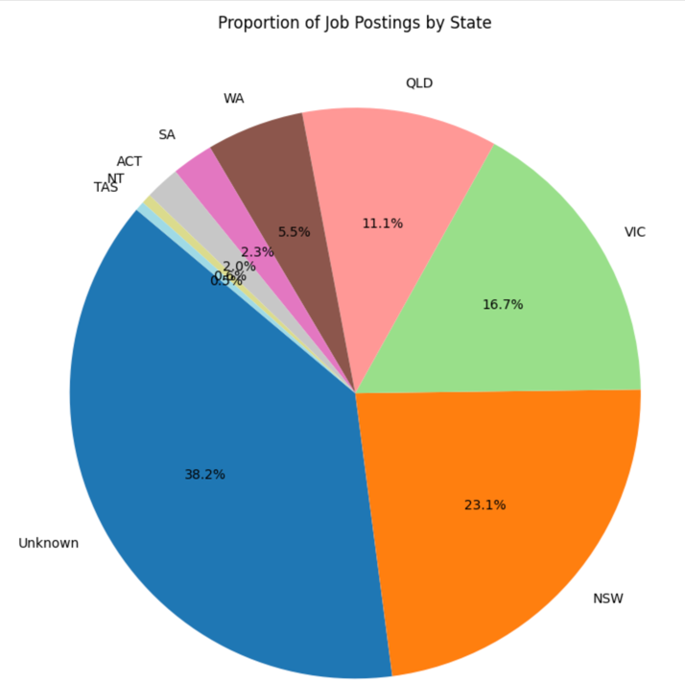

Figure 1 Proportion of jobs by states

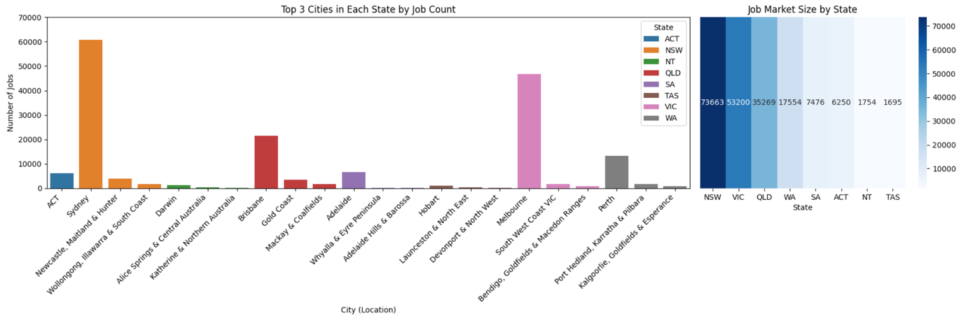

Figure 2 Top 3 jobs hub cities by states

The Australian job market displays a strong geographic concentration, particularly within the eastern states of New South Wales, Victoria, and Queensland. Figures 1 and 2 highlight that NSW alone recorded over 73,000 job postings, with Sydney accounting for the majority. Melbourne and Brisbane also serve as central hubs in VIC and QLD respectively. These three cities dominate their regional markets, while in contrast, states like WA and SA present a more distributed job structure. Despite 38% of the data labelled as "Unknown," the remaining dataset reliably captures consistent trends in market concentration, job centralization, and regional employer clustering.

Figure 3 Major cities hubs by states

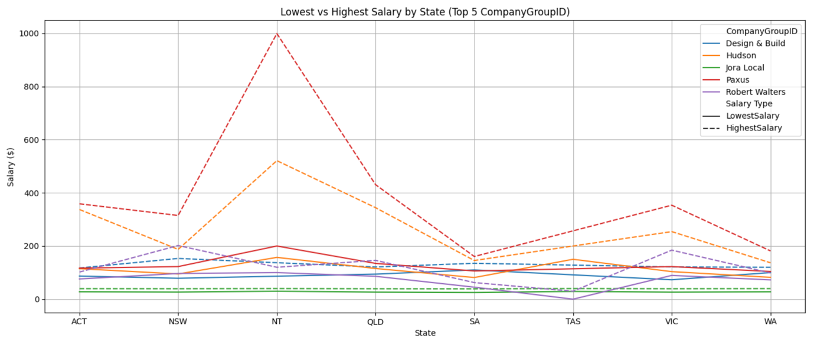

Figure 4 Lowest and highest salaries comparison among top 5 companies

Figures 3 and 4 explore salary differences by state and employer. While ACT shows the highest overall average salary when considering all job postings, Figure 4 reveals that NT features extreme outliers—most notably, Paxus—offering exceptionally high salaries likely due to specialized or high-demand roles. These outliers in NT contrast with ACT’s more consistent salary range across top companies. These findings reinforce that salary levels are influenced by both geographical context and specific employer practices.

Figure 5 Average salary ranges by states

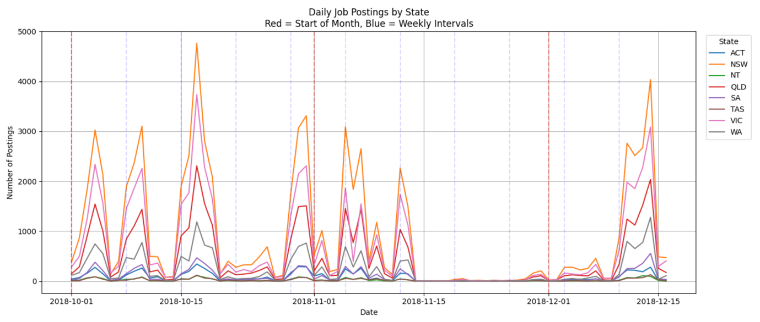

Figure 6 Job advertisements behavior by states

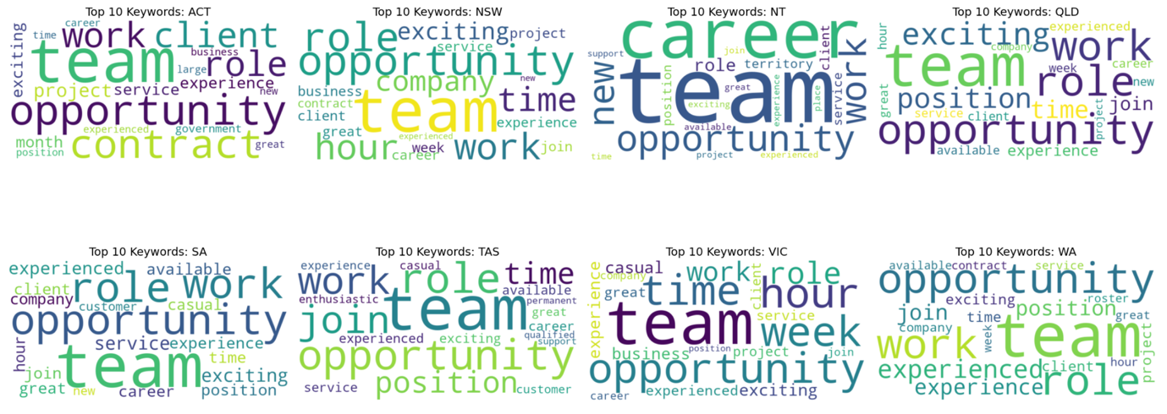

Figure 7 Top 20 requirement keywords by states and salary bins

Figures 5 to 7 shift focus to salary distributions and requirement language. Salaries across states were compared using salary bins, revealing that high-paying roles (over 150K) consistently yield the highest averages, particularly in ACT and NT. These positions are often associated with government, healthcare, and project-based roles, as suggested by frequent keywords such as “contract,” “project,” and “health.” This aligns with earlier findings showing high salaries in NT being driven by specific companies like Paxus. Time-series analysis of job postings (Figure 6) shows consistent spikes at the beginning of each month, reflecting structured recruitment cycles. Finally, TF-IDF analysis of requirement keywords (Figure 7) indicates that terms like “team,” “opportunity,” and “role” are common nationwide, while high-salary bins tend to feature more specialized or formal terms, suggesting a strong link between job description language and salary expectations.