**1. Introduction**

**Background**

In the last few years there was a huge jump in numbers of café in Saudi Arabia due to increased demand for it. And there will be a huge competition on this sector, and to overcome this from affecting your business you should make a better judgment of the market, and using data is the most powerful technique for making a better chances for success.

**Problem**

Due to increased competition on café businesses there will be a huge demand for data associated with it and analysis of it which will make a better chance for business success. There are multiple criteria that will make you a better place for customers such as location, price level, etc. and in this project we will determine which factor has the most impact for customer satisfaction and it will be gathered from customers reviews on Google Maps , and determine if it associated with any of the criteria.

**Interest**

Of course, there will be an interest from business owners to gather data and analysis of café shops in Saudi Arabia.

**2.Data acquisition and cleaning**

**Data sources**

Most of our data is taken from Google Places API which will allow us to access more data than foursquare because of a huge usage of Google Maps in Saudi Arabia

**Data cleaning**

Data is collected from Google Places API while it makes it data separated 20 per request there was multiple request to increase our subject numbers and it was joined together in a single DataFrame to make it easily accessible, it was cleaned from unnecessary objects in our project. Any values of NaN are removed to make better estimations. Any column name with an ambiguity changed for simplification.

**Feature selection**

After data cleaning there was 41 samples and 13 features in the data.

**Methodology:**

**3.Exploratory data analysis**

Rating of the customer is a very important to determine if your business is going to continue or fail. As we can see in the next box graph our data collection gave us that the most of our rating is between 3.9 and 4.2 and the median is almost 4.0.

صورة تحتوي على لقطة شاشة

تم إنشاء الوصف تلقائياً

Also, there was a normal distribution of our data with the ratings and total user rating and as we can see in scatter graph below.

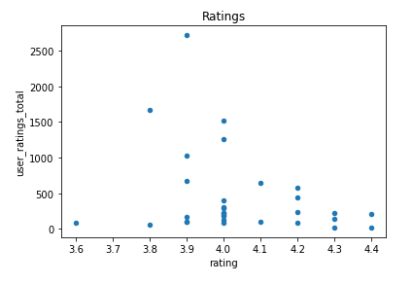

**Relationship between customers reviews with location**

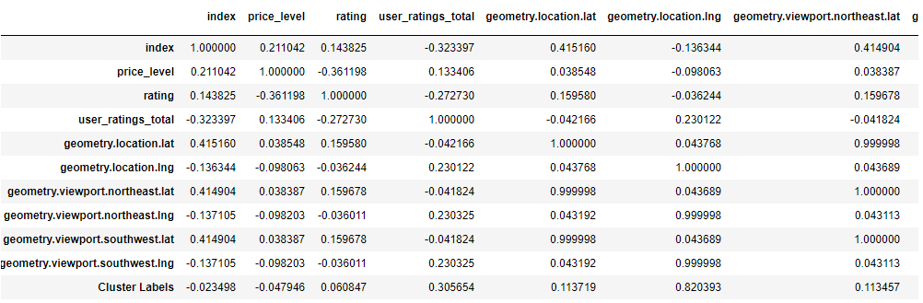

As can wee see there almost no correlation between location and customer reviews due to correlation factor was almost to 0.06 between Cluster Labels which was out location clusters and ratings which means that there is no correlation.

**Relationship between customers reviews with price level.**

صورة تحتوي على أبيض, المصباح, أكبر

تم إنشاء الوصف تلقائياً

As can we see in our data from cluster red there is a moderate correlation between price level and rating of the customers which was a inversely correlation which means that the customer prefer café shops that gave them the best price for there coffee which give us our first hint for our business.

**Results**

For better chances for a customer pleasing from our data there was a moderate inverse correlation between price level and customer ratings which means that customers are pleased with low prices of coffee , which gave business owners to give the customer what he/she needs.

**Recommendations**

If business owners want to grow their businesses, they need to get the customer and from our data the best way was to give them good prices.

**Conclusion**

Data was gathered and analyzed and gave us a small hint to the price and customer pleasing , but it was not enough data to determine all the factors to gave success of the business, I wish in the future data become more available and gathered more often because it will leads our future to a better life.