وصال (Wusal) — Pitch Deck

Arabic Sign-Language Conversation · Patent-Pending PoC · Partnership with SDAIA Ecosystem
Jeham AI · Confidential — for government / innovation partnership discussion
Export: copy each slide block into PowerPoint or Google Slides · Screenshots in `docs/assets/`

Slide 1 — Title
وصال — مساعد محادثة بلغة الإشارة العربية
*From sign video → trusted knowledge → sign video answer*
- Jeham AI
- Patent-pending system & method
- Working PoC + open engineering repo (private handover on license)
- Purpose of meeting: demo architecture · explore IP license, joint R&D, or acquisition of PoC + patent

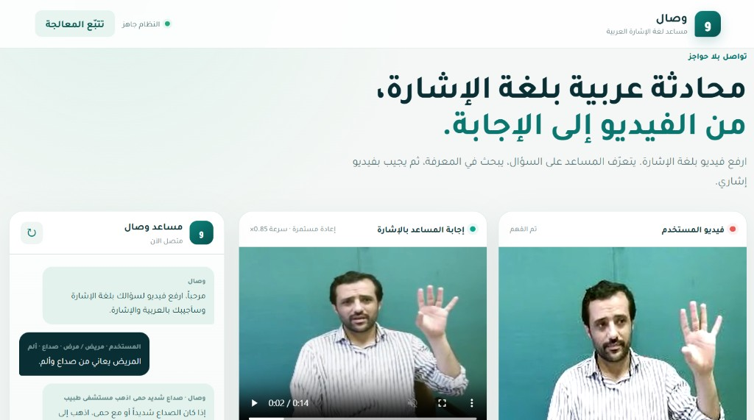

Slide 2 — Problem (Saudi context)
- Millions rely on accessible government and health services; Deaf and hard-of-hearing users often face sign ↔ Arabic text barriers.
- Generic chatbots do not produce sign-language answers and hallucinate without grounded knowledge.
- Vision 2030 & digital government: need trustworthy Arabic AI with explainable stages and local knowledge.
Our focus: a conversation bridge — not replacing human interpreters, but enabling 24/7 assisted access and service triage patterns.

Slide 3 — Solution in one sentence
وصال accepts Arabic sign video, understands the question using recognition + Arabic NLP, answers using retrieval-grounded generation (RAG), and responds with a composed sign-language video from a controlled dictionary with safe fallbacks.

Slide 4 — What you see in the demo (frontend)
The product UI (وصال) is built for non-technical stakeholders:
UI zone | Function
**فيديو المستخدم** | Upload / drag-drop sign video; optional **continuous sentence** mode (pause segmentation)
**مساعد وصال (chat)** | Shows reconstructed **Arabic question** and **grounded Arabic answer**
**إجابة المساعد بالإشارة** | Plays composed **H.264 answer video** (dictionary clips + fingerspelling)
**تتبّع المعالجة** | Technical trace for due diligence — full AI pipeline visible
*Screenshot:* `assets/wusal-demo-live.png` (live PoC: recognition + RAG + sign answer video)
*Optional:* trace panel capture → `assets/wusal-trace-panel.png`

Slide 5 — Patent-pending method (differentiation)
We protect the orchestrated system, not one neural net:
- Sign video → sign tokens (temporal recognizer, confidence gating)
- Tokens → Arabic question (reconstruction without adding facts)
- Local RAG over approved knowledge (no answer without retrieval context)
- Grounded Arabic answer (concise, actionable; recommended lines in knowledge base)
- Arabic answer → Saudi ArSL gloss plan (sign-language ordering, not word-for-word MSA)
- Gloss → media via dictionary match + lexical safety on semantic neighbors
- Fallback: alphabet fingerspelling + review_required flags
PoC proves reduction to practice of the above — suitable for IP diligence.

Slide 6 — Pipeline (engineering slide)
flowchart LR
A[Sign video input] --> B[KArSL-100 recognizer]
B --> C[Arabic question LLM]
C --> D[RAG on local knowledge]
D --> E[Grounded answer LLM]
E --> F[ArSL gloss planner LLM]
F --> G[KArSL-502 dictionary + alphabet]
G --> H[Answer sign MP4]
Trace panel labels (from live UI):
- التعرّف على الإشارات
- السؤال العربي
- سياق RAG
- إجابة RAG
- جملة الإشارة السعودية من LLM
- القاموس والتهجئة
- بناء فيديو الإجابة

Slide 7 — PoC status (honest metrics)
Component | Status
End-to-end pipeline | **Working** — FastAPI + Arabic RTL UI
Input vocabulary | **100** KArSL word/phrase classes (demo recognizer)
Output vocabulary | **502** KArSL clips (463 semantic + 39 alphabet isolated)
Knowledge | Curated **Arabic service RAG** (health / safety patterns)
Tests | Automated core tests (normalization, dictionary safety, spelling)
Production claims | **Not claimed** — signer-independent benchmarks = Phase 2
Message: Ready for innovation demo & IP discussion, not national rollout announcement.

Slide 8 — Why not “just a chatbot”?
Generic LLM + avatar | **وصال**
Text in / text out | **Sign in / sign out**
Open-domain answers | **RAG-grounded** answers
Random video lookup | **Thresholded dictionary** + spelling
Black box | **7-stage trace** for audit
Aligns with SDAIA trustworthy AI narrative: retrieval, traceability, human review hooks.

Slide 9 — Scale with SDAIA data & infrastructure
Phase 2 — national-scale architecture (proposed joint work)

A. Knowledge (RAG)
- Replace demo markdown with SDAIA-governed corpora: public service FAQs, accessibility guides, approved health education (under PDPL and data-sharing agreements).
- Same pipeline: retrieve → generate → sign output.

B. Sign language corpus (“SDAIA DB” narrative)
- Expand vocabulary beyond 100 input / 502 output toward domain packs (government services, education, emergencies).
- Multi-signer capture: age, gender, region, camera setups — with consent and metadata.
- Store: video, landmarks, gloss labels, signer ID — for retraining and evaluation.

C. Model training — more words & different persons
- Recognition model: temporal network (BiLSTM / Transformer) on landmarks or video; train on combined KArSL + Saudi-collected data.
- Generalization: hold out entire signers (not random clips) for validation; report accuracy per signer cohort.
- Personalization layer (optional): calibration per user or lightweight adapter — improves recognition when the same person returns without retraining full model.
- Output side: grow licensed sign clip library; keep alphabet fallback for OOV terms until clips exist.

D. Sovereign AI
- Swap cloud LLM for on-prem Arabic foundation model; RAG and sign stages unchanged.
- Inference within KSA for data residency.
*This slide is the scale story SDAIA buys — PoC de-risks the architecture; data + retrain de-risks coverage.*

Slide 10 — Roadmap (12–18 months)
Quarter | Milestone
**Q0** (now) | PoC demo, IP / license negotiation, MOU
**Q1** | Pilot knowledge integration; deaf-community UX review; on-prem LLM path
**Q2** | Signer-diverse data collection protocol; expanded recognizer v2
**Q3** | Signer-independent eval report; domain pack (e.g. health + gov services)
**Q4** | Pilot with one agency; accessibility certification pathway

Slide 11 — Demo script (rehearsed)
- Show empty UI → upload video (e.g. headache / patient scenario).
- Let input video play; pipeline runs automatically.
- Point to chat (Arabic Q&A).
- Play output sign video.
- Open تتبّع المعالجة — scroll stages 1–7 in ~90 seconds.
- Close: *“Patent covers this chain; SDAIA partnership scales data, signers, and sovereign LLM.”*
Backup: pre-recorded screen capture if live recognition fails.

Slide 12 — IP & commercial models
Model | Includes
**License (exclusive KSA gov sector)** | Patent rights field-of-use, codebase, docs, transition
**Joint R&D** | Jeham AI retains IP; SDAIA partner funds data + eval; revenue share / license fee
**Acquisition** | Assignment of patent + PoC + handover period
*Financial terms: separate term sheet (SAR) — not in this deck.*

Slide 13 — Team & ask
Jeham AI — architecture, PoC, patent prosecution support.
We ask today:
- Confirmation of innovation / IP procurement path (license vs joint lab vs grant).
- Introduction to accessibility & Arabic AI stakeholders.
- Agreement on next step: NDA + technical deep-dive + pilot scoping.
Contact: [your name · email · Jeham AI]

Slide 14 — Disclaimer
- Research prototype — not medical, legal, or emergency dispatch advice.
- Sign language output requires validation with Deaf users and certified interpreters.
- Third-party sign datasets subject to license confirmation for production.
- Cloud LLM in demo only; production assumes sovereign deployment.

Appendix — Slide assets checklist
Asset | Path / action
Main UI screenshot | `docs/assets/wusal-main-ui.png`
Trace panel screenshot | Capture after demo → `docs/assets/wusal-trace-panel.png`
Chat + output video | Capture after demo → `docs/assets/wusal-chat-result.png`
Architecture PDF | `Utility_SL.pdf` (patent figures — do not distribute publicly without counsel)
Live demo URL | `http://127.0.0.1:8000` (local) or deployed staging for visit

*End of deck · Jeham AI · وصال signlanguage PoC*

