This report demonstrates a systematic healthcare data analytics pipeline designed to analyze patient metrics and identify high-risk clinical correlates of cardiovascular disease. Leveraging python-driven statistical computation and visualization, this project serves as a key academic portfolio piece showcasing the data-to-insight transition from basic clinical observations to structured digital healthcare solutions.
Clinical Patient Outcomes & Diagnostics
Project Title:
Patient Outcomes Analysis (UCI
Heart Disease Framework)

Target Program:
Public Health / Health Informatics /

1
. Abstract & Executive Summary
An End-to-End Healthcare Data Analytics & Quality Summary Report

2. Dataset Characterization & Variables
The database maps clinical variables across 303 patient encounters. Key features include quantitative biometrics such as resting blood pressure (trestbps), serum cholesterol (chol), and maximum achieved heart rate (thalach), categorized alongside categorical diagnostic criteria including chest pain patterns and electrocardiographic findings.
Figure 1: Histogram detailing patient cohort distribution across age groups stratified by disease presence.

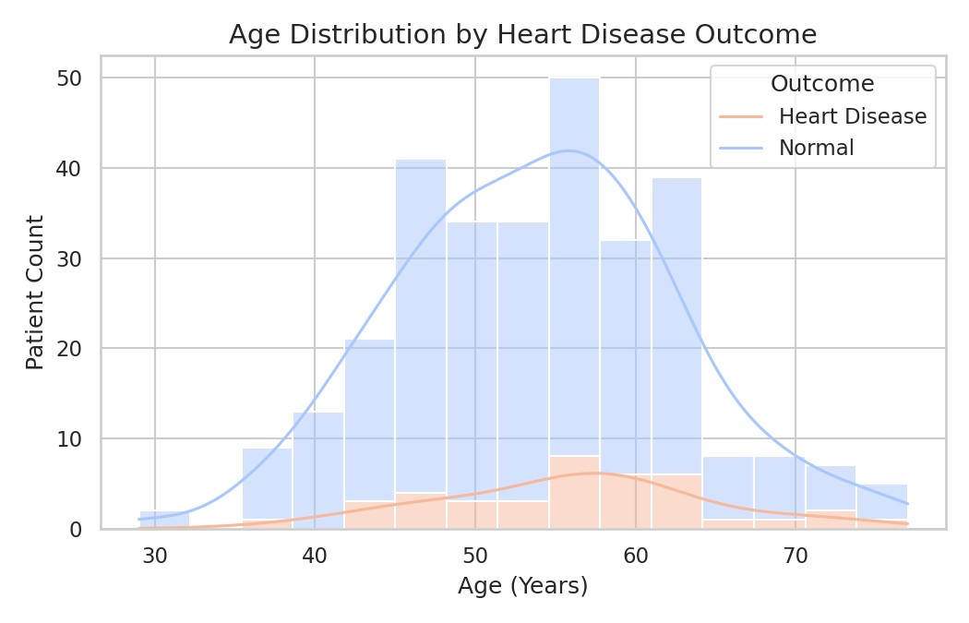
3. Key Analytical Insights & Clinical Correlates
Initial analysis highlights that patients presenting with targeted pathologic signals display distinct demographic distributions. Exploratory scatterplots map the complex covariance between continuous biometric values such as age and metabolic metrics.
Figure 2: Scatter matrix correlating age against serum cholesterol readings.
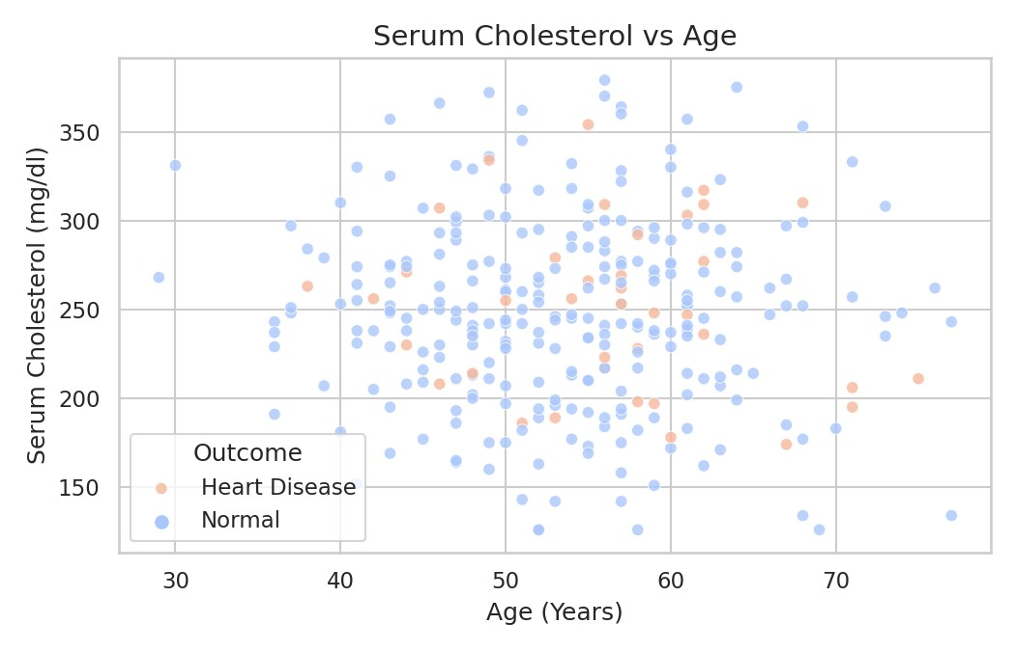
Gender-based stratification reveals distinct disparities in sample clinical frequency within this dataset, highlighting the critical role that demographic variable tracking plays in healthcare operations and epidemiological screening metrics.
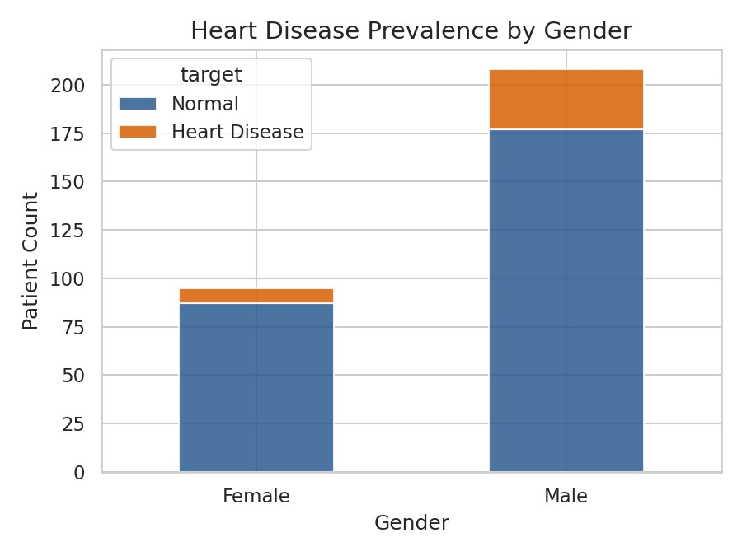
Figure 3: Gender representation and target cardiovascular outcome diagnostics.

4. Feature Covariance & Analytical Matrix
A Pearson's correlation index matrix was computed across all clinical variables to capture and flag positive/ negative clinical dependencies natively, without administrative overhead.
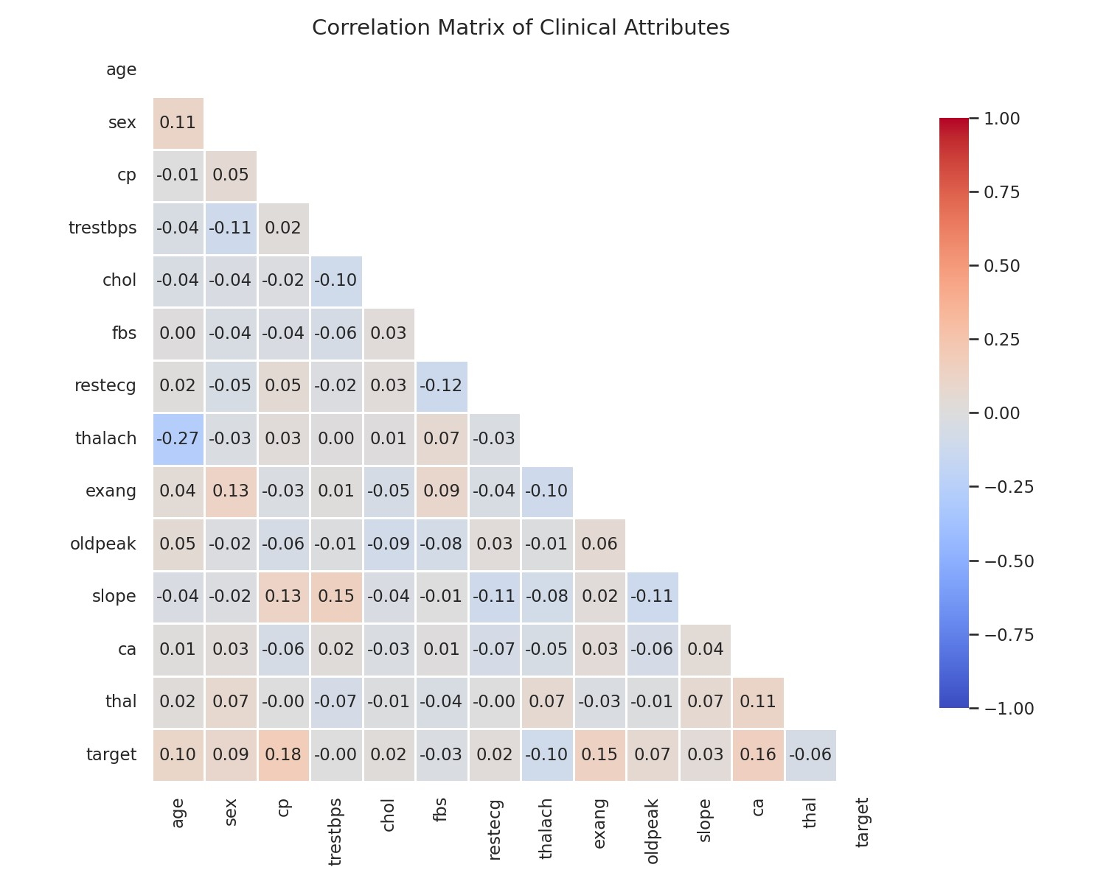
Figure 4: Full correlation heatmap indicating metrics mapping to clinical outcomes.

5. Conclusion & Academic Alignment
By structuring this comprehensive analytical workspace, this project mirrors genuine healthcare data methodologies. It bridges the gap between active healthcare clinical competencies (MBBS foundations) and downstream technology tracks (Health Informatics, Data Engineering, and Digital Health systems), forming a complete narrative optimized for rigorous Master's level review.

