this is the function to build a dataframe dictionary using company code as key, here is the screenshot of the source website company number 1556608

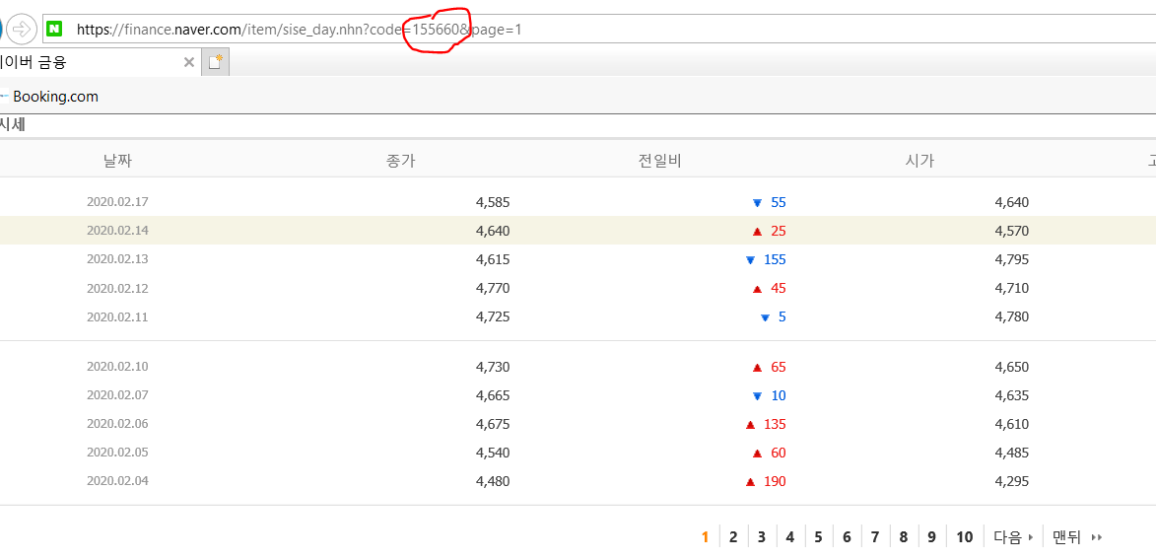

I tested with only 10 input and as a result we can retrieve the dataframe using the company code, however, all data need to be tested (2353 entries)

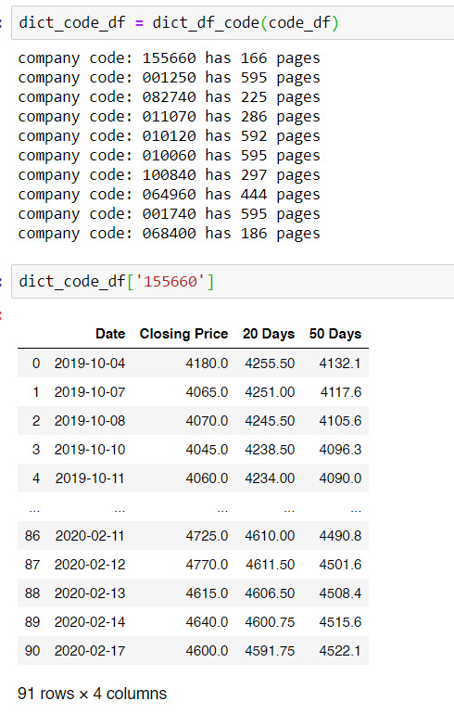

Additional libraries added

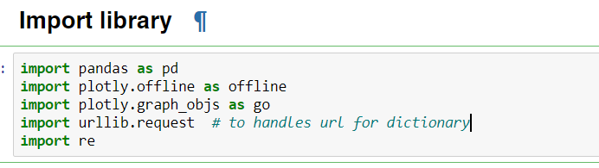

Dictionary function added

