BayanihanHub — Bug Fixes, Features & Notification System
Inspect the existing BayanihanHub project first and implement all changes directly in the current architecture.
Core Rules
- Preserve existing functionality.
- Reuse existing frontend components, backend APIs, database models, authentication, notification system, and email infrastructure.
- Do not replace real data with mock frontend data.
- Do not hard-code user IDs, post IDs, or email addresses.
- Fix root causes instead of hiding layout problems.
- Backend must enforce authorization and ownership.
- Do not expose backend errors, stack traces, passwords, tokens, or private data to users.
- Keep the UI consistent with the existing BayanihanHub design.

1. Bug Fix — Photo Preview After Posting
Fix the broken/unavailable image preview after submitting a post.
Inspect the complete flow:
Select image
→ Frontend preview
→ Submit post
→ Backend upload
→ Database image record
→ API response
→ Browse/details image rendering
Requirements:
- Show an immediate image preview when the user selects a file.
- Preserve the preview while the form is being submitted.
- Correctly upload the image.
- Correctly save the image relationship in the database.
- Return the correct image URL/path from the API.
- Display the uploaded image immediately after successful posting.
- Image must remain available after page refresh.
- Fix incorrect API-base-URL/path handling.
- Support existing allowed image formats and size restrictions.
- Add a fallback image when an image is unavailable.
- Do not display broken-image icons.
- Verify the image works in both development and production environments.
Check all locations where the image should appear:
- Browse cards.
- Post details.
- User's own posts.
- Saved items.
- Admin listings.
- Search results, if applicable.

2. Bug Fix — Favorite/Heart Toggle
The Browse Dashboard currently has incorrect favorite behavior.
Fix the state logic completely.
If the post is not saved
When the user clicks the heart:
API → Save item successfully
→ Heart becomes active/filled
→ Show "Added to favorites"
If the post is already saved
When the user clicks the heart:
API → Remove item successfully
→ Heart becomes inactive/uncolored
→ Show "Removed from favorites"
Requirements:
- Initialize the heart from the actual backend saved/favorite state.
- Do not assume the initial state.
- Update the icon only after a successful API operation.
- If the API request fails, restore the previous state.
- Prevent duplicate/rapid requests.
- Prevent contradictory toast messages.
- Correctly update the state after page refresh.
- Correctly update the state when browsing paginated/infinite-scroll results.
- Keep Browse, Item Details, and Saved Items synchronized.
- Use the existing saved/favorite database relationship.
The message and icon state must always describe the same action.

3. Bug Fix — Three-Dot Post Context Menu
Fix the three-dot dropdown where actions such as Report Post are cut off, hidden, or rendered behind adjacent elements.
Inspect:
- overflow: hidden.
- z-index.
- Stacking contexts.
- Absolute/fixed positioning.
- Parent clipping.
- Dropdown portals.
- Click event propagation.
- Responsive positioning.
Requirements:
- All menu items must be visible.
- Report Post must be fully visible and clickable.
- Menu must not be hidden behind cards.
- Menu must not be clipped by its parent.
- Menu must remain inside the viewport.
- If near the right edge, reposition the menu toward the left.
- If near the bottom edge, open upward when necessary.
- Clicking outside closes the menu.
- Escape closes the menu.
- Keyboard navigation works.
- Touch interaction works.
- Preserve all existing menu actions.
Do not simply add global overflow-x: hidden or excessively high z-index values without fixing the underlying layout.

4. Responsive Layout Fix
Perform a responsive audit of the affected pages and the overall application.
Test:
Mobile
- 320px
- 360px
- 375px
- 390px
- 414px
Tablet
- 768px
- 820px
- 1024px
Desktop
- 1280px
- 1440px
- 1920px
Fix:
- Buttons rendered outside the viewport.
- Buttons that cannot be clicked.
- Text overlapping buttons/icons.
- Dropdowns extending outside the viewport.
- Modals exceeding screen height/width.
- Cards overflowing containers.
- Tables becoming unusable.
- Header/sidebar overlap.
- Bottom navigation covering content.
- Fixed elements blocking clicks.
- Incorrect mobile navigation.
- Search/filter controls overflowing.
- Post cards becoming too narrow.
- Long titles/usernames breaking layouts.
- Insufficient touch-target sizes.
Ensure all interactive elements remain visible and clickable.
Use responsive flex/grid layouts and existing design-system breakpoints.

5. Feature — Post Timestamps
Add the actual post creation time to post headers and detail views.
Examples:
Posted just now
Posted 5 minutes ago
Posted 2 hours ago
Posted yesterday
Posted 3 days ago
Posted September 19, 2026
Requirements:
- Use the actual database created_at timestamp.
- Never generate the timestamp on the frontend when the post is created.
- Use a reusable relative-time formatter.
- Correctly handle timezone conversion.
- Show the full date/time through a tooltip or accessible alternative when appropriate.
- Handle invalid/missing timestamps gracefully.
Display the timestamp on:
- Browse cards.
- Post details.
- User's own posts.
- Admin listings.
- Search results where applicable.

6. Feature — Users Can Delete Their Own Posts
Add self-service post deletion.
Frontend Flow
Three-dot menu
→ Delete Post
→ Confirmation modal
→ Confirm
→ API request
→ Success
→ Remove post from current UI
Confirmation should clearly tell the user what will happen.
Backend Requirements
The backend must verify:
- User is authenticated.
- Post exists.
- Current user owns the post.
- Post has not already been deleted.
- User cannot delete another user's post by changing the post ID.
Never rely solely on frontend ownership checks.
Deletion
Use the existing soft-delete/removal mechanism if available.
After deletion:
- Remove the post from Browse.
- Remove it from public search.
- Remove it from active listings.
- Preserve required audit information.
- Preserve moderation history where applicable.
- Safely handle associated images.
- Safely handle saved-item relationships.
- Safely handle requests/exchanges associated with the post.
Clearly distinguish:
User Deleted
Admin Removed
Moderator Removed
where the existing system supports those states.

7. Admin Ratings Tab
Improve the Admin Panel's Ratings tab.
The Admin should be able to view the ratings associated with a user in a clear and organized manner.
User Rating View
For each user, display:
- User name.
- Profile image where permitted.
- Overall rating/average.
- Total number of ratings.
- Individual ratings.
- Rating value.
- Reviewer information according to existing privacy rules.
- Review/comment where applicable.
- Date of rating.
- Related transaction/exchange if available.
Sorting
Allow Admin to view ratings:
Highest → Lowest
Lowest → Highest
Newest → Oldest
Oldest → Newest
The default view may show the most relevant aggregate information, while allowing the Admin to inspect the individual ratings.
Do not calculate ratings incorrectly from only the currently visible/paginated records.
Use backend aggregation where appropriate.
Moderation Safety
Ratings should be information available to Admins for moderation review, not an automatic ban mechanism.
Do not automatically ban or suspend a user solely because their rating falls below a hard-coded threshold.
If the existing moderation system allows Admin action after reviewing a user's history, provide the appropriate existing moderation controls, such as:
- Review user.
- View reports.
- View rating history.
- Suspend.
- Restrict.
- Remove, where already supported.
Any suspension/removal must continue to use the existing authorization, confirmation, reason, and audit-log system.

8. Transactional Email Notification System
Set up and test reusable email notification templates using the existing backend/email architecture.
All emails must:
- Use the verified email associated with the account.
- Respect notification preferences where applicable.
- Use environment variables for email provider credentials.
- Never expose credentials in frontend code.
- Never expose password-reset tokens in logs.
- Use secure links.
- Have clear subject lines.
- Match BayanihanHub branding.
- Work in development and production configurations.
- Record success/failure if the existing notification architecture supports delivery tracking.
If an email cannot be sent, the primary user action should not unnecessarily fail.

9. Account Lifecycle Email Templates
Create and test these templates.
Registration Welcome
Trigger:
Successful account registration
Include:
- Welcome message.
- Account/email information.
- Verification/approval status if applicable.
- Next steps.
- BayanihanHub link.
Do not tell the user their account is approved unless it actually is.

Account Approval
Trigger:
Admin approves account
Include:
- Approval confirmation.
- Basic account information.
- Login link.
- Short explanation that the account can now be used.

Account Suspension
Trigger:
Admin suspends account
Include:
- Suspension notification.
- Suspension reason, when appropriate.
- Start date.
- End date for temporary suspensions.
- Contact/support instructions.
Do not expose internal moderation information unnecessarily.

Account Deletion
Trigger:
Account is deleted
Include:
- Account deletion confirmation.
- Relevant reason/message if the existing workflow provides one.
- Important consequences.
- Support/contact information where appropriate.

10. Security Email — Password Reset
Implement/test a secure password reset email.
Flow:
Forgot Password
→ User enters email
→ Secure reset token generated
→ Email sent
→ User opens reset link
→ Token validated
→ New password submitted
→ Token invalidated
Requirements:
- Token must be cryptographically secure.
- Token must expire.
- Token must be single-use.
- Do not store plaintext reset tokens if the architecture supports secure hashing.
- Do not expose tokens in logs.
- Do not reveal whether an email belongs to an account through an overly specific response.
- Invalidate the token after successful password reset.
- Invalidate previously active reset tokens where appropriate.

11. Messaging Email Notifications
Create and test email notifications for:
Direct Message Received
Trigger when another user sends a direct message.
Email should include:
- Sender name.
- Generic message notification.
- Link to the conversation.
- Appropriate privacy-safe preview if message previews are supported.
Do not unnecessarily include sensitive message content.
Unread Message Notification
If the user has unread messages, send an unread-message notification according to the existing notification preference/frequency system.
Prevent email spam by avoiding one email for every individual message when a notification batching mechanism is appropriate.
Example:
You have 3 unread messages on BayanihanHub.
Include a link directly to Messages.

12. Email Trigger Testing
Test every trigger independently.
Trigger | Expected Email
Registration | Welcome email
Admin approval | Approval email
Suspension | Suspension email
Account deletion | Deletion email
Password reset | Secure reset link
Direct message | New message email
Unread messages | Unread notification
For each trigger verify:
- Correct recipient.
- Correct subject.
- Correct template.
- Correct event timing.
- Correct link.
- No duplicate emails.
- Correct notification preferences.
- Failure handling.
- No sensitive data leakage.

13. Final Regression Testing
After implementation:
- Run the complete frontend.
- Run the complete backend.
- Log in as a normal user.
- Create a post with an image.
- Verify image preview.
- Verify uploaded image after posting.
- Verify timestamp.
- Delete the post as its owner.
- Attempt to delete another user's post and confirm it is rejected.
- Test favorite → added.
- Test favorite → removed.
- Refresh and verify favorite state.
- Open the three-dot menu.
- Verify Report Post is visible.
- Test the menu near screen edges.
- Test all affected pages on mobile/tablet/desktop.
- Log in as Admin.
- Open Ratings.
- Verify user ratings.
- Test highest-to-lowest sorting.
- Test lowest-to-highest sorting.
- Test registration email.
- Test approval email.
- Test suspension email.
- Test deletion email.
- Test password reset email.
- Test direct-message email.
- Test unread-message notification.
- Verify no duplicate emails.
- Verify no secrets are exposed.
- Verify existing features still work.
Final Acceptance Criteria
The implementation is complete only when:
- Photo previews and uploaded images work correctly.
- Favorite state and notification are synchronized.
- Three-dot menus are fully visible and clickable.
- Responsive layouts work across mobile, tablet, and desktop.
- Posts show accurate creation timestamps.
- Users can securely delete their own posts.
- Admins can inspect and sort user ratings from highest to lowest and lowest to highest.
- Ratings are presented as moderation information rather than an automatic ban rule.
- Registration, approval, suspension, deletion, password reset, messaging, and unread-message email triggers are implemented and tested.
- Existing BayanihanHub functionality remains intact.
- All data comes from the actual backend/database.
- No mock frontend data is introduced.
- No sensitive credentials or tokens are exposed.

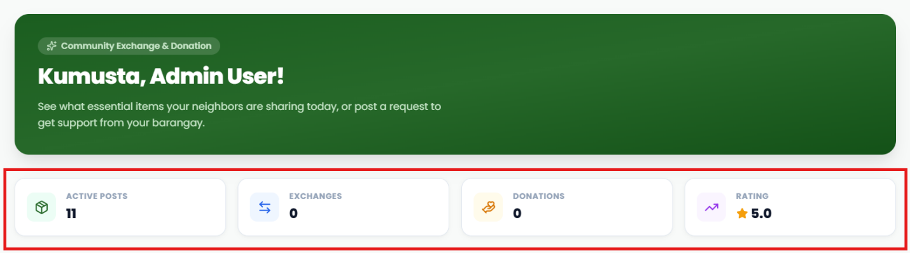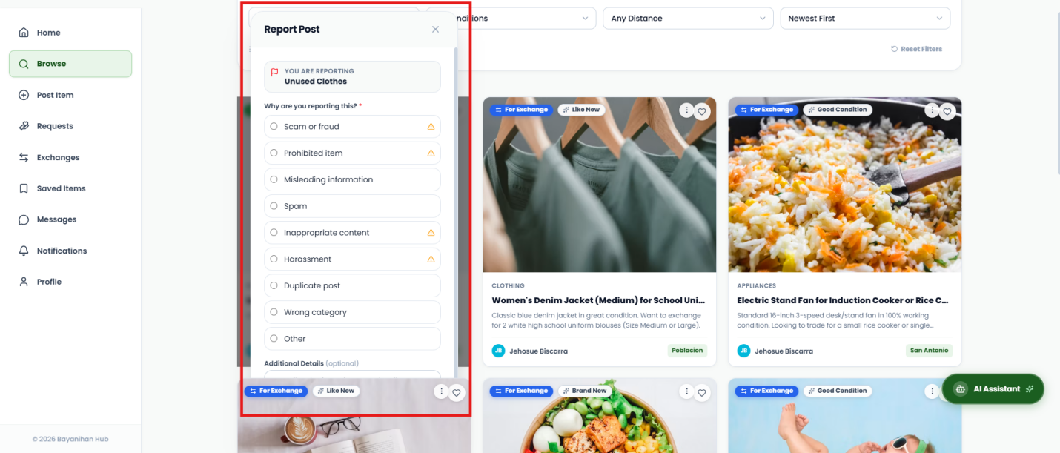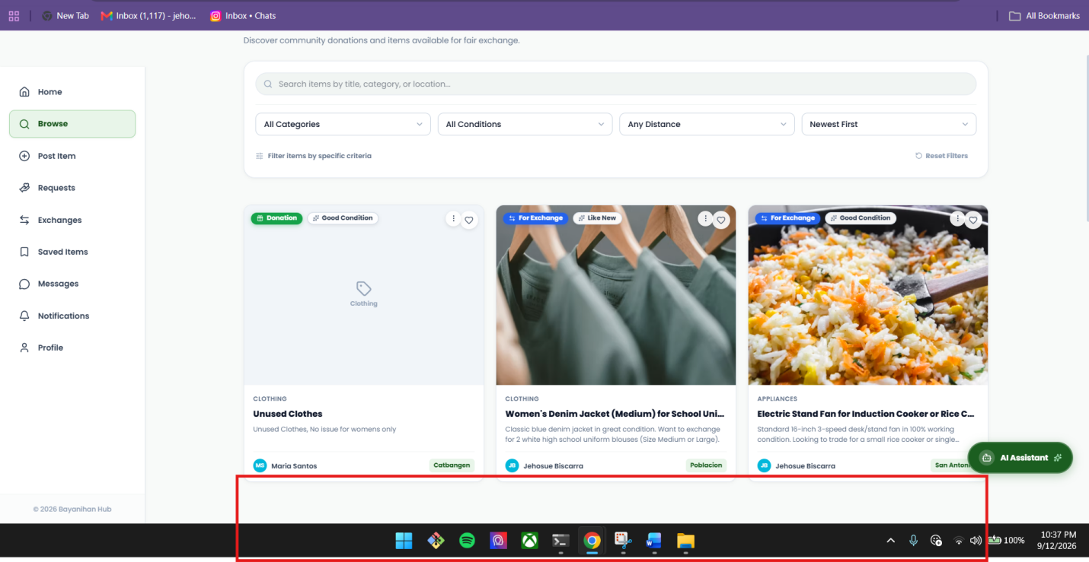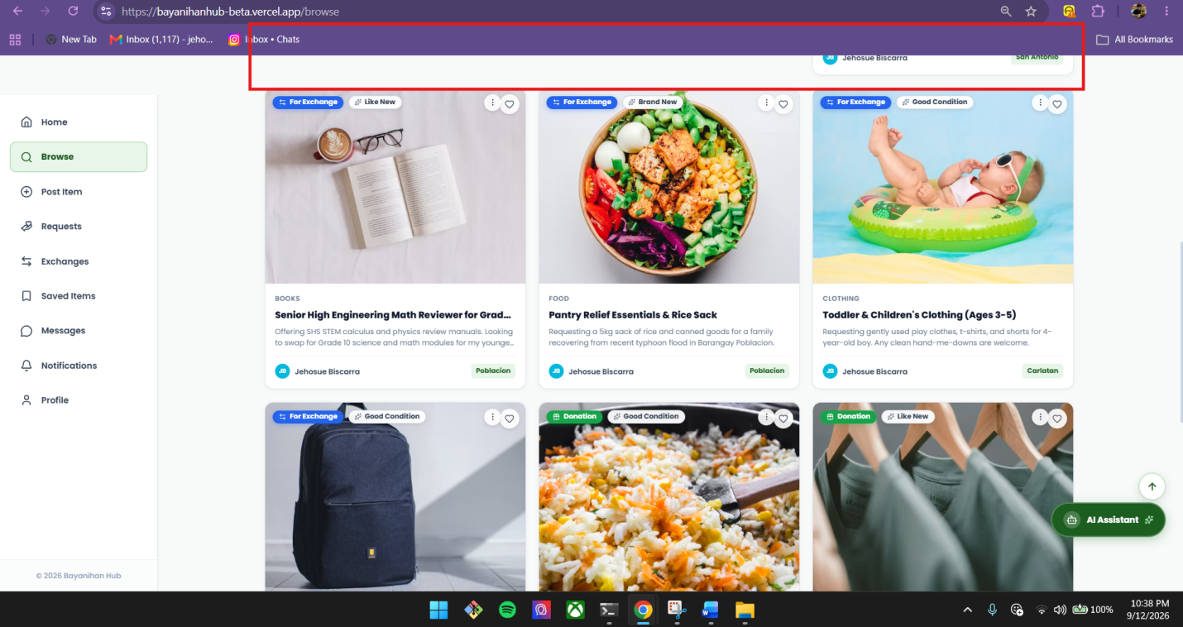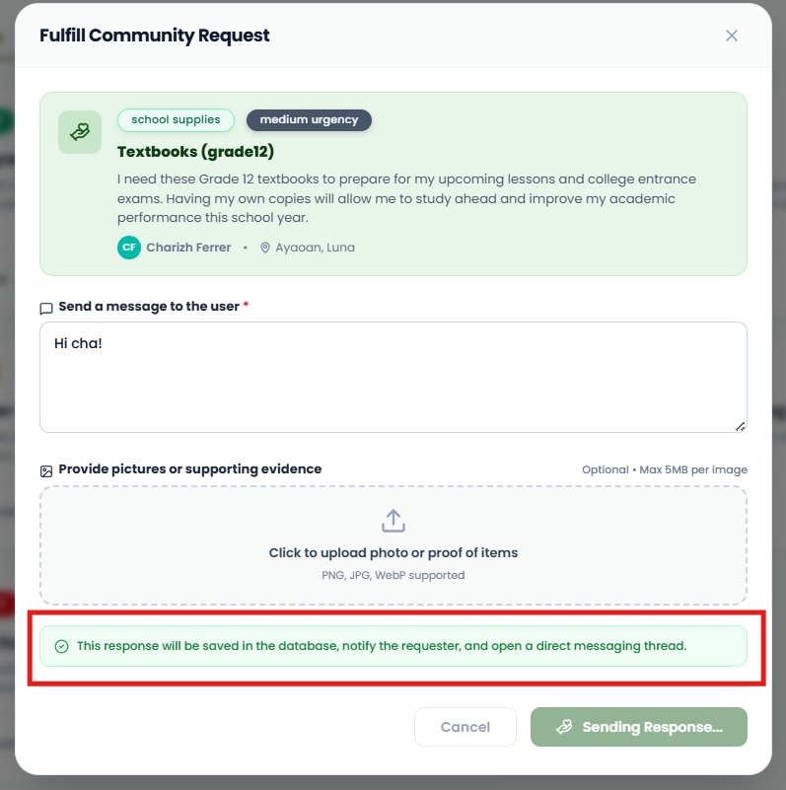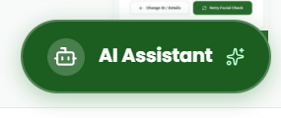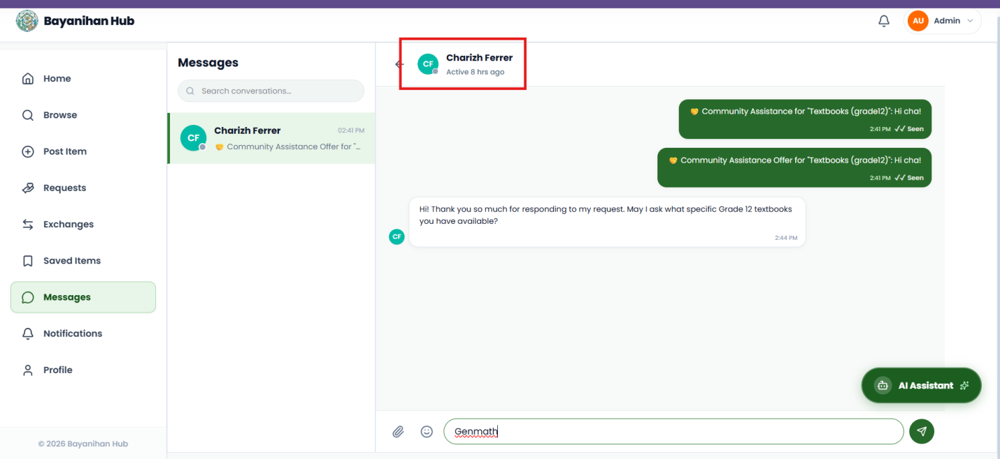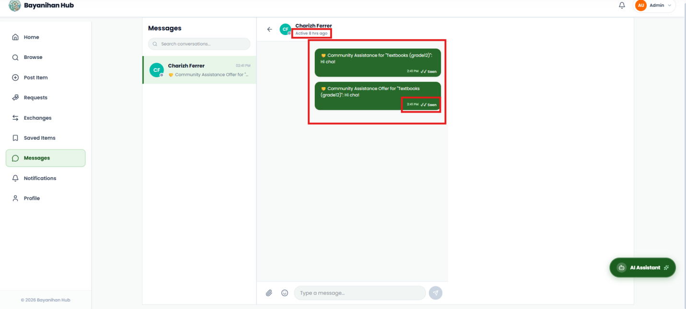
THERE IS A GLITCH HERE WHEN THE HEAD OR BUTTOM OF THE POST WAS EXACTLY PLACED HERE FOR A MOMENTS OR LONG MOMENTS
BUTTONS NOT VISIBLE DUE TO THE IT GOES TO THE BACK OF THE POST
REMOVE THS
THERE IS A GLITCH HERE WHEN THE HEAD OR BUTTOM OF THE POST WAS EXACTLY PLACED HERE FOR A MOMENTS OR LONG MOMENTS
REMOVE THIS
REMOVE THE INDICATOR AND JUST REMAIN THE ROBOT ICON

ACTIVITY STATUS IS NOT WORKING, CHARIZH IS ACTIVE THAT TIME AND WE’RE CHATTING LIVE
TIME IS NOT ACCURATE I SENT IT 10:41PM BUT DISPLAYED 2:41PM ALSO IF YOU NOTICE IT’S SO SPACY TO THE RIGHT
ADD A FEATURE THAT WHEN CLICKED THIS PART THE USER WILL BE DIRECTED TOTH E USER PROFILE

