SMART-MOBILE BASED SOLAR-POWERED CHICKEN FEEDING SYSTEM WITH AUTOMATED DISPENSING AND REAL TIME ALERT
Chapter II
Methodology
This chapter presents the methods and procedures used in developing and evaluating the Smart Mobile-Based Solar-Powered Chicken Feeding System with Automated Dispensing and Real-Time Alerts. It includes the research design, materials and equipment, data gathering procedure, system development, testing and evaluation, data management, and ethical considerations.
Research Design
This study will utilize a quantitative and descriptive research design to develop and evaluate the Smart Mobile-Based Solar-Powered Chicken Feeding System with Automated Dispensing and Real-Time Alerts. The quantitative descriptive research design will be used to collect and analyze numerical data through a structured questionnaire to evaluate the developed system. The proposed system will combine solar power, Internet of Things (IoT) technology, and a mobile application to automate the feeding process, send real-time notifications, and allow users to monitor and control the system remotely. These features aim to improve the efficiency and sustainability of poultry farming (Batuto et al., 2020; Hasan & Siddika, 2025).
After the prototype is developed, it will be evaluated based on its System Performance (System Accuracy, Feeding Response Time, Notification Response Time and Solar Energy Efficiency) System Quality (Automated Feeding Functionality, Operational Reliability, Mechanical and Structural Durability; Electrical and Operational Safety) User Acceptability (Perceived Usefulness, Ease of Use, Convenience and User Satisfaction The results of the evaluation will help determine whether the developed system is effective, reliable, and acceptable for use by poultry farmers (Laksono et al., 2023).
Materials and Equipment
The development of the Smart Mobile-Based Solar-Powered Chicken Feeding System with Automated Dispensing and Real-Time Alerts requires several essential materials. These include a solar panel, solar charge controller, rechargeable battery, ESP32 microcontroller, servo motor, real-time clock (RTC) module, feed hopper, and an automated feed dispensing mechanism. A mobile application will also be used to allow users to monitor the system remotely and receive real-time notifications.
Supporting materials such as jumper wires, connectors, and a printed circuit board (PCB) will be used during assembly. A digital weighing scale will be utilized to test the accuracy of the feed dispensing, while evaluation questionnaires will be prepared to gather feedback from the respondents. Before testing begins, all components will be inspected and tested to ensure that the system functions properly and reliably throughout the study.
General Procedure
Gathering and Preparation of Materials
The study will begin by gathering and preparing the essential materials and equipment needed for the development of the Smart Mobile-Based Solar-Powered Chicken Feeding System with Automated Dispensing and Real-Time Alerts. The primary components include a solar panel, solar charge controller, rechargeable battery, ESP32 microcontroller, servo motor, real-time clock (RTC) module, feed hopper, feed dispensing mechanism, and the necessary electronic components such as jumper wires, connectors, and a printed circuit board (PCB) or breadboard for circuit assembly. A mobile application will also be prepared to enable remote monitoring, automated feeding control, and real-time notifications. In addition, a digital weighing scale will be used during system testing to evaluate the accuracy and consistency of feed dispensing, while evaluation questionnaires will be prepared to gather users' assessments of the system's performance, functionality, usability, and overall acceptability.
After gathering all the required materials, each component will undergo inspection and functional testing before the assembly of the prototype. The solar panel, charge controller, and rechargeable battery will be tested to ensure efficient power generation, storage, and distribution. The ESP32 microcontroller will be programmed and configured to control the automated feeding schedule, manage system operations, and transmit real-time notifications to the mobile application. The RTC module will be calibrated to maintain accurate feeding schedules, while the servo motor and feed dispensing mechanism will be tested to ensure consistent and reliable feed delivery. The mobile application will likewise be evaluated to verify its ability to provide remote monitoring and timely alerts regarding the system's operation. Finally, the evaluation questionnaire will be reviewed and validated to ensure that it effectively measures users' perceptions of the system. This preparation phase will ensure that all materials, equipment, and evaluation instruments are fully operational and ready for the successful implementation of the study.
Assembly of the Prototype
The assembly of the Smart Mobile-Based Solar-Powered Chicken Feeding System with Automated Dispensing and Real-Time Alerts will begin by positioning the solar panel in an area with maximum sunlight exposure to ensure efficient energy collection. The panel will be connected to the solar charge controller and rechargeable battery, which will store excess energy and allow the system to operate during night time or limited sunlight conditions. Proper connections among the solar panel, charge controller, battery, power switch, and DC-DC step-down regulator will be ensured to provide a stable power supply for the system. The use of solar energy supports the development of sustainable and energy-efficient agricultural technologies.
Following this, the control unit and automated feeding mechanism will be installed. The ESP32 microcontroller will serve as the central controller, coordinating the different components and providing wireless communication for remote monitoring (Safputra et al., 2023). It will be connected to the DS3231 RTC module to manage the scheduled feeding times (Fesariton et al., 2024). The feed hopper and dispensing mechanism will then be connected to the servo motor, which will open and close the dispenser according to the programmed schedule. The load cell and HX711 amplifier will be installed below the dispensing outlet to measure the amount of feed released and ensure that the target quantity is reached (Saharman et al., 2022). This feedback-based process will help improve dispensing accuracy and minimize feed waste (Ferdian et al., 2022).
An ultrasonic sensor will also be placed inside the feed hopper to monitor the remaining feed level. As the feed level decreases, the distance measured by the sensor will increase. When the reading reaches the predetermined threshold, the system will identify a low-feed condition and generate an alert (Salam et al., 2023). Through Wi-Fi connectivity, the ESP32 will transmit system information to the mobile application, allowing users to remotely monitor the feeding status, feed weight, feed level, battery condition, and system status (Laksana & Zaky, 2024; Bustami & Riyadi, 2023). Real-time notifications will also be provided for feeding completion, low feed level, low battery, and system errors (Rufa’i & Ansori, 2022). After all components have been assembled, the system will be tested to verify the proper operation of the power supply, scheduled feeding, accurate dispensing, feed-level detection, mobile monitoring,and real-time alert functions.
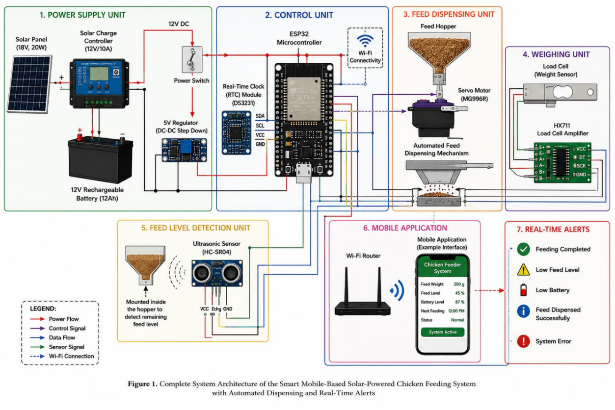
Figure 1. Complete System Architecture of the Smart Mobile-Based Solar-Powered Chicken Feeding System with Automated Dispensing and Real-Time Alerts. This system architecture illustrates the different components and processes involved in the operation of the Smart Mobile-Based Solar-Powered Chicken Feeding System with Automated Dispensing and Real-Time Alerts. At the center of the system is the ESP32 microcontroller, which serves as the main control unit. It receives information from the Real-Time Clock (RTC) module, load cell with HX711 amplifier, and ultrasonic sensor, then controls the servo motor and communicates with the mobile application through Wi-Fi. The system is powered by a solar panel that converts sunlight into electrical energy. The generated power passes through the solar charge controller, which regulates the energy and safely charges the rechargeable battery. The stored energy in the battery provides a continuous power supply to the system. A power switch controls the main electrical supply, while the DC-DC step-down regulator adjusts the voltage to the appropriate level required by the electronic components. The RTC module provides accurate time information to the ESP32 for scheduled feeding.
When the programmed feeding time is reached, the ESP32 sends a control signal to the servo motor. The servo motor then operates the automated feed dispensing mechanism, allowing feed from the hopper to pass into the feeding tray. The amount of dispensed feed is measured using the load cell, which is connected to the HX711 load cell amplifier module.
As the feed falls onto the weighing tray, the load cell detects its weight and sends the information through the HX711 to the ESP32. The microcontroller compares the measured weight with the programmed target amount. If the target weight has not yet been reached, the servo motor continues the dispensing process.
Once the desired amount of feed is reached, the servo motor stops automatically, helping prevent overfeeding and feed waste. An ultrasonic sensor is installed inside the feed hopper to monitor the remaining feed level. The sensor measures the distance between its position and the surface of the feed. When the feed level drops below the predetermined threshold, the ESP32 detects the low-feed condition and sends a warning notification to the mobile application. The system is connected to a Wi-Fi network, allowing the ESP32 to transmit information to the mobile application.
Through the application, users can remotely monitor the feeding status, feed weight, remaining feed level, battery condition, and next feeding schedule. The system also provides real-time alerts for conditions such as feeding completed, feed successfully dispensed, low feed level, low battery, and system errors. Once all components are properly connected, the feed hopper will be filled with the appropriate poultry feed and attached to the dispensing mechanism.
The system will then be tested to ensure that the servo motor dispenses the correct amount of feed at the scheduled time. The load cell will be used to verify the accuracy of the dispensed feed, while the ultrasonic sensor will monitor the remaining feed inside the hopper.
Finally, the mobile application and real-time alert functions will be tested to ensure that system information and notifications are successfully transmitted to the user, completing the assembly and operation of the proposed smart chicken feeding system.
Figure 2. Isometric View of Smart Feed
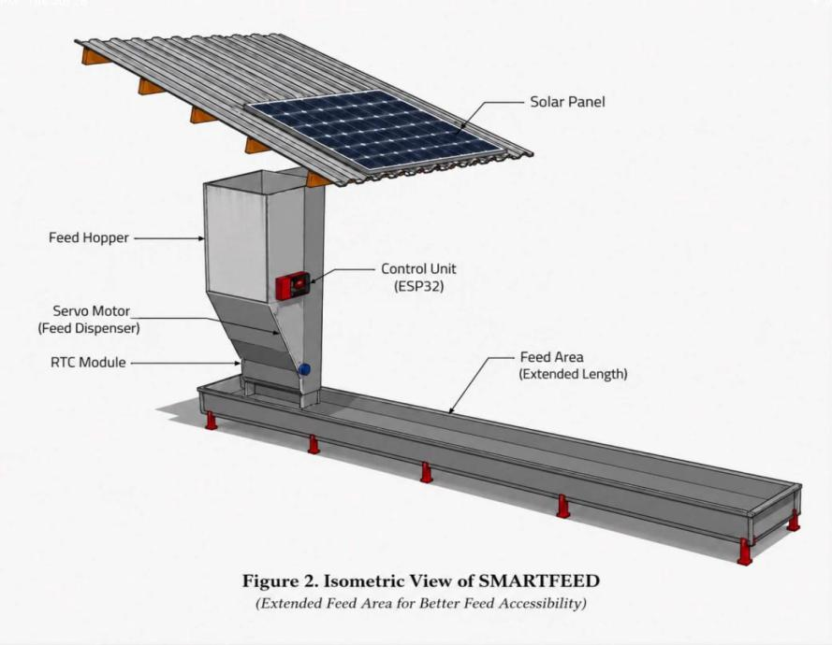
Parts and Functions of the Device
The Smart Mobile-Based Solar-Powered Chicken Feeding System with Automated Dispensing and Real-Time Alerts consists of the following key components:
Parts | Function
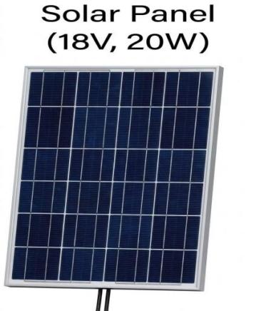  - Solar Pannel | Converts sunlight into electrical energy to power the system.
2
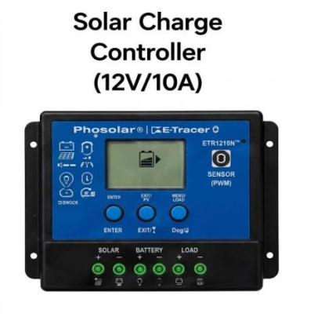  - Solar Charge Controller | Regulates battery charging and prevents overcharging.
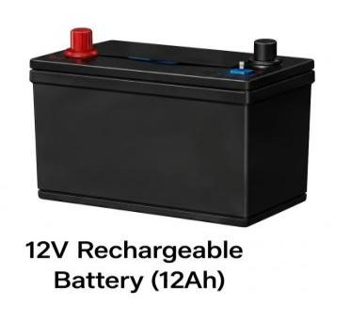  - Rechargeable Battery | Stores solar energy and supplies power when sunlight is unavailable.
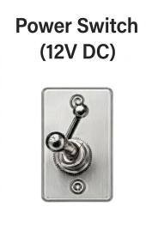  - Power Switch (12V DC) | Serves as the main physical toggle to control the power supply flow from the battery to the rest of the circuit.
- 5V Regulator (DC-DC Step Down)  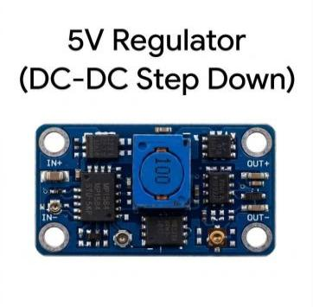 | Converts a higher DC input voltage (such as 12V from the battery) down to a lower, stable 5V DC output.
- Ultrasonic Sensor (HC-SR04)  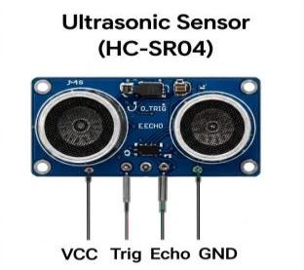 | Measures distance by emitting sound waves and calculating the time it takes for the echo to bounce back.
- ESP32 Microcontroller  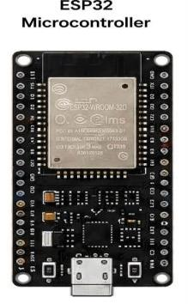 | Controls the feeding schedule, hardware operation, and Wi-Fi communication.
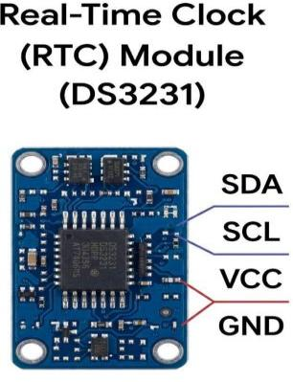  - Real-Time Clock (RTC) Module | Maintains accurate time for automatic feed dispensing.
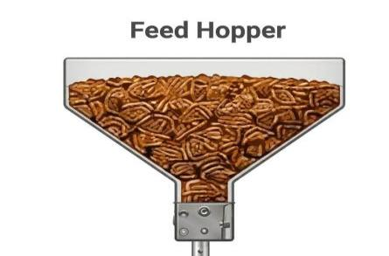  - Feed Hopper | stores the chicken feed.
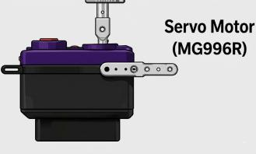  - Servo Motor | Dispenses a predetermined amount of feed at scheduled times.
- Load Cell (Weight Sensor)  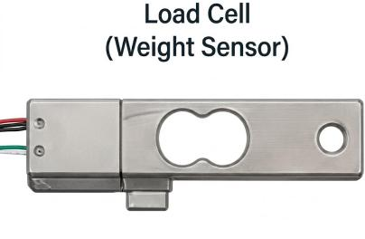 | Converts physical force or weight into an electrical signal.
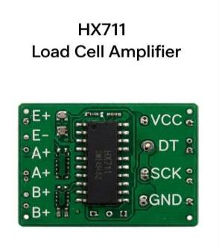  - HX711 Load Cell Amplifier | Amplifies the extremely small millivolt signals generated by the load cell and converts them into a digital format.
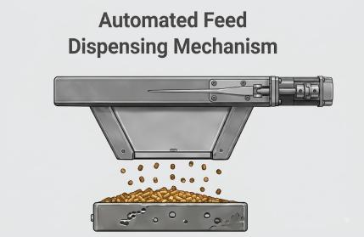  - Automated Feed Dispensing Mechanism | The complete mechanical assembly (combining the motor, chute, and release plate) that drops the feed.
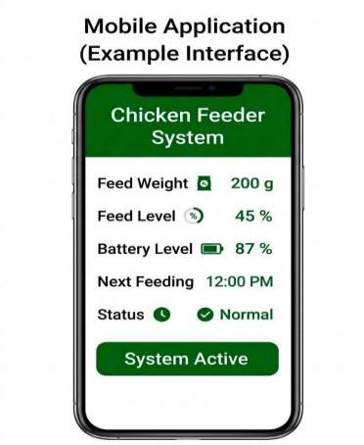  - Mobile Application | Allows remote monitoring, manual feeding, and real-time system alerts. These components work together to provide an automated, accurate, and energy-efficient poultry feeding system.

