**Jeiberth Camilo Malagon Gomez - 2306497**

**Final Project Document**

**Project Scope**

This project envisions a transformative shift in how both financial institutions and individual users interact with their finances. Going beyond traditional financial management approaches, the aim is to revolutionize the user experience. By tailoring the platform to cater to administrators and users, the project strives to create an inclusive and user-centric ecosystem. The overarching goal is to be a game-changer, providing exceptional benefits to a diverse range of clients, from large financial entities seeking advanced solutions to individual users desiring enhanced financial control and convenience.

**Project Functionalities**

**User-Friendly Access: Log in (MainWindow.xaml)**

The central hub for user interaction is the Log in page, serving as a welcoming gateway for both users and administrators. This entry point opens the door to a world of seamless and sophisticated financial functionalities.

**Administrators' Toolbox**

**Administrator's Main Page (WindowAdmin.xaml)**

The Administrator's Main Page is designed for functionality without sacrificing user-friendliness. It serves as a hub presenting administrators with a comprehensive array of tools in a visually intuitive interface.

**Create Account Window (CreateAccountWindow.xaml)**

* Empowers administrators to effortlessly and securely generate new user or administrator accounts.
* The process involves connecting to the robust database architecture and creating a new data entry with the required information.

**Transaction Management (TransactionsAdmin.xaml)**

* Administrators gain a panoramic view of existing accounts and detailed transaction histories.
* Facilitates seamless fund transfers between accounts based on the availability of funds.

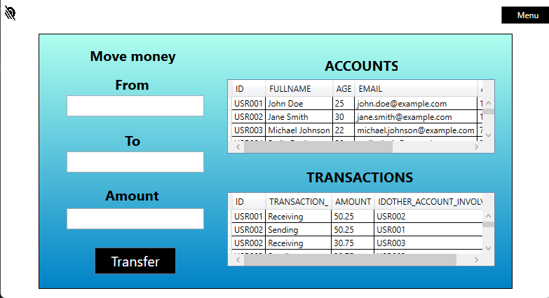

**Modify Account (WindowModify.xaml)**

* The zenith of administrative empowerment, allowing selective access to any created account using a unique identifier.
* Enables viewing and modification of user information, including updating or deleting accounts for streamlined and efficient account management.

**Users' Hub**

**User's Main Page (WindowUser.xaml)**

The User's Main Page acts as the epicenter of user interaction, providing a tailored interface for two pivotal functionalities.

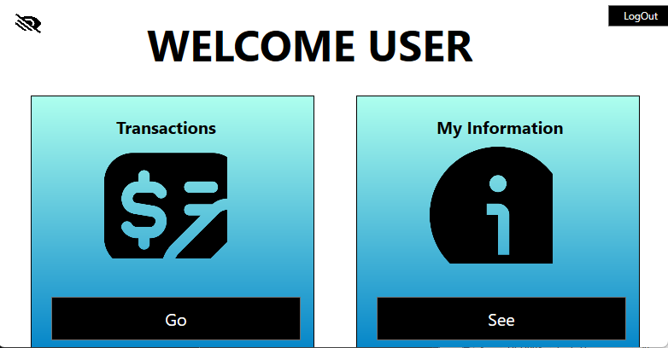

**Transactions (PersonalWindow.xaml)**

* Users traverse their financial journey by accessing a detailed transaction history.
* Real-time visibility into available funds empowers users to seamlessly transfer funds to any account via the account's unique identifier.

**My Information (info.xaml)**

* Empowers users to access and review their account information.
* For any alterations or issues, users are guided to consult administrators, ensuring a robust layer of security and oversight.

**Project Setup**

**Database Foundation**

The project's foundation rests on two crucial databases: "person" and the transaction tracking database “Personal_transaction”. The "person" database holds essential user information, including ID, Full_name, Age, Email, Amount, Password_, and Admin (1 for administrators, 0 for regular users). The transaction tracking database includes fields like ID, transaction type (receiving or sending), amount, and ID_OTHER_ACCOUNT_INVOLVED.

Setting up this robust database infrastructure is straightforward, requiring the execution of a pre-existing query in the project folder, with no modifications needed for seamless implementation.

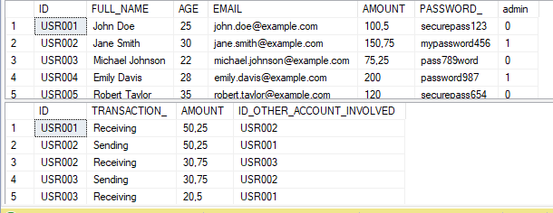

**Visual Studio Integration**

Ensuring universal accessibility, the project seamlessly integrates with all versions of Visual Studio. The operationalization involves a minor yet pivotal modification in the code within all .xaml files. Specifically, the line of code static SqlConnection con = new SqlConnection(@"____"); requires the insertion of the connection to the local server after executing the provided query, laying the foundation for a fully functional and primed database.

**Work Progress in the Future**

Looking ahead, the project opens doors to continuous improvement and expansion. Future enhancements may include:

Enhanced User Experience

Advanced Security Measures

Mobile Compatibility

Feedback Mechanism

Integration with External Services

Expanded Educational Resources

Community Engagement