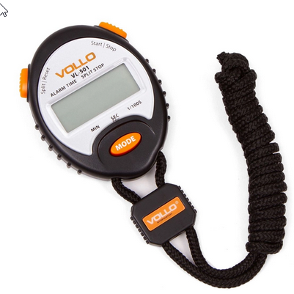

https://www.submarino.com.br/produto/70937457/cronometro-profissional-vollo-vl-501-com-alarme-e-relogio?WT.srch=1&acc=d47a04c6f99456bc289220d5d0ff208d&epar=bp_pl_00_go_g35160&gclid=CjwKCAiA9bmABhBbEiwASb35V61mBTVPtdyDjKXRW_W8ME7eI0OqsaBBpKsQUkRON27V21tWUKcHjRoCJG0QAvD_BwE&i=56f30b7aeec3dfb1f8ebed1c&o=5ccb51386c28a3cb50b8ba41&opn=XMLGOOGLE&sellerid=18552346000168