Paper or report template

# Abstract

This is a **Quarto** *document.* Quarto uses a simple Markdown formatting syntax for authoring HTML, PDF, and MS Word or .odt documents. For more details on using Quarto see <https://quarto.org/>.

Here is our abstract. We discovered that medaka fish can eat Arabidpopsis shoop apical meristeme cells to regulate energy metabolism (data not shown). Here is some **text in bold** *italic* underline and superscript.

# Introduction

*Platynereis dumerilii* is a marine annelid… (Ozpolat et al., 2021). It is also the coolest model organism. It lives in shallow sea on seagrass. Ischia is a good sampling location.

# Results

## Adding references

You can add references either by referring to their id in the .bib file e.g., (Marinković et al., 2019), or by switching to the visual editor (Cogwheel in the .Rmd menu -> Use Visual Editor). (Jacobs and Ryu, 2023; Jokura et al., 2023)

In the visual editor mode, go to ‘Insert’ -> @ Citation You can select a Zotero library, PubMed, CrossRef etc. and insert the citations. (Jacobs and Ryu, 2023)

One easy and techy way is to use the command line:

curl -LH "Accept: application/x-bibtex" https://doi.org/10.7554/eLife.91258.1 >> references.bib  
  
#make sure to use >> and not > otherwise you will overwrite your file!

The references are stored in manuscript/references.bib (needs to be defined in the Yaml header). This file will automatically updated when you insert a new reference through the Visual editor > Insert > Citations.

(Lohmann et al., 2023; Lohmann et al., 2001; Ozpolat et al., 2021; Saile et al., 2023; Wu et al., 2020)

In this documents, references will be formatted in the style of eLife. This is defined in the Yaml header under: csl: elife.csl. The elife.csl file is saved in the /manuscript folder.

If you would like to use a different citation format, download the respective .csl file (e.g., from the Zotero style repository <https://www.zotero.org/styles>), save it in the /manuscript folder of the project and change the Yaml to csl: your_favourite_journal.csl.

Now edit the text, add a few references and press -> Render and see how the changes show up on the rendered document. It is easier and faster to render your document to html. You will get a very nice dynamic layout that you can read in the browser (use Firefox). You can also render into pdf, but you need to install a version of latex for that. An easy alternative to generate a nice pdf is to open the html version in a browser (in this case Chrome gives the best results) and print to a pdf file.

## Inserting figures

You can add your figures into the rendered document. We saved the figures into /manuscript/figures or /manuscript/figure_supplements and can insert them from there. We use knitr::include_graphics for this. The title and legend can also be edited, as well as the width of the output figure.

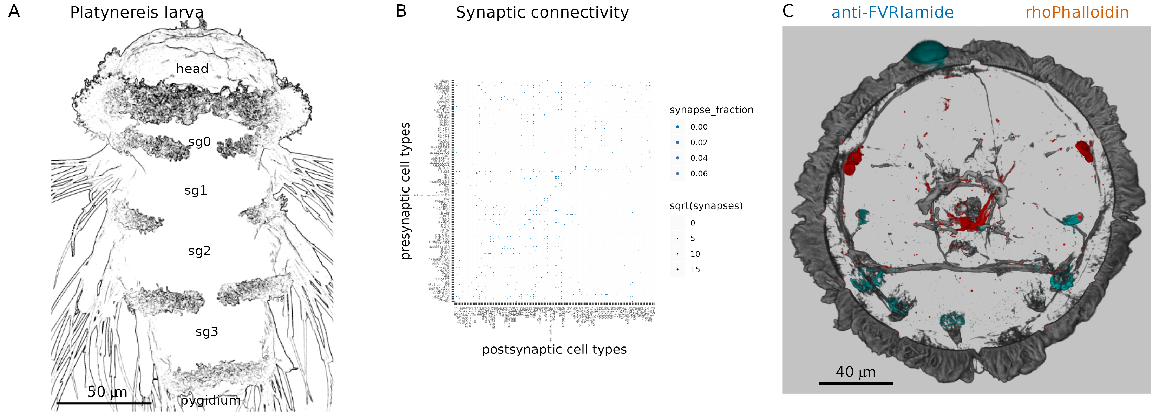

**Figure 1. A figure** (A) A nice picture. (B) legend. (C) (D)

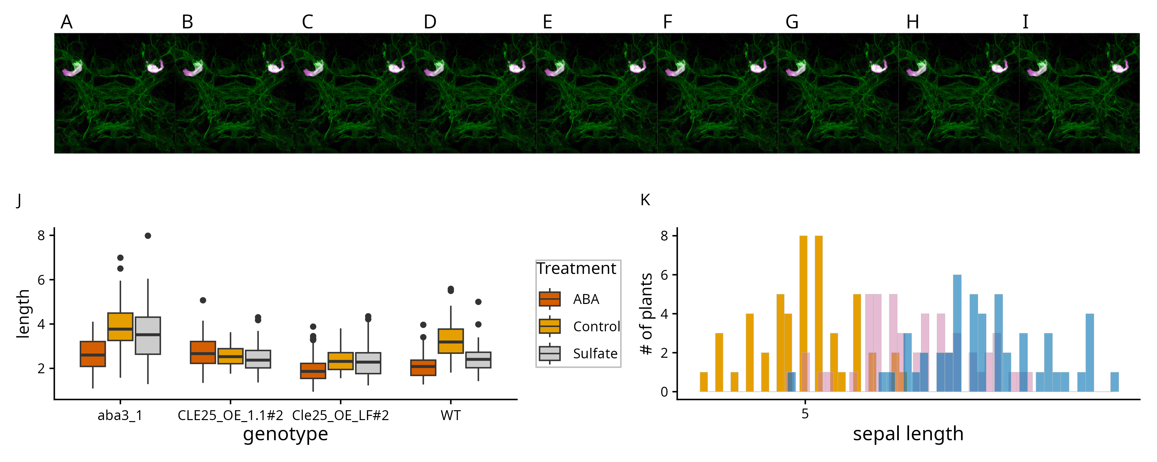

**Figure 1. Our nice figure from yesterday** (A) A nice picture. (B) legend. (C) (D)

## Adding equations

Equations can also be inserted, Insert -> Display Math:

## Sourcing code and working with variable

The mean value of Nanog expression was 0.0909 indicating that Nanog is downregulated. The ‘analysis/scripts/statistics_for_paper.R’ script is sourced and it runs but the output is not included in the knitted output. But we can access the variables defined in the sourced script simply by adding ` r var_name ` between ` backticks, in this case max_PRC value is 21 (now this number comes from our sourced script).

If we update the data, the script can recalculate the variable we want to refer to in the text and update the number.

## Inserting comments

Inserting comments: You can also use the visual editor and insert -> comment.

Test comment here.

# Acknowledgements

We would like to thank the [Jekely lab](https://github.com/JekelyLab) for the [R project template](https://github.com/JekelyLab/new_paper_template) we used to write this paper. This work was funded by xy funding agency.

# Materials and Methods

You can insert tables from source data, such as .csv or Excel files and render them in html with the tinytable package.

Alternatively, you can use the Markdown grid table format. For more complex tables, you can use the [tablesgenerator](https://www.tablesgenerator.com/markdown_tables) online grid table editor/converter (e.g. converts csv or excel files).

The output may differ between html and pdf, for most consistent results use the grid table format described [here](https://quarto.org/docs/authoring/tables.html).

**Key Resources Table**

Warning: The `placement` argument in `tt()` is deprecated. Please use this  
instead: `theme_tt(table, 'placement')`

| Reagent type (species) or resource | Designation | Source or reference | Identifiers | Additional information |
| --- | --- | --- | --- | --- |
| biological sample (N. vectensis) | larval, juvenile and adult N. vectensis | Specimens obtained form the Marine Invertebrate Culture Unit of the University of Exeter | N/A | NA |
| biological sample (cDNA) | cDNA obtained from N. vectensis | this study | N/A | RNA extracted with Trizol and cDNA synthesized with cDNA synthesis kit according to manufacturers recommendation |
| biological sample (peptide extract) | peptide extracts obtained from N. vectensis | this study | N/A | Peptides extracted from N. vectensis according to protocol explained in Material and Methods |
| genetic reagent (cDNA synthesis) | SuperScript™ III First-Strand Synthesis System | Invitrogen (from ThermoFisher) | 18080051 | NA |
| genetic reagent (Polymerase) | Q5® Hot Start High-Fidelity DNA Polymerase | New England Biolabs | M0493L | NA |
| genetic reagent (DNA assembly) | NEBuilder® HiFi DNA Assembly Master Mix | New England Biolabs | E2621L | NA |
| genetic reagent (restriction enzyme) | EcoRV restriction enzyme | New England Biolabs | R3195L | NA |
| genetic reagent (restriction enzyme) | Afl2 restriction enzyme | New England Biolabs | R0520L | NA |

Grid Table example

| Col1 | Col2 | Col3 | Col4 | Col5 |
| --- | --- | --- | --- | --- |
| a | b | c | d | e |
| d |  |  |  |  |
| v | n | f |  | f |

## Complex grid table example

This table was generated by tt() as the output of an r chunk in a Quarto doc. For larger multi-page tables, this method gives correct page breaks in the pdf and html outputs. You can change the relative column widths with {tbl-colwidths=“[10,20,20,20,30]”} placed after the table caption declaration at the end.

More complex Grid Table example

| Reagent type (species) or resource | Designation | Source or reference | Identifiers | Additional information |
| --- | --- | --- | --- | --- |
| biological sample (N. vectensis) | larval, juvenile and adult N. vectensis | Specimens obtained form the Marine Invertebrate Culture Unit of the University of Exeter | N/A | NA |
| biological sample (cDNA) | cDNA obtained from N. vectensis | this study | N/A | RNA extracted with Trizol and cDNA synthesized with cDNA synthesis kit according to manufacturers recommendation |
| biological sample (peptide extract) | peptide extracts obtained from N. vectensis | this study | N/A | Peptides extracted from N. vectensis according to protocol explained in Material and Methods |
| genetic reagent (cDNA synthesis) | SuperScript™ III First-Strand Synthesis System | Invitrogen (from ThermoFisher) | 18080051 | NA |
| genetic reagent (Polymerase) | Q5® Hot Start High-Fidelity DNA Polymerase | New England Biolabs | M0493L | NA |
| genetic reagent (DNA assembly) | NEBuilder® HiFi DNA Assembly Master Mix | New England Biolabs | E2621L | NA |
| genetic reagent (restriction enzyme) | EcoRV restriction enzyme | New England Biolabs | R3195L | NA |
| genetic reagent (restriction enzyme) | Afl2 restriction enzyme | New England Biolabs | R0520L | NA |

# References

Jacobs EAK, Ryu S. 2023. Larval zebrafish as a model for studying individual variability in translational neuroscience research. *Frontiers in Behavioral Neuroscience* **17**. doi:[10.3389/fnbeh.2023.1143391](https://doi.org/10.3389/fnbeh.2023.1143391)

Jokura K, Ueda N, Gühmann M, Yañez-Guerra LA, Słowiński P, Wedgwood KCA, Jékely G. 2023. Nitric oxide feedback to ciliary photoreceptor cells gates a UV avoidance circuit. doi:[10.7554/elife.91258.1](https://doi.org/10.7554/elife.91258.1)

Lohmann J, de Luxán-Hernández C, Gao Y, Zoschke R, Weingartner M. 2023. Arabidopsis translation factor eEF1Bγ impacts plant development and is associated with heat-induced cytoplasmic foci. *Journal of Experimental Botany* **74**:2585–2602. doi:[10.1093/jxb/erad050](https://doi.org/10.1093/jxb/erad050)

Lohmann JU, Hong RL, Hobe M, Busch MA, Parcy F, Simon R, Weigel D. 2001. A Molecular Link between Stem Cell Regulation and Floral Patterning in Arabidopsis. *Cell* **105**:793–803. doi:[10.1016/s0092-8674(01)00384-1](https://doi.org/10.1016/s0092-8674(01)00384-1)

Marinković M, Berger J, Jékely G. 2019. Neuronal coordination of motile cilia in locomotion and feeding. *Philosophical Transactions of the Royal Society B: Biological Sciences* **375**:20190165. doi:[10.1098/rstb.2019.0165](https://doi.org/10.1098/rstb.2019.0165)

Ozpolat BD, Randel N, Williams EA, Bezares-Calderón LA, Andreatta G, Balavoine G, Bertucci PY, Ferrier DEK, Gambi MC, Gazave E, Handberg-Thorsager M, Hardege J, Hird C, Hsieh Y-W, Hui J, Mutemi KN, Schneider SQ, Simakov O, Vergara HM, Vervoort M, Jékely G, Tessmar-Raible K, Raible F, Arendt D. 2021. The Nereid on the rise: *Platynereis* as a model system. *Zenodo*. doi:[10.5281/ZENODO.4907400](https://doi.org/10.5281/ZENODO.4907400)

Saile J, Wießner-Kroh T, Erbstein K, Obermüller DM, Pfeiffer A, Janocha D, Lohmann J, Wachter A. 2023. SNF1-RELATED KINASE 1 and TARGET OF RAPAMYCIN control light-responsive splicing events and developmental characteristics in etiolated Arabidopsis seedlings. *The Plant Cell* **35**:3413–3428. doi:[10.1093/plcell/koad168](https://doi.org/10.1093/plcell/koad168)

Wu H, Qu X, Dong Z, Luo L, Shao C, Forner J, Lohmann JU, Su M, Xu M, Liu X, Zhu L, Zeng J, Liu S, Tian Z, Zhao Z. 2020. WUSCHEL triggers innate antiviral immunity in plant stem cells. *Science* **370**:227–231. doi:[10.1126/science.abb7360](https://doi.org/10.1126/science.abb7360)