LABORATORY EXERCISE 9

SEARCH AND FILTERING SYSTEM

Learning Objectives
By the end of this laboratory exercise, students should be able to:
- Implement client-side search filtering using jQuery for dynamic user experience.
- Develop server-side search functionality using CodeIgniter's database queries.
- Create a responsive search interface using Bootstrap components.
- Integrate AJAX techniques to display search results without page reload.
- Understand the differences between client-side and server-side search approaches.

Prerequisite student experiences and knowledge
Before starting this exercise, students should have:
- Completed Laboratory Exercise 8 (Real-time Notifications with jQuery).
- Solid understanding of CodeIgniter's MVC architecture and database operations.
- Proficiency in writing jQuery and JavaScript code for DOM manipulation.
- Experience with AJAX requests and handling JSON responses.
- Familiarity with Bootstrap form components and grid system.
- Knowledge of SQL queries, particularly LIKE operators for search functionality.

Background
An effective search system is crucial for any Learning Management System (LMS) to help users quickly find relevant courses and content. This exercise focuses on implementing a dual-approach search system: client-side filtering for immediate feedback and server-side searching for comprehensive results. jQuery provides the tools for dynamic client-side filtering, while CodeIgniter's database class enables efficient server-side search using SQL LIKE queries. The combination creates a seamless user experience where search results update in real-time without page refreshes, enhancing the overall usability of the application.

Materials/Resources
- Personal Computer with Internet Access
- XAMPP/WAMP/LAMP server installed
- CodeIgniter Framework
- Visual Studio Code or any code editor
- Git and GitHub Account
- Web Browser (Chrome, Firefox, etc.)
Laboratory Activity
Step 1: Project Setup
- Open your existing ITE311-LASTNAME CodeIgniter project.
- Ensure your database has a courses table with sample data for testing search functionality.
- Verify that your course listing page is functional from previous exercises.

Step 2: Create Search Controller Method
- Navigate to your Course.php controller in app/Controllers/.
- Add a new method named search():
  - This method should accept GET or POST requests with a search term parameter.
  - Use CodeIgniter's Query Builder to search the courses table using LIKE queries.
  - Return the results as JSON for AJAX requests or render a view for regular requests.
- Implement the search logic
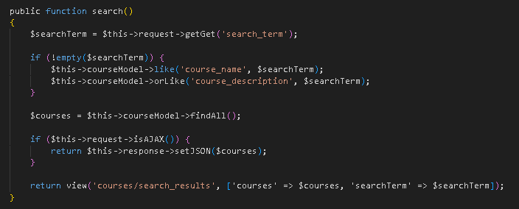

Step 3: Add Search Route
- Open app/Config/Routes.php.
- Add routes for the search functionality:
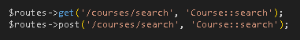

Step 4: Create Search Interface
- Modify your courses view file (app/Views/courses/index.php).
- Add a search form with Bootstrap styling
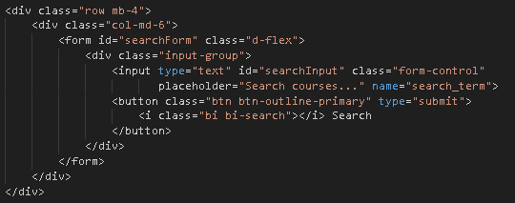

Step 5: Implement Client-Side Filtering with jQuery
- Add jQuery script for instant client-side filtering
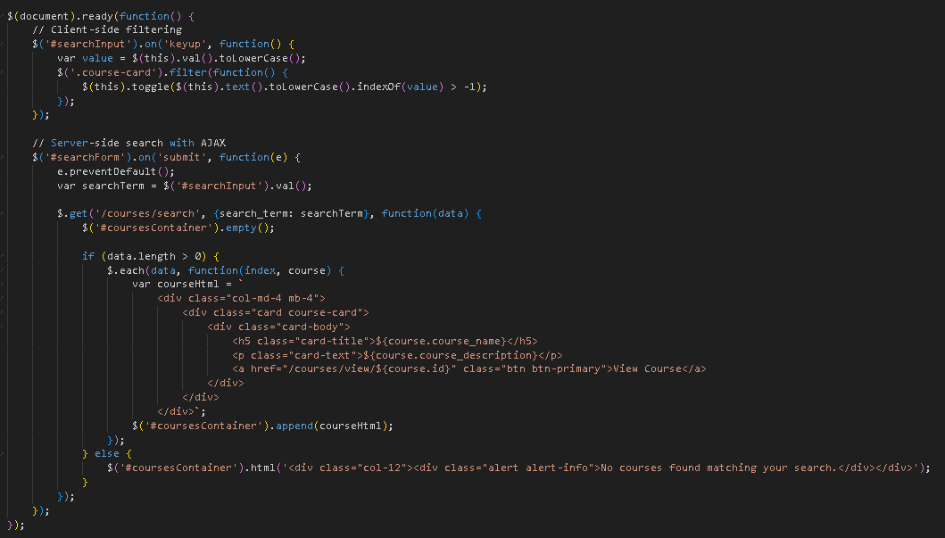

Step 6: Update Courses View Structure
- Modify your courses listing to work with the search functionality
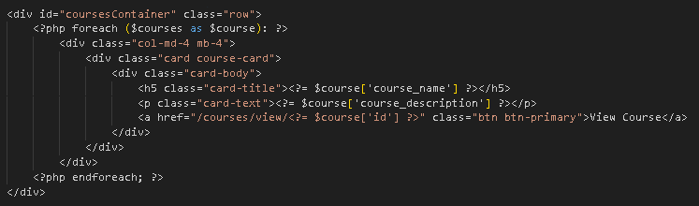
- To simulate real-time updates, you can set an interval to fetch notifications every 60 seconds (optional advanced task).

Step 7: Test the Search Functionality
- Load the courses page in your browser.
- Test the client-side filtering by typing in the search box courses should filter instantly.
- Test the server-side search by submitting the form results should load via AJAX without page refresh.
- Verify that both empty search results and successful searches display appropriate messages.

Step 9: Push to GitHub
- Stage and commit your search functionality
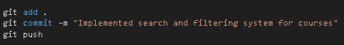

Output / Results
- Screenshot of the courses page with the search interface implemented.
- Screenshot showing filtered courses during client-side search.
- Screenshot of browser Developer Tools Network tab showing AJAX request to server-side search.
- Screenshot of search results displaying when no courses match the search term.
- Screenshot of GitHub repository with the latest commit.

QUESTIONS:
- What are the advantages and limitations of client-side filtering compared to server-side search?
- Client-side filtering happens in the user’s browser. Its main advantage is speed for small data because results appear instantly. It also reduces work on the server. The downside is it only works with data already loaded and can be slow or unsafe with large or sensitive information. Server-side search happens on the server, so it can handle large amounts of data and keeps sensitive information safe. The drawback is it can be slower and put more load on the server when many people search at the same time.

- How does using AJAX for search improve the user experience compared to traditional form submission?
- AJAX allows search results to show up without reloading the whole page. Unlike regular form submission, it gives instant feedback and keeps the page in the same state, so users don’t lose their place. This makes searching faster, smoother, and more convenient.

- What security considerations should be taken when implementing search functionality with user input?
- When allowing users to search, it’s important to check their input and remove anything harmful. Use safe ways to handle data in the database to avoid attacks. Make sure search results don’t reveal sensitive information and always protect the data being sent over the internet.

Output / Results
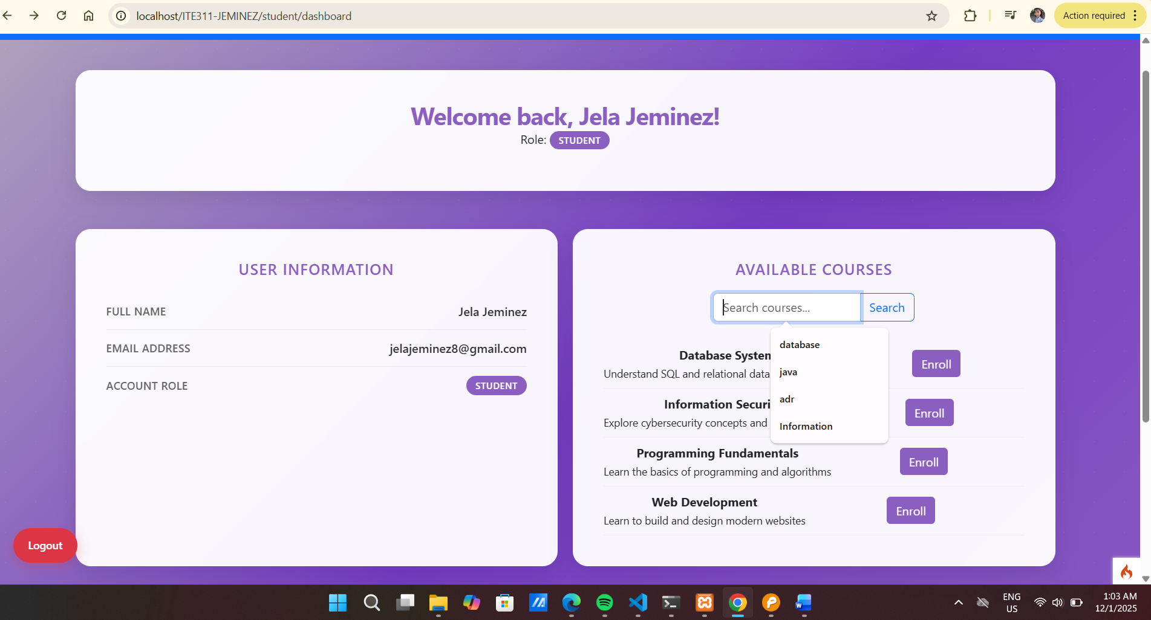

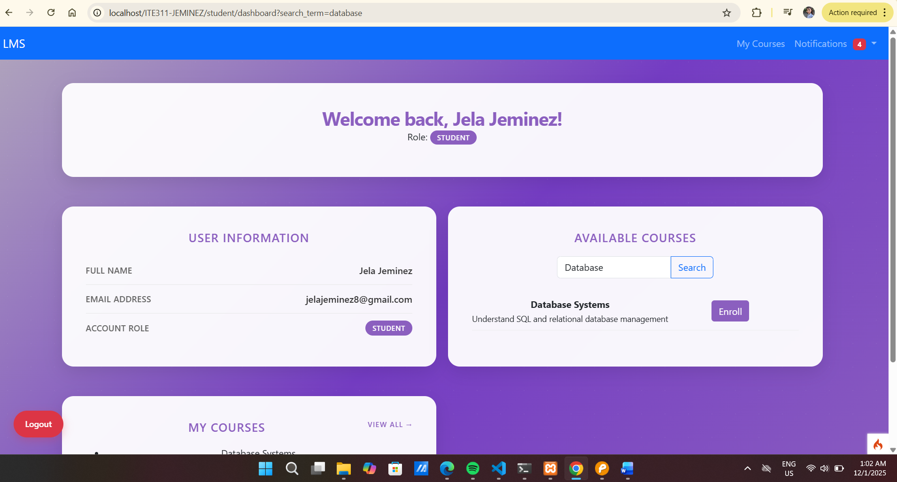

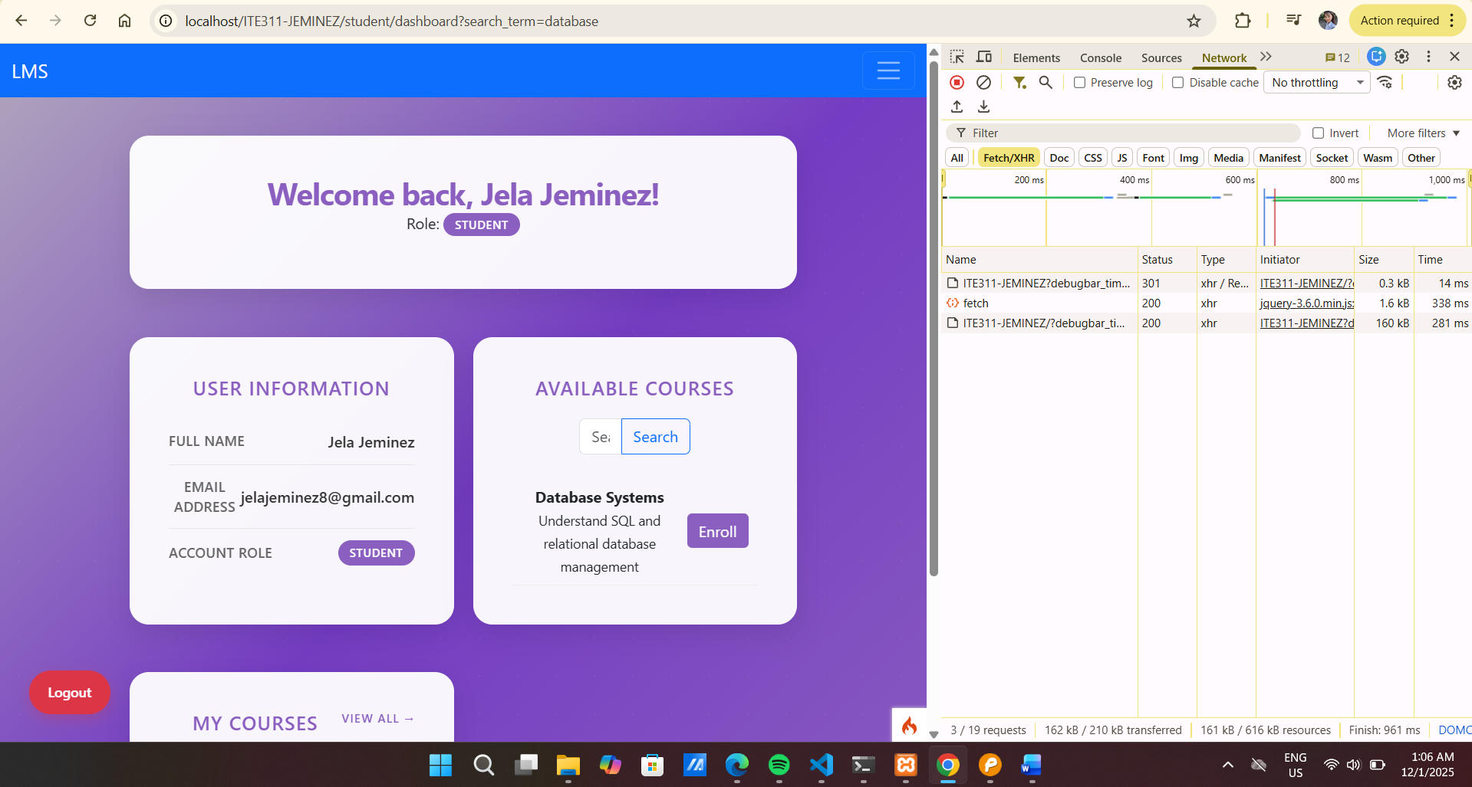

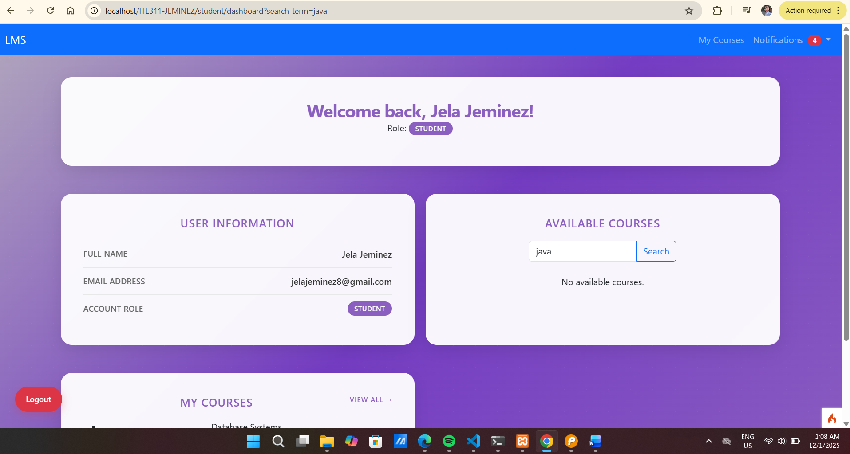

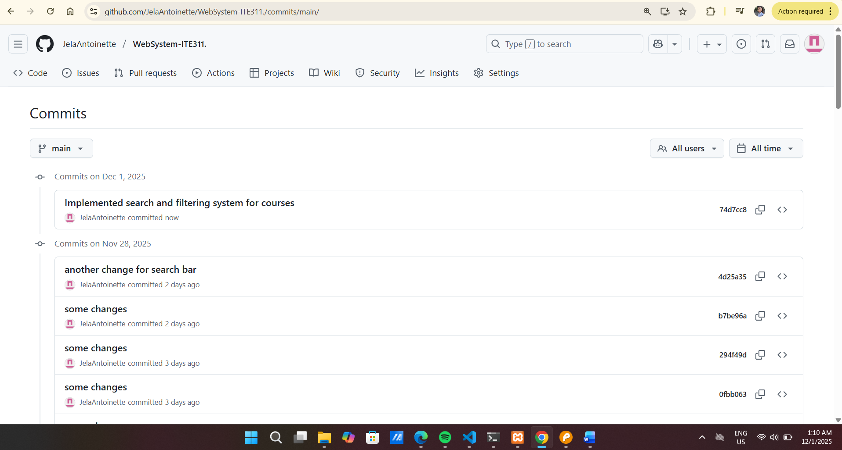

Conclusion
In this laboratory exercise, we learned how to create a search and filtering system for our courses page. By using both browser-side and server-side methods, we made a system that is fast and reliable. Browser-side filtering lets users see results immediately as they type, giving quick feedback and a smooth experience. This works well for small sets of data because it doesn’t need to contact the server every time. Server-side search, on the other hand, can handle larger amounts of data and keeps sensitive information safe. It makes sure that only the correct results are shown, even when there is too much data to load all at once in the browser.

